Task001
package day08_java;
class Node1 {
int data;
Node1 next;
Node1(int data) {
this.data = data;
this.next = null;
}
}
// Circular linked list class renamed to DeleteNode
public class DeleteNode {
Node1 head;
// Add node at the end
public void add(int data) {
Node1 newNode = new Node1(data);
if (head == null) {
head = newNode;
head.next = head;
} else {
Node1 current = head;
while (current.next != head) {
current = current.next;
}
current.next = newNode;
newNode.next = head;
}
}
// Display list elements
public void display() {
if (head == null) {
System.out.println("The list is empty.");
return;
}
Node1 current = head;
System.out.print("Circular Linked List Elements: ");
do {
System.out.print(current.data + " ");
current = current.next;
} while (current != head);
System.out.println();
}
// Delete first occurrence of key
public void delete(int key) {
if (head == null) return;
// Only one node
if (head.next == head && head.data == key) {
head = null;
return;
}
// If head node needs deletion
if (head.data == key) {
Node1 last = head;
while (last.next != head) {
last = last.next;
}
head = head.next;
last.next = head;
return;
}
// Deleting other nodes
Node1 prev = head;
Node1 curr = head.next;
while (curr != head) {
if (curr.data == key) {
prev.next = curr.next;
return;
}
prev = curr;
curr = curr.next;
}
}
// Test the implementation
public static void main(String[] args) {
DeleteNode list = new DeleteNode();
list.add(20);
list.add(25);
list.add(30);
list.add(40);
list.display(); // Output: 20 25 30 40
list.delete(25);
list.display(); // Output: 20 30 40
list.delete(20); // Deleting head
list.display(); // Output: 30 40
list.delete(40); // Deleting last
list.display(); // Output: 30
list.delete(30); // Deleting sole node
list.display(); // Output: The list is empty.
}
}
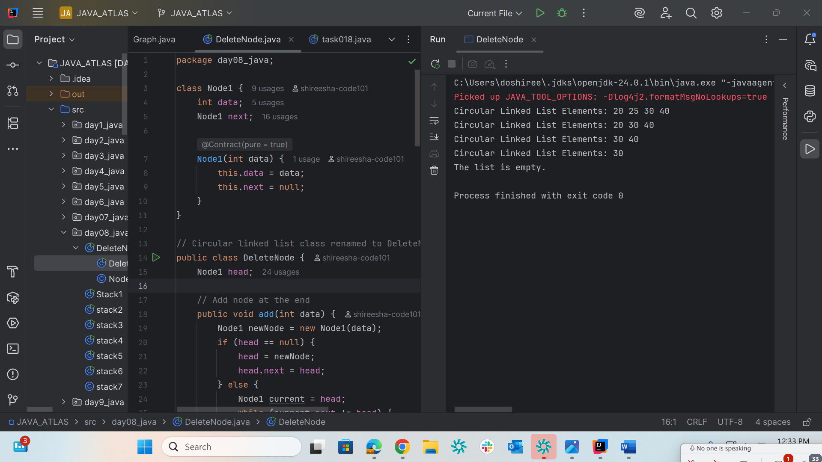

Task002
package day08_java;
import java.util.Stack;
public class Stack1 {
public static void main(String[] args) {
Stack<Integer> stack = new Stack<>();
stack.push(10);
stack.push(20);
stack.push(30);
System.out.println("Stack: " + stack);
int poppedElement = stack.pop();
System.out.println("Popped element: " + poppedElement);
System.out.println("Stack after pop: " + stack);
}
}
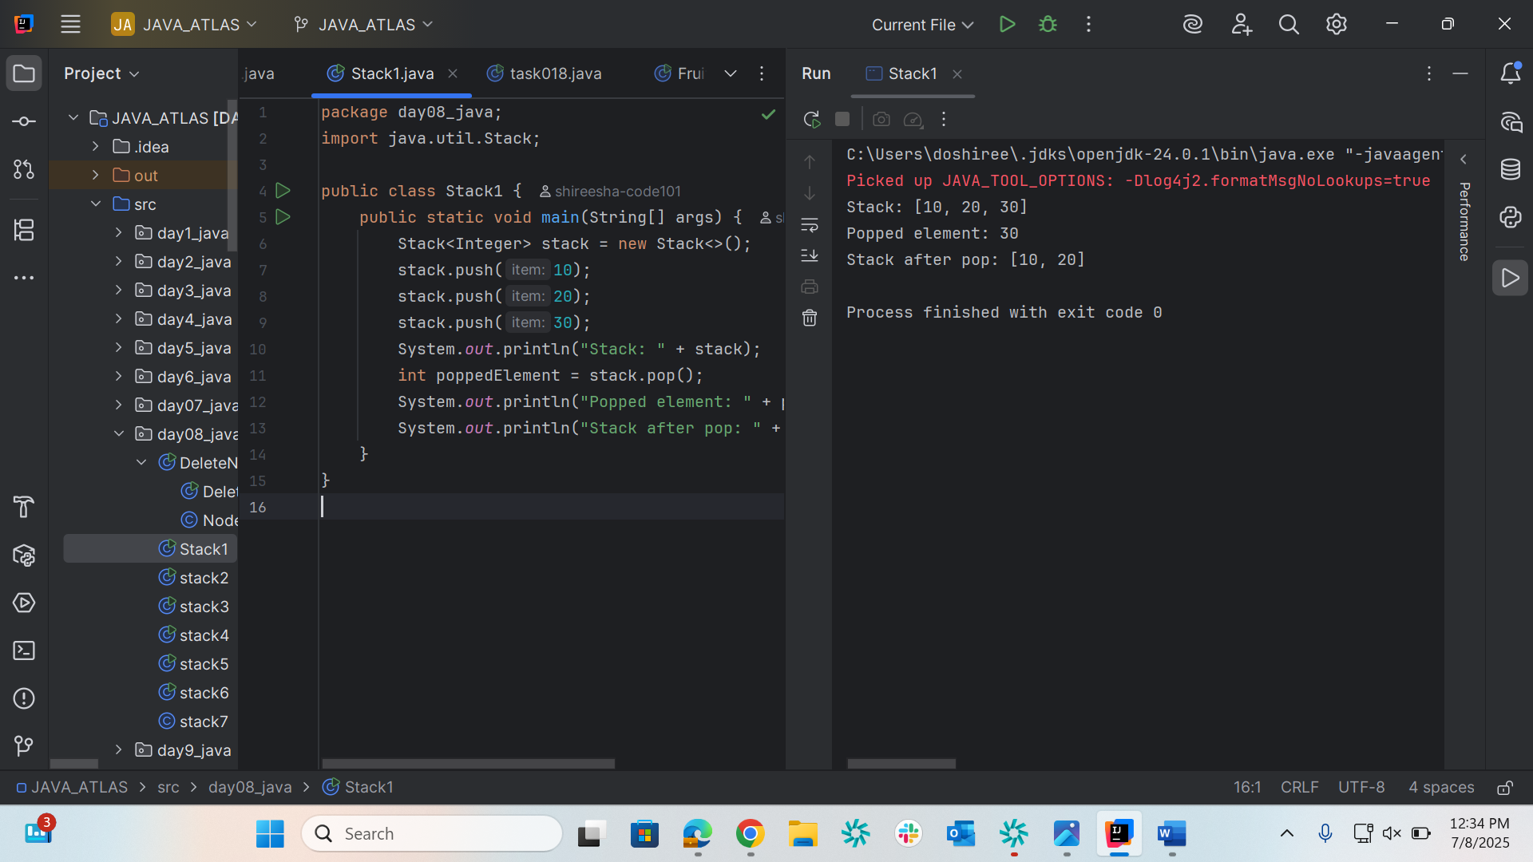

Task003
package day08_java;
import java.util.Stack;
public class stack2 {
public static void main(String[] args) {
Stack<String> names= new Stack<>();
names.push("Prasunamba");
names.push("Meher");
names.push(".MK");
System.out.println("before deletion ");
System.out.println("Stack of names: " + names);
System.out.println("after deletion ");
String dummy = names.pop();
System.out.println("Stack of names: " + names);
System.out.println("deleted element is "+ dummy);
}
}
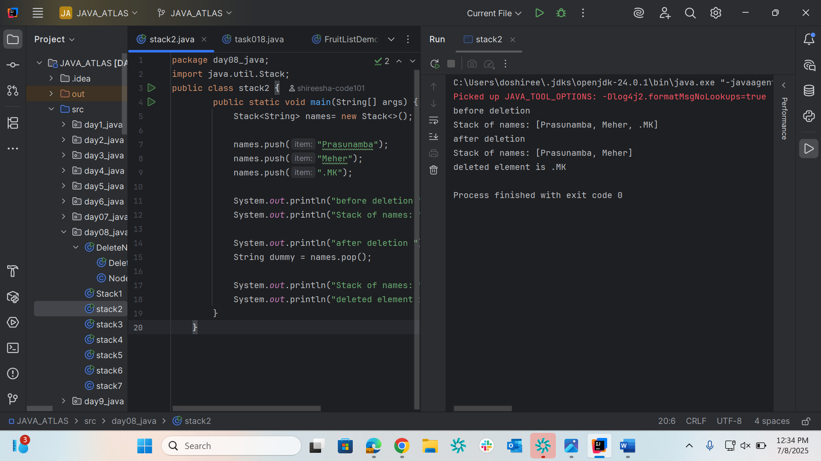

Task004
package day08_java;
import java.util.Stack;
public class stack3 {
public static void main(String[] args) {
Stack<Integer> names = new Stack<>();
names.push(10);
names.push(20);
names.push(30);
names.push(40);
int searchName = 40;
int position = names.search(searchName);
System.out.println("20 is in " + position);
}
}
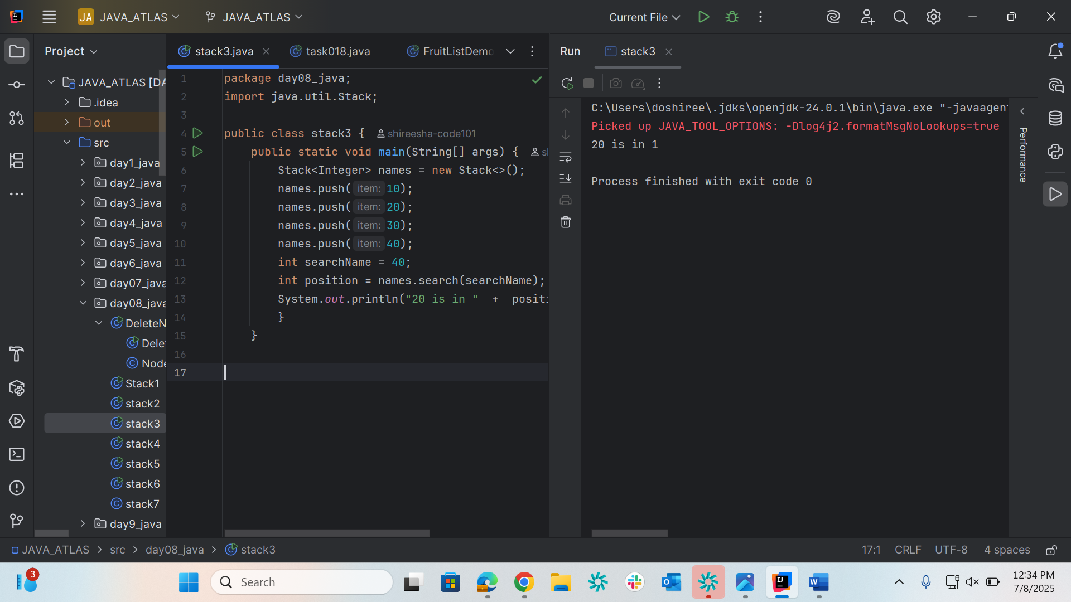

Task005
package day08_java;
import java.util.Stack;
public class stack4 {
public static void main(String[] args) {
Stack<Object> stack = new Stack<>();
stack.push("Prasunamba");
stack.push("Meher");
stack.push(3);
Object top = stack.peek();
boolean result = stack.empty();
System.out.println("Top element (peek): " + top);
System.out.println("Stack after peek(): " + stack);
System.out.println(result);
}
}
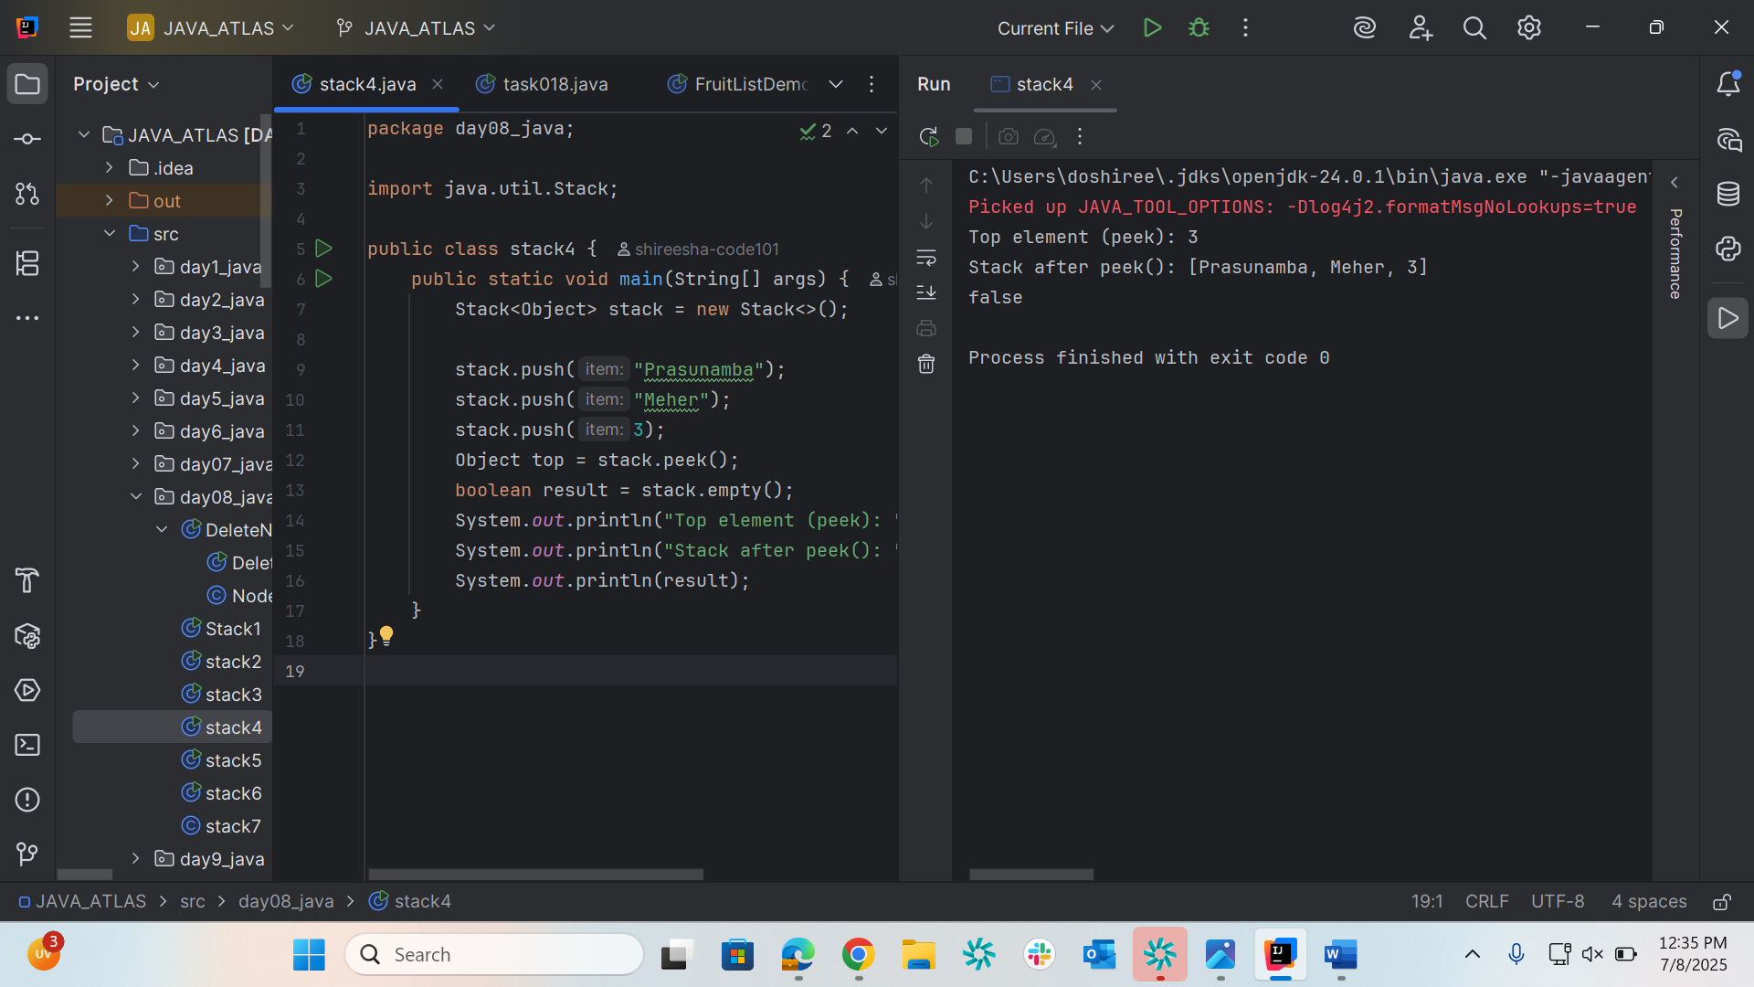
Task006
package day08_java;
import java.util.Stack;
public class stack5 {
public static void main(String[] args) {
// Create a stack of integers
Stack<Integer> stack = new Stack<>();
// Push elements onto the stack
stack.push(10);
stack.push(20);
stack.push(30);
stack.push(40);
boolean result = stack.empty();
System.out.println("check list is empty or not : " + result);
}
}
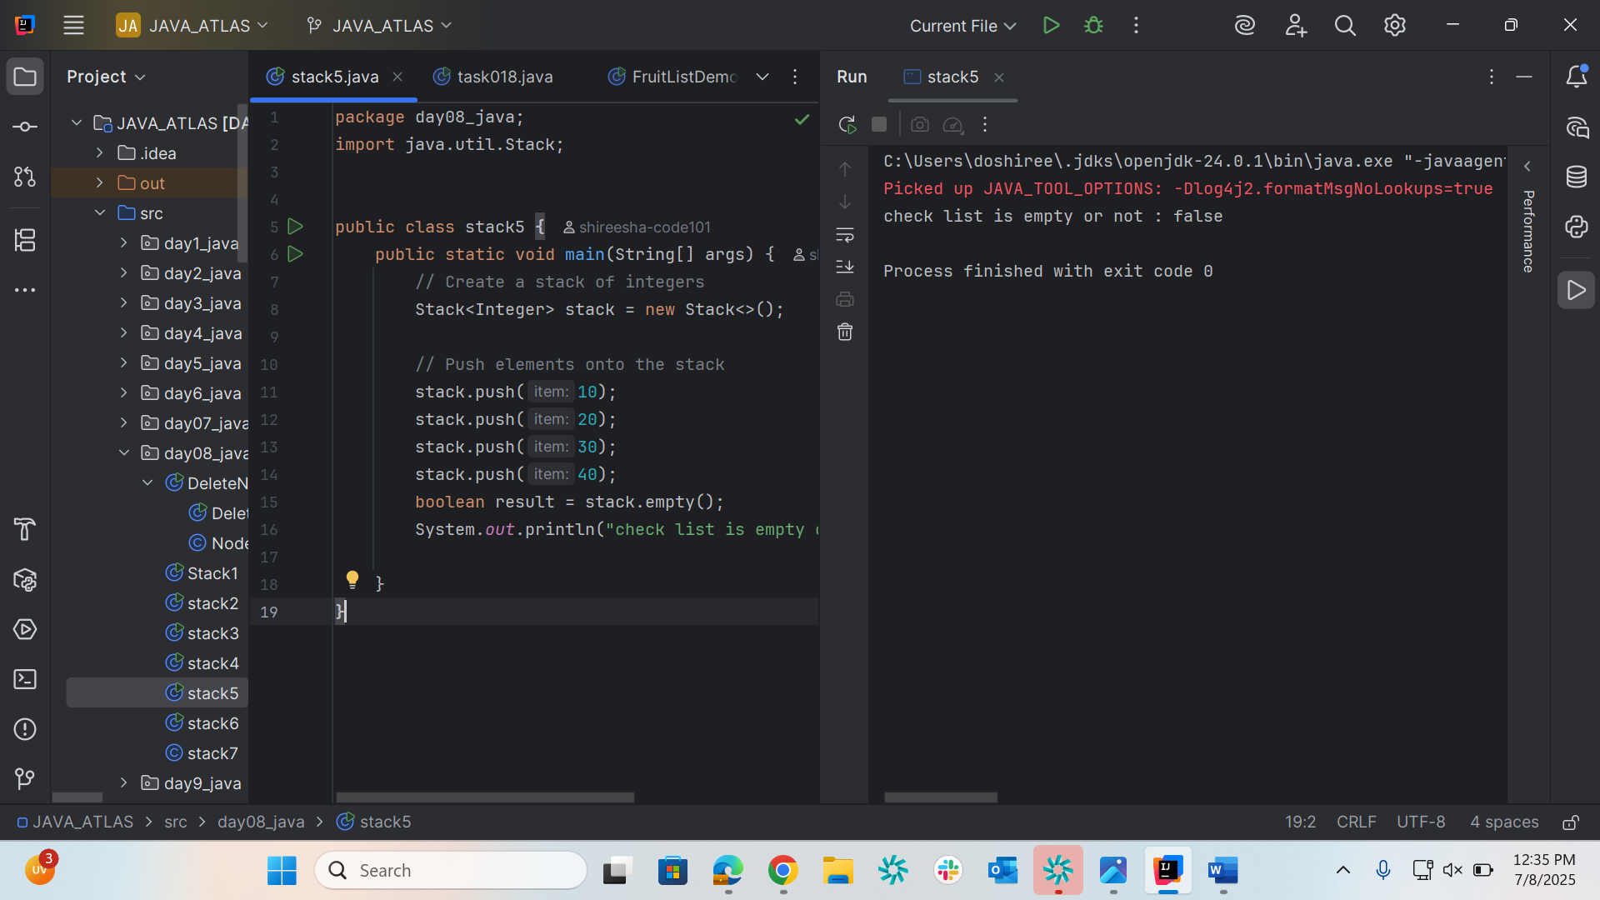

Task007
package day08_java;
public class stack6 {
int queueLength = 4;
int items[] = new int[queueLength];
int front = -1;
int back = -1;
void deQue(){
if(isEmpty()){
System.out.println("Queue is empty. Nothing to dequeue");
} else if (front == back){
front = back = -1;
} else {
front++;
}
}
void enQue(int itemValue) {
if(isFull()){
System.out.println("Queue is full");
} else if(front == -1 && back == -1){
front = back = 0;
items[back] = itemValue;
} else{
back++;
items[back] = itemValue;
}
}
boolean isFull(){
if(back == queueLength - 1){
return true;
} else {
return false;
}
}
boolean isEmpty(){
if(front == -1 && back == -1){
return true;
} else {
return false;
}
}
void display(){
int i;
if(isEmpty()){
System.out.println("Queue is empty");
} else {
for(i = front; i <= back; i++){
System.out.println(items[i]);
}
}
}
void peek(){
System.out.println("Front value is: " + items[front]);
}
public static void main(String[] args) {
stack6 myQueue = new stack6();
myQueue.enQue(100);
myQueue.enQue(200);
myQueue.enQue(300);
myQueue.enQue(400);
myQueue.display();
myQueue.peek();
}
}
