Algo for avl tree
- Create node
- Check if tree is empty r no
- If tree us empty the node will become the root node
- If tree is not empty do binary search tree insertion and check the balance factor for the node
- If the balance factors exceeds 1 we should do rotations on the heavy weighted tree and repeat the insertion from step 4
Pseudo code
function insert(node, key):
if node == null:
return new Node(key)
if key < node.key:
node.left = insert(node.left, key)
else if key > node.key:
node.right = insert(node.right, key)
else:
return node // duplicate
node.height = 1 + max(height(node.left), height(node.right))
balance = height(node.left) - height(node.right)
if balance > 1 and key < node.left.key:
return rotateRight(node) // LL
if balance < -1 and key > node.right.key:
return rotateLeft(node) // RR
if balance > 1 and key > node.left.key:
node.left = rotateLeft(node.left)
return rotateRight(node) // LR
if balance < -1 and key < node.right.key:
node.right = rotateRight(node.right)
return rotateLeft(node) // RL
return node

code
package day11_java;
import java.util.*;
class Node {
int key, height;
Node left, right;
Node (int d) {
key = d;
height = 1;
}
}
public class AVLTree {
Node root;
int height (Node N) {
if (N == null)
return 0;
return N.height;
}
int max (int a, int b) {
return (a > b) ? a : b;
}
Node rightRotate (Node y) {
Node x = y.left;
Node T2 = x.right;
x.right = y;
y.left = T2;
y.height = max (height (y.left), height (y.right)) + 1;
x.height = max (height (x.left), height (x.right)) + 1;
return x;
}
Node leftRotate (Node x) {
Node y = x.right;
Node T2 = y.left;
y.left = x;
x.right = T2;
x.height = max (height (x.left), height (x.right)) + 1;
y.height = max (height (y.left), height (y.right)) + 1;
return y;
}
int getBalance (Node N) {
if (N == null)
return 0;
return height (N.left) - height (N.right);
}
Node insert (Node node, int key) {
if (node == null)
return (new Node (key));
if (key < node.key)
node.left = insert (node.left, key);
else if (key > node.key)
node.right = insert (node.right, key);
else
return node;
node.height = 1 + max (height (node.left), height (node.right));
int balance = getBalance (node);
if (balance > 1 && key < node.left.key)
return rightRotate (node);
if (balance < -1 && key > node.right.key)
return leftRotate (node);
if (balance > 1 && key > node.left.key) {
node.left = leftRotate (node.left);
return rightRotate (node);
}
if (balance < -1 && key < node.right.key) {
node.right = rightRotate (node.right);
return leftRotate (node);
}
return node;
}
void printTree(Node root){
if (root == null)
return;
if (root != null) {
printTree(root.left);
System.out.print(root.key + " ");
printTree(root.left);
}
}
public static void main(String args[]) {
AVLTree tree = new AVLTree();
tree.root = tree.insert(tree.root, 5);
tree.root = tree.insert(tree.root, 15);
tree.root = tree.insert(tree.root, 44);
tree.root = tree.insert(tree.root, 35);
tree.root = tree.insert(tree.root, 65);
tree.root = tree.insert(tree.root, 78);
System.out.println("AVL Tree: ");
tree.printTree(tree.root);
}
}
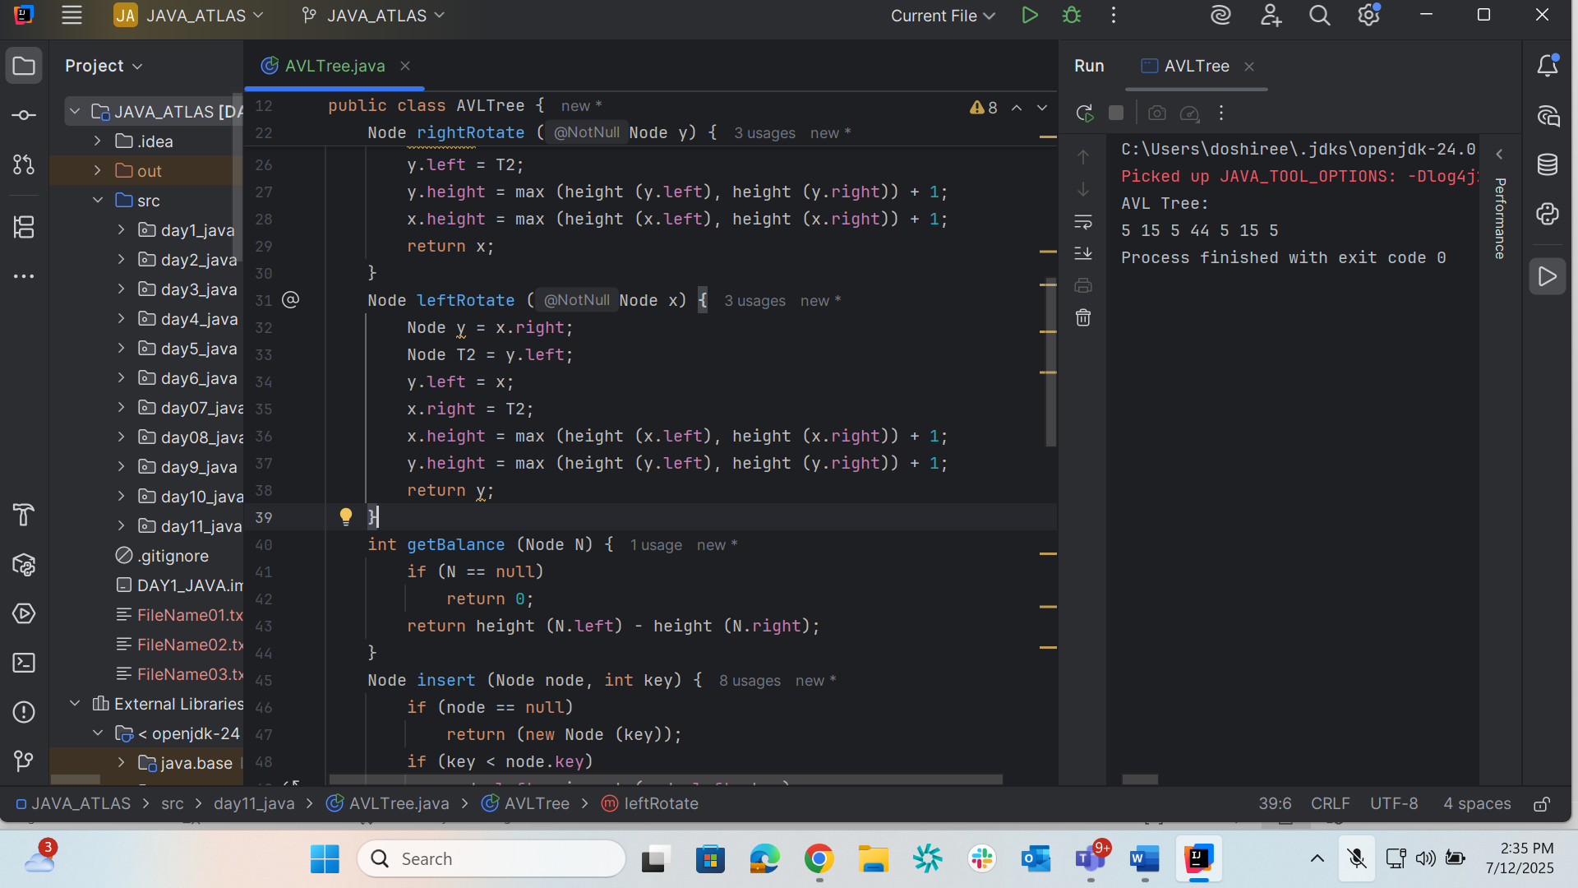

Red black graph
Property # | Rule
1 | Node color: red or black
2 | Root is black
3 | Leaf NIL nodes are black
4 | No red node has a red child
5 | All root–leaf paths have same number of black nodes (black-height)

