GIT AND GIT HUB
- Git : git is a tool that helps to track changes in the code
- Github : allows developers to store and manage their code using git
- To check git version
git –version
- git workflow
git init ----- working directory
git add ----- staging area
git commit ----- repository
git push ----- github
- git bash
git init
git add <filename.txt>
git commit -m <”…..”>
git clone <link>
git remote add origin <link>
git config –global user.email <”email”>
git config –global user.name <”username”>
git status
git add .
git push origin master
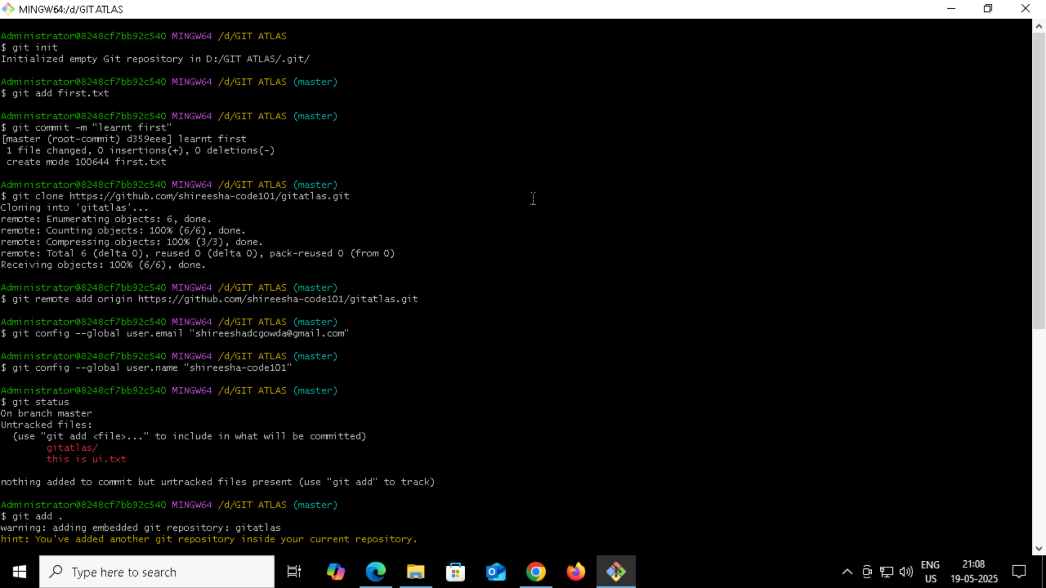

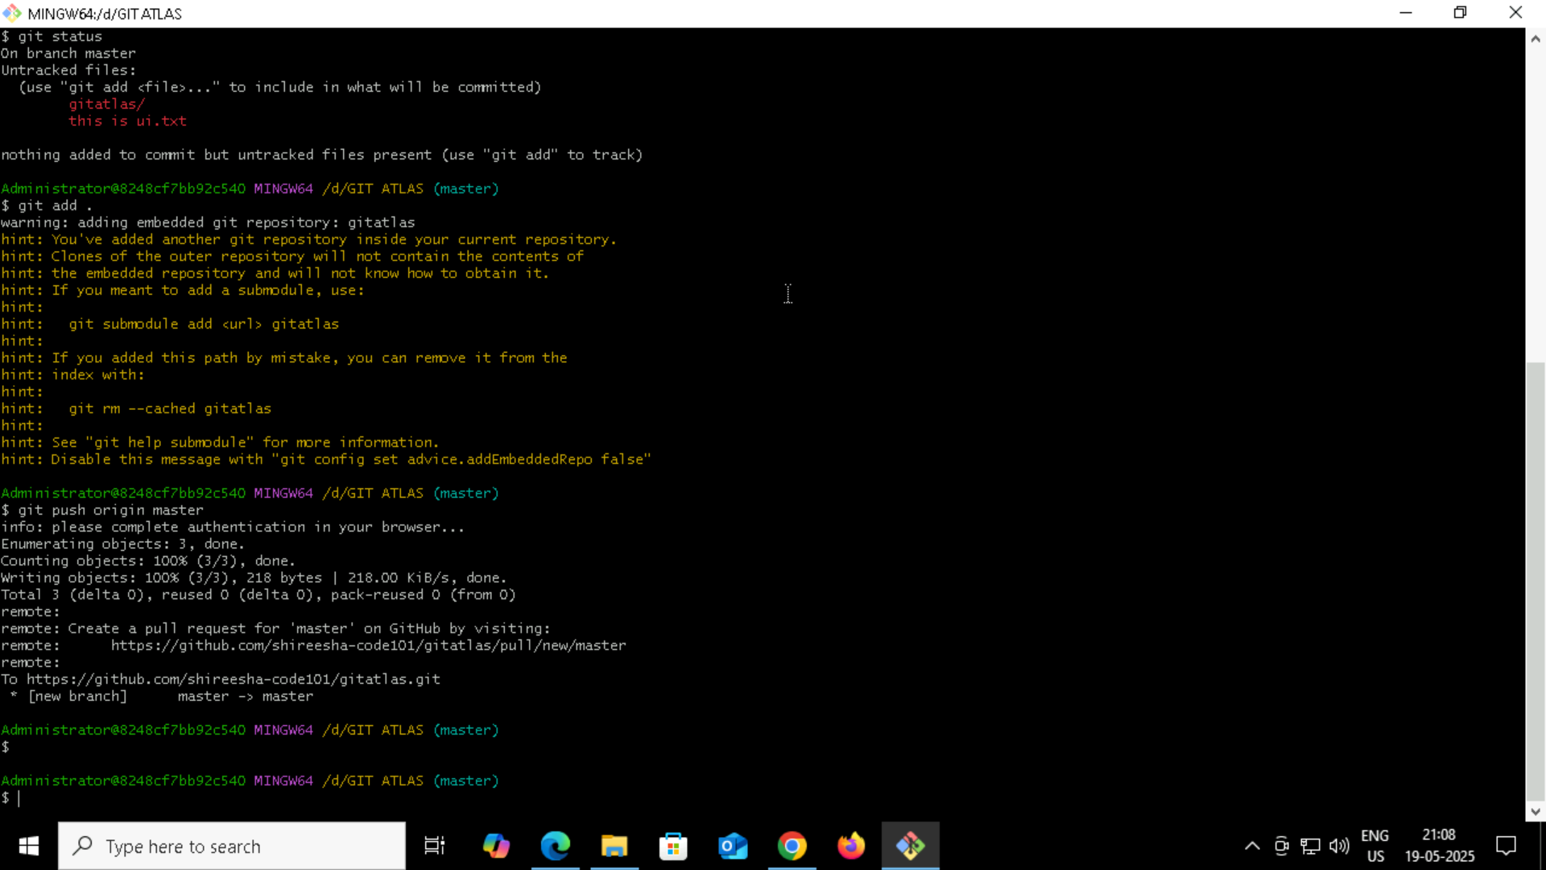

- To create a new branch
Git log
Git checkout -b branchname
Git add <branchname.txt>
Git commit -m <”….”>
Git push origin <branchname>
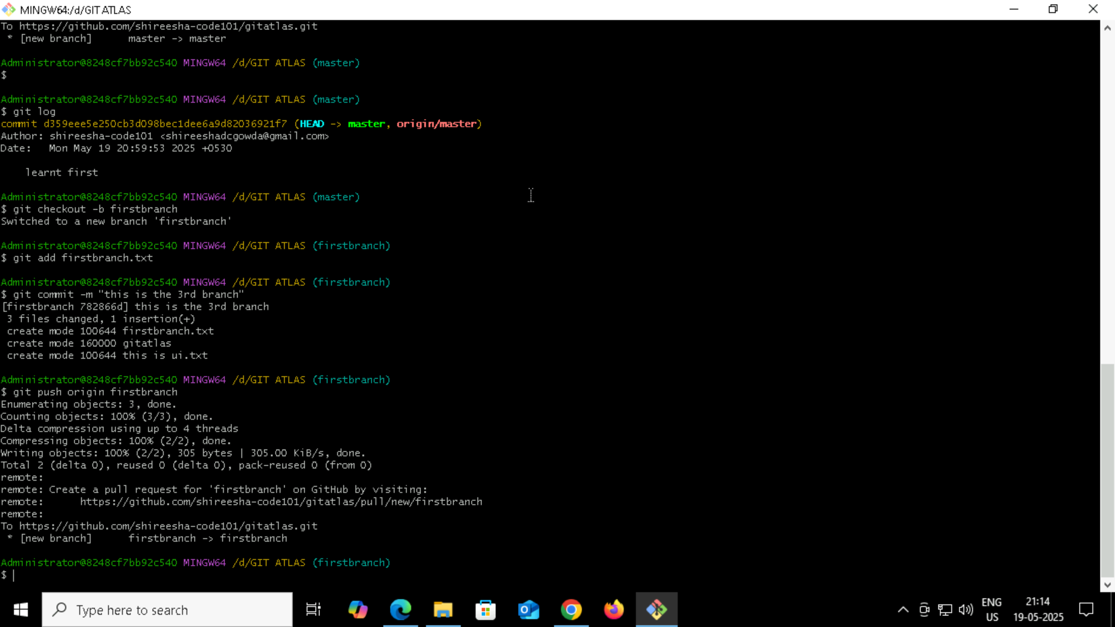

To stash
Git stash
Git stash apply
Git stash pop
Git stash list
Git stash drop stash@{1}
To clear all stashes
Git stash clear

- To reset
git reset <file name>
or
git reset .

