Mongod –version
Mongod
Mongosh
- To create database
Use school
- To create collection
db.students.insertOne(
{
“name”:”siri”,
“age’:20
}
)

- To see which db we are in
db
- To see collections
Show collections
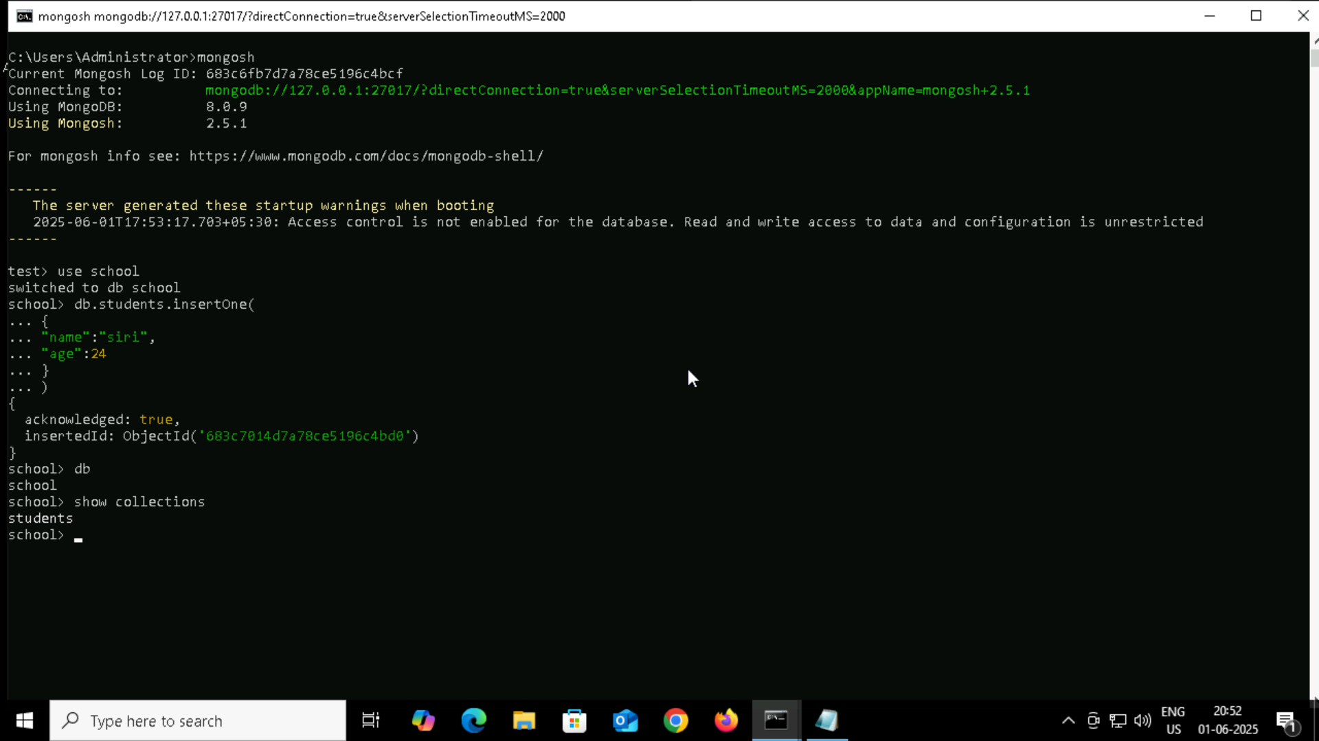
- CURD operations
Create: insertOne() , insertMany()
Read: find(),findOne()
Update: updateOne() , updateMany()
Delete: deleteOne(),deleteMany()

- Sample document for insertOne

Syntax: db.collectionname.insertOne({})

db.teachers.insertOne(
{
name:"roger",
subject:"maths"
}
)

- Sample document for insertMany
Syntax: db.collectionname.insertMany({},{}…)

db.teachers.insertMany([
{
name:"roger",
subject:"maths"
},
{
name:"anita",
subject:"chemistry"
},
{
name:"thomas",
subject:"physics"
},
{
name:"tina",
subject:"maths"
},
{
name:"jonty",
subject:"english"
}
]
)

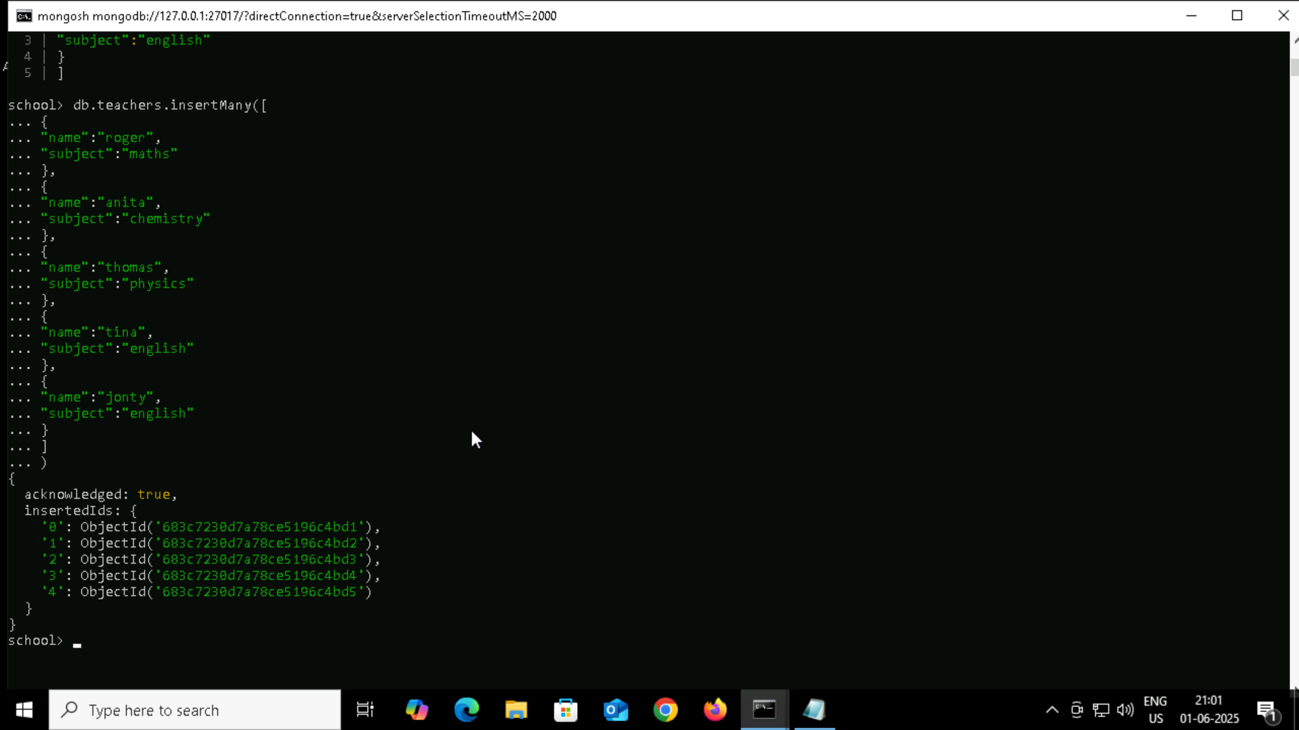
READ
db.collectionname.find({})

UPDATE
UpdateOne()
Syntax : db.collectionname.updateOne({},{})

db.cars.updateOne(
{model: “Nexon”},
{$set:{colour:”red”}}
)
db.cars.updateOne(
{model: “Nexon”},
{$push:{features:”red”}}
)

$push to push the data

$set : to set

UpdateMany()

db.cars.updateMany({},$set:{}}}

Delete

deleteOne()
db.cars.deleteOne({fule_type:”petrol”})
db.cars.deleteMany({fule_type:”petrol”})

db.aggregateproduct.insertMany( [
{ product: "register", quantity: 25, size: { height: 14, weight: 21, unit: "cm" }, status: "A" },
{ product: "book", quantity: 50, size: { height: 8.5, weight: 11, unit: "in" }, status: "A" },
{ product: "sheet", quantity: 100, size: { height: 8.5, weight: 11, unit: "in" }, status: "D" },
{ product: "timetable", quantity: 75, size: { height: 22.85, weight: 30, unit: "cm" }, status: "D" },
{ product: "envelop", quantity: 45, size: { height: 10, weight: 15.25, unit: "cm" }, status: "A" },
{ product: "register", quantity: 25, size: { height: 14, weight: 21, unit: "cm" }, status: "A" },
{ product: "book", quantity: 50, size: { height: 8.5, weight: 11, unit: "in" }, status: "A" },
{ product: "sheet", quantity: 100, size: { height: 8.5, weight: 11, unit: "in" }, status: "D" },
{ product: "timetable", quantity: 75, size: { height: 22.85, weight: 30, unit: "cm" }, status: "D" },
{ product: "envelop", quantity: 45, size: { height: 10, weight: 15.25, unit: "cm" }, status: "A" },
{ product: "register", quantity: 25, size: { height: 14, weight: 21, unit: "cm" }, status: "A" },
{ product: "book", quantity: 50, size: { height: 8.5, weight: 11, unit: "in" }, status: "A" }
]);

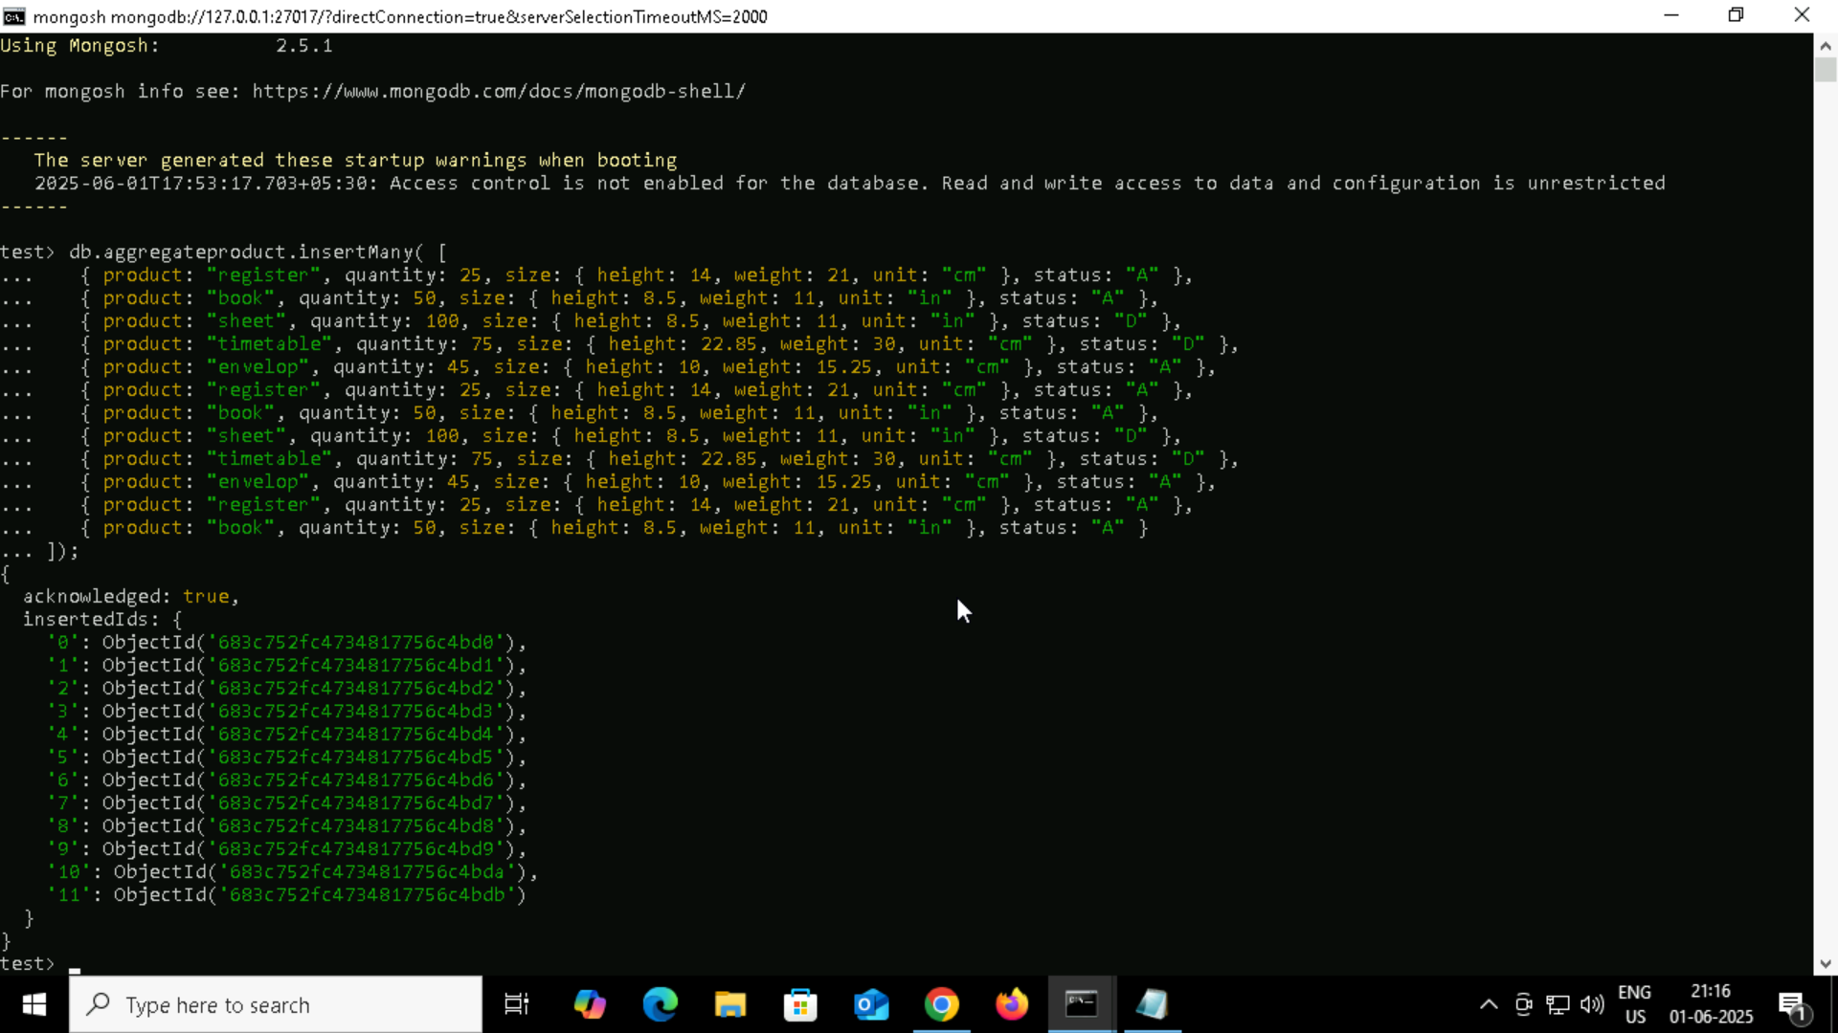

db.aggregateproduct.aggregate([
{ $match: { status: "A" } },
{ $group: { _id: "$product", total: { $sum: "$quantity" } } }
])

db.aggregateproduct.aggregate([
{ $match: { status: "A" } },
{ $group: { _id: "$product", total: { $sum: "$quantity" } } },
{$sort : { total : 1 }
}
])

db.aggregateproduct.aggregate([
{ $match: { status: "A" } },
{ $addFields: {
maxWeight: { $max: "$size.weight" },
minSizeHeight: { $min: "$size.height" }
} }
])

db.aggregateproduct.aggregate([
{ $match: { status: "A" } },
{ $addFields: {
maxQ: { $max: "$quantity" },
minSizeHeight: { $min: "$size.height" }
} }
])

db.aggregateproduct.aggregate([
{ $project : { product : 1,quantity : 1 } } , //optional line
{ $group: { _id: "$product", total: { $sum: "$quantity" } } },
{$sort : { total : 1 }
}
])

firstdb> db.aggregateproduct.aggregate([
... { $project : { product : 1,quantity : 1 } } ,
... { $group: { _id: "$product", total: { $sum: "$quantity" } } },
... {$sort : { total : 1 }
... }
... ])
[
{ _id: 'register', total: 75 },
{ _id: 'envelop', total: 90 },
{ _id: 'book', total: 150 },
{ _id: 'timetable', total: 150 },
{ _id: 'sheet', total: 200 }
]
firstdb> db.aggregateproduct.aggregate([{ $group: { _id: "$product", total: { $sum: "$quantity" } } }, { $sort: { total: 1 } }] )
[
{ _id: 'register', total: 75 },
{ _id: 'envelop', total: 90 },
{ _id: 'book', total: 150 },
{ _id: 'timetable', total: 150 },
{ _id: 'sheet', total: 200 }
]

