- To create directory and and path in linux
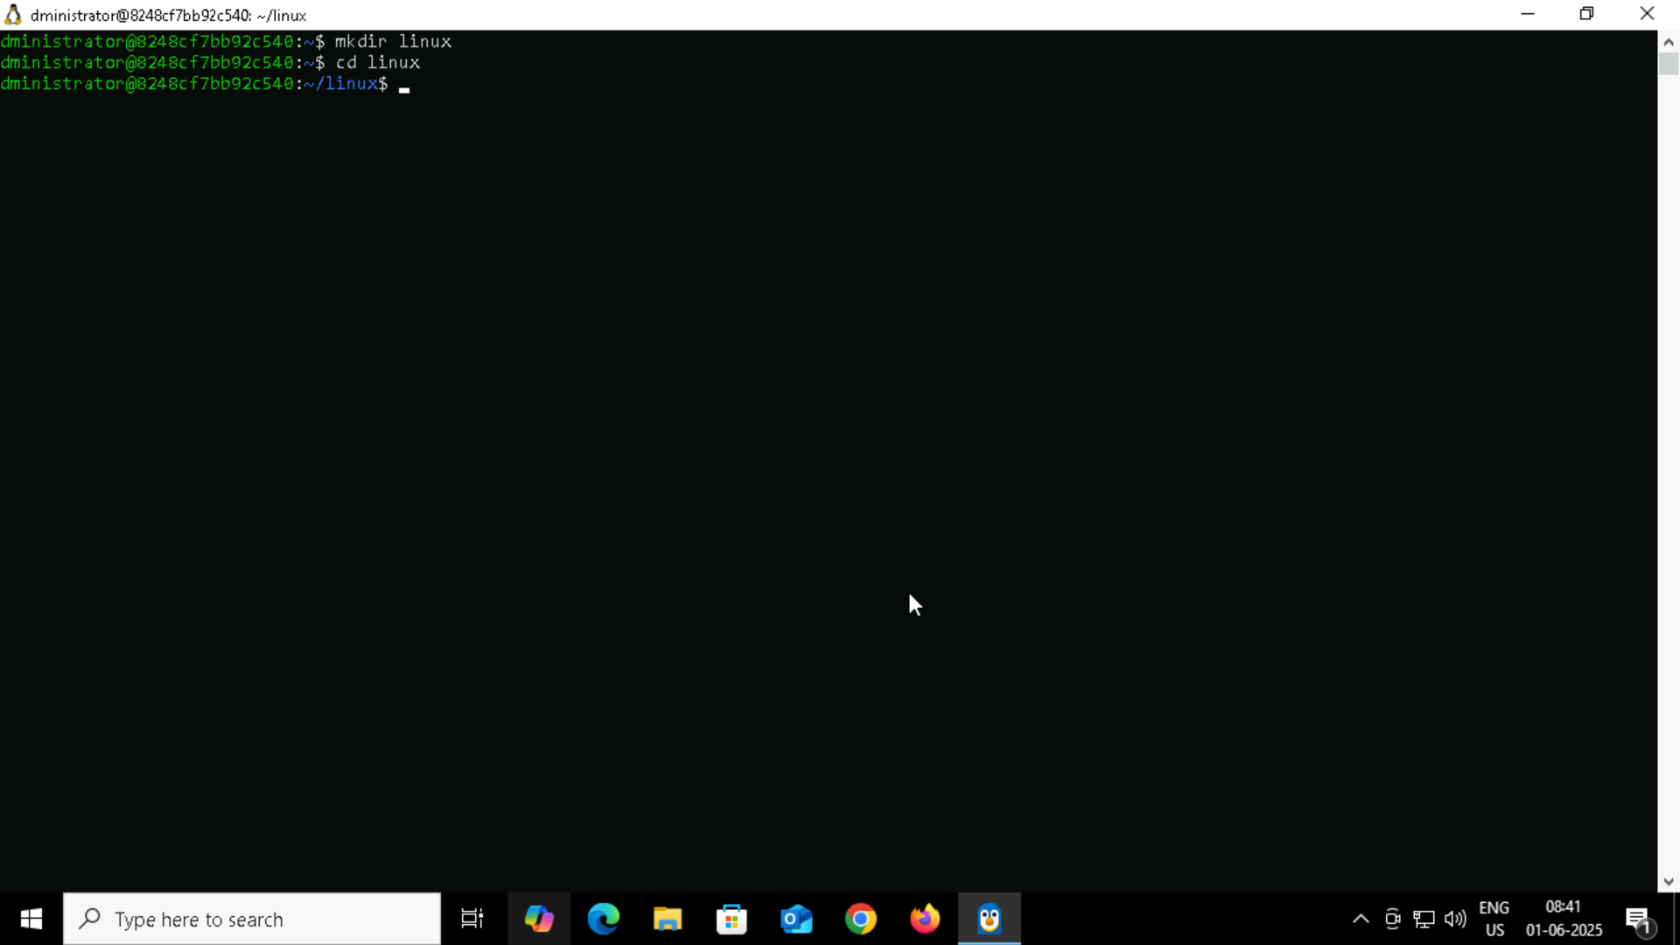
- Create a file name TestFile1.txt and add the content to it.

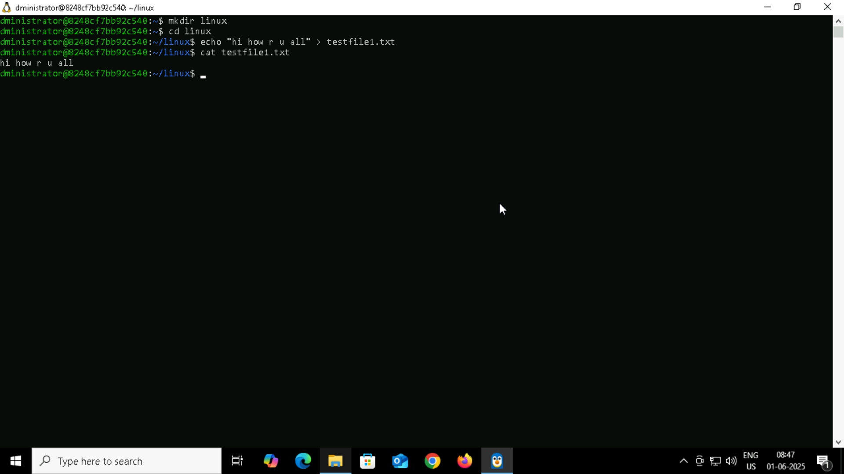

- Creating the dummy folder and deleting
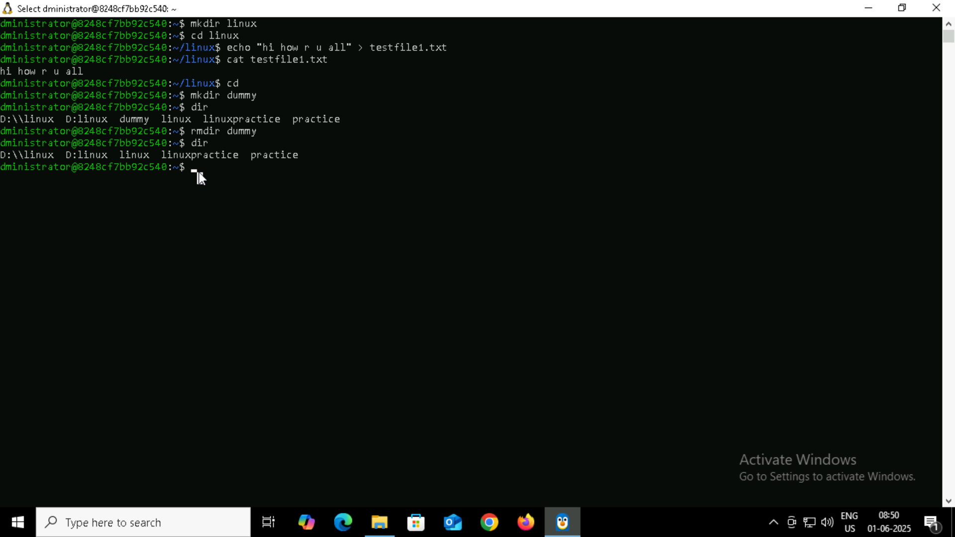

- check the working directory
- How do you check all the files and directories in the directory you are in?

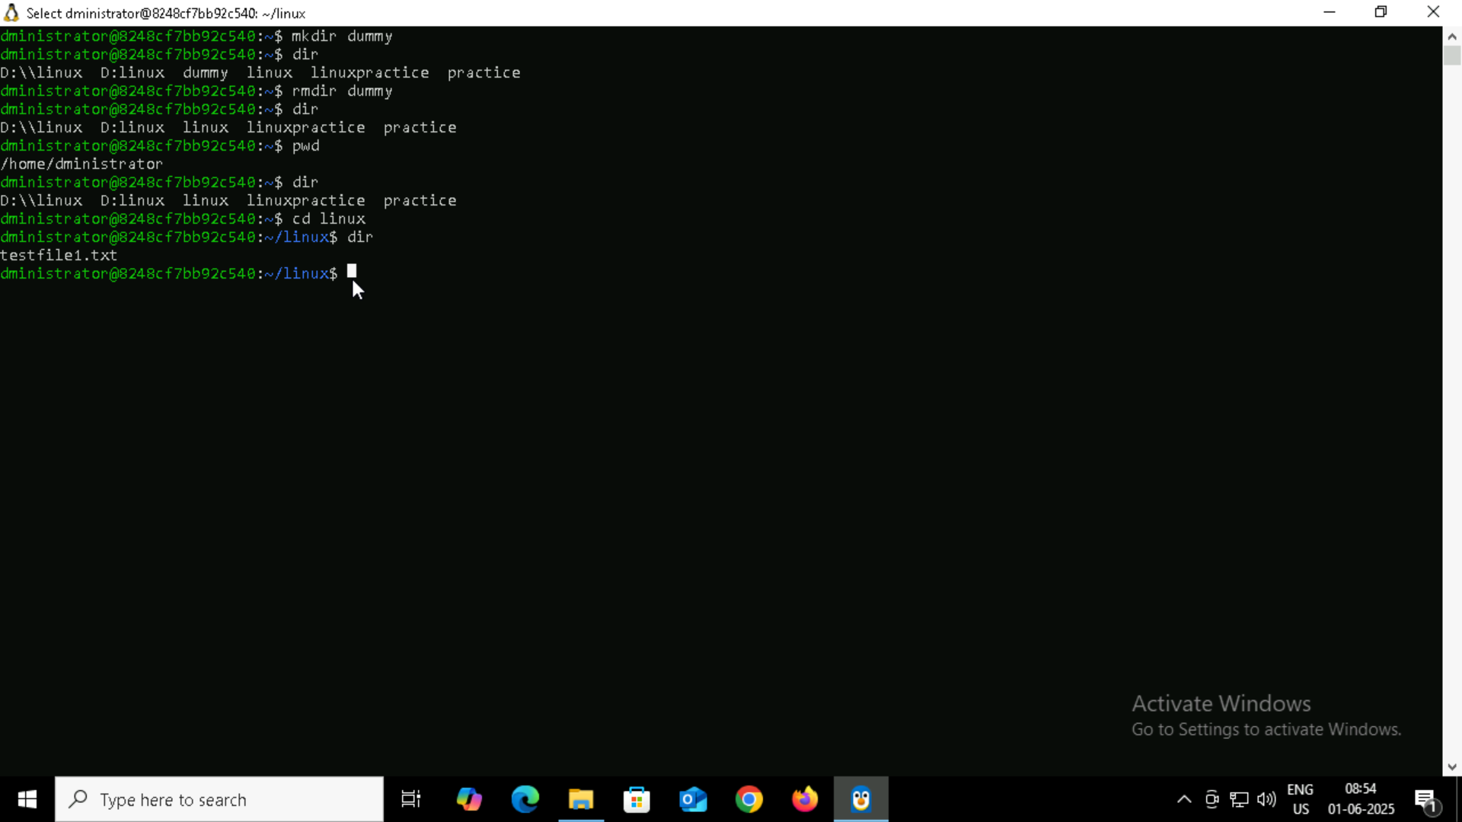

- Create five files named TestFile2.txt.. TestFile3.txt… and so on till TestFile6.txt
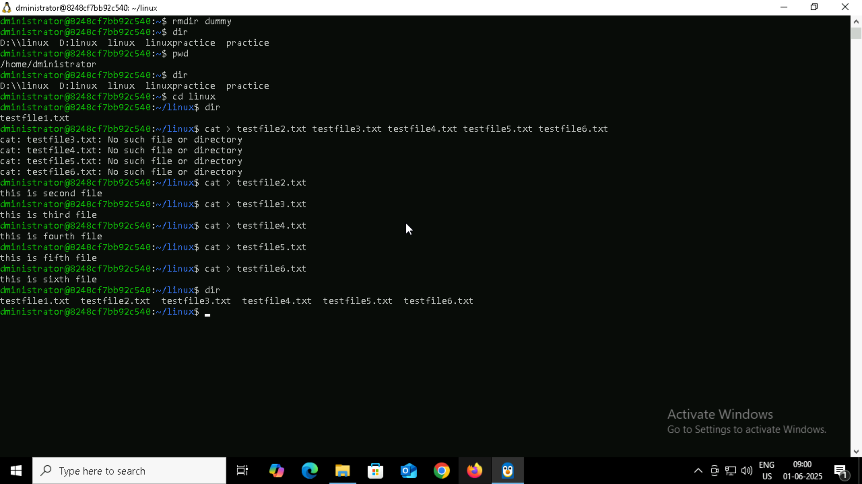

To print calender
