Task001
package day2_java;
public class task001 {
// Inner static class to represent an object with a value
static class MyClass {
int value;
MyClass(int value) {
this.value = value;
}
}
public static void main(String[] args) {
// Create the original 2D array with objects
MyClass[][] originalArray = {
{new MyClass(1), new MyClass(2)},
{new MyClass(3), new MyClass(4)}
};
// Perform the deep copy
MyClass[][] deepCopiedArray = deepCopy2DArray(originalArray);
// Modify an element in the original array to demonstrate independence
originalArray[0][0].value = 99;
// Display the original and deep copied arrays
System.out.println("Original Array:");
print2DArray(originalArray);
System.out.println("\nDeep Copied Array:");
print2DArray(deepCopiedArray);
}
// Method to perform a deep copy of a 2D array with objects
private static MyClass[][] deepCopy2DArray(MyClass[][] originalArray) {
int rows = originalArray.length;
int cols = originalArray[0].length;
MyClass[][] copiedArray = new MyClass[rows][cols];
for (int i = 0; i < rows; i++) {
for (int j = 0; j < cols; j++) {
// Create a new instance of the object for each element
copiedArray[i][j] = new MyClass(originalArray[i][j].value);
}
}
return copiedArray;
}
// Method to print a 2D array with objects
private static void print2DArray(MyClass[][] array) {
for (MyClass[] row : array) {
for (MyClass element : row) {
System.out.print(element.value + " ");
}
System.out.println();
}
}
}
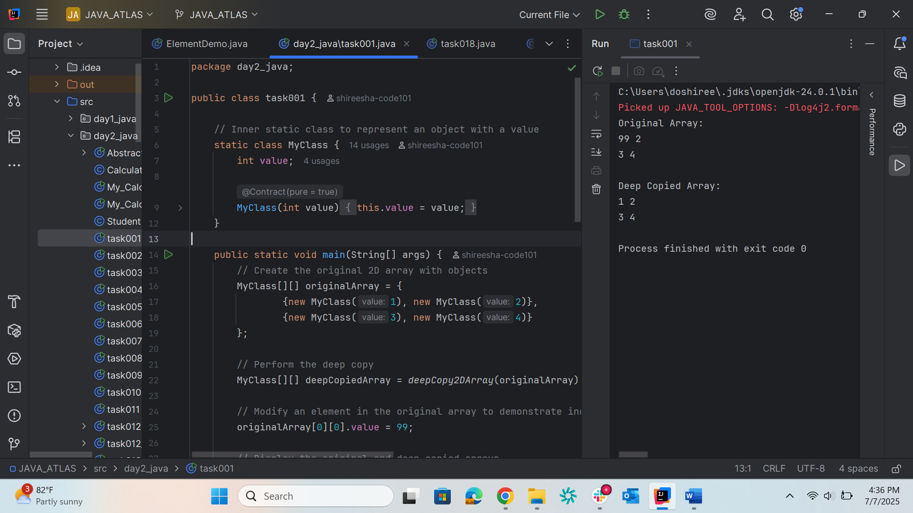
Task002
package day2_java;
public class task002 {
public static void main(String[] args)
{
// initializing array
int[] arr = { 1, 2, 3, 4, 5 };
// size of array
int n = arr.length;
// traversing array
for (int i = 0; i < n; i++)
System.out.print(arr[i] + " ");
}
}
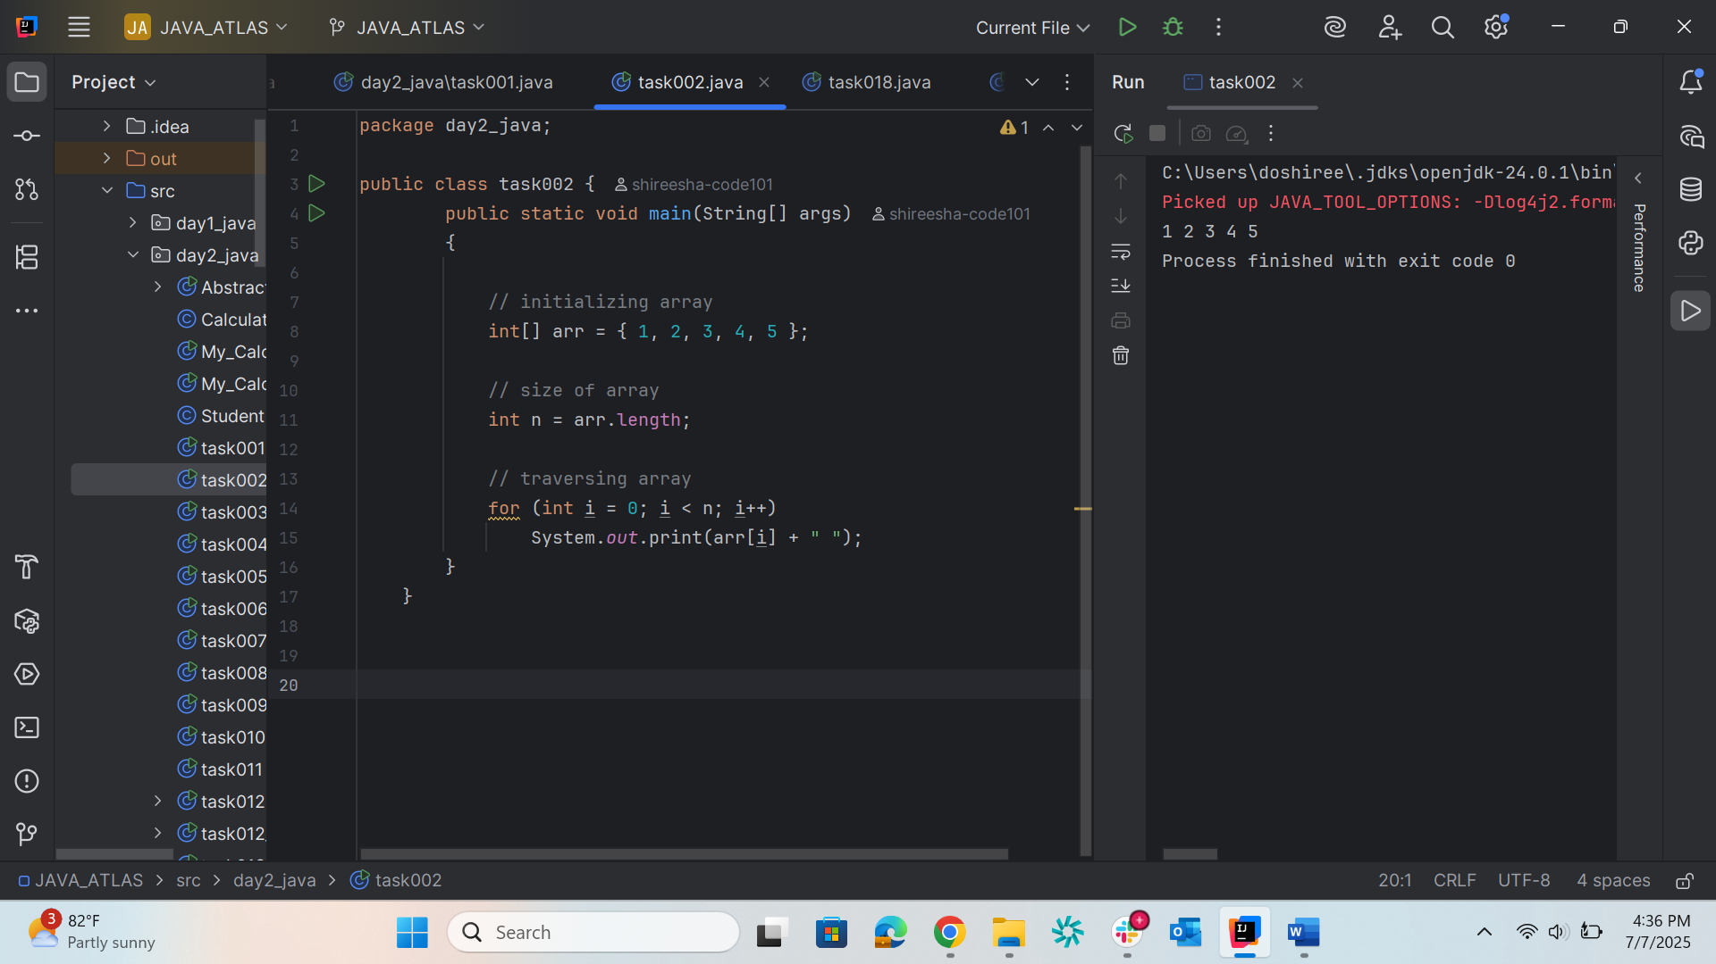
Task003
package day2_java;
// Java program to illustrate creating an array
// of integers, puts some values in the array,
// and prints each value to standard output.
class task003 {
public static void main(String[] args)
{
// declares an Array of integers.
int[] arr;
// allocating memory for 5 integers.
arr = new int[5];
// initialize the elements of the array
// first to last(fifth) element
arr[0] = 10;
arr[1] = 20;
arr[2] = 30;
arr[3] = 40;
arr[4] = 50;
// accessing the elements of the specified array
for (int i = 0; i < arr.length; i++)
System.out.println("Element at index "
+ i + " : " + arr[i]);
}
}
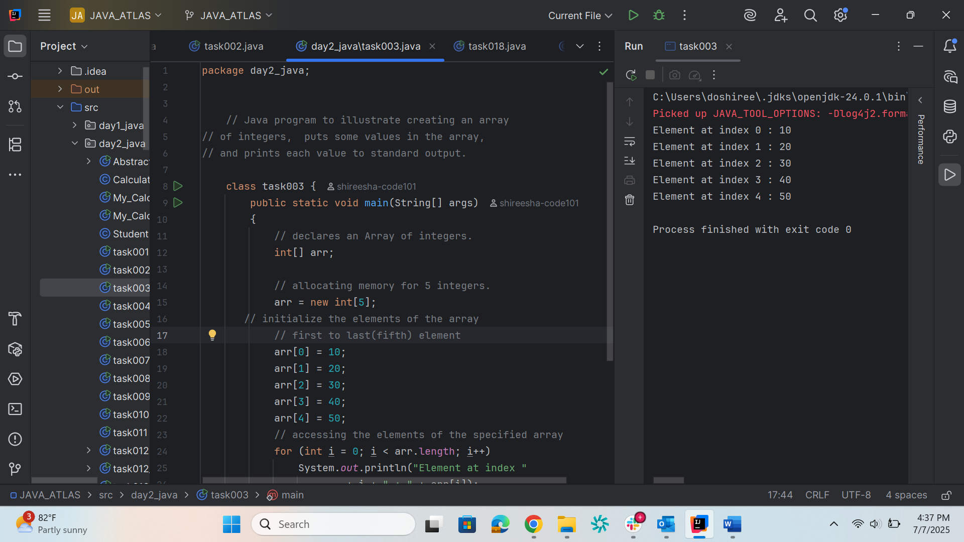

Task004
package day2_java;
public class task004 {
public static void main(String[] args) {
// Declare and initialize the array of Student objects
Student[] myStudents = new Student[] {
new Student("Dharma"),
new Student("Sanvi"),
new Student("Rupa"),
new Student("Ajay")
};
// Iterate through the array and print each student
for (Student m : myStudents) {
System.out.println(m);
}
}
}
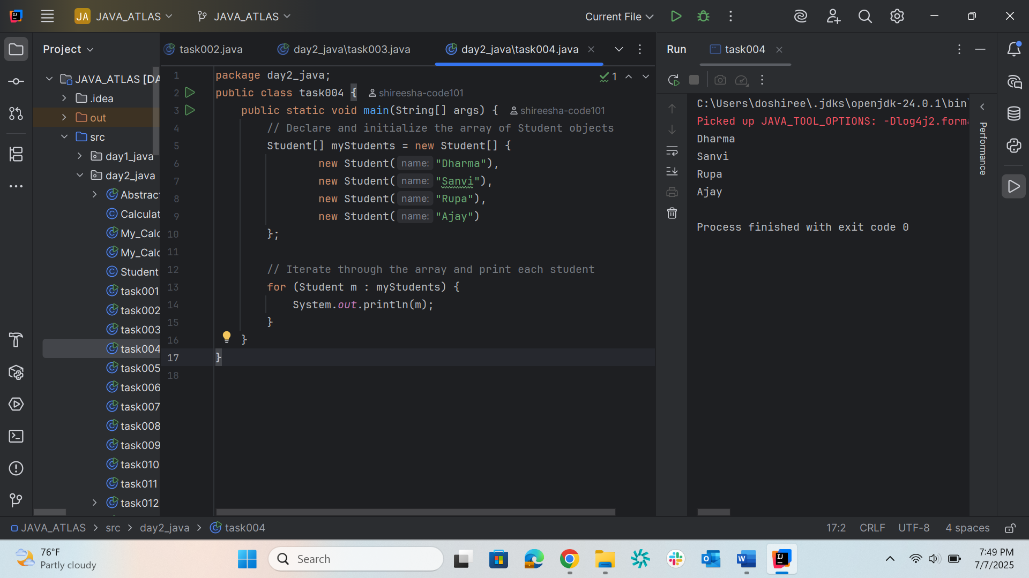

Task005
package day2_java;
public class task005 {
public static void main(String[] args)
{
int[] arr = new int[4];
arr[0] = 10;
arr[1] = 20;
arr[2] = 30;
arr[3] = 40;
System.out.println(
"Trying to access element outside the size of array");
System.out.println(arr[5]);
}
}
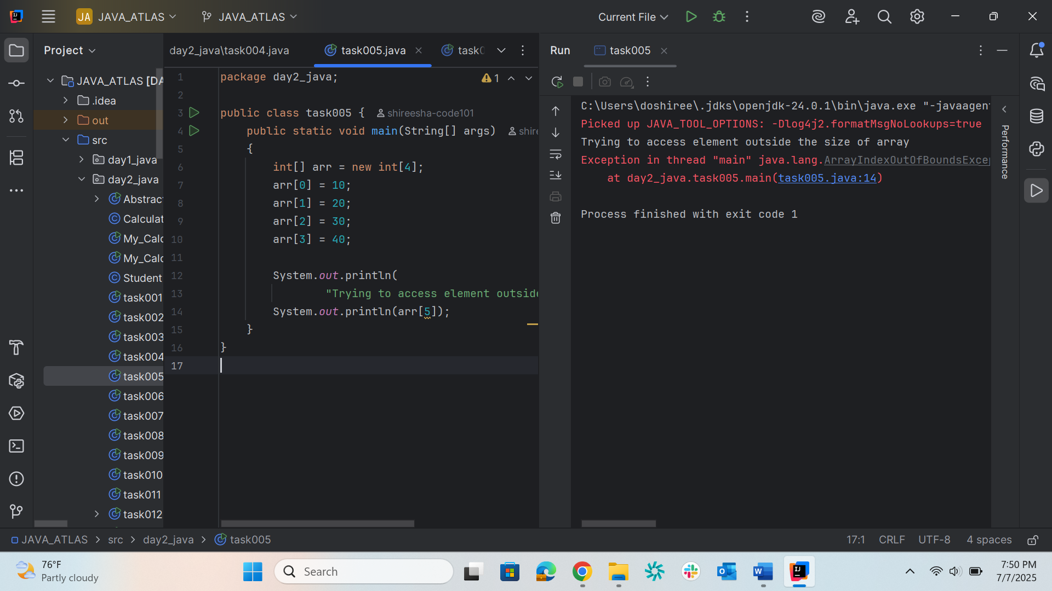

Task006
package day2_java;
import java.io.*;
class task006 {
public static void main(String[] args){
// Two Dimensional Array
// Declared and Initialized
int[][] arr = new int[3][3];
// Number of Rows
System.out.println("Rows : " + arr.length);
// Number of Columns
System.out.println("Columns : " + arr[0].length);
}
}
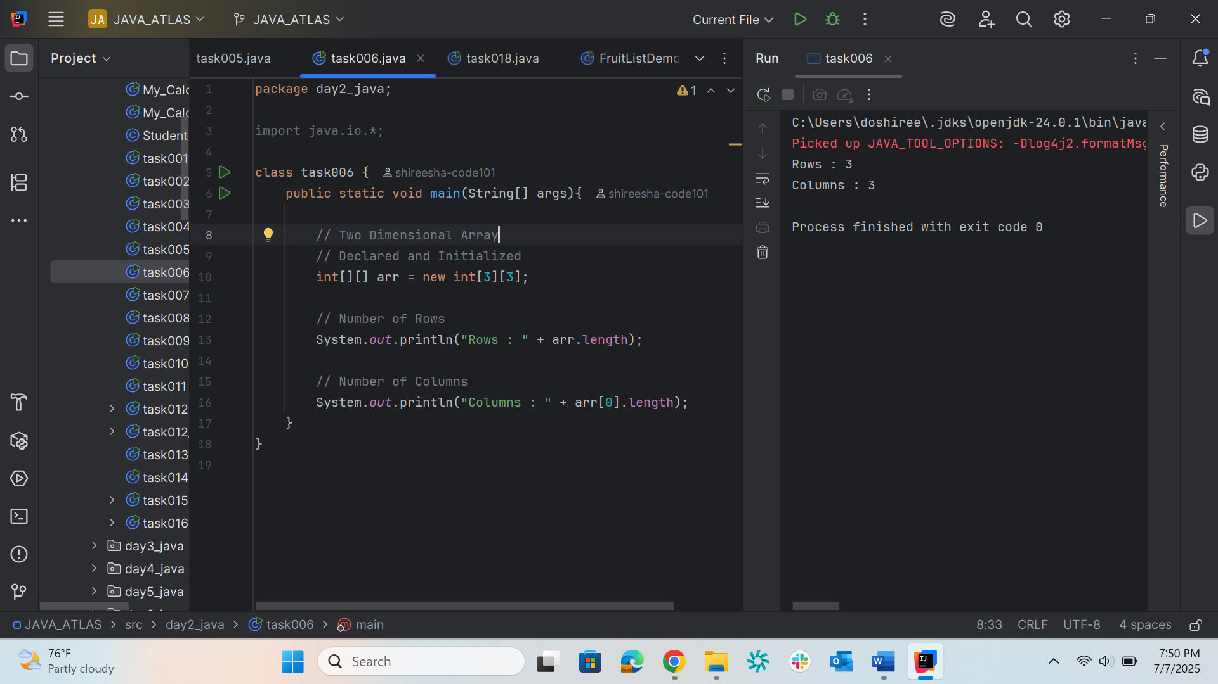

Task007
package day2_java;
public class task007 {
// main function
public static void main(String args[])
{
// declaring and initializing 2D array
int arr[][] = { { 2, 7, 9 }, { 3, 6, 1 }, { 7, 4, 2 } };
// printing 2D array
for (int i = 0; i < 3; i++) { // rows
for (int j = 0; j < 3; j++) // columns
System.out.print(arr[i][j] + " ");
System.out.println();
}
}
}
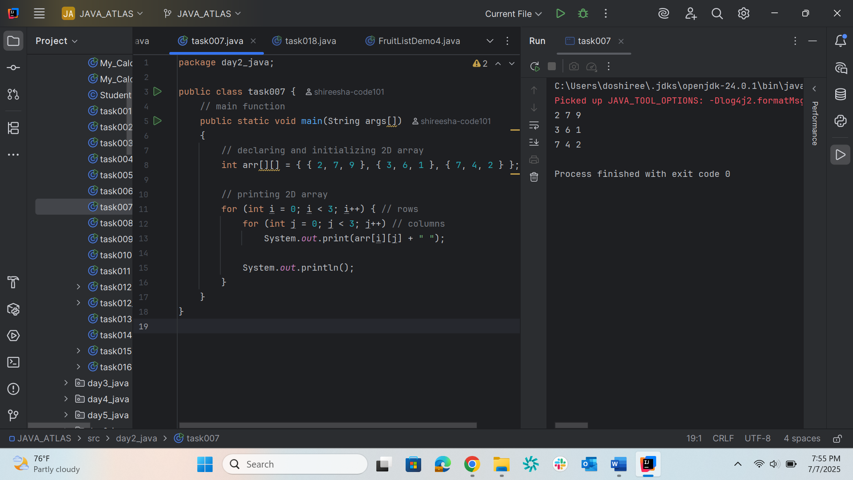

Task008
package day2_java;
public class task008 {
// Driver method
public static void main(String args[])
{
int arr[] = { 3, 1, 2, 5, 4 };
// passing array to method m1
sum(arr);
}
public static void sum(int[] arr)
{
// getting sum of array values
int sum = 0;
for (int i = 0; i < arr.length; i++)
sum += arr[i];
System.out.println("sum of array values : " + sum);
}
}
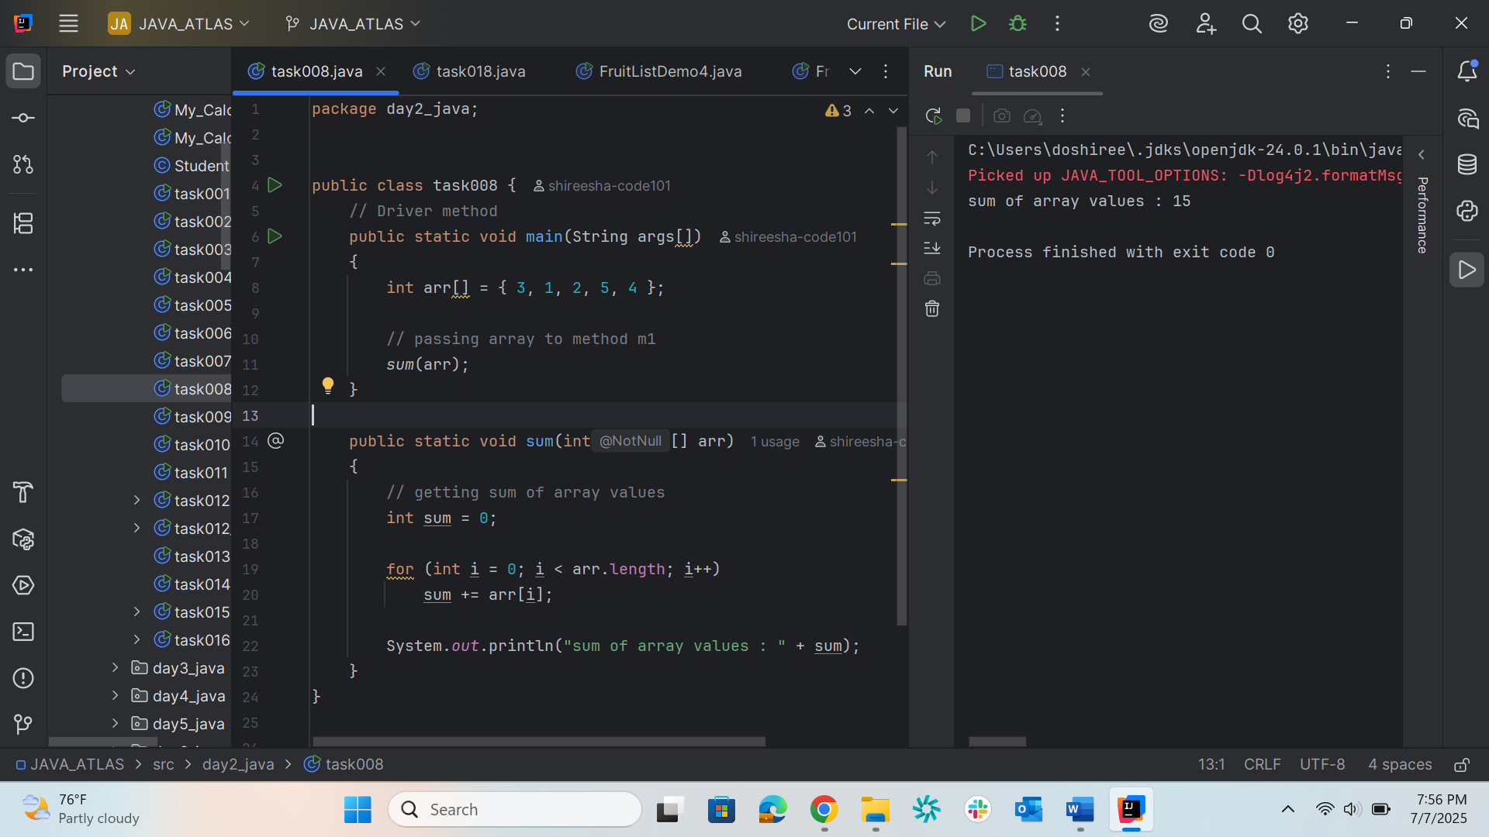
Task009
package day2_java;
class task009 {
// Driver method
public static void main(String args[])
{
int arr[] = m1();
for (int i = 0; i < arr.length; i++)
System.out.print(arr[i] + " ");
}
public static int[] m1()
{
// returning array
return new int[] { 1, 2, 3 };
}
}
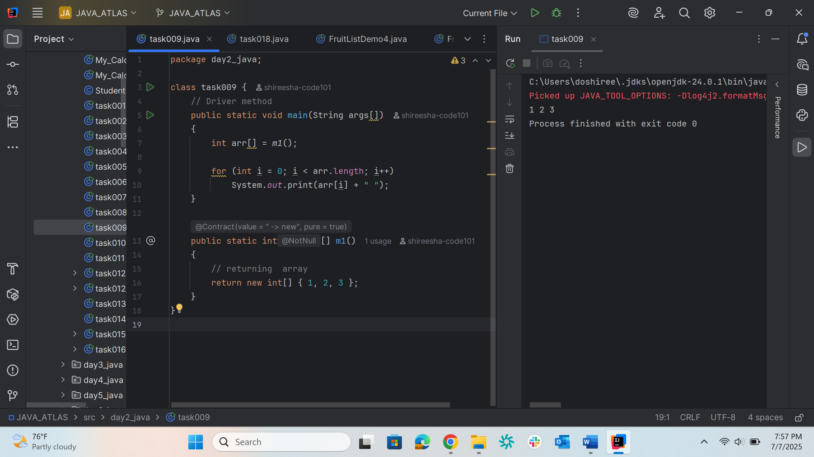

Task010
package day2_java;
class task010 {
public static void main(String args[]) {
int intArray[] = {1, 2, 3};
int cloneArray[] = intArray.clone();
// will print false as shallow copy is created
System.out.println(intArray == cloneArray);
for (int i = 0; i < cloneArray.length; i++) {
System.out.print(cloneArray[i] + " ");
}
}
}
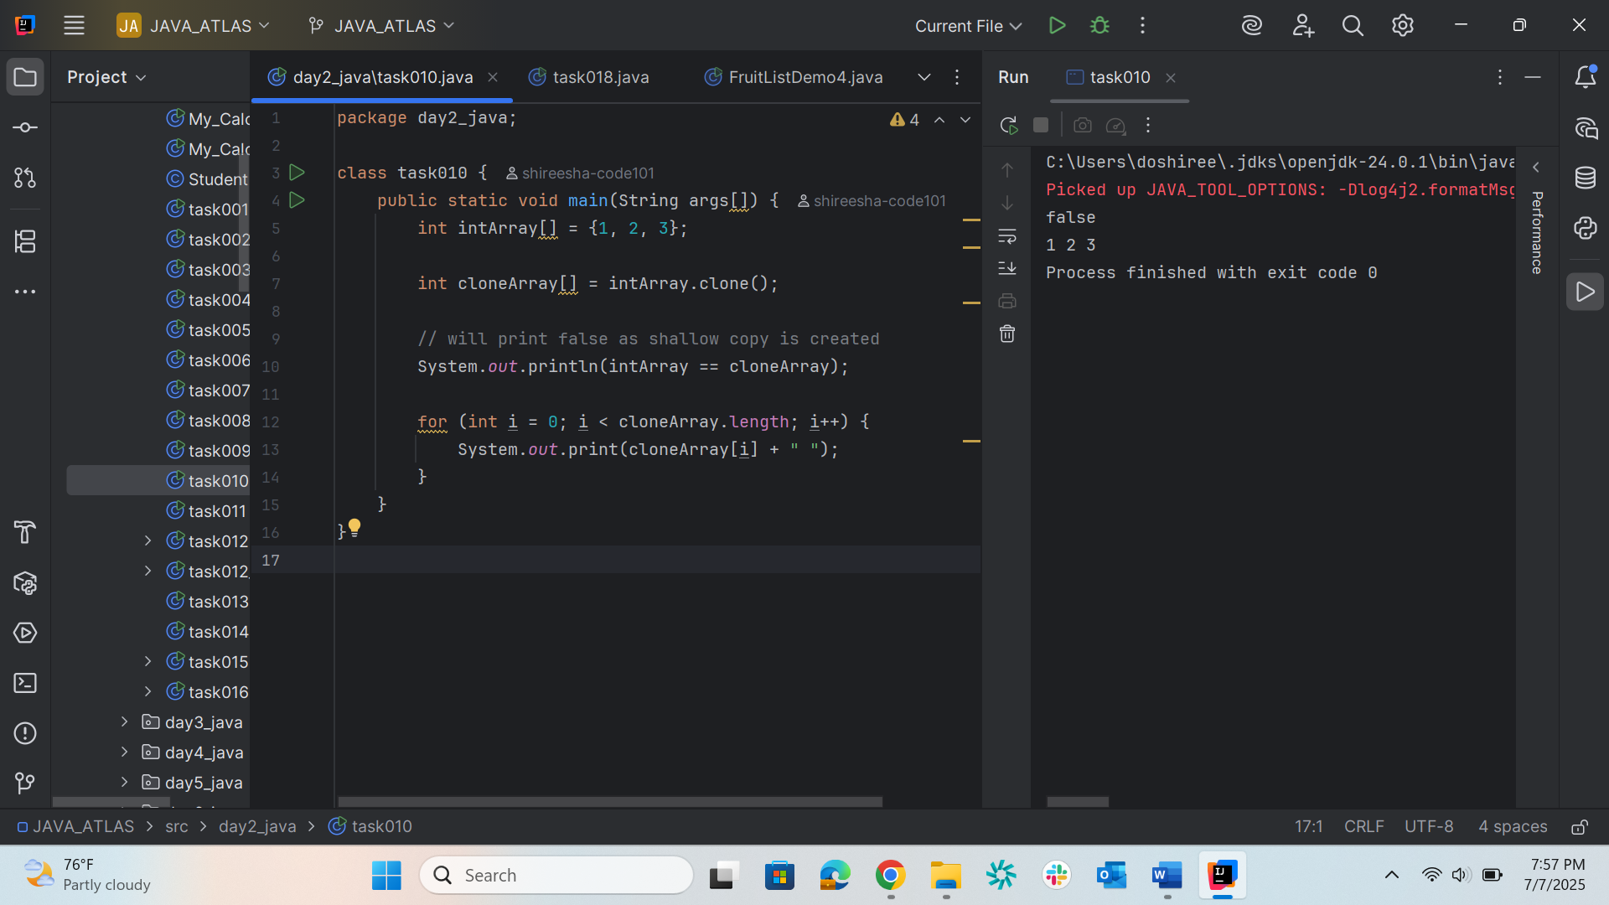

Task011
package day2_java;
class task011 {
public static void main(String args[])
{
int intArray[][] = { { 1, 2, 3 }, { 4, 5 } };
int cloneArray[][] = intArray.clone();
// will print false
System.out.println(intArray == cloneArray);
// will print true as shallow copy is created
// i.e. sub-arrays are shared
System.out.println(intArray[0] == cloneArray[0]);
System.out.println(intArray[1] == cloneArray[1]);
}
}

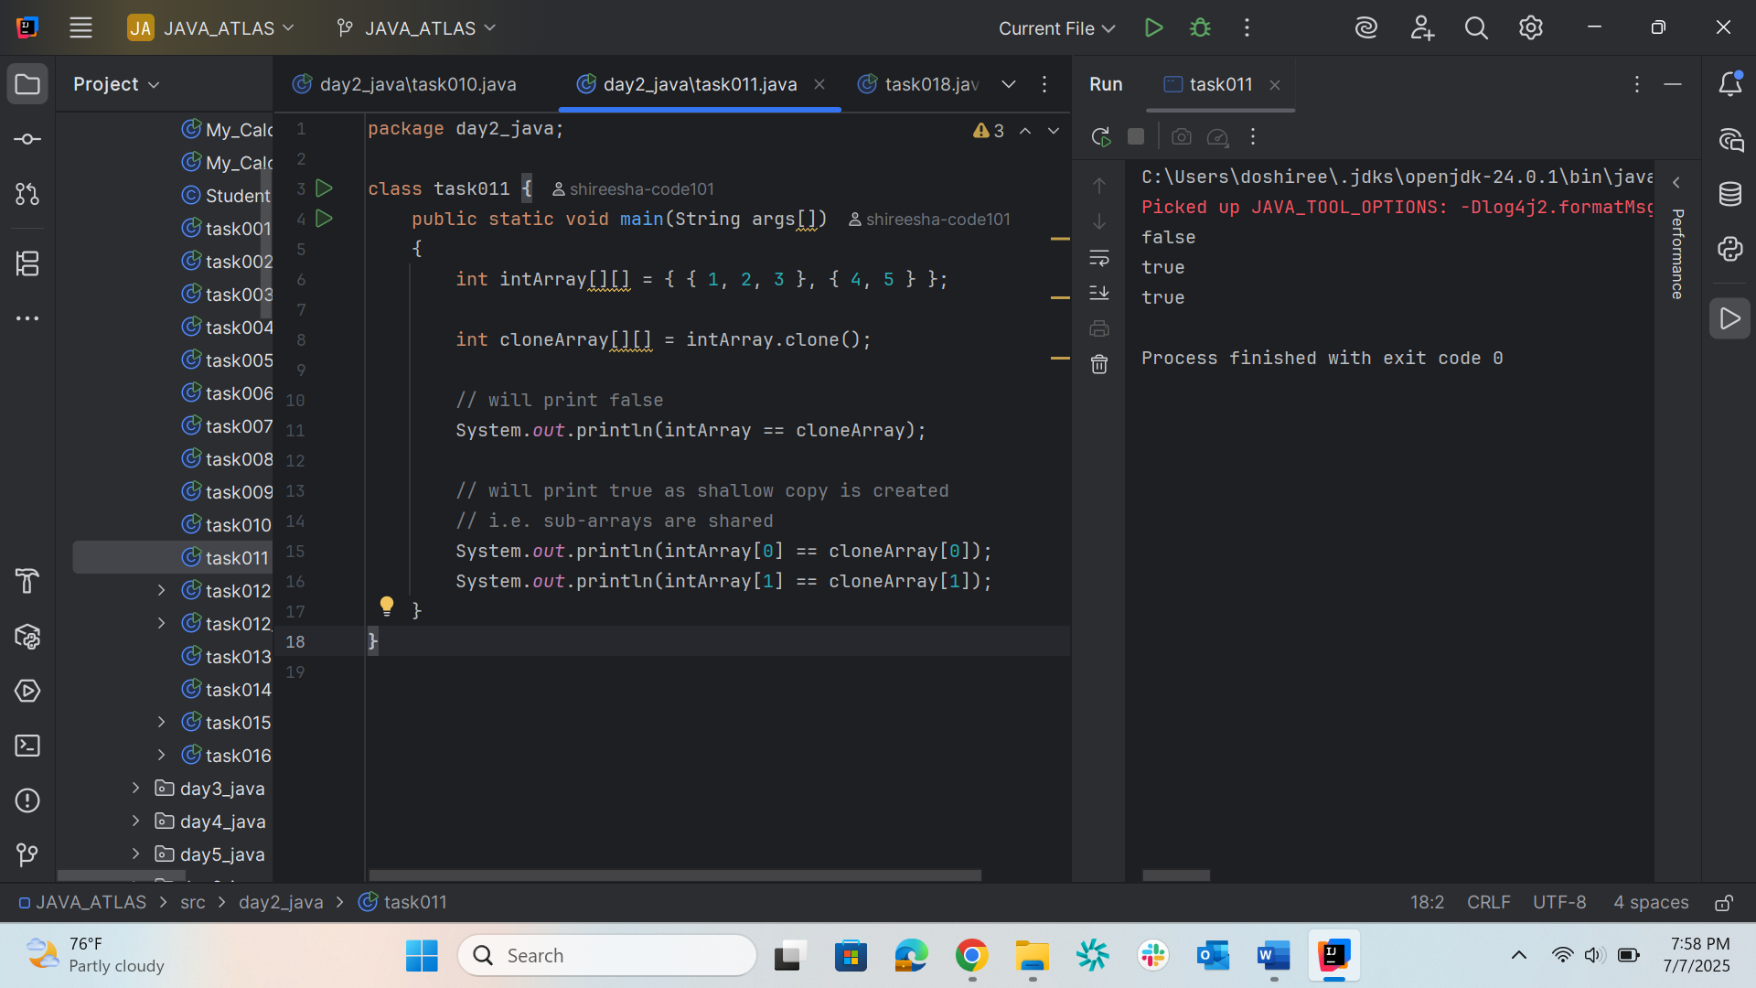

Task012
package day2_java;
class Customer{
int cost = 40;
String items = "Tomatoes";
Customer(){
System.out.println("Constructor called");
}
void purchage_list(){
System.out.println("cost of tomatoes in Customer class is "+ cost);
}
}
public class task012 extends Customer {
void billing(){
String items = "onions";
int cost = 30;
super.items = "Potatoes";
super.cost = 50;
super.purchage_list();
System.out.println(items);
System.out.println(cost);
System.out.println("***************************");
System.out.println(super.items);
System.out.println(super.cost);
// return 0;
}
public static void main(String[] args){
Customer cobj =new Customer();
cobj.purchage_list();
task012 tobj = new task012();
tobj.billing();
}
}
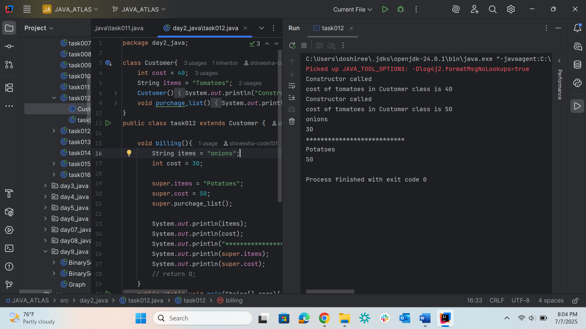

Task012_1
package day2_java;
class Superclass{
int var;
Superclass(int var){
this.var = var;
}
public void getVar(){
System.out.println("var value in super class is "+ var);
}
}
public class task012_1 extends Superclass{
task012_1(int var) {
super(var);
}
public static void main(String[] args){
Superclass sobj = new Superclass(100);
sobj.getVar();
task012_1 tobj = new task012_1(200);
tobj.getVar();
}
}
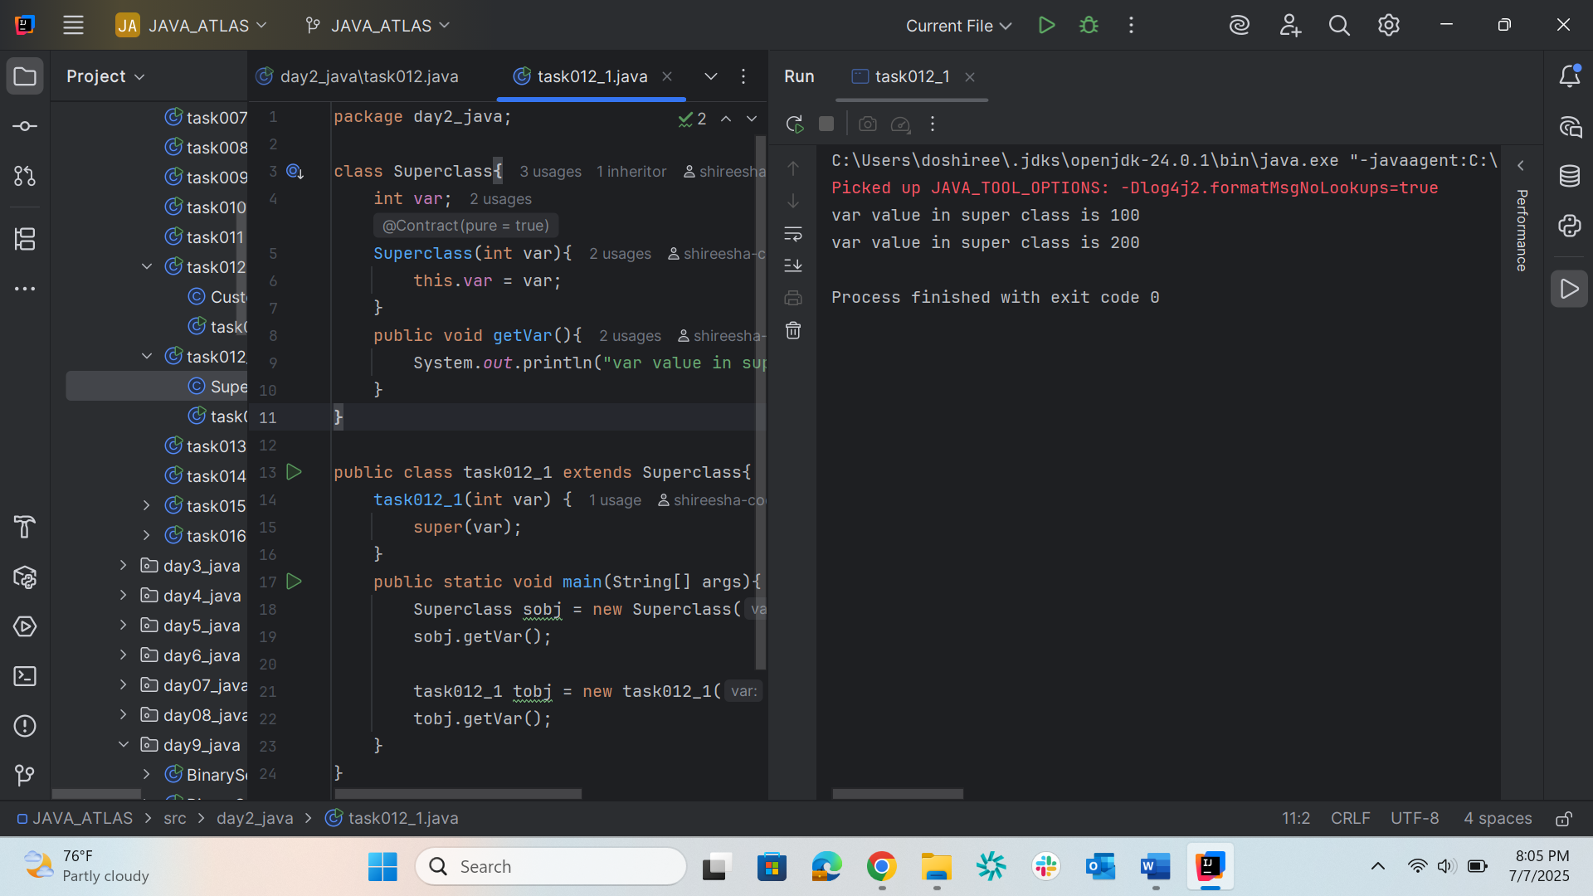
Task013
package day2_java;
public class task013 {
void add(char x, char y) {
System.out.println("x: " + x + ", y: " + y);
}
void add(int x, int y) {
System.out.println("x: " + x + ", y: " + y);
}
public static void main(String[] args) {
task013 task = new task013();
task.add('d', 'a');
task.add(100, 100);
}
}
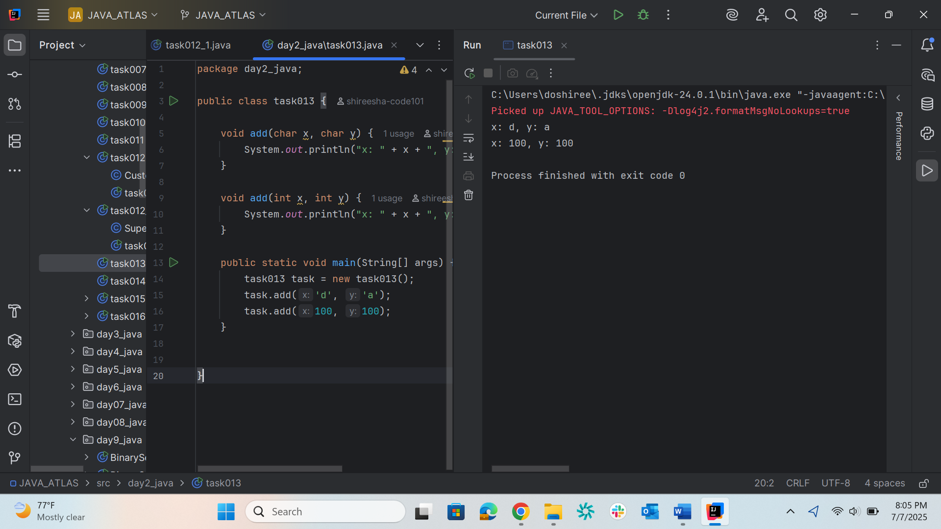
Task014
package day2_java;
public class task014 {
// Overloaded add method: int + float
void add(int x, float y) {
System.out.println("add(int, float) called with x = " + x + ", y = " + y);
System.out.println("Result: " + (x + y));
}
// Overloaded add method: float + int
void add(float x, int y) {
System.out.println("add(float, int) called with x = " + x + ", y = " + y);
System.out.println("Result: " + (x + y));
}
public static void main(String[] args) {
task014 calc = new task014();
calc.add(10.50f, 60); // calls add(float, int)
calc.add(100, 80.80f); // calls add(int, float)
}
}
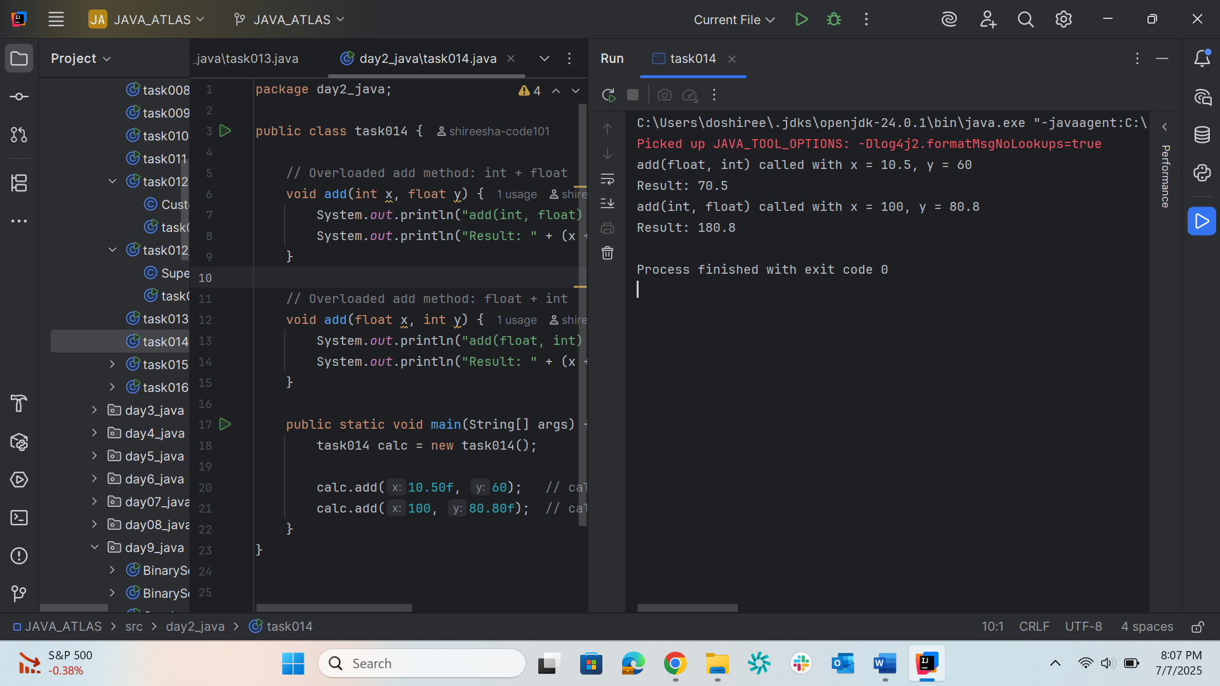
Task015
package day2_java;
// Abstract class defining the blueprint for all gadgets
abstract class Gadgets {
abstract void turnOn();
abstract void turnOff();
}
// Concrete class: TVRemote
class TVRemote extends Gadgets {
@Override
void turnOn() {
System.out.println("TV is turned ON.");
}
@Override
void turnOff() {
System.out.println("TV is turned OFF.");
}
}
// Concrete class: ACRemote
class ACRemote extends Gadgets {
@Override
void turnOn() {
System.out.println("AC is turned ON.");
}
@Override
void turnOff() {
System.out.println("AC is turned OFF.");
}
}
// New Concrete class: FanRemote
class FanRemote extends Gadgets {
@Override
void turnOn() {
System.out.println("Fan is turned ON.");
}
@Override
void turnOff() {
System.out.println("Fan is turned OFF.");
}
}
// New Concrete class: CoolerRemote
class CoolerRemote extends Gadgets {
@Override
void turnOn() {
System.out.println("Cooler is turned ON.");
}
@Override
void turnOff() {
System.out.println("Cooler is turned OFF.");
}
}
// Main class to demonstrate abstraction
public class task015 {
public static void main(String[] args) {
Gadgets tv = new TVRemote();
Gadgets ac = new ACRemote();
Gadgets fan = new FanRemote();
Gadgets cooler = new CoolerRemote();
// Operate each gadget
tv.turnOn();
tv.turnOff();
ac.turnOn();
ac.turnOff();
fan.turnOn();
fan.turnOff();
cooler.turnOn();
cooler.turnOff();
}
}
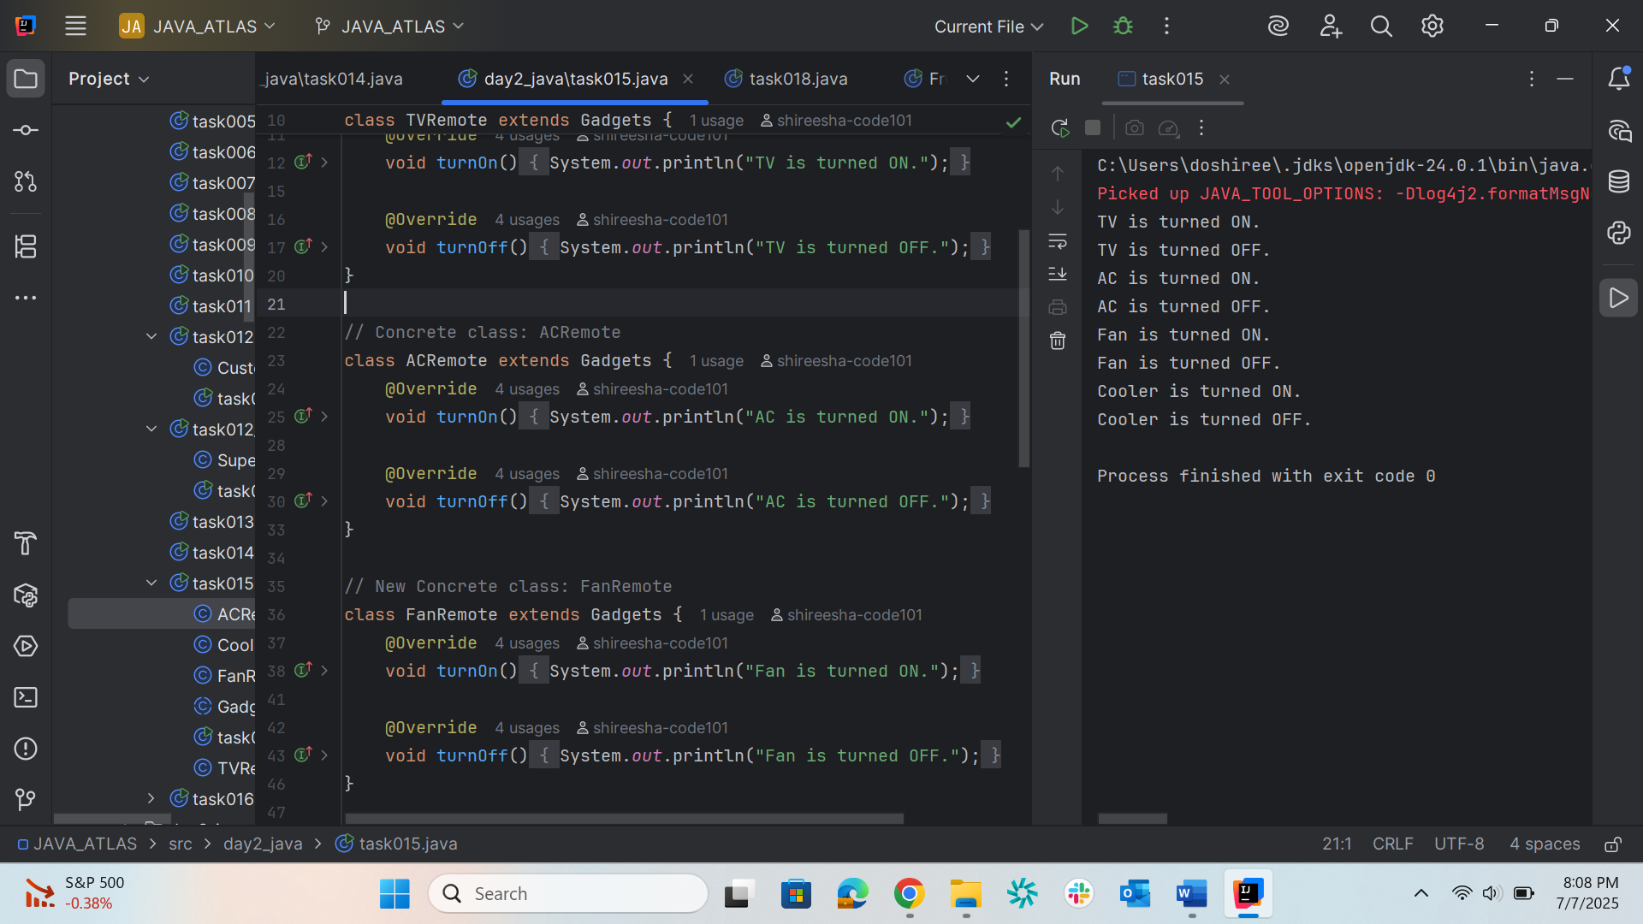

Task016
package day2_java;
// Interface declared with a constant and an abstract method
interface testInterface {
// Implicitly public, static, and final
int tax = 10;
// Implicitly public and abstract
void display();
}
// Concrete class implementing the interface
class TestClass implements testInterface {
@Override
public void display() {
System.out.println("Myclass");
}
}
public class task016 {
public static void main(String[] args) {
TestClass t = new TestClass();
t.display(); // prints "Myclass"
System.out.println(t.tax); // prints the constant: 10
}
}
