Day9_java

Task001

package day3_java;  
  
public class task001 {  
  
 public static void main(String[] args) {  
  
 int[] myNumbers = {1, 2, 3};  
  
 System.*out*.println(myNumbers[10]);  
 }  
}

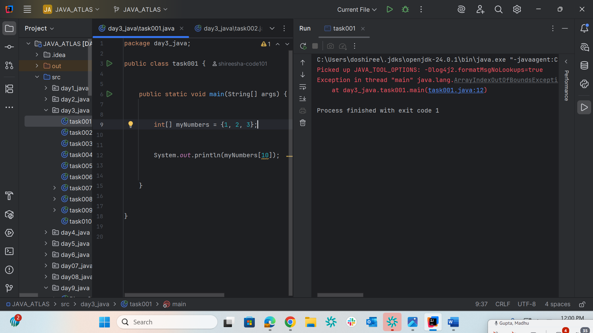

Task002

package day3_java;  
  
public class task002 {  
  
 public static void main(String[] args) {  
  
 try {  
 int[] myNumbers = {1, 2, 3};  
 System.*out*.println(myNumbers[10]);  
  
 } catch (Exception e) {  
 // Catch block with the corrected variable 'e'  
 System.*out*.println("Something went wrong: " + e.getMessage());  
 }  
  
 }  
  
}

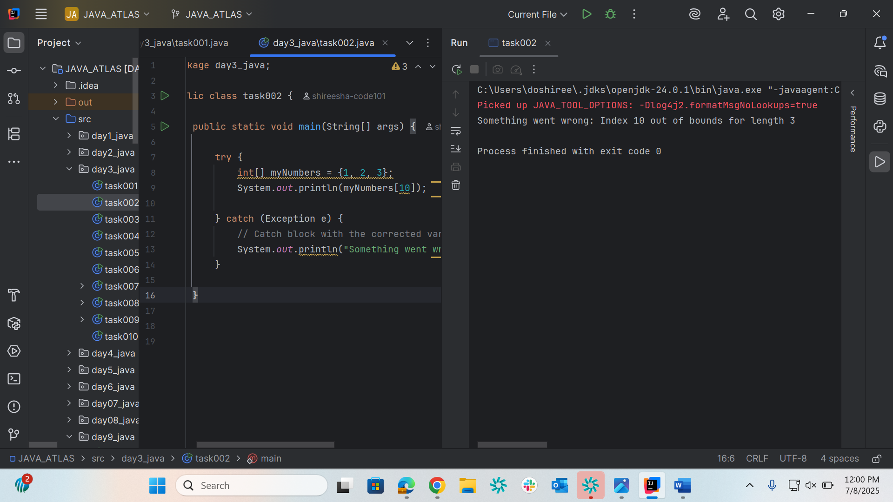

Task003

package day3_java;

public class task003 {

public static void main(String[] args) {

try {

int[] myNumbers = {1, 2, 3}

System.out.println(myNumbers[10])

} catch (Exception e) {

System.out.println("Something went wrong.");

} finally {

System.out.println("I'm from finally block.");

}

}

}

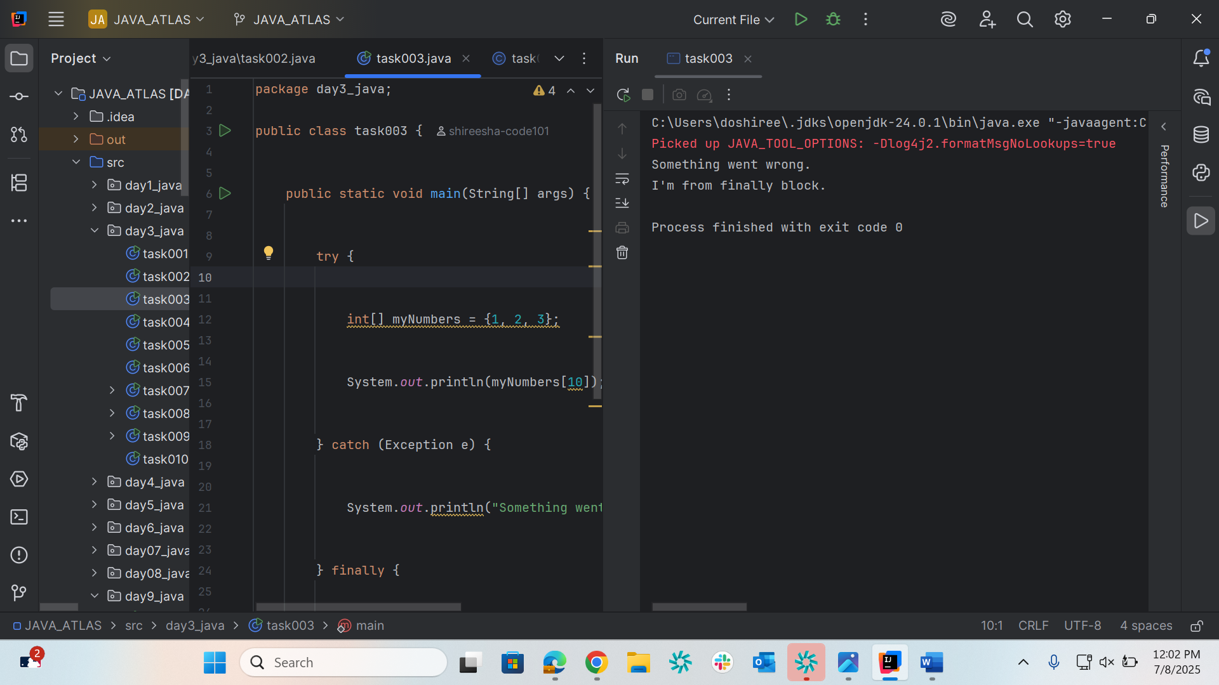

Task004

package day3_java;  
  
public class task004 {  
  
 public static void main(String[] args) {  
  
 try {  
 int[] myNumbers = {1, 2, 3};  
  
 // Accessing the valid index 2  
 System.*out*.println(myNumbers[2]);  
  
 } catch (Exception e) {  
 System.*out*.println("Something went wrong.");  
 } finally {  
 System.*out*.println("I'm from finally block.");  
 }  
  
 }  
  
}

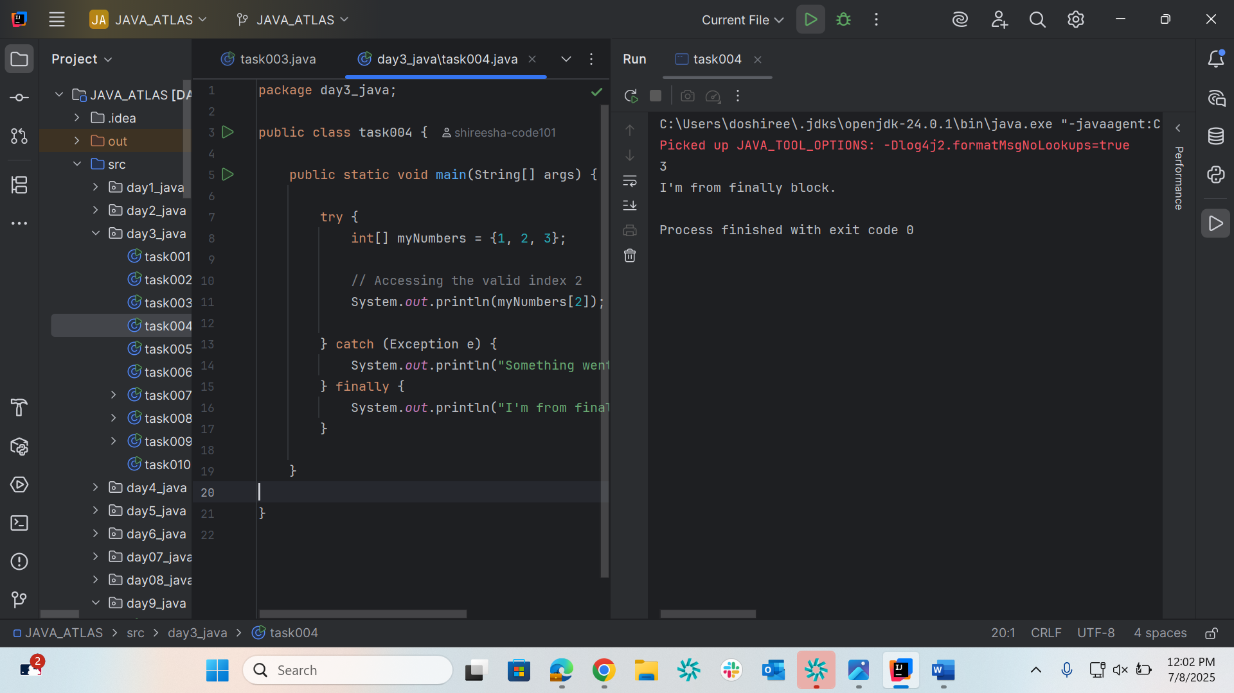

Task005

package day3_java;  
  
public class task005 {  
  
 public static void main(String args[]) {  
 try {  
 int a[] = new int[2];  
 int b = 0;  
 int c = 1/b;  
 System.*out*.println("Access element three :" + a[3]);  
 }  
 catch (ArithmeticException e) {  
 System.*out*.println("ArithmeticException thrown :" + e);  
 }  
 catch (ArrayIndexOutOfBoundsException e) {  
 System.*out*.println("ArrayIndexOutOfBoundsException thrown :" + e);  
 }catch (Exception e) {  
 System.*out*.println("Exception thrown :" + e);  
 }  
 System.*out*.println("Out of the block");  
 }  
}

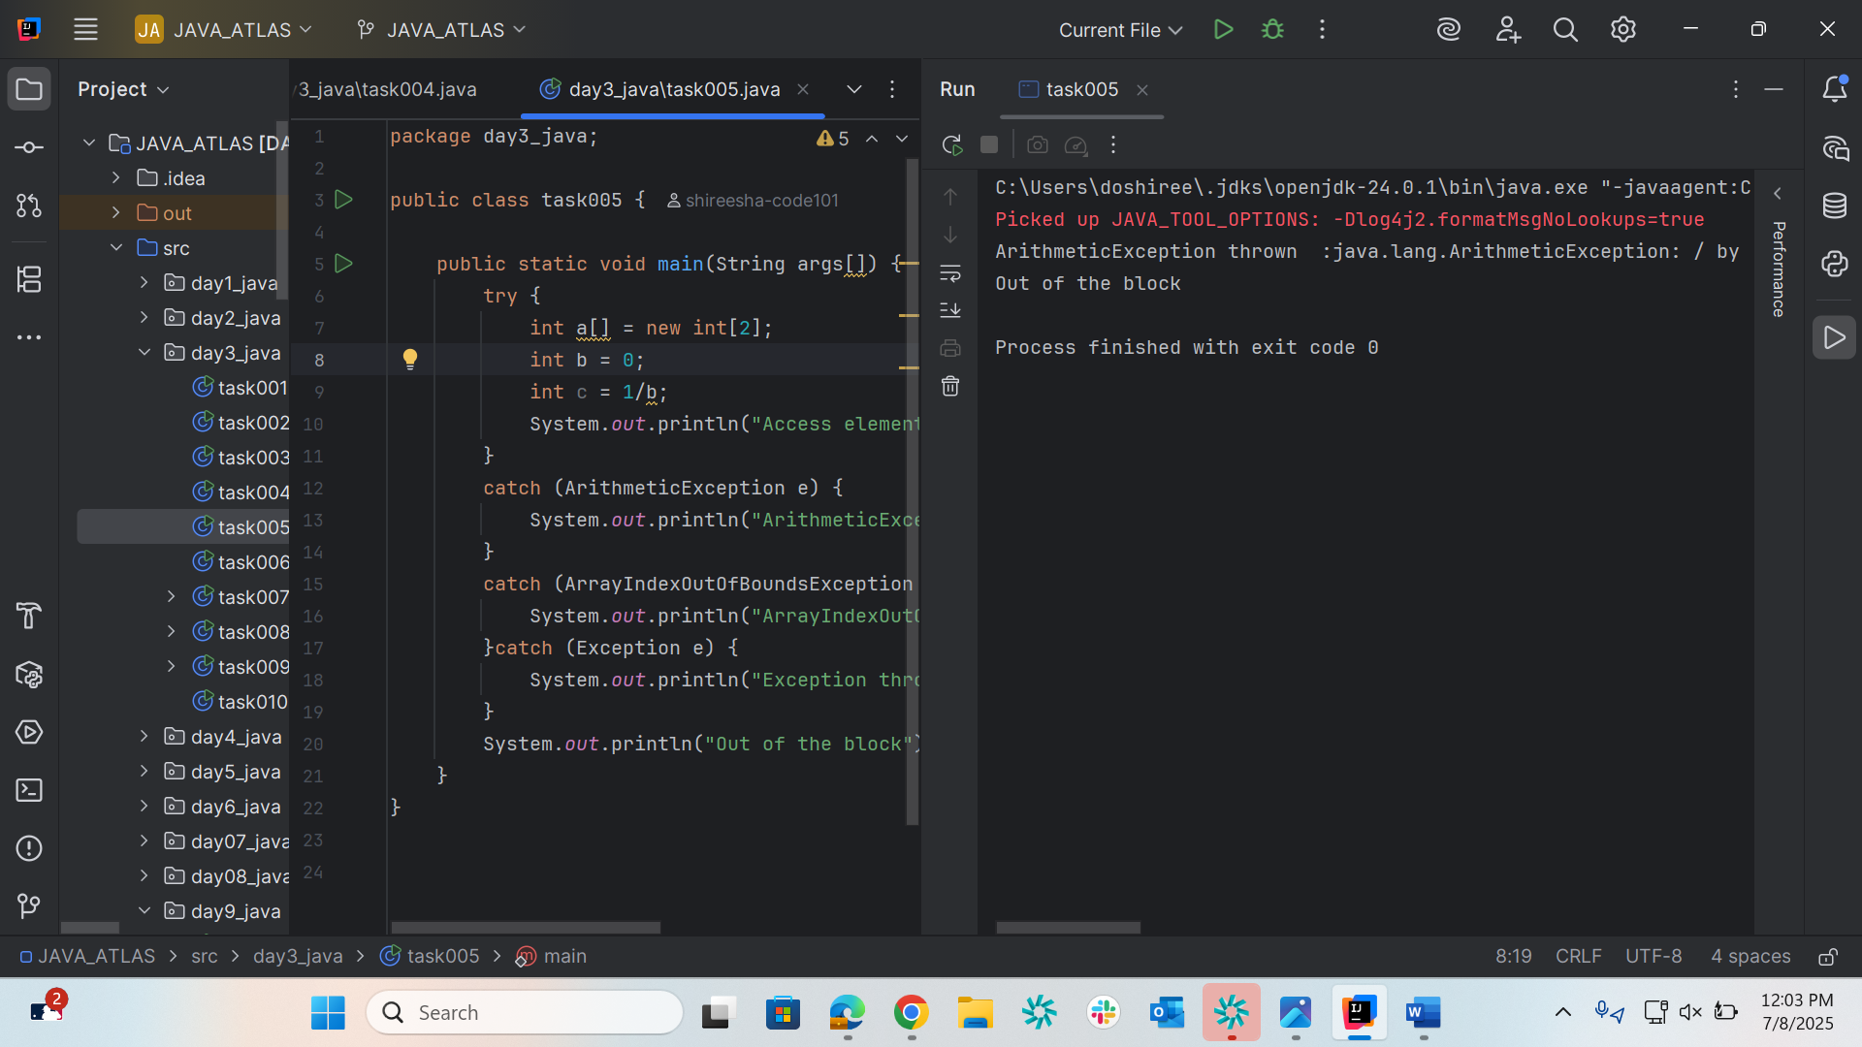

Task006

package day3_java;  
  
public class task006 {  
  
 public static void main(String args[]) {  
 try {  
 int a[] = new int[2];  
 System.*out*.println("Access element three :" + a[2]); // try with a[0] or a[1] ===> and check if control goes to inner try block..  
 try {  
 int b = 0;  
 int c = 1/b;  
 }catch(Exception e) {  
 System.*out*.println("Exception thrown: " + e);  
 }  
 System.*out*.println("Access element three :" + a[3]);  
 }  
 catch (ArrayIndexOutOfBoundsException e) {  
 System.*out*.println("Exception thrown: " + e);  
 }  
 System.*out*.println("Out of the block");  
 }  
}

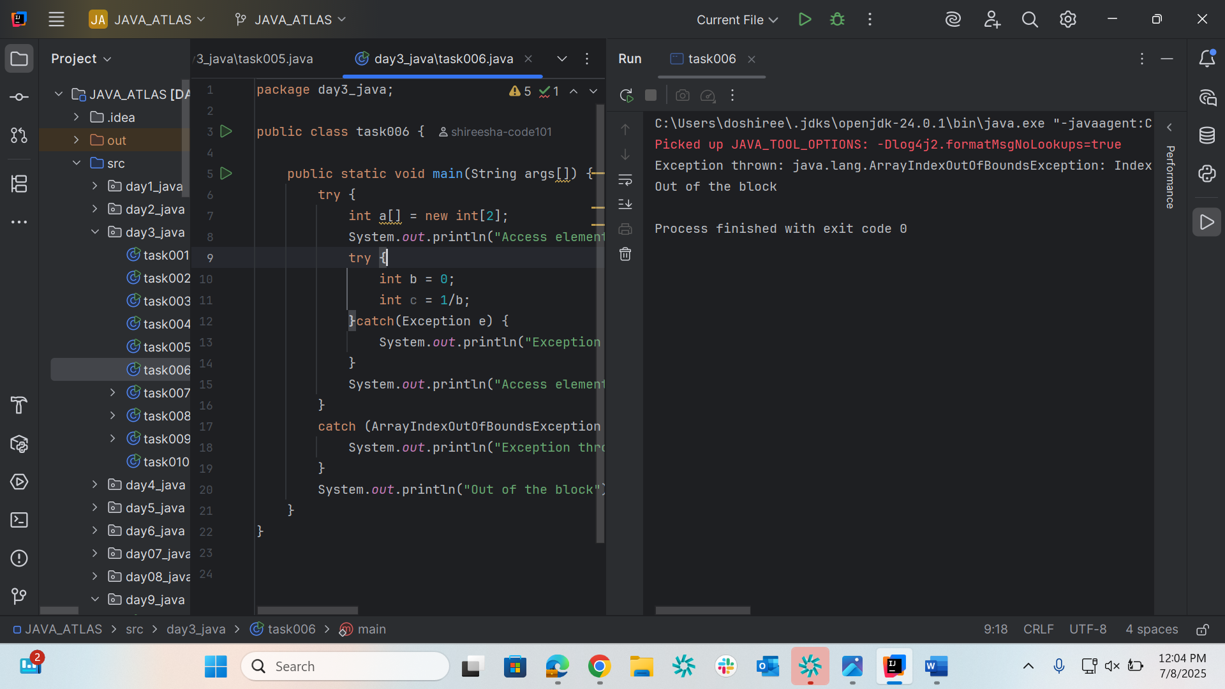

Task007

package day3_java;  
  
class MyClass {  
  
 static void fun() throws IllegalAccessException  
 {  
 System.*out*.println("Inside fun(). ");  
 throw new IllegalAccessException("demo exception by fun method");  
 }  
  
 public static void main(String args[])  
 {  
 try {  
 *fun*();  
 }  
 catch (IllegalAccessException e) {  
 System.*out*.println("Caught in main." + e.getMessage());  
 }  
 }  
}

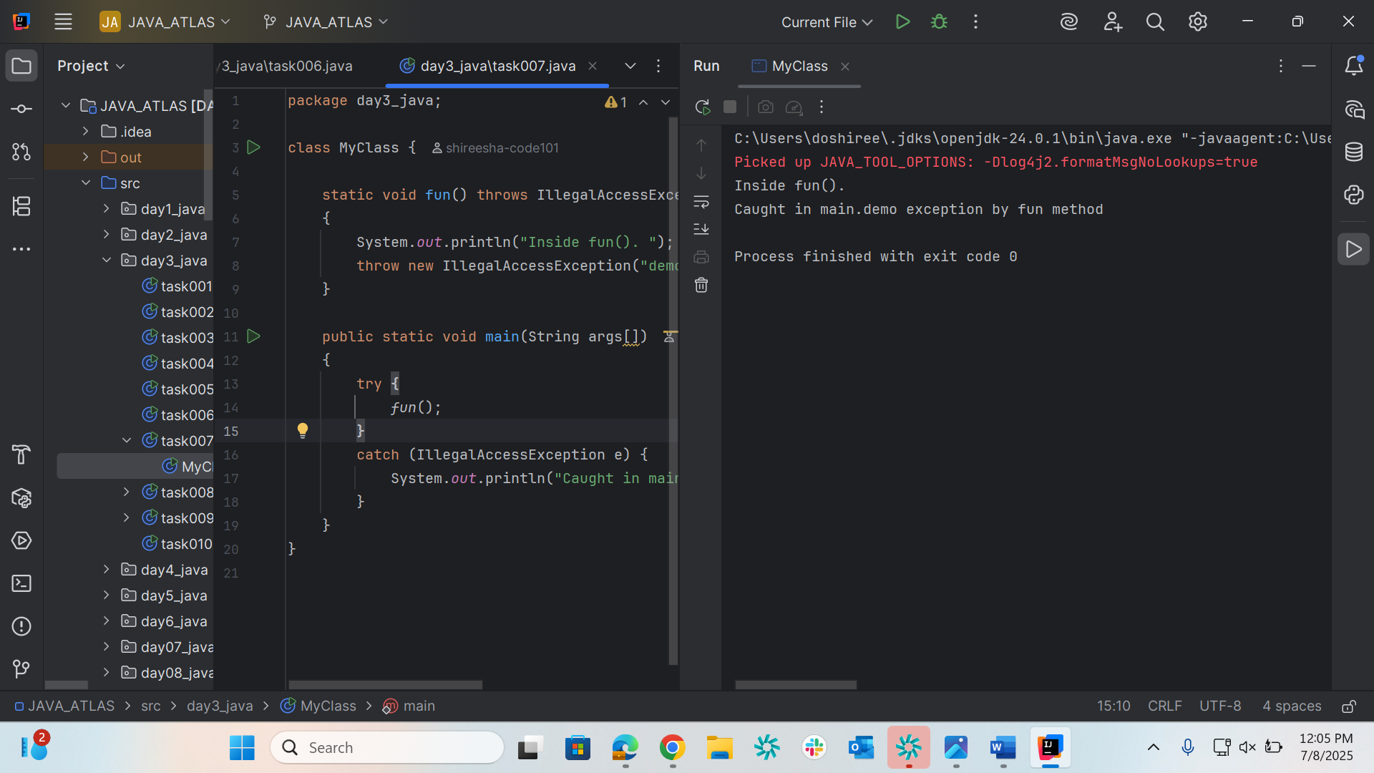

Task008

package day3_java;  
  
// A Class that represents user-defined exception  
class MyException extends Exception { // exception is a predefined class – parent class for MyException  
 public MyException(String m) {  
//inr age ====> scan in put ===> if clock if age <0 ==? Throw an exception  
 super(m); // calling the parent class constructor with parameters  
 }  
}  
  
// A Class that uses the above MyException  
public class task008{  
 public static void main(String args[]) {  
 try {  
  
 // Throw an object of user-defined exception  
 throw new MyException("This is a custom exception");  
 }  
 catch (MyException ex) {  
 System.*out*.println("Caught");  
 System.*out*.println(ex.getMessage());  
 }  
 }  
}

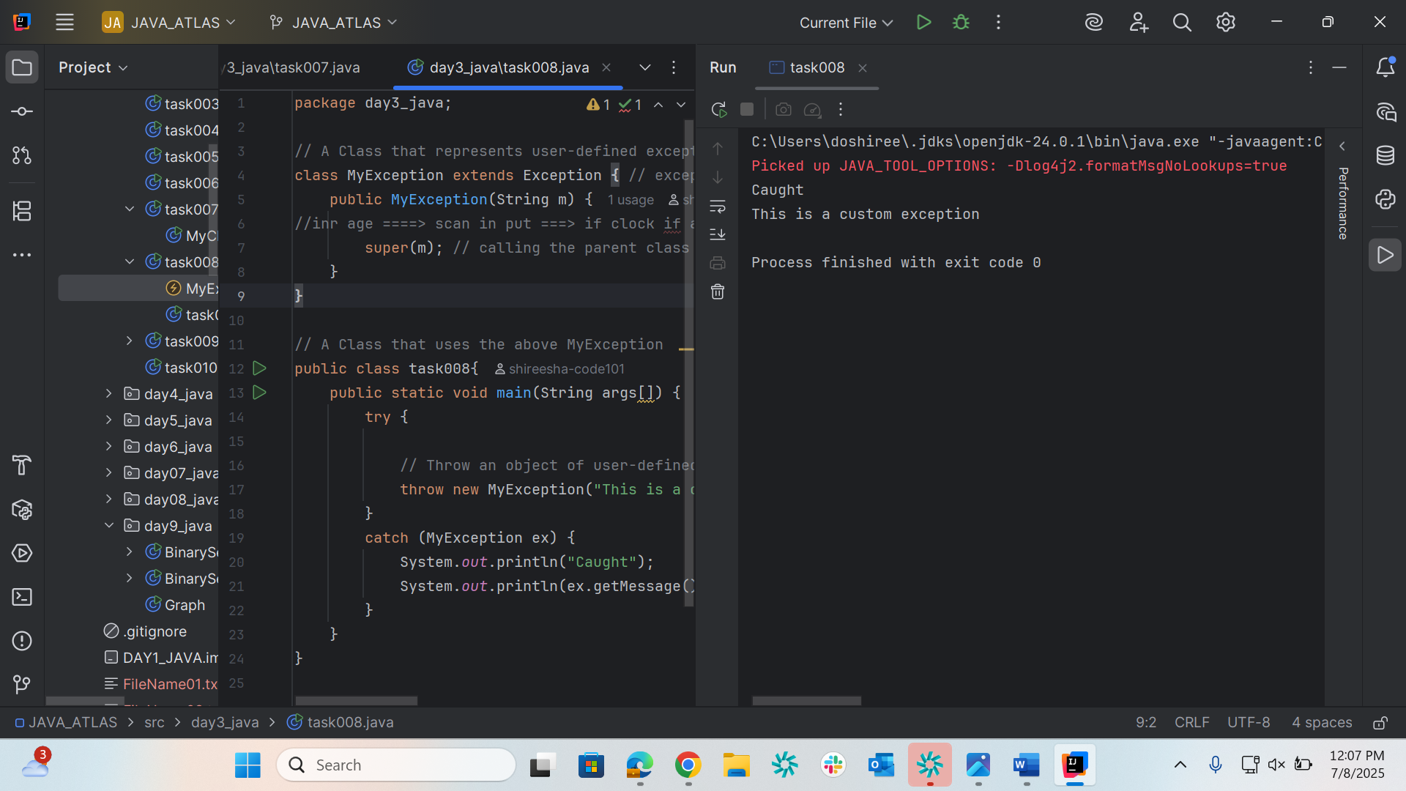

Task009

package day3_java;  
  
import java.util.ArrayList;  
class Main {  
 public static void main (String[] args) {  
 // Creating an ArrayList  
 ArrayList<Integer> a = new ArrayList<Integer>();  
 // Adding Element in ArrayList  
 a.add(1);  
 a.add(2);  
 a.add(3);  
  
 // Printing ArrayList  
 System.*out*.println(a);  
 }  
}

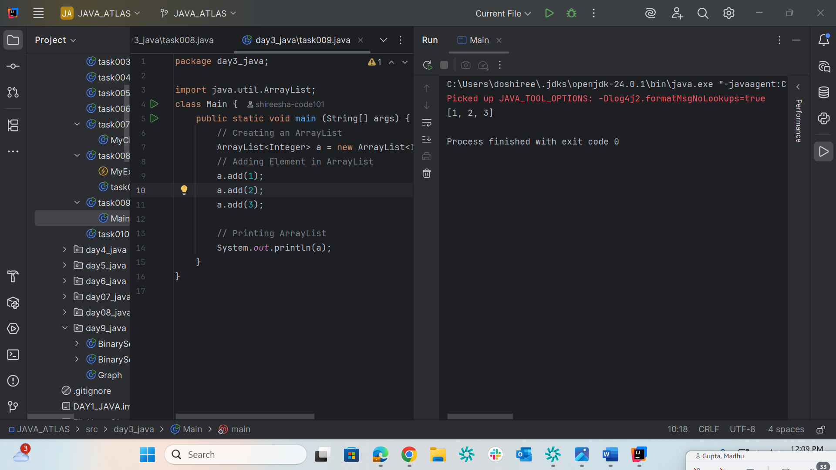

Task010

package day3_java;  
  
import java.util.*;  
class task010 {  
 public static void main(String args[]){  
 ArrayList<String> al = new ArrayList<>();  
 al.add("Prasunamba");  
 al.add("Meher");  
 System.*out*.println("Original List : "+al);  
  
 al.add(1, "Hello");  
 System.*out*.println("After Adding element at index 1 : "+ al);  
  
 al.remove(0);  
 System.*out*.println("Element removed from index 0 : "+ al);  
  
 al.remove("Prasunamba");  
 System.*out*.println("Element Prasunamba removed : "+ al);  
  
 al.set(0, "K");  
 System.*out*.println("List after updation of value : "+al);  
 }  
}

