1. To create directory and and path in linux

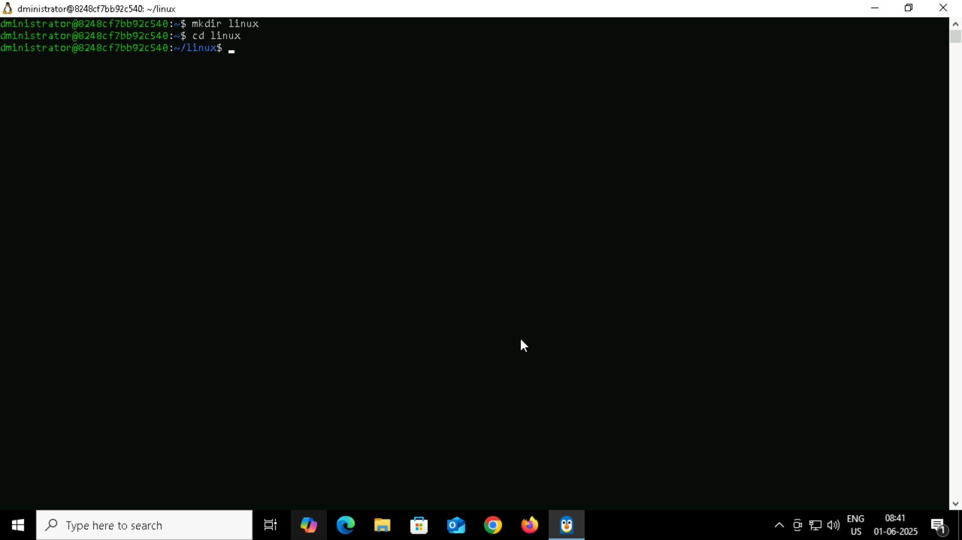

1. Create a file name TestFile1.txt and add the content to it.

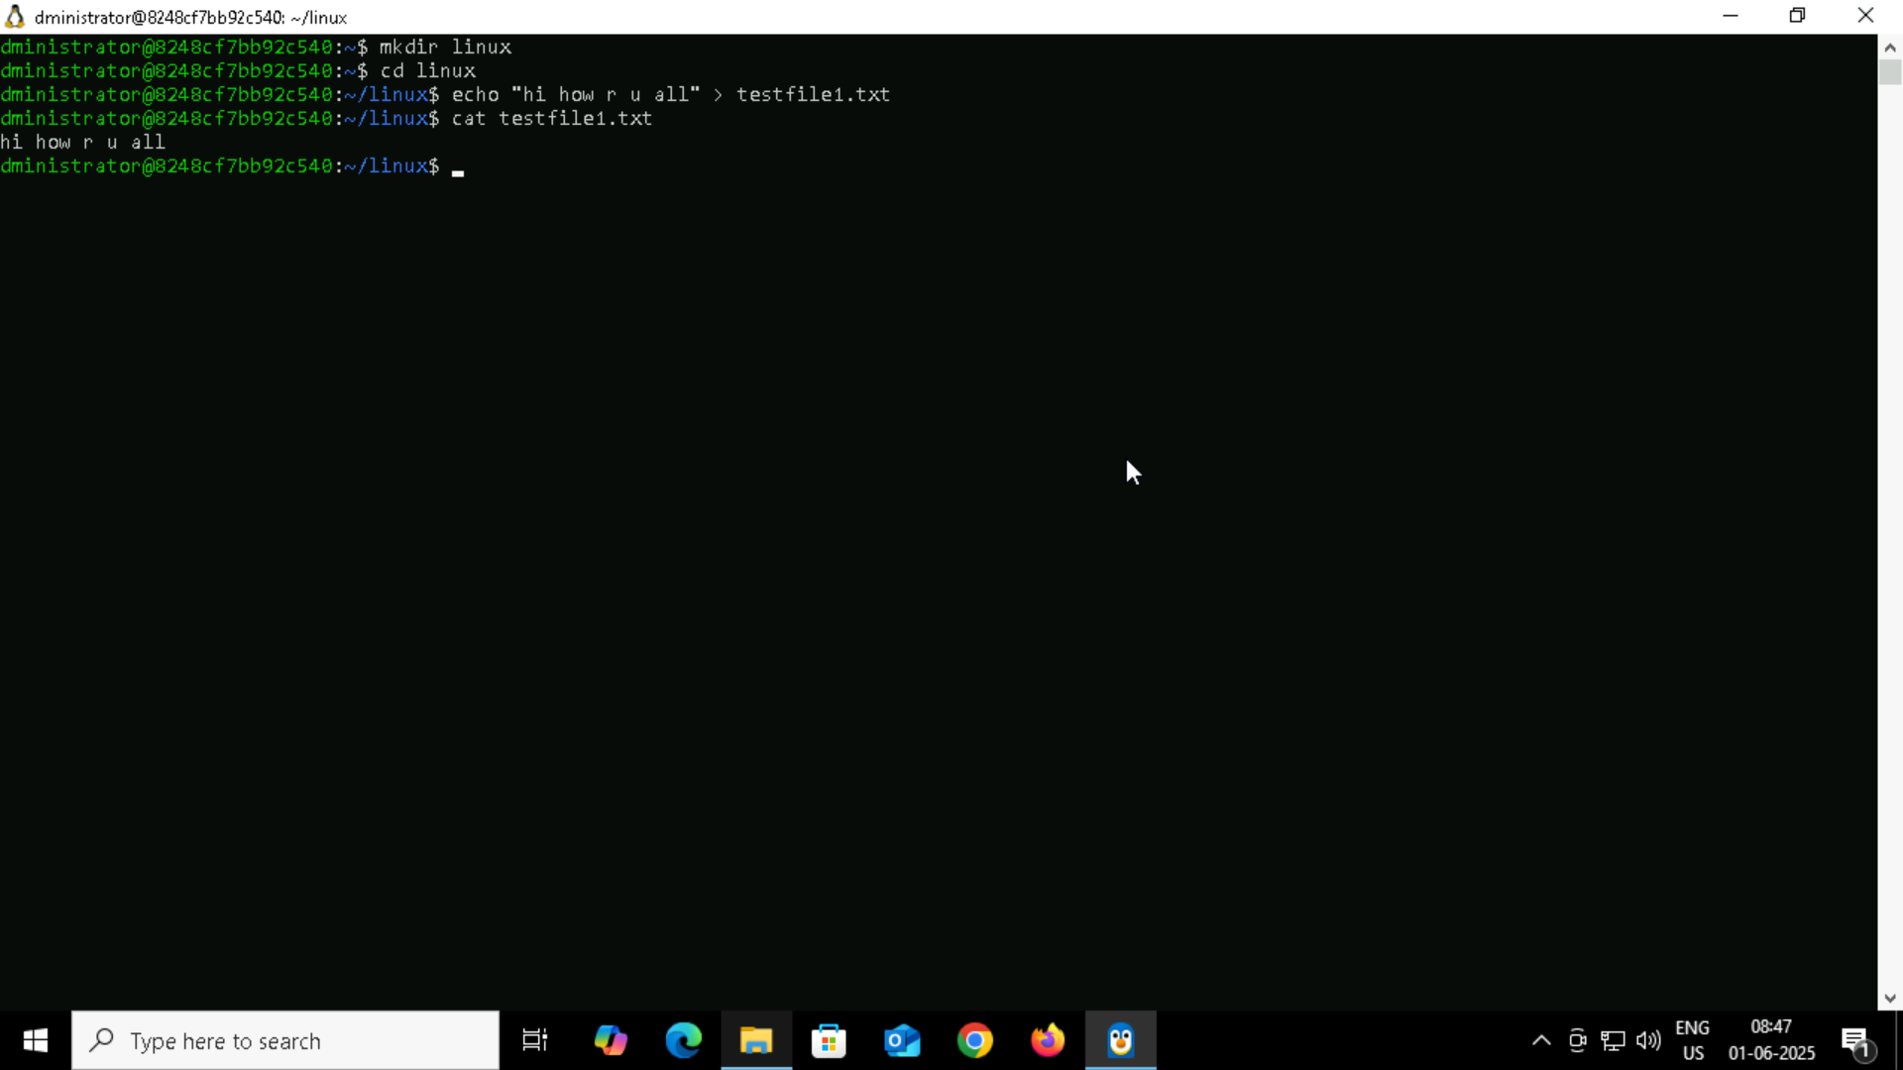

1. Creating the dummy folder and deleting

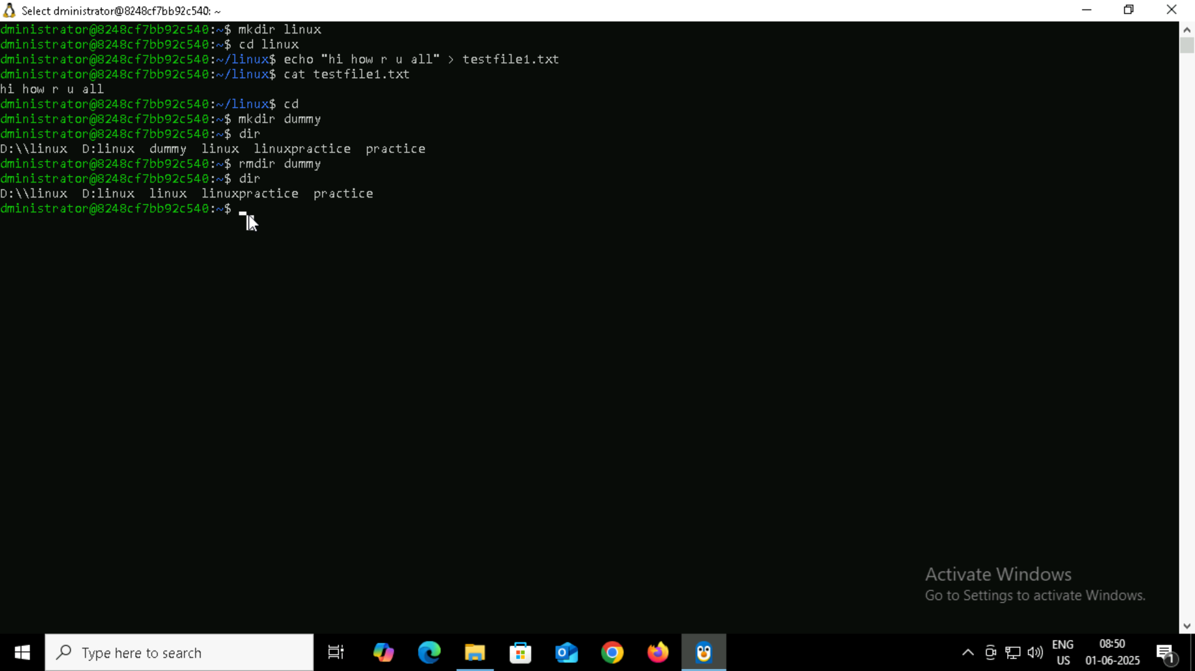

1. check the working directory
2. How do you check all the files and directories in the directory you are in?

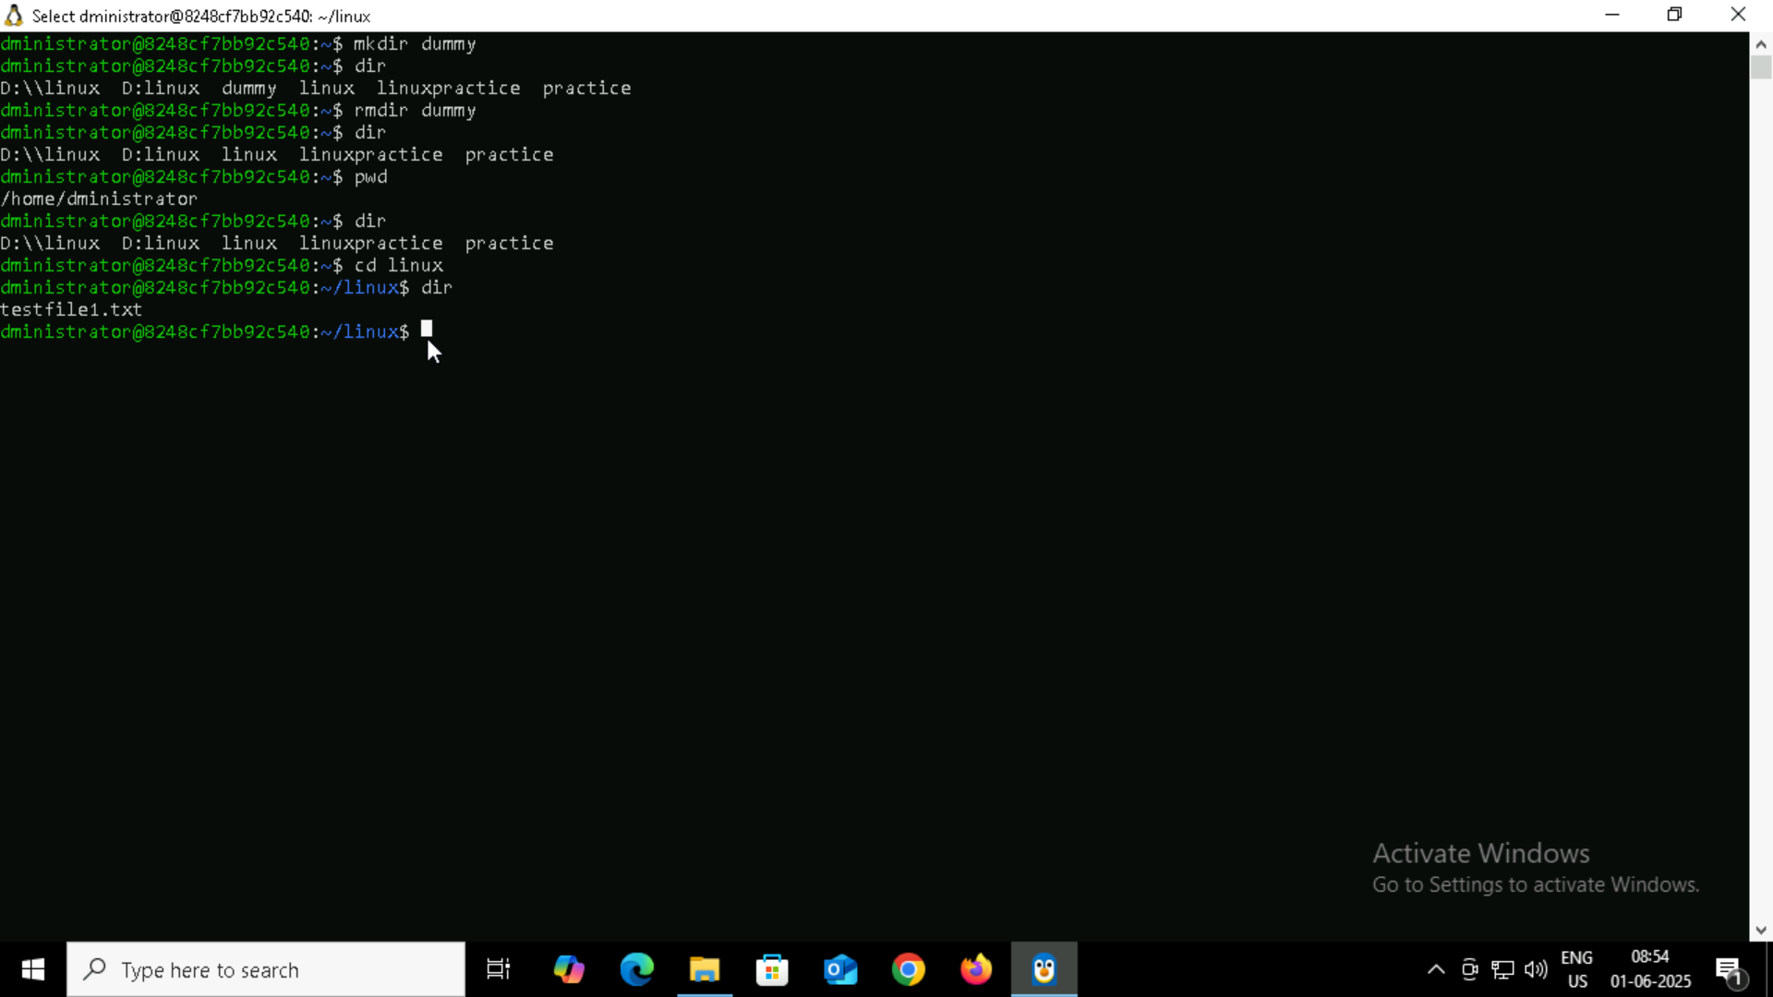

1. Create five files named TestFile2.txt.. TestFile3.txt… and so on till TestFile6.txt

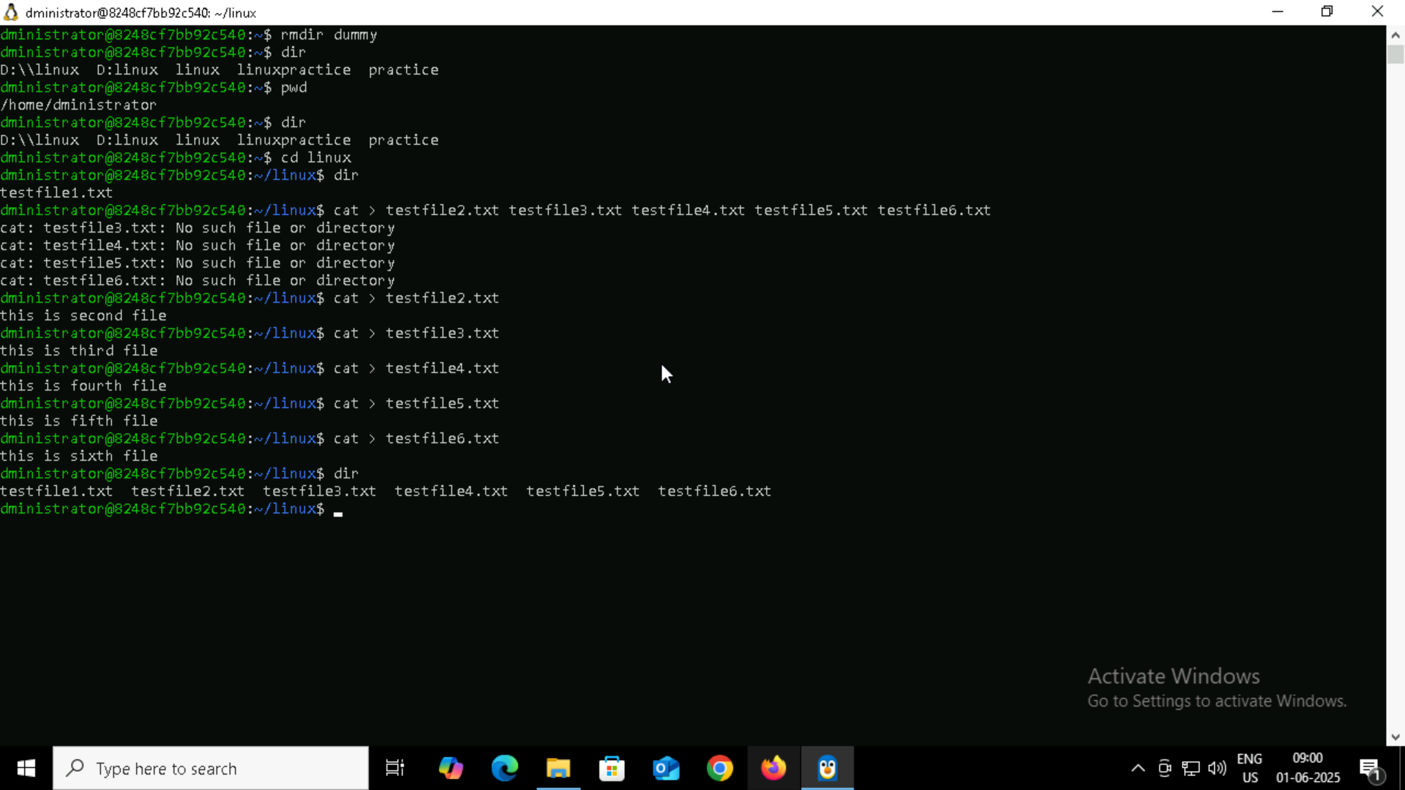

To print calender

