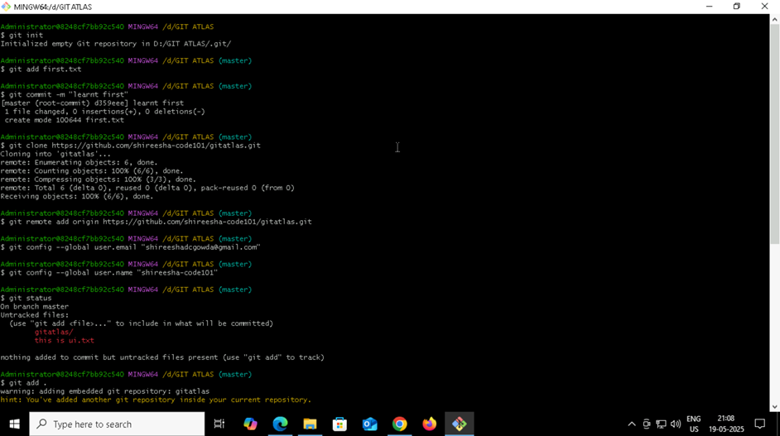
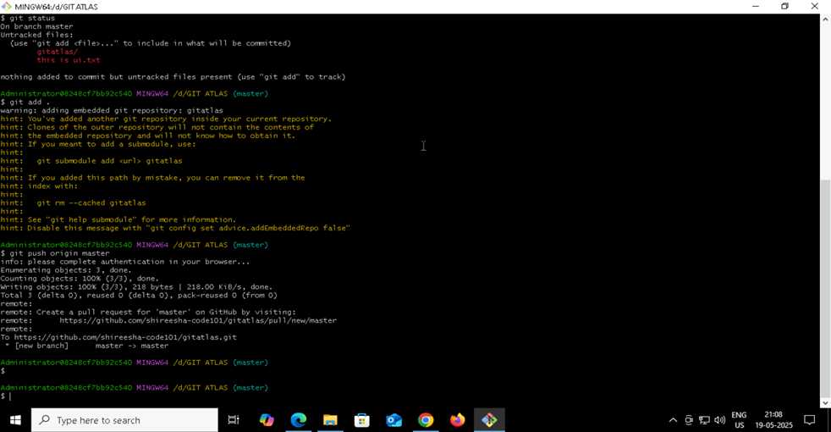
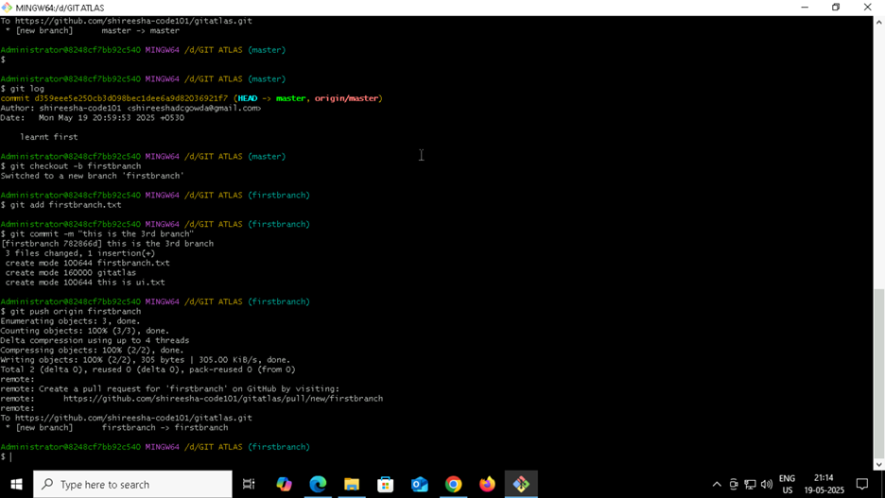
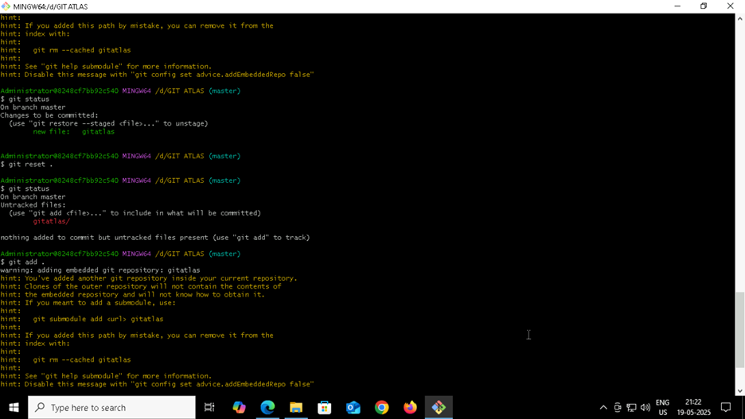
GIT AND GIT HUB
· Git : git is a tool that helps to track changes in the code
· Github : allows developers to store and manage their code using git
· To check git version
git –version
· git workflow
git init ----- working directory
git add ----- staging area
git commit ----- repository
git push ----- github
· git bash
git init
git add <filename.txt>
git commit -m <”…..”>
git clone <link>
git remote add origin <link>
git config –global user.email <”email”>
git config –global user.name <”username”>
git status
git add .
git push origin master

· To create a new branch
Git log
Git checkout -b branchname
Git add <branchname.txt>
Git commit -m <”….”>
Git push origin <branchname>

· To reset
git reset <file name>
or
git reset .

