GIT AND GIT HUB

* Git : git is a tool that helps to track changes in the code
* Github : allows developers to store and manage their code using git
* To check git version   
  git –version
* git workflow

git init ----- working directory

git add ----- staging area

git commit ----- repository

git push ----- github

* git bash

git init

git add <filename.txt>

git commit -m <”…..”>

git clone <link>

git remote add origin <link>

git config –global user.email <”email”>

git config –global user.name <”username”>

git status

git add .

git push origin master

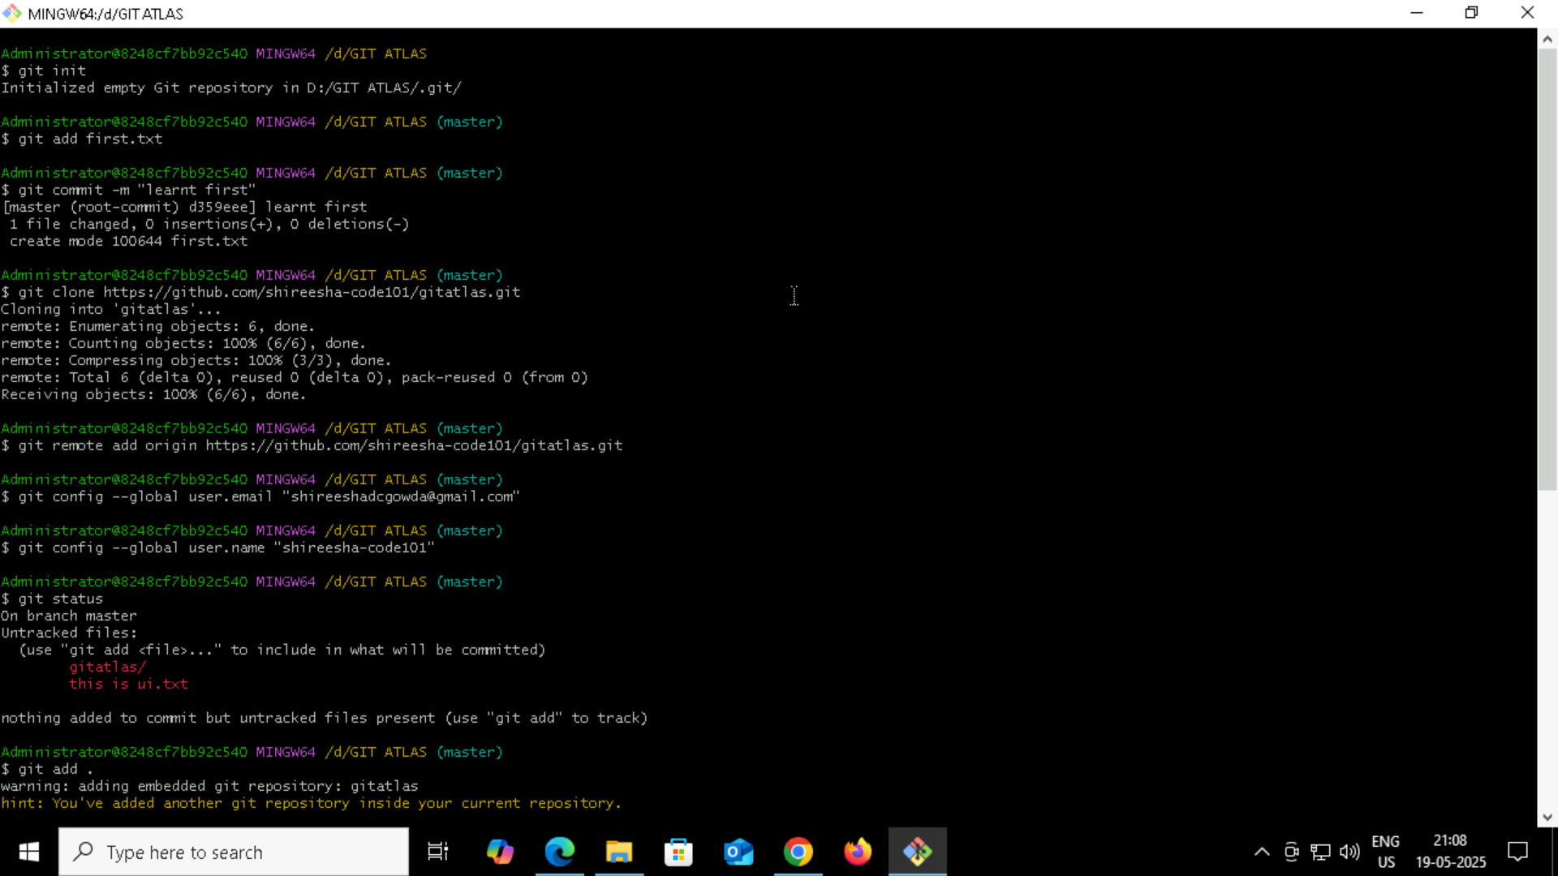

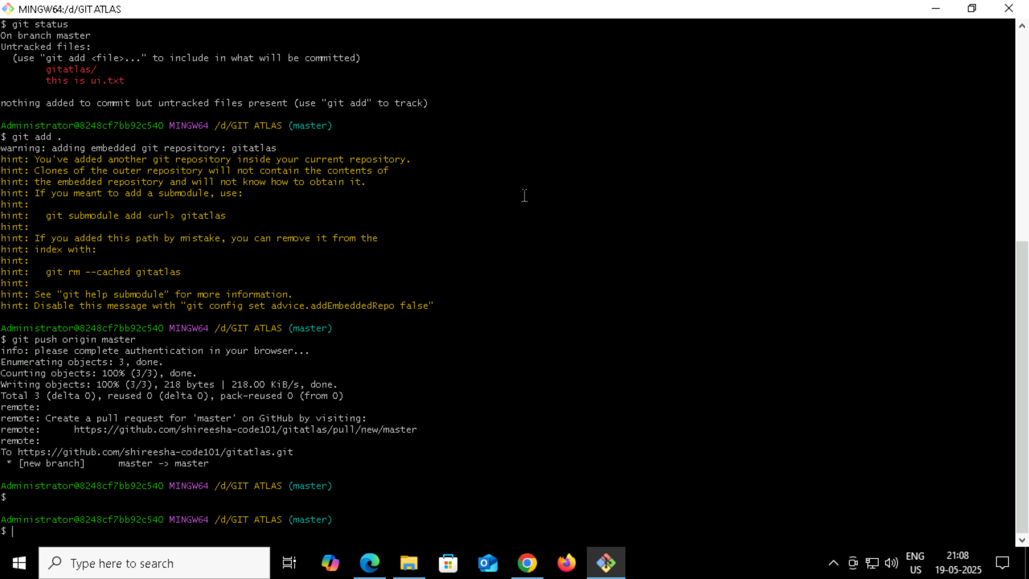

* To create a new branch

Git log

Git checkout -b branchname

Git add <branchname.txt>

Git commit -m <”….”>

Git push origin <branchname>

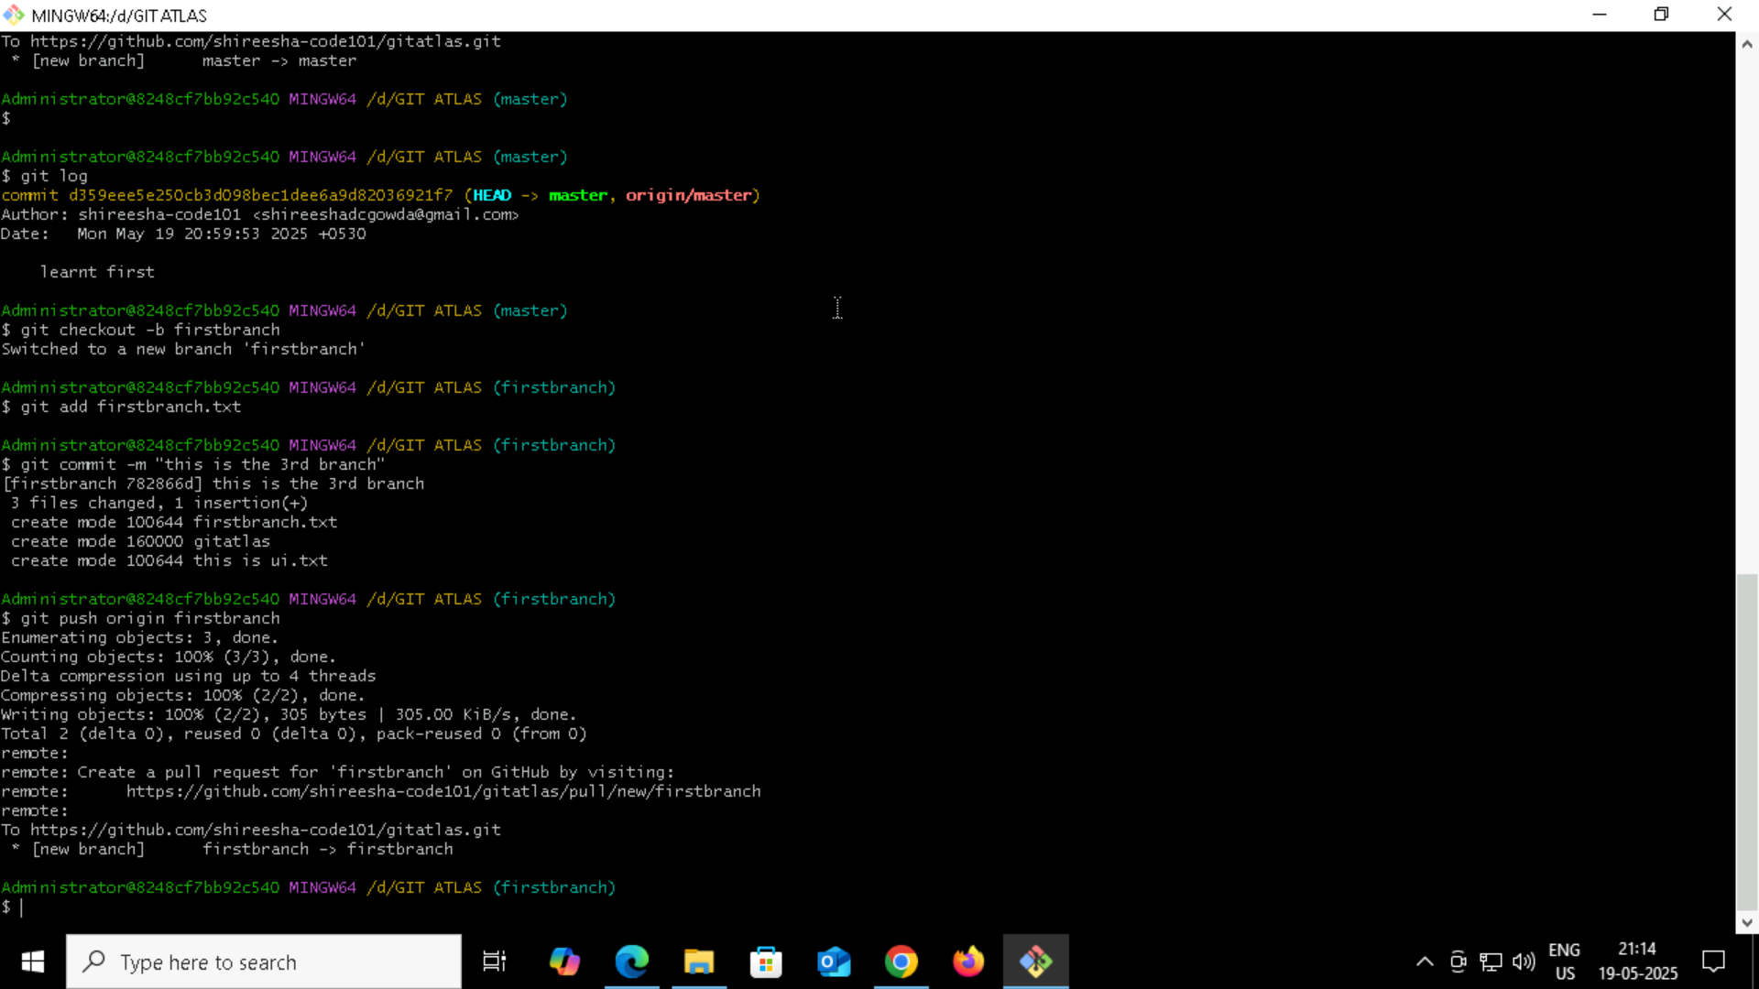

* To reset

git reset <file name>

or

git reset .

