- Create the google cloud console free account

- It is a two step process

- It is deducting the 2 rupees from your account and it will give the 330$ free credit points.

NOTE: Don’t active the full account

- Once the account is created u can login to google cloud console

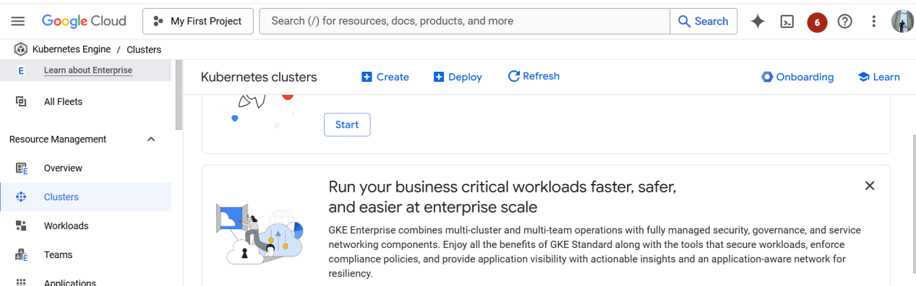

- NOW CREATE THE KUBERNETES CLUSTER

Open the cloud shell

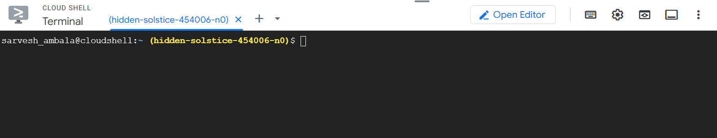

To see the cluster list run the below command

Gcloud container clusters list ( no clusters are there)

You create the cluster with below command

gcloud container clusters create my-cluster --zone us-central1-a

Cluster creation is taking 5 to 10 mints time

Once the cluster is created u can see the below message automatically

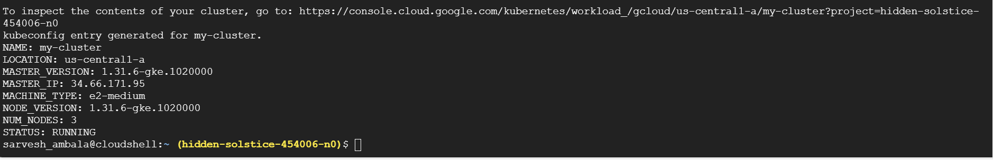

Now u go and check kubernetes engine--->cluster , you can see the my-cluster is running

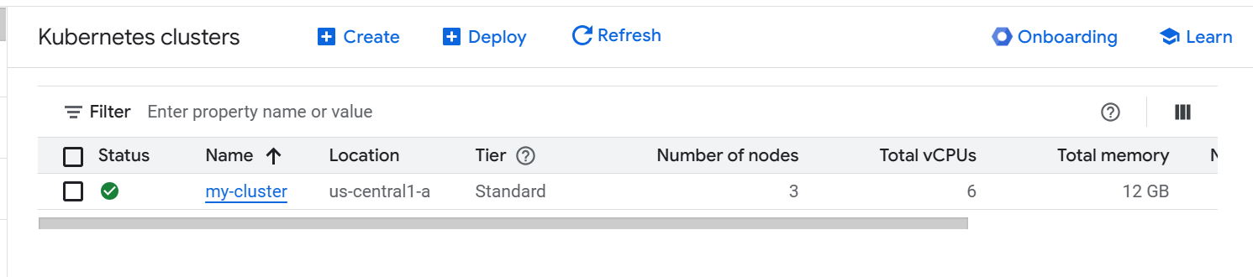

Run the below command

gcloud container clusters get-credentials my-cluster --zone us-central1-a

To see the list of nodes

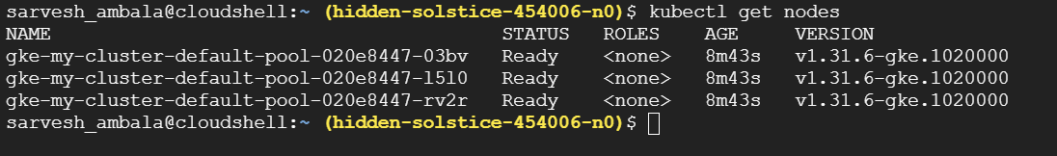

Create the pods

Kubectl run --image tomcat webserver

To see the pods list

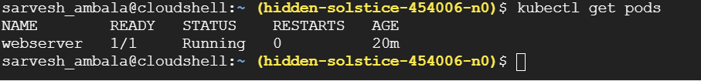

To get the list of pods along with ip address and which node the pod is running

Kubectl get pods -o wide

Actually u can create the pod using definition file

Create pd-df1.yaml

Vim pd-df1.yaml

apiVersion: v1
kind: Pod
metadata:
name: jenkins-pod
spec:
containers:
- name: myjenkins
image: jenkins/jenkins
ports:
- containerPort: 8080
hostPort: 8080

for accessing the application u need to open the port

How to open the port

gcloud compute firewall-rules create rule2 --allow tcp:8080

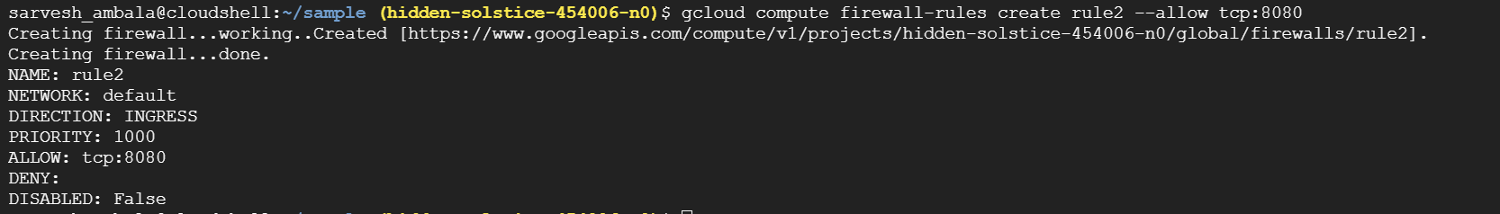

Kubectl create -f pd-df1.yaml

Kubectl get pods -o wide

Kubectl get nodes -o wide

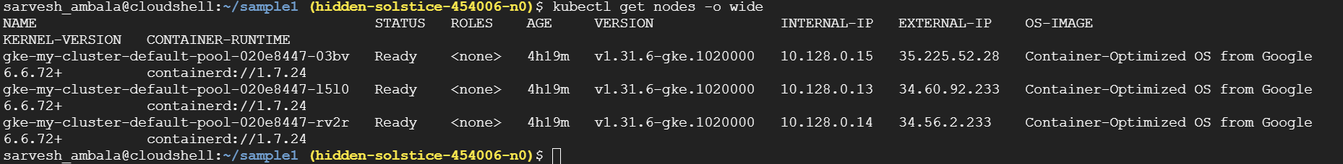

How can we access the pod

Take the external ip add the port no 8080

Open the browser paste ipaddress:8080

Now u can able to see the jenkins

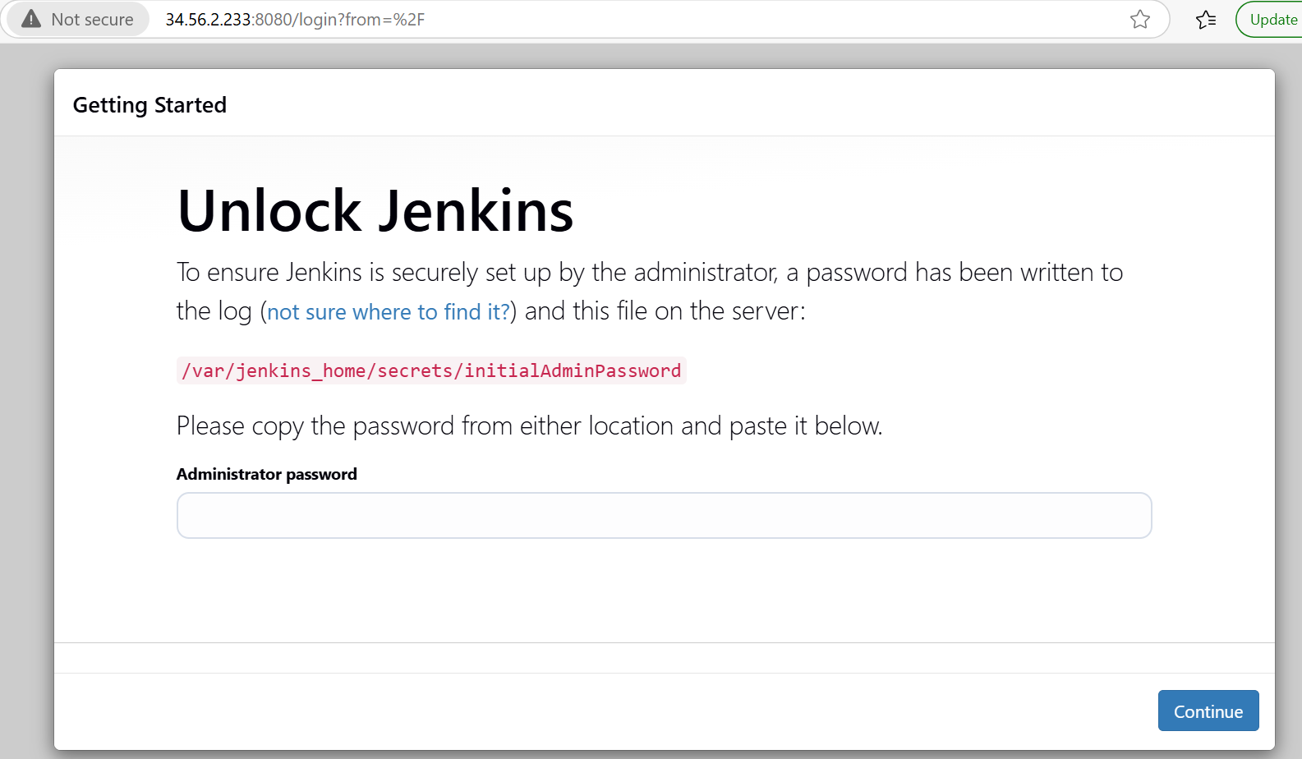

PROMETHEUS SETUP:

helm repo add prometheus https://prometheus-community.github.io/helm-charts

helm repo update

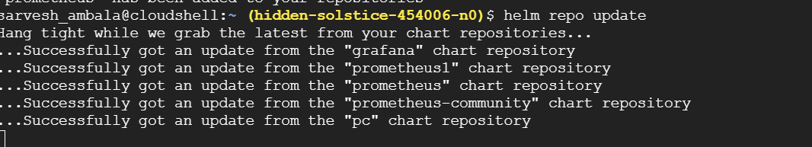

helm install prometheus prometheus-community/kube-prometheus-stack --namespace monitoring --create-namespace

This will install prometheus,alermanager and grafana

Check the prometheus pods and services

kubectl get pods -n monitoring

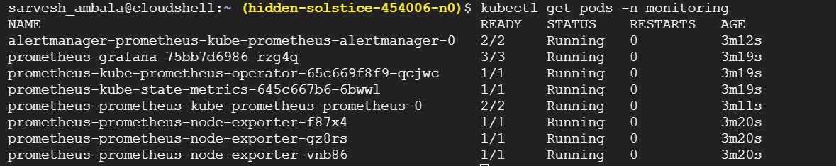

kubectl get svc -n monitoring

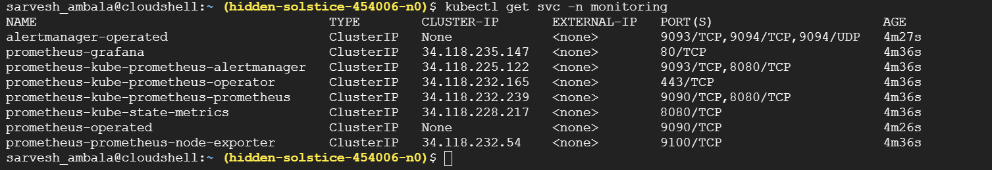

Access prometheus and port forwarding

kubectl port-forward svc/prometheus-kube-prometheus-prometheus 9090:9090 -n monitoring

Click on the webpreview

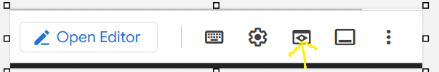

Change port no to 9090

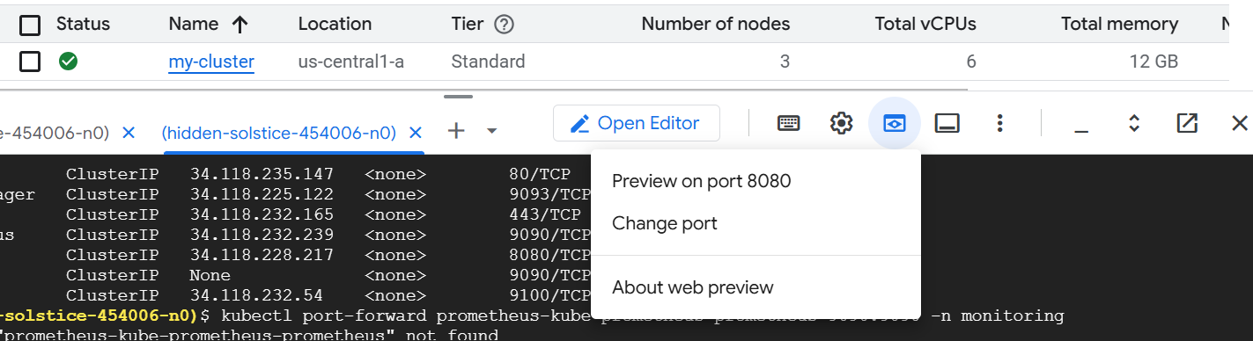

Click on change and preview

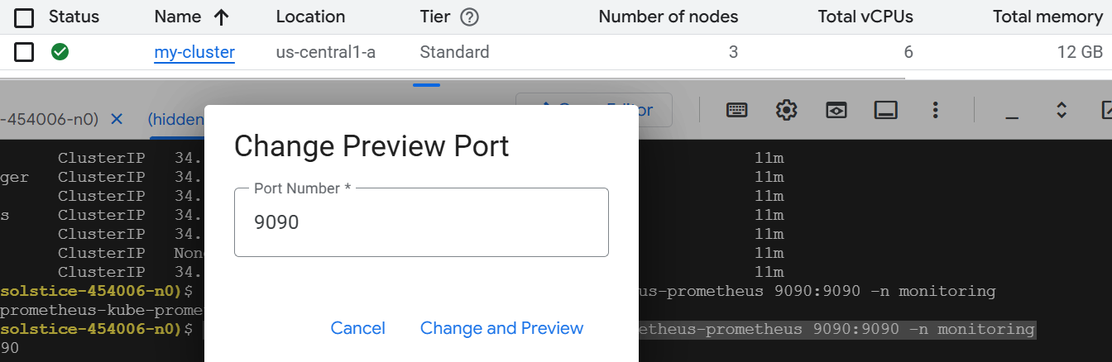

Now u can able to see prometheus in the browser

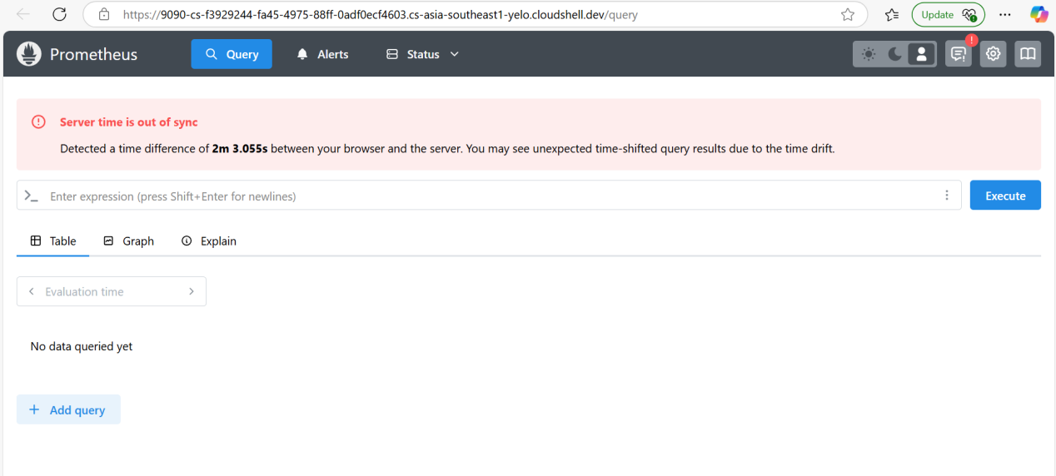

ACCESS GRAFANA :

kubectl get secret prometheus-grafana -n monitoring -o jsonpath="{.data.admin-user}" | base64 --decode ; echo

If you run the above command u can see the username for grafana (admin)

kubectl get secret prometheus-grafana -n monitoring -o jsonpath="{.data.admin-password}" | base64 --decode ; echo

If you run the abvoe command u can see the password for grafana (prom-operator)

PORT FORWARDING

kubectl port-forward svc/prometheus-grafana 3000:80 -n monitoring

Click on the web preview give the port no 3000 and click on change and preview u can see the grafana

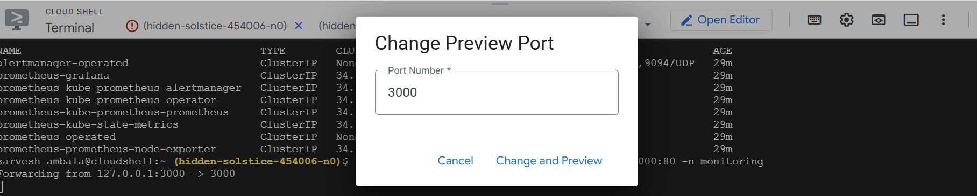

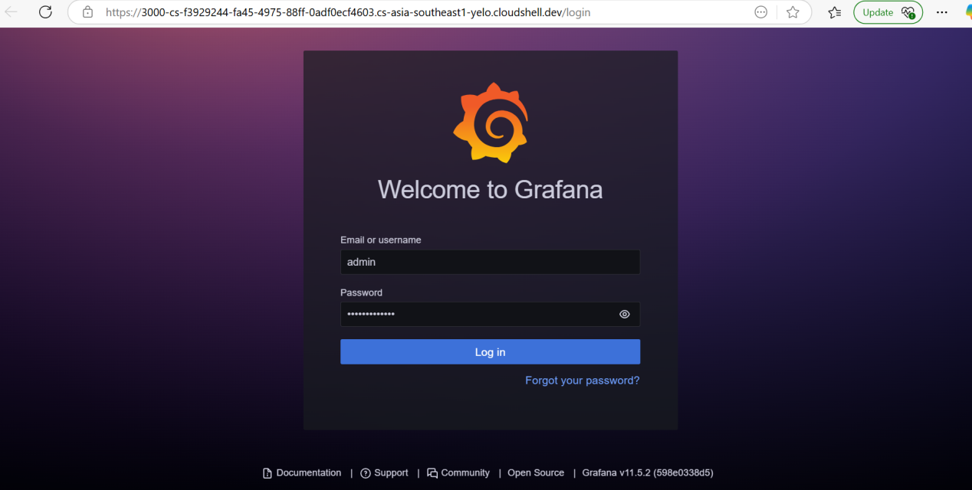

You can login with admin and prom-operator

