sudo su -

**yum install docker -y**

**systemctl start docker**

**sudo curl -L "https://github.com/docker/compose/releases/latest/download/docker-compose-$(uname -s)-$(uname -m)" -o /usr/local/bin/docker-compose**

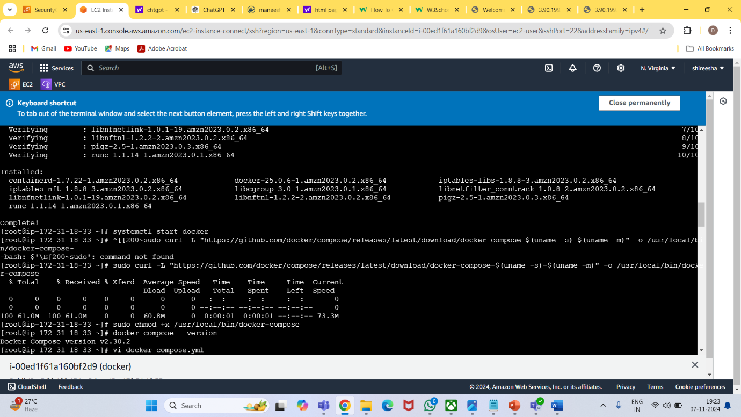

**vi docker-compose.yml**

**docker-compose up**

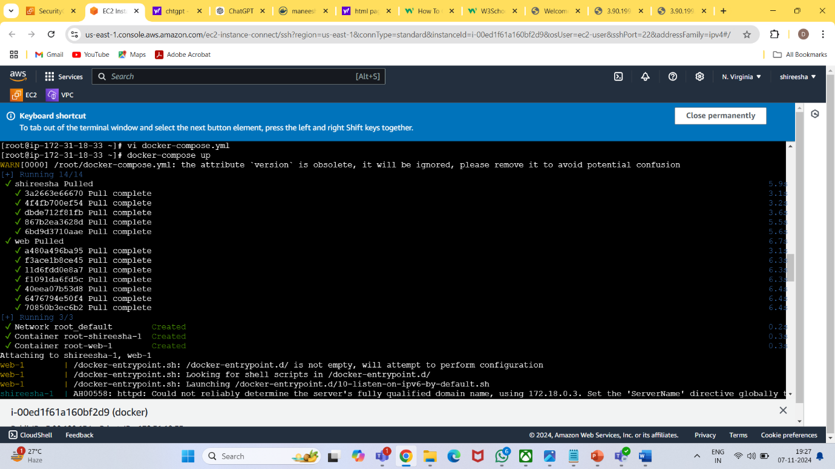

**docker ps**

**docker login**

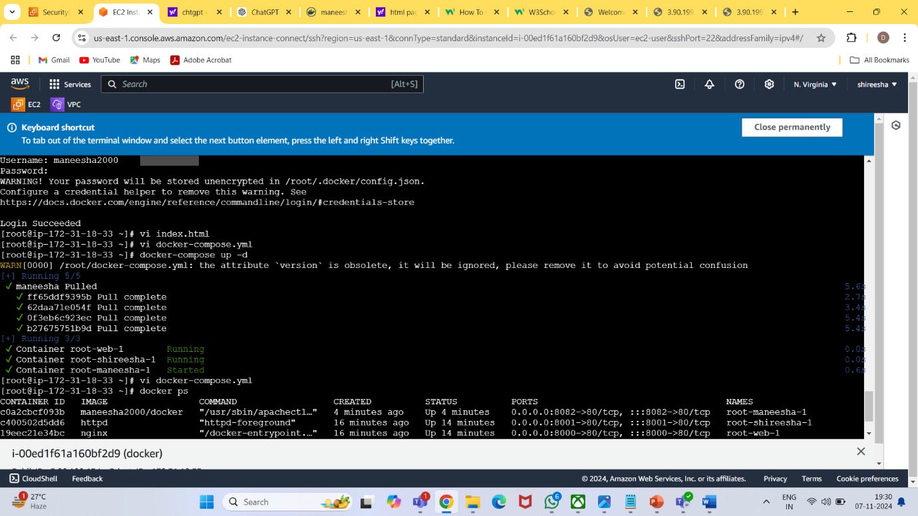

**vi index.html**

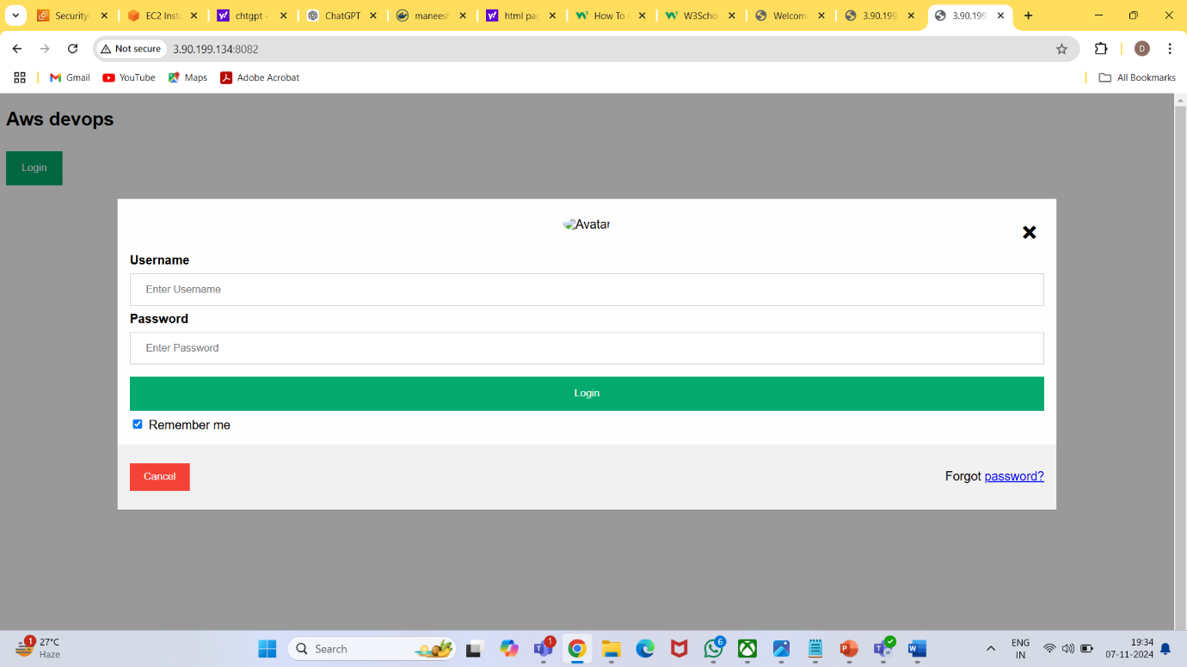

**vi docker-compose.yml**

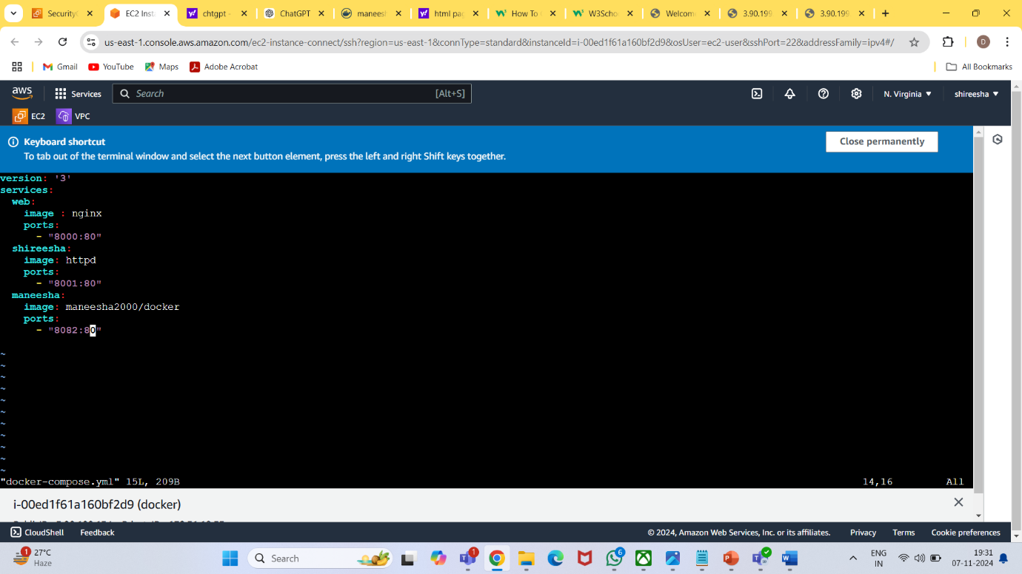

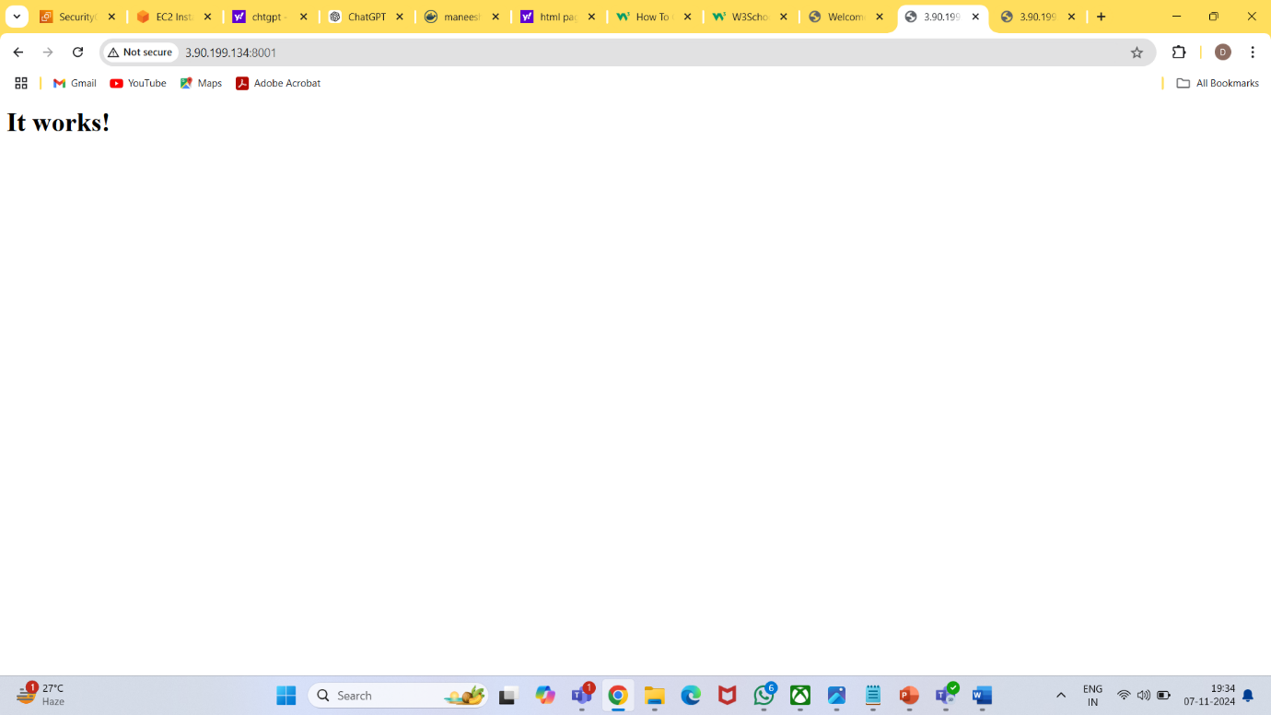

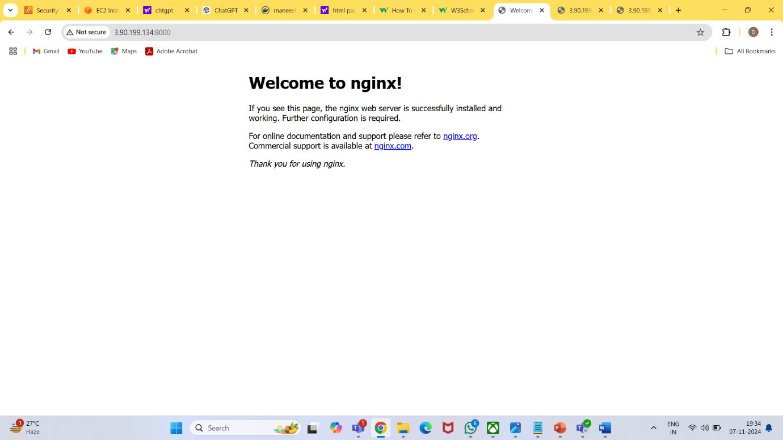

**docker-compose images**

