sudo su –

apt update -y

curl -fsSL https://get.docker.com -o get-docker.sh

sudo sh get-docker.sh

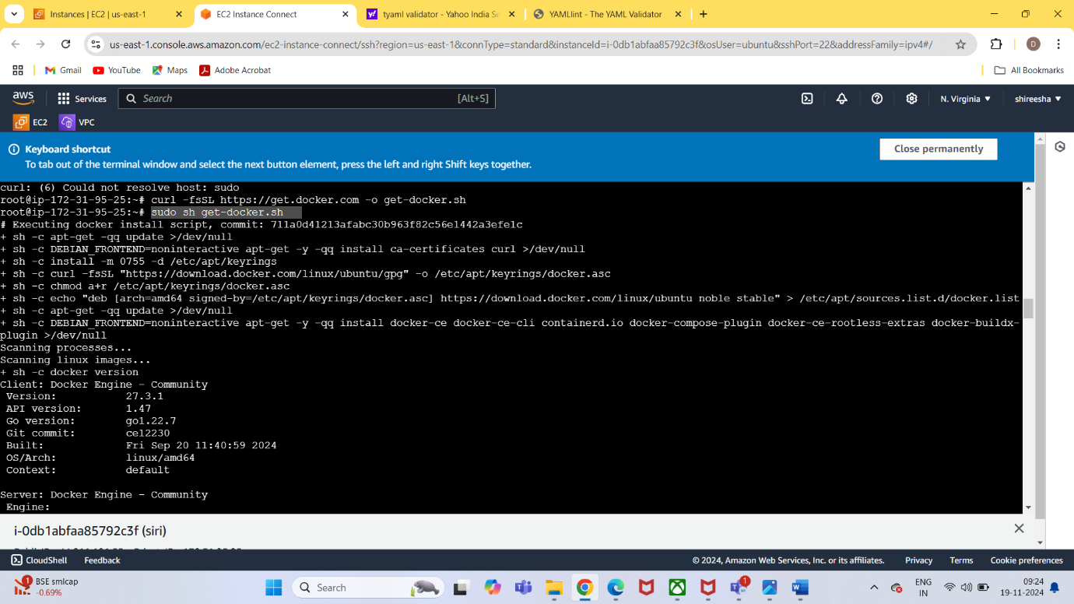

chmod 777 get-docker.sh

./get-docker.sh

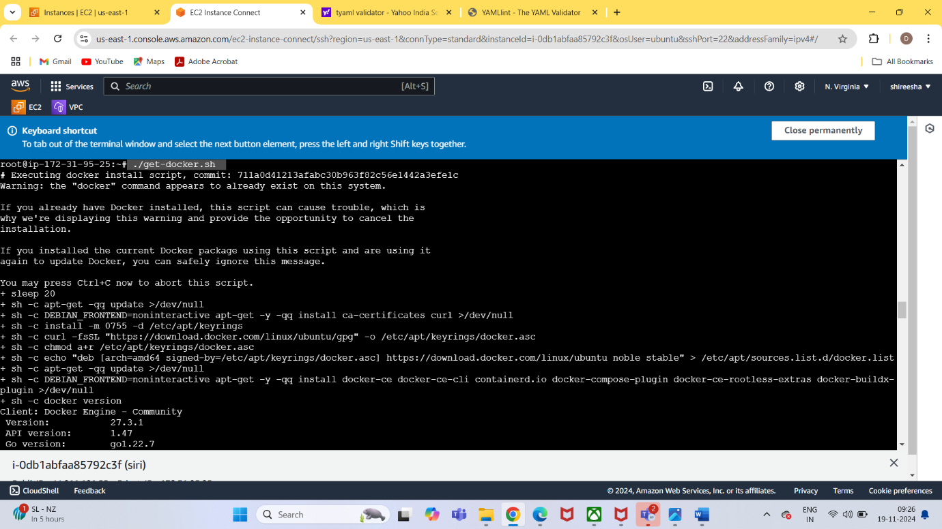

systemctl start docker

systemctl start docker

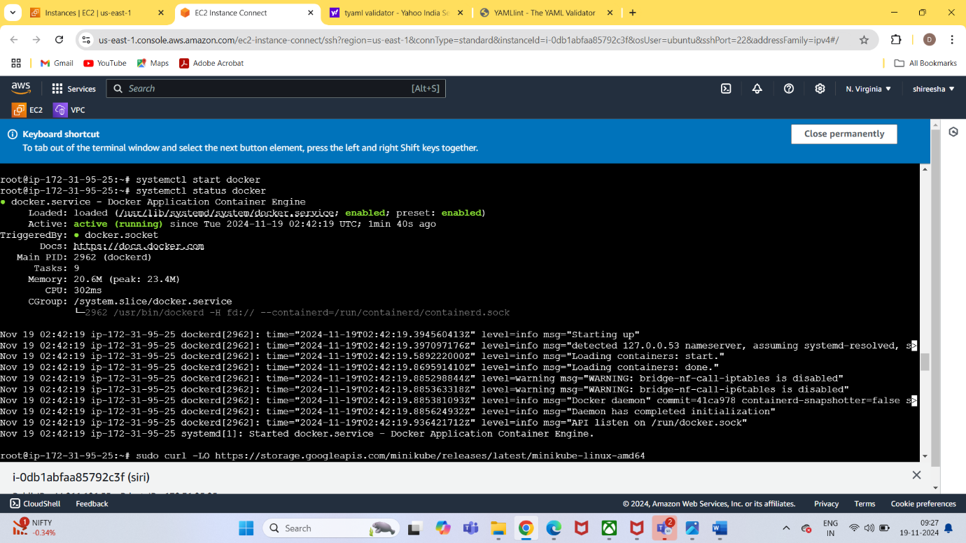

sudo curl -LO <https://storage.googleapis.com/minikube/releases/latest/minikube-linux-amd64>

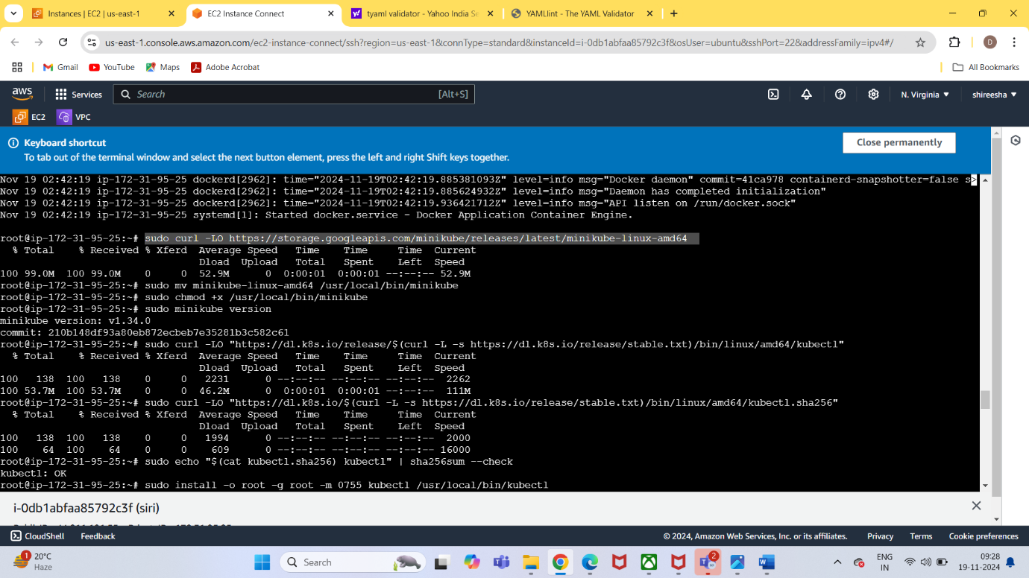

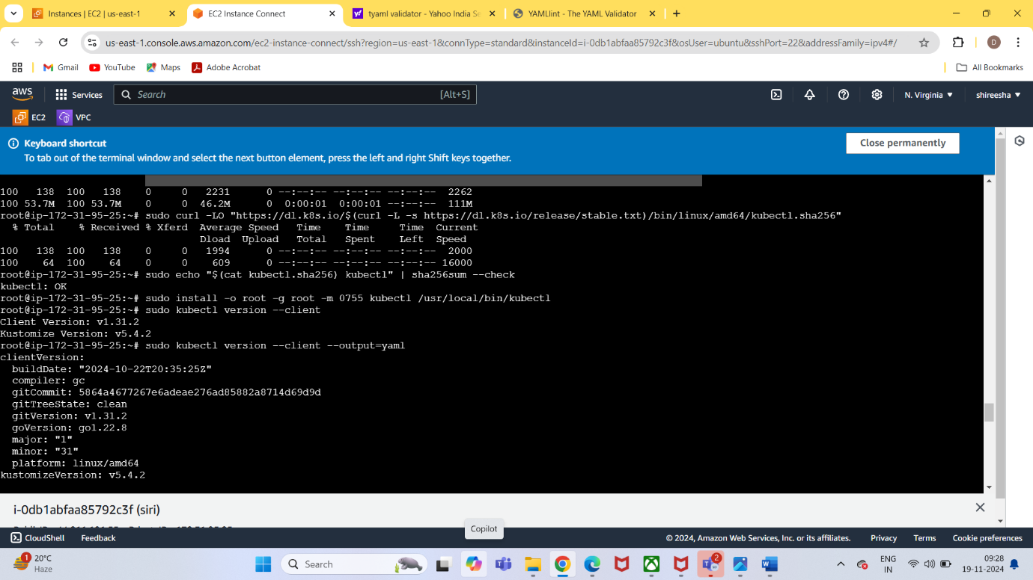

vi multi-container-pod.yaml

