**Access the nginx application using kops**

**Install docker:**

**Snap info docker**

**Docker version**

**apt install docker.io**

**systemctl status docker**

**snap install aws-cli --channel=v1/stable --classic**

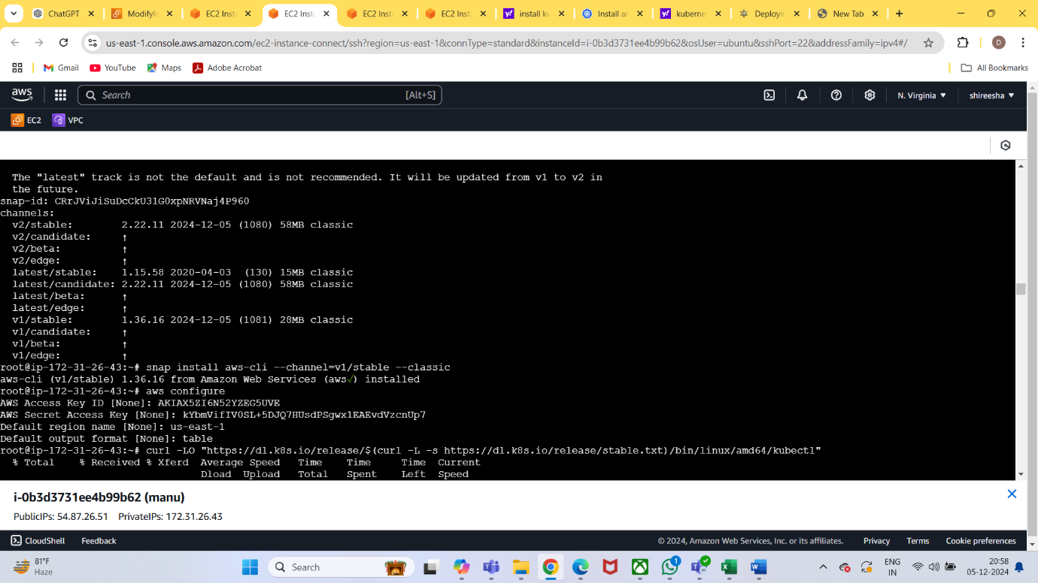

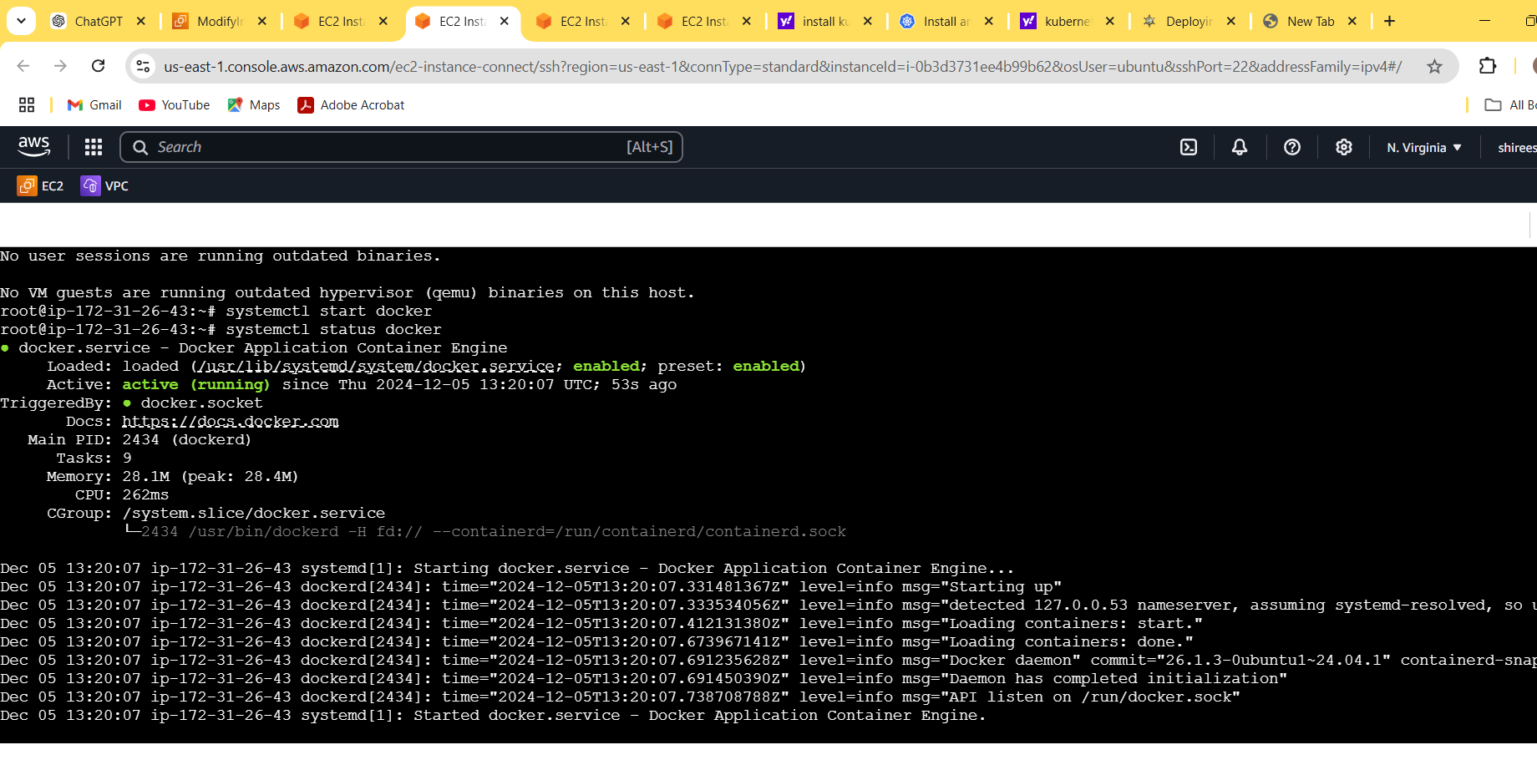

**Install kubectl:**

**curl -LO "https://dl.k8s.io/release/$(curl -L -s https://dl.k8s.io/release/stable.txt)/bin/linux/amd64/kubectl"**

**chmod +x kubectl**

**Install kops:**

**curl -Lo kops https://github.com/kubernetes/kops/releases/download/$(curl -s https://api.github.com/repos/kubernetes/kops/releases/latest | grep tag_name | cut -d '"' -f 4)/kops-linux-amd64**

**chmod +x kops**

**sudo mv kops /usr/local/bin/kops**

Export the path open the file **vi .bashrc**

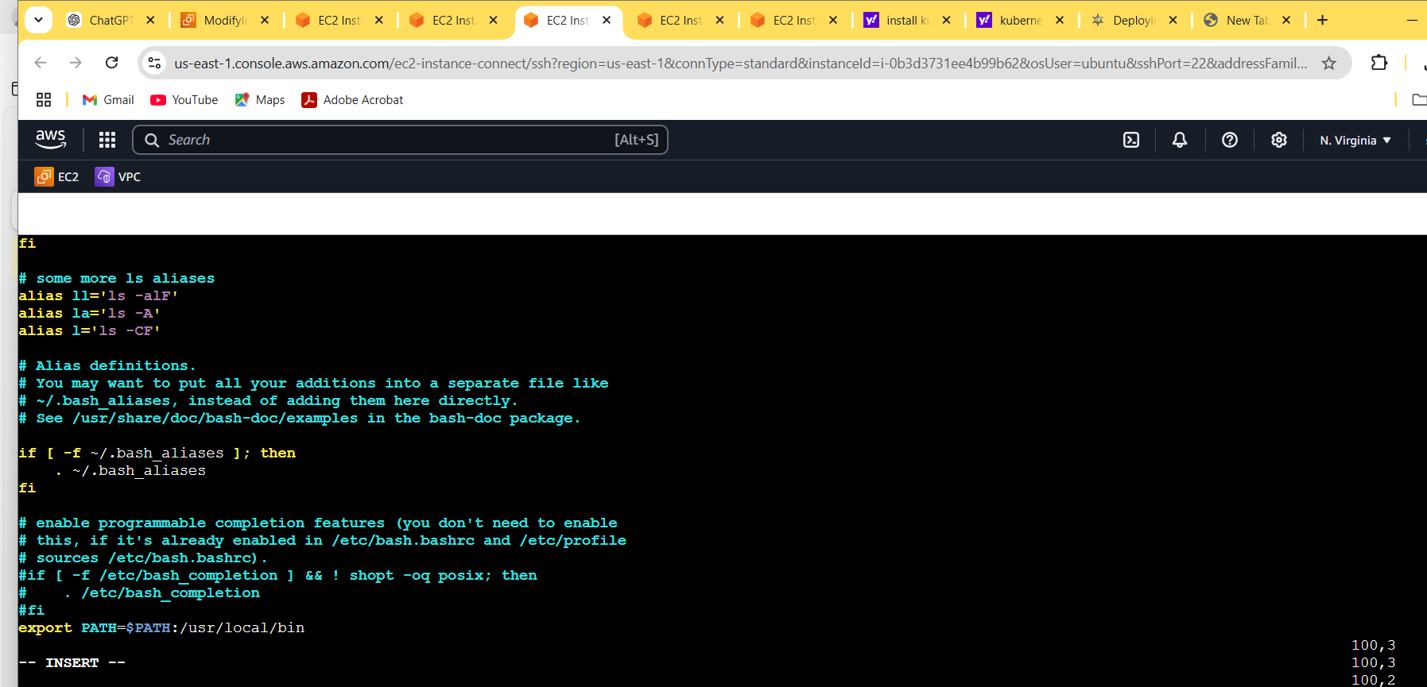

Execute the file **source .bashrc**

Move both files kubectl and kops in usr/local/bin

**mv kops /usr/local/bin/kops**

**mv kubectl /usr/local/bin/kubectl**

Deploy the aws and create the buckets use this command

**aws s3api create-bucket \**

**--bucket sirisha.local \**

**--region us-east-1**

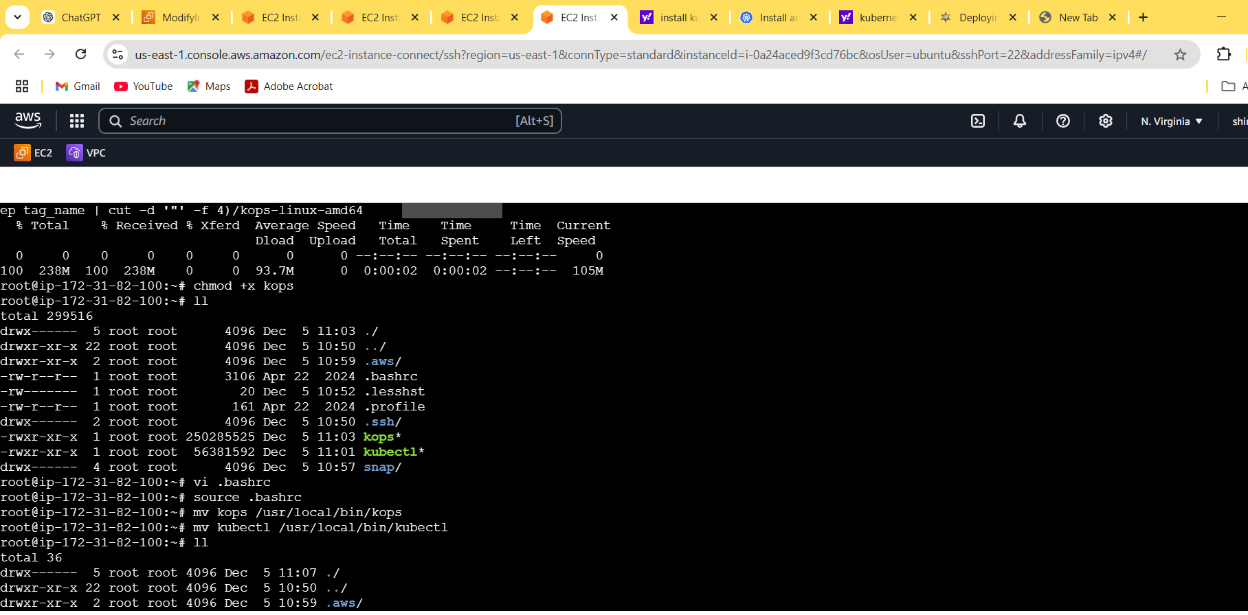

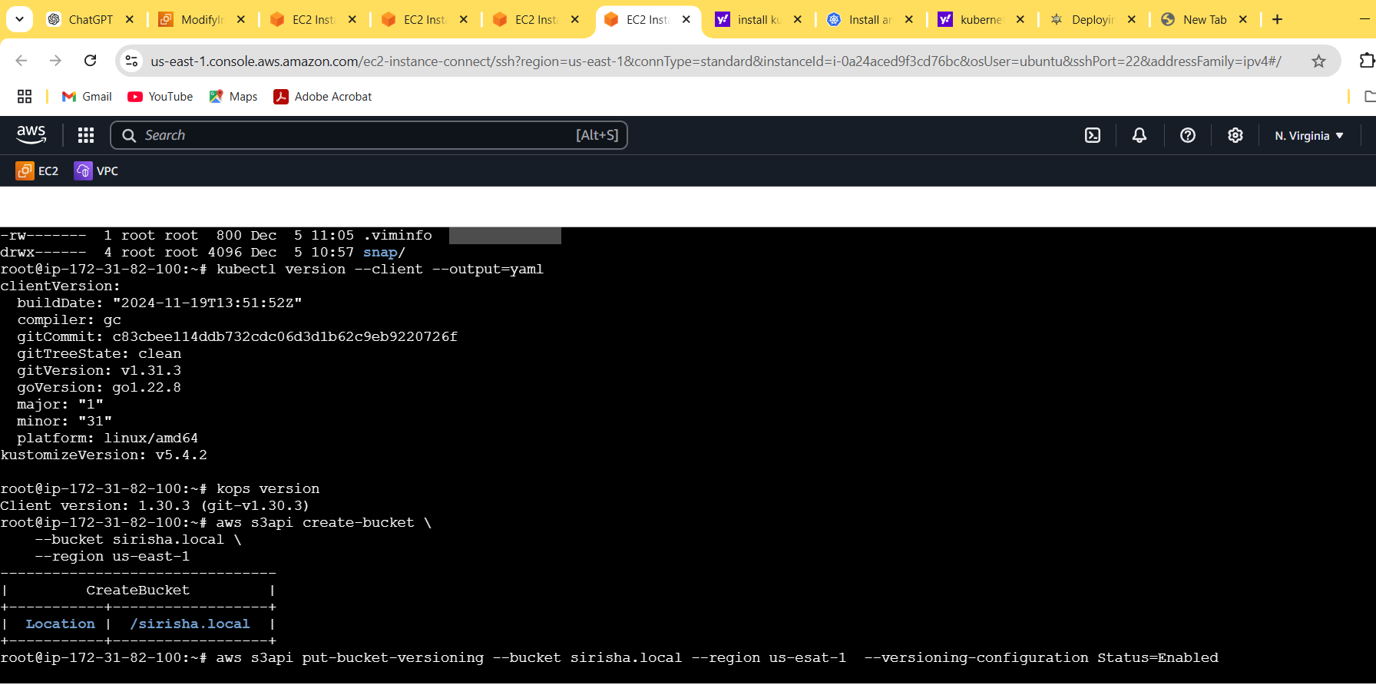

**export KOPS_STATE_STORE=s3://sirisha.local**

**kops create cluster --name kopscluster.k8s.local --zones us-east-1b --state=s3://sirisha.local --master-size t2.medium --node-size t2.micro**

Update the cluster

**kops update cluster --name kopscluster.k8s.local --yes –-admin**

**state=s3://sirisha.local**

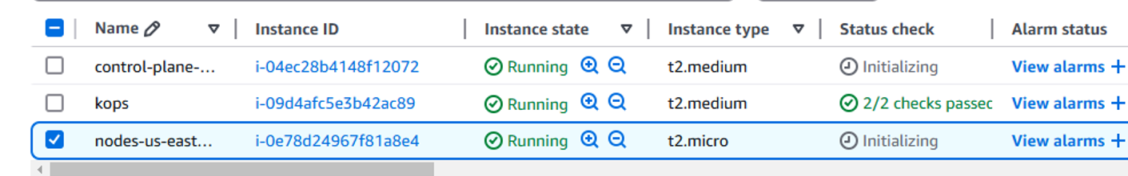

see the cluster list **kops get cluster --state=s3://Sirisha.local**

See the nodes list **kubectl get nodes –show-labels**

Create the pod in yaml **vi pod.ymal**



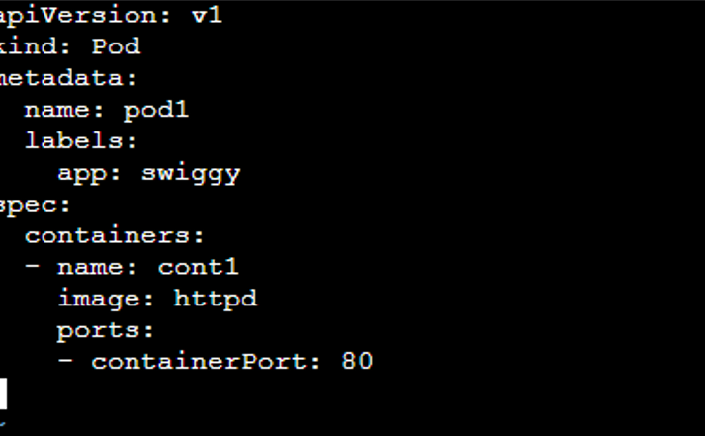

**kubectl apply –f pod.ymal**

Create service  **vi service.ymal**

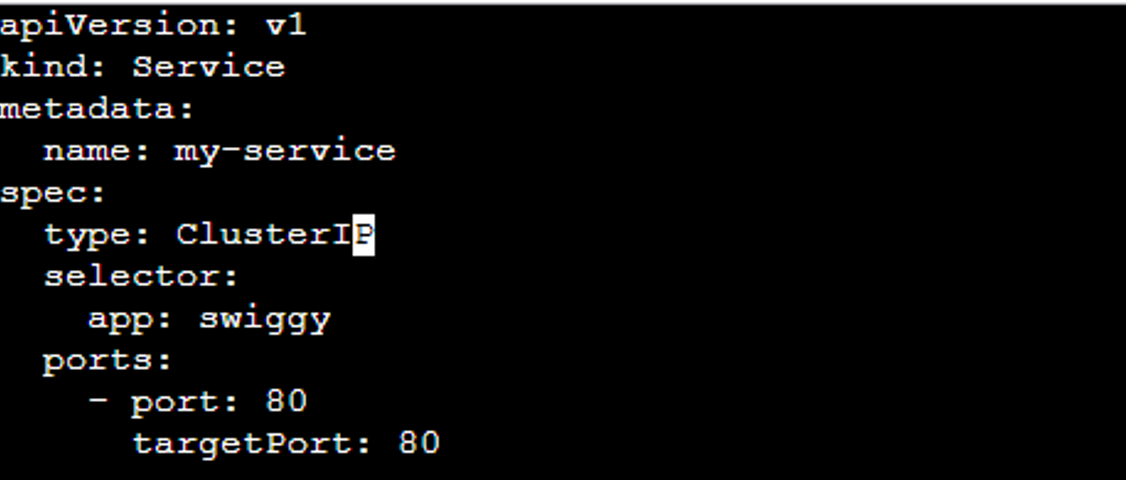

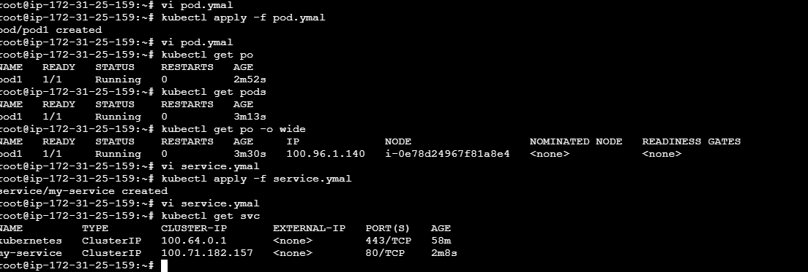

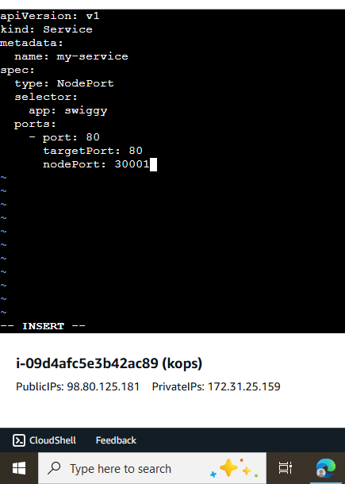

master node public ip and give the port number 30001

