first switch to the root user using **sudo su –.**

 install Docker with **yum install docker -y**

start the Docker service using **systemctl start docker**

change the hostname to “manager” **with hostnamectl hostname manager** and confirm the change with hostname.

 initialize Docker Swarm with **docker swarm init.**

**Docker service create --name ammu –replicas 3 --publish 80:80 httpd**

**Docker ps**

**Docker service create --name maneesha –replicas 3 --publish 81:80 httpd**

**Docker ps**

**Docker service create --name shireesha --replicas 3 --publish 80:80 httpd**

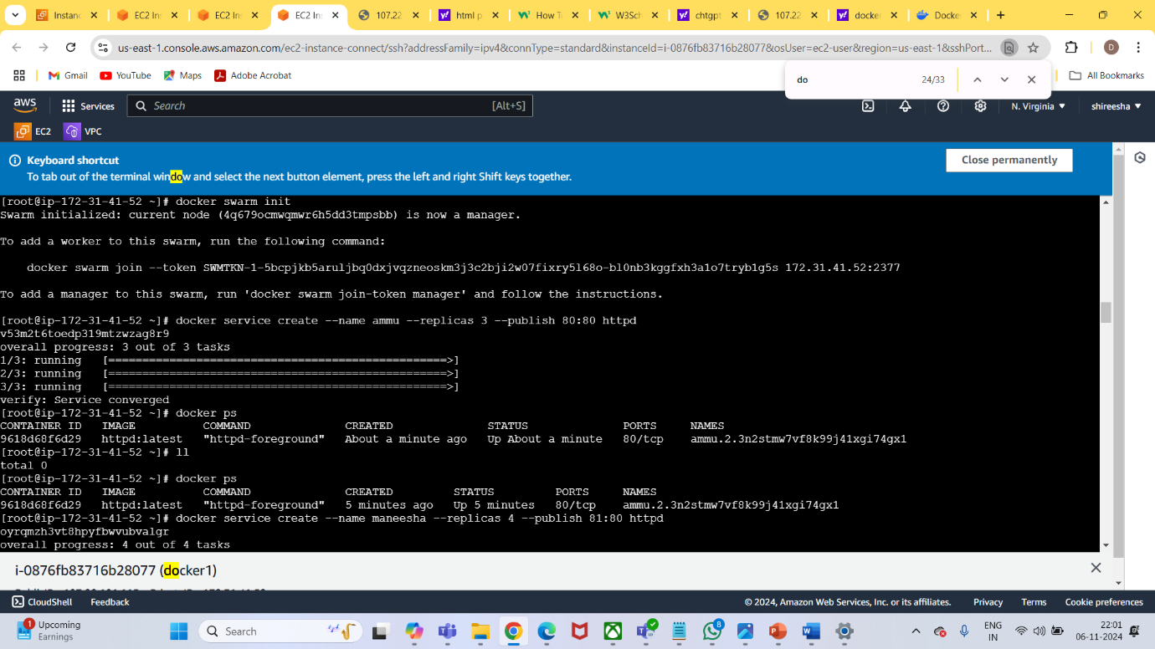

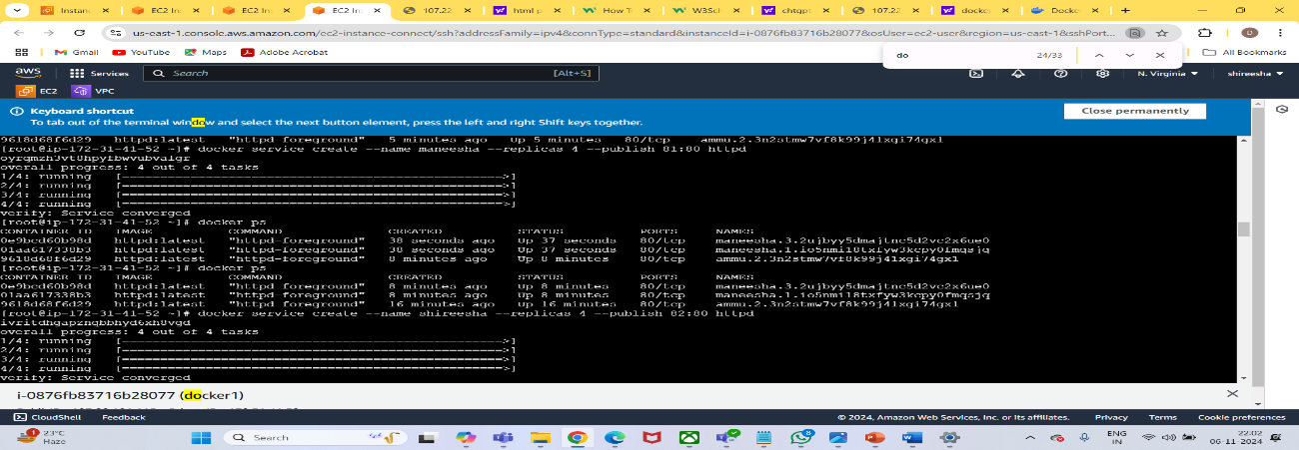

Docker service ls

Vi index.html

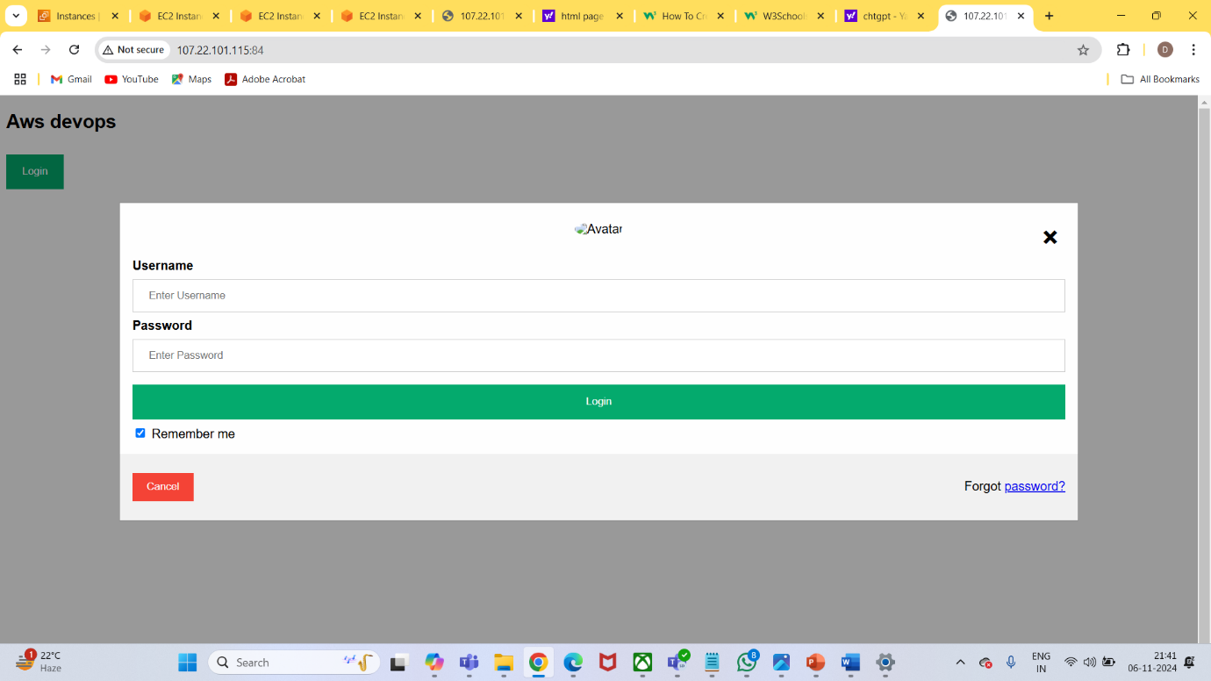

**Vi Dockerfile**

**docker build -t siri .**

**docker service create --name siri --replicas 4 --publish 84:80 siri**

**docker ps**

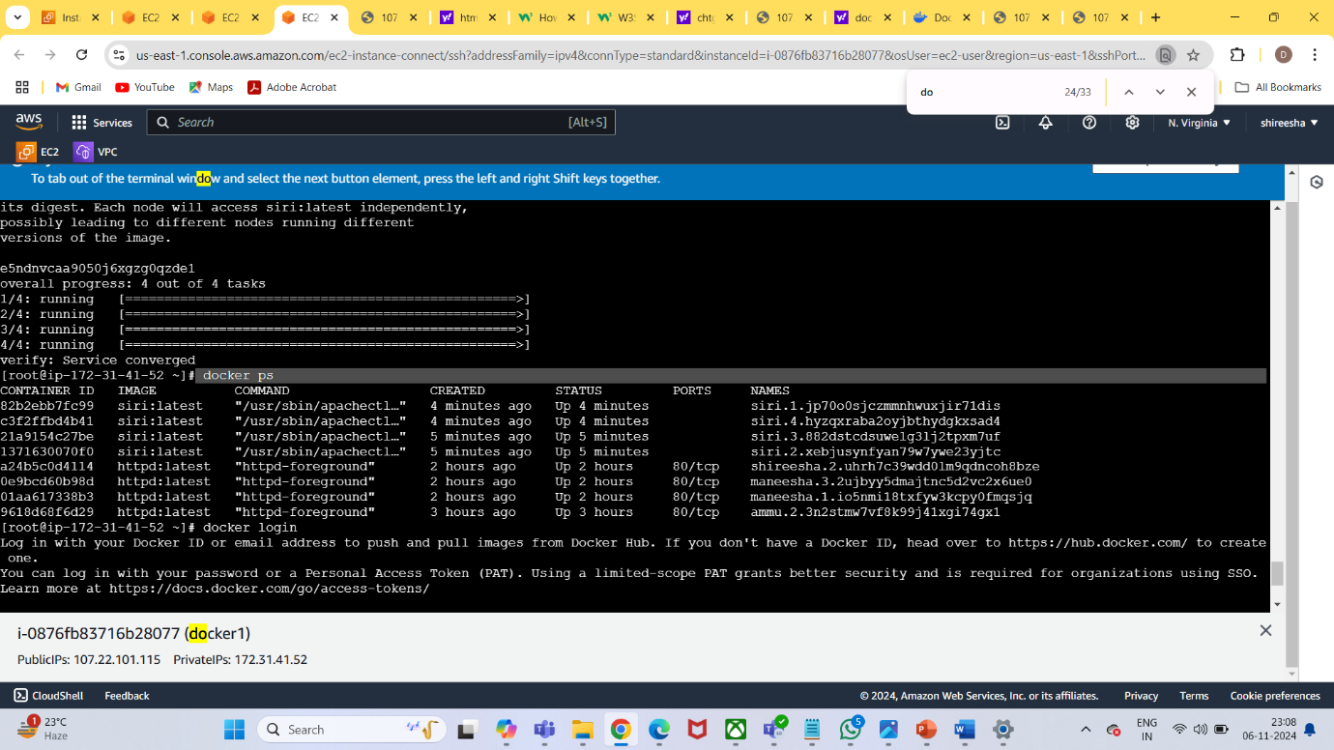

**Docker login**

**Username: password:-----**

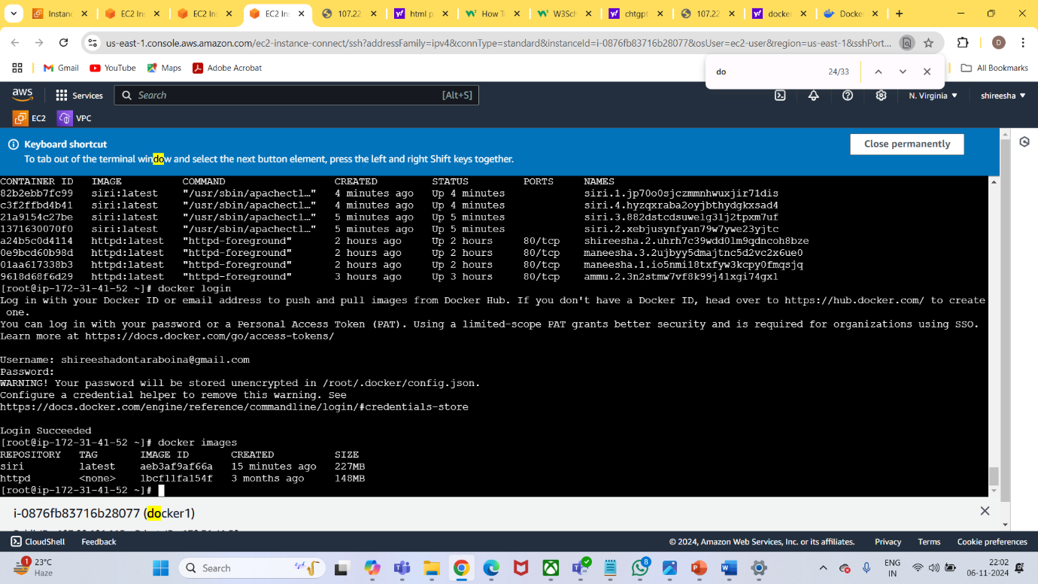

**docker images**

**docker tag siri maneesha2000/docker**

**docker push maneesha2000/docker**

