1. **Sudo su -**
2. Update the linux   **sudo update –y**
3. Next, we will install docker follow the below commands
4. **yum install docker –y**
5. **Systemctl start docker**
6. **Systemctl status docker**
7. **sudo docker run -it ubuntu**
8. **Apt update**
9. **docker network ls**
10. **docker run –it ubuntu**
11. Back to root user **exit**
12. See the container ls **docker ps  ,docker ps –a**
13. Inspect the container     **docker inspect 73c0e1ed6d9d**

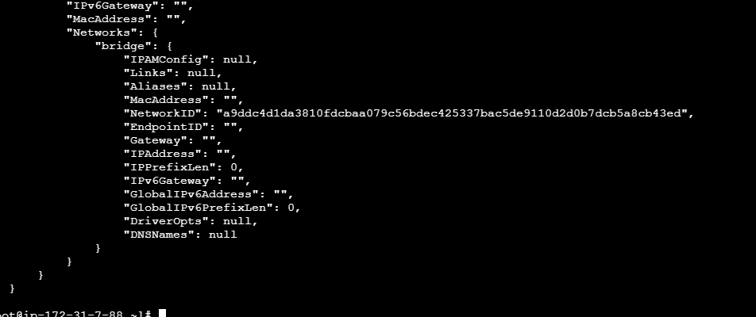

1. Create the network           **docker network create shireesha**
2. Go to check the network it will add or not    **docker network ls**
3. **Docker run –it –-name cont1 –-network shireesha  ubuntu**
4. 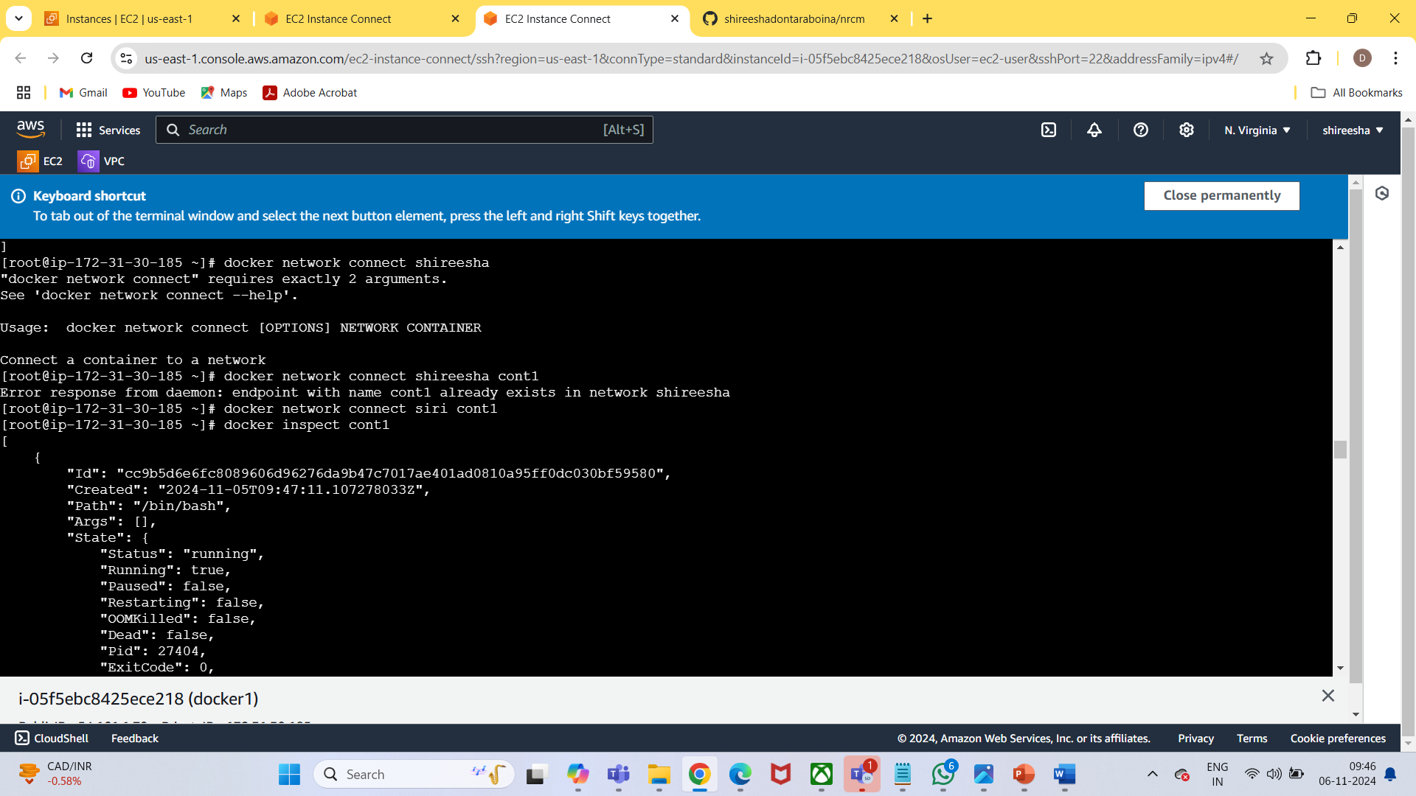
5. Back to root user  use **exit** command
6. Next see the continer list  **docker  ps –a**
7. Inspect the container    **docker inspect cont1**
8. **Docker attach cont1**
9. First update   **apt update –y ,**
10. Next install ping**apt install iputils-ping**
11. See the networking status    **ping goole.com**
12. 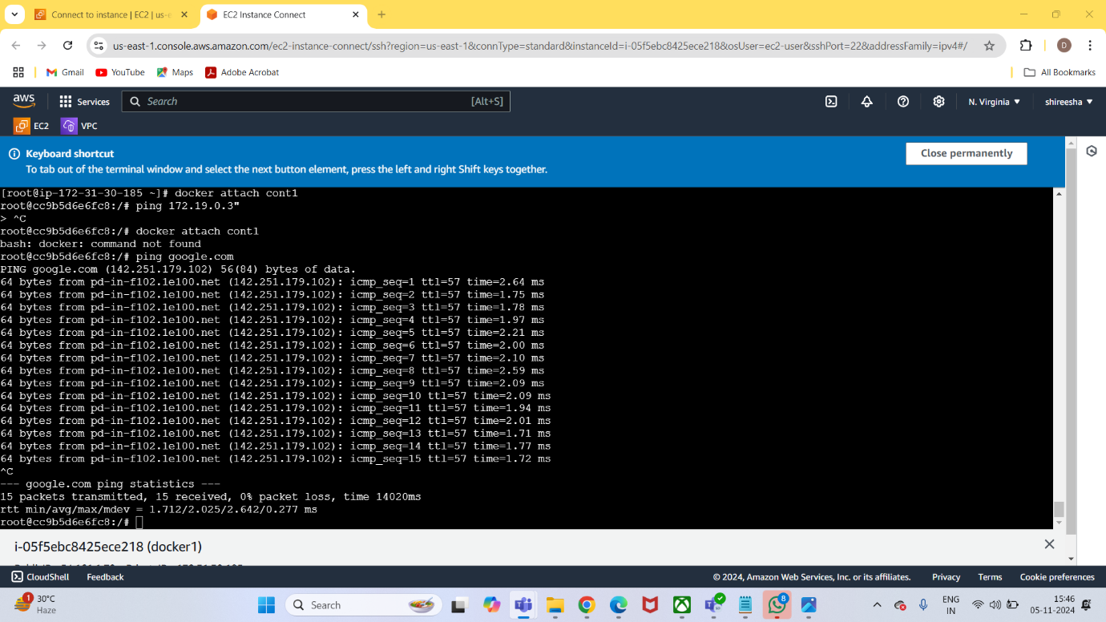
13. Back to root user **Exit,  docker ps –a**
14. Next we will attach the  exsiting    **container  docker attach**
15. First we need to update   **apt update**
16. **apt install iputils-ping**
17. **Ping goole.com,   back to root user exit**
18. **Docker ps –a**
19. **Docker inspect  73c0e1ed6d9d**
20. **Docker attach cont1**
21. ping ip addres cont 1
22. **Exit, docker ps –a**
23. Copy the defalut container
24. **docker network connect devops naughty_chebyshev**
25. **Docker inspect  73c0e1ed6d9d**
26. **Docker attach cont1**
27. 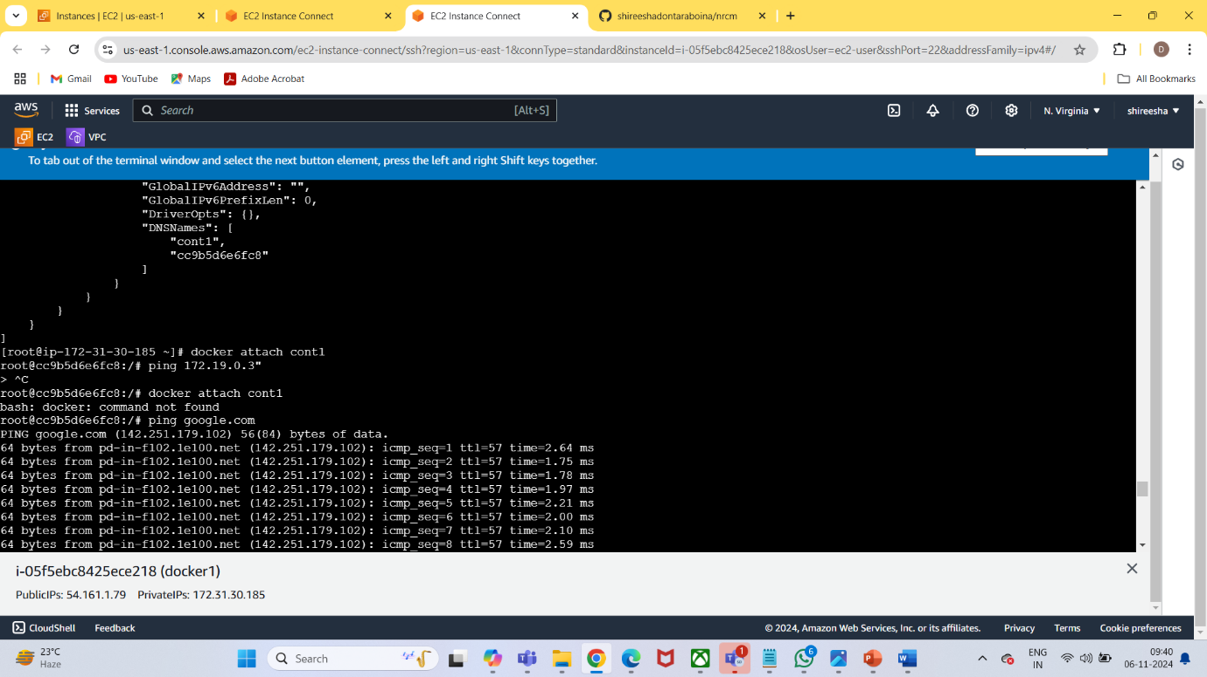
28. **Ping  ip adress**
29. **Exit** back to root user
30. We can remove un used networks      **docker network prune** this will remove all custom network.

initialize swarm   **docker swarm init**

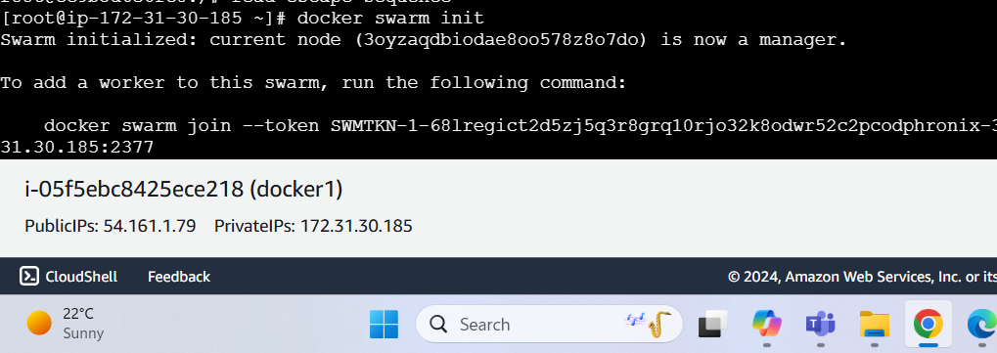

.next we edit inbound rule alltrafic,anywhere

4. next we will launch another worker ec2 instance , edit inbound rule allow alltrafic.

5. **sudo su -**

6.  install docker      **yum install docker –y**

7. **systemctl start docker**

**8. systemctl status docker**

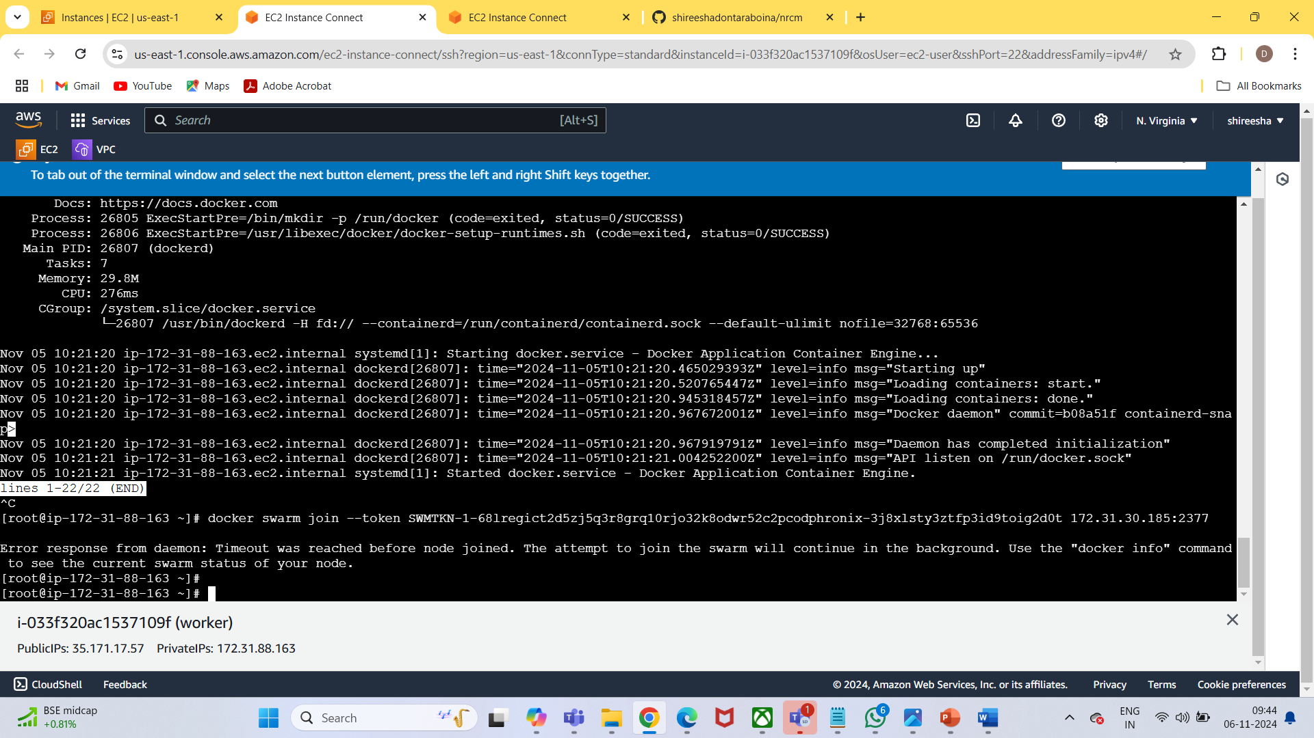

**Docker node ls**

**Docker service create –name janu --publish 8080:80 httpd**

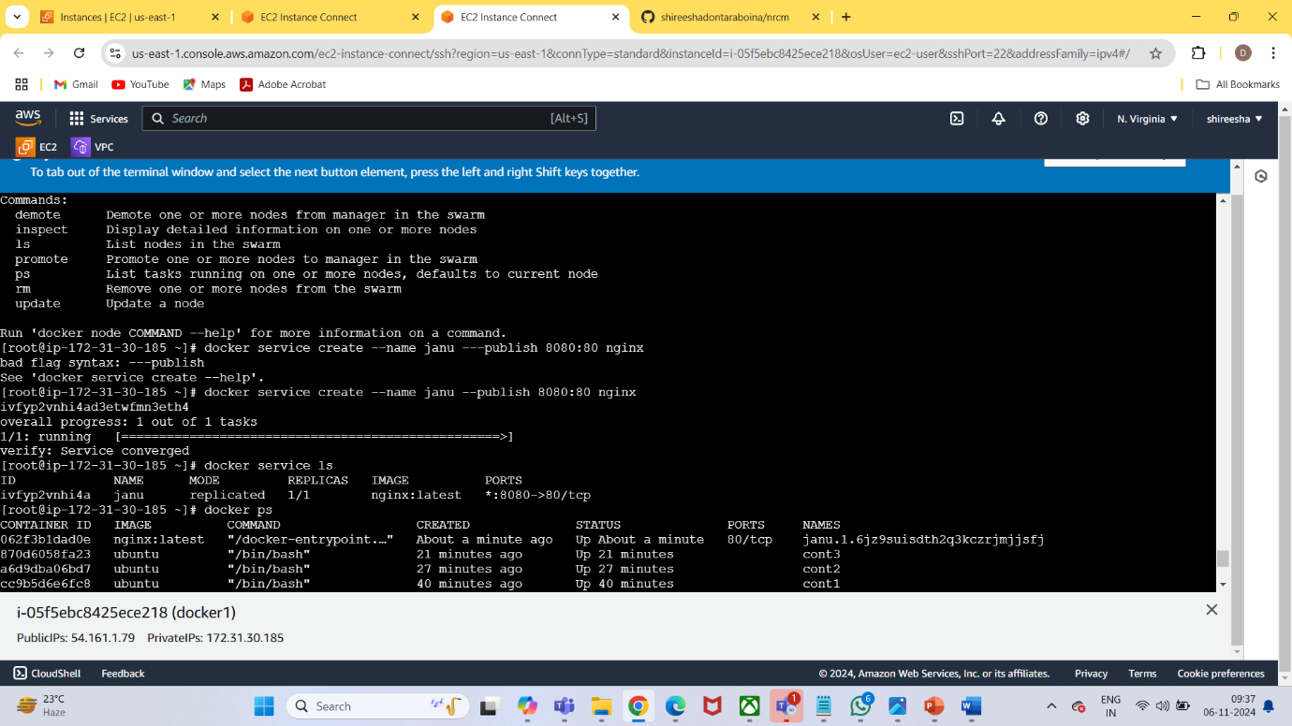

**Docker ps**

13. Create another change only prot and name

**docker service create --name anu --publish 8081:80 httpd**

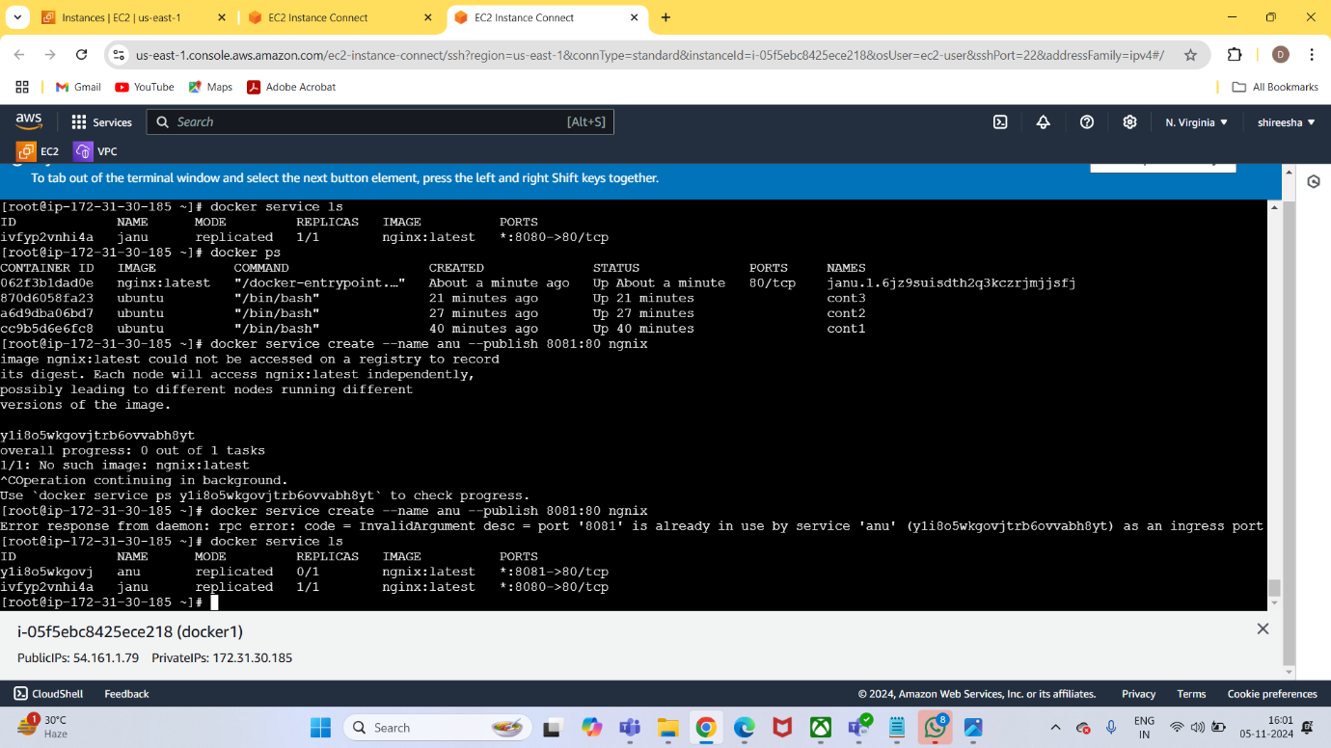

see in worker ec2  service created or not

**docker service ls    (dockerec2)**

. **Docker ps (worker)**

We have only one service in server ec2

 Modifyandupdate

