Image Processing - Exercise 4

Shir Hana Stern, shirste, 325945236

# Introduction

In this project, we undertook the implementation of a stereo mosaicing algorithm. The primary objective was to develop a system capable of stitching together a sequence of overlapping images captured from a moving camera to create a panoramic view.

The core of the algorithm involved several fundamental computer vision concepts. Firstly, feature detection and matching were employed to establish correspondences between key points in consecutive frames. The Scale-Invariant Feature Transform (SIFT) algorithm, renowned for its robustness to scale and rotation changes, was instrumental in this regard. These detected features acted as anchor points, guiding the subsequent steps in the process.

Secondly, the concept of transformation was pivotal. Once corresponding features were identified, a homography matrix was computed to model the geometric transformation between the frames. This matrix encapsulated the translation, rotation, and scaling required to align one image with another. By applying this trasformation to each frame, we were able to warp them into a common coordinate system.

Finally, image stitching was performed to combine the warped images into a seamless panorama. This involved blending the overlapping regions of the images to create a visually coherent output.

In essence, this project involved a systematic process of feature detection, matching, homography estimation, and image warping to achieve the goal of creating panoramic images from video sequences.

# Algorithm

In general, this stereo mosaicing algorithm operates in the following stages:

**Feature Detection and Description:** The Scale-Invariant Feature Transform (SIFT) algorithm is employed to identify distinctive keypoints within each frame of the input video sequence. For each detected keypoint, a unique descriptor is extracted, capturing the local image information.  
**Feature Matching:** Keypoints are matched between consecutive frames using a nearest neighbor search approach. To enhance the accuracy of matching, a ratio test is applied, which retains only those matches where the distance to the best match is significantly smaller than the distance to the second-best match.  
**Homography Estimation:** The RANSAC (Random Sample Consensus) algorithm is utilized to estimate the homography matrix that relates the corresponding keypoints between two frames. RANSAC is robust to outliers and effectively handles potential mismatches, ensuring a reliable estimation of the geometric transformation between frames.  
**Image Warping:** Each frame is then warped using the computed homography matrix. This involves transforming the coordinates of each pixel in the current frame to its corresponding location in the reference frame. To seamlessly integrate the warped frames, techniques such as linear blending or pyramid blending can be employed to minimize artifacts in the final panorama.  
**Panorama Generation:** The warped frames are accumulated into a final panoramic image. This process is repeated for each pair of consecutive frames in the video sequence, resulting in a series of overlapping panoramas. These individual panoramas are then stitched together to create a dynamic panoramic video.

For changing viewpoint mosaic, the algorithm explores different viewpoints within each frame to create multiple panoramas.By shifting the "center" of focus within each frame and stitching together the corresponding warped strips, the algorithm effectively generates a series of panoramic images with varying perspectives. This allows the user to explore different sections of the overall scene captured in the video.

For dynamic mosaic, the algorithm segment refines the panorama generation process by intelligently selecting and combining portions of the warped frames. It iterates through the width of the canvas, effectively dividing it into vertical strips. For each strip, it analyzes the warped frames, identifying regions with a significant number of non-zero pixels, indicating the presence of meaningful visual information. By establishing a threshold for the number of non-zero pixels, the algorithm filters out frames that do not contribute substantially to the overall panorama. This selective approach helps to reduce noise, minimize artifacts, and enhance the visual clarity of the final panorama by ensuring that only the most informative portions of the warped frames are integrated into the output.  
Essentially, this mechanism creates multiple "columns" within the panorama. Each column represents a slightly different viewpoint within the scene, as it focuses on a specific vertical region of each frame. This multi-column approach allows for a more comprehensive and nuanced representation of the captured scene.

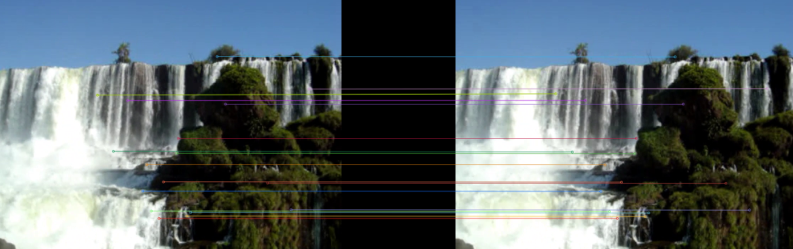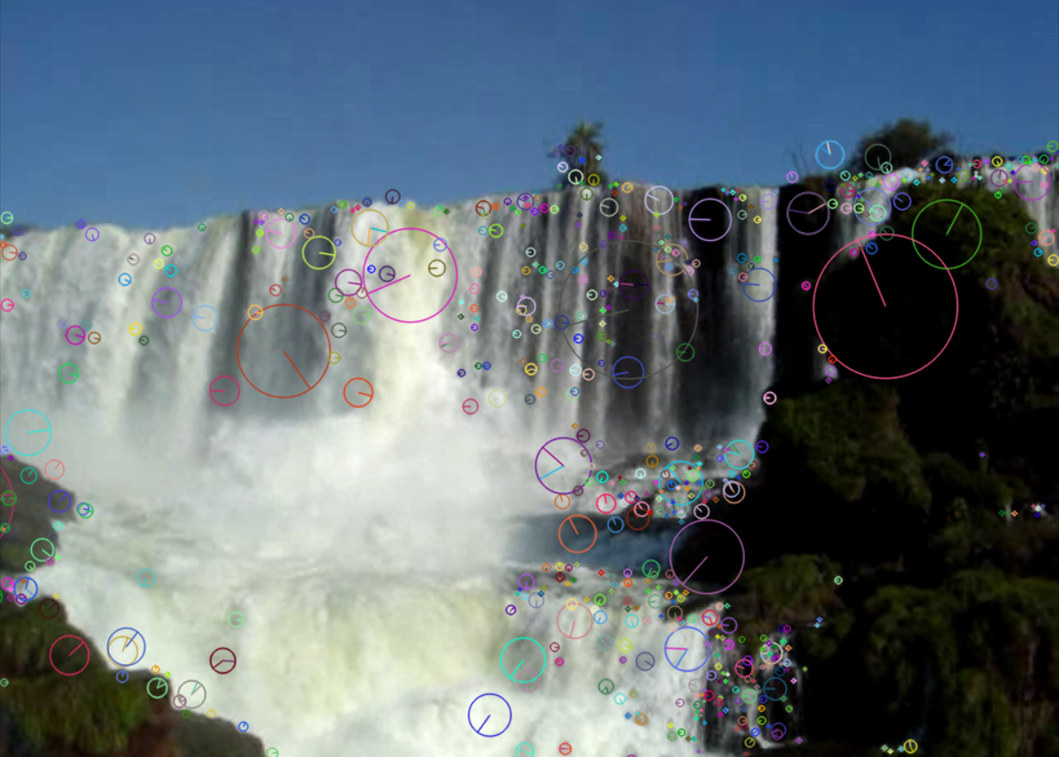**Feature Detection and Description Feature Matching**

**Feature Detection and Description:** Input: A single video frame. Output: Keypoints (locations with size and orientation) and feature descriptors (local structural data). Visualize by overlaying circles and arrows on the frame to indicate keypoints and their orientations.  
**Feature Matching:** Input: Keypoints and descriptors from two consecutive frames. Output: Matches indicating corresponding points between the frames. Visualize by displaying the frames side by side with lines connecting matched keypoints.  
**Homography Estimation:** Input: Matched keypoints. Output: A transformation matrix for aligning frames and a set of consistent matches. Visualize by showing consistent points on one frame and their mapping onto the other, using different colors for valid and invalid matches.  
**Image Warping:** Input: A frame and a transformation matrix. Output: The warped frame aligned with a reference frame. Visualize by displaying the original and warped frames side by side.  
**Panorama Generation:** Input: Warped frames and blending settings. Output: A panoramic image. Visualize intermediate panoramas as they build, highlighting frame overlaps and blending.  
**Changing Viewpoint Mosaic:** Input: Warped frames and focus regions (vertical strips). Output: Multiple panoramas with varying perspectives. Visualize by displaying panoramas side by side, marking the regions of focus.  
**Dynamic Mosaic:** Input: Warped frames and a threshold for meaningful areas. Output: A refined panorama including only the most informative parts. Visualize by overlaying heatmaps on the final mosaic to highlight selected areas and showing examples of excluded regions.

Vestibulum ut metus non mauris pretium eleifend. Morbi iaculis maximus erat, sit amet mattis velit consequat sit amet. Suspendisse ac elit eget justo eleifend ornare. Morbi rutrum metus urna, id lobortis ipsum accumsan non. Vivamus ut elementum est, vel ultricies sem. Morbi dignissim efficitur rutrum. Proin cursus erat erat, imperdiet sodales nisi ornare ut. Nullam fringilla urna volutpat odio luctus, at fermentum ipsum aliquet.

Aliquam turpis ante, consectetur ac scelerisque sed, ultrices nec libero. Nulla vel accumsan velit. Aliquam erat volutpat. Integer faucibus id turpis vel viverra. Mauris fringilla eu sapien vel rhoncus. Maecenas ultrices enim nunc, sit amet semper neque dignissim vel. Vivamus finibus, mauris sit amet venenatis rhoncus, nibh turpis semper enim, ut dapibus tortor mi sed erat.

Orci varius natoque penatibus et magnis dis parturient montes, nascetur ridiculus mus. Curabitur tempor scelerisque elit non auctor. Proin massa metus, facilisis lobortis velit a, posuere mollis metus. Nullam laoreet, neque eu condimentum luctus, quam libero tincidunt dolor, nec tincidunt urna tellus quis magna. Cras porta arcu in lacinia aliquam. Aenean urna enim, faucibus eu facilisis sit amet, gravida vitae velit. Integer purus elit, aliquet id hendrerit et, aliquam ut arcu. Ut auctor quam diam, varius rhoncus nibh tristique eu. Quisque sodales eleifend dui sit amet fermentum. Phasellus volutpat ante et commodo pretium. Vestibulum et blandit lectus. Sed orci diam, accumsan ac placerat gravida, bibendum vel felis.

# 

# Implementation Details

Aliquam volutpat libero at pellentesque rutrum. Vivamus sed laoreet nisi. Nulla id nisl facilisis, euismod orci vel, tempor nulla. Cras hendrerit turpis lectus, sit amet ultrices libero tempor tristique. Sed in aliquet justo. Morbi a risus nec est ultrices auctor a et ipsum. In lobortis libero a lacus pharetra blandit. Sed id augue in velit accumsan lobortis. Etiam vitae nunc eu lectus tincidunt faucibus ac sit amet ante. Aliquam efficitur massa ac nulla tempus, eget dictum turpis egestas.

Orci varius natoque penatibus et magnis dis parturient montes, nascetur ridiculus mus. Curabitur tempor scelerisque elit non auctor. Proin massa metus, facilisis lobortis velit a, posuere mollis metus. Nullam laoreet, neque eu condimentum luctus, quam libero tincidunt dolor, nec tincidunt urna tellus quis magna. Cras porta arcu in lacinia aliquam. Aenean urna enim, faucibus eu facilisis sit amet, gravida vitae velit. Integer purus elit, aliquet id hendrerit et, aliquam ut arcu. Ut auctor quam diam, varius rhoncus nibh tristique eu. Quisque sodales eleifend dui sit amet fermentum. Phasellus volutpat ante et commodo pretium. Vestibulum et blandit lectus. Sed orci diam, accumsan ac placerat gravida, bibendum vel felis. Suspendisse eget imperdiet lectus, eu accumsan nulla. Proin vitae risus ut dui vulputate gravida in in nisi. Nulla vitae velit odio. Sed egestas arcu lectus, nec molestie diam hendrerit in.

Orci varius natoque penatibus et magnis dis parturient montes, nascetur ridiculus mus. Curabitur tempor scelerisque elit non auctor. Proin massa metus, facilisis lobortis velit a, posuere mollis metus. Nullam laoreet, neque eu condimentum luctus, quam libero tincidunt dolor, nec tincidunt urna tellus quis magna. Cras porta arcu in lacinia aliquam. Aenean urna enim, faucibus eu facilisis sit amet, gravida vitae velit. Integer purus elit, aliquet id hendrerit et, aliquam ut arcu. Ut auctor quam diam, varius rhoncus nibh tristique eu. Quisque sodales eleifend dui sit amet fermentum. Phasellus volutpat ante et commodo pretium. Vestibulum et blandit lectus. Sed orci diam, accumsan ac placerat gravida, bibendum vel felis. Suspendisse eget imperdiet lectus, eu accumsan nulla. Proin vitae risus ut dui vulputate gravida in in nisi. Nulla vitae velit odio. Sed egestas arcu lectus, nec molestie diam hendrerit in.

Orci varius natoque penatibus et magnis dis parturient montes, nascetur ridiculus mus. Curabitur tempor scelerisque elit non auctor. Proin massa metus, facilisis lobortis velit a, posuere mollis metus. Nullam laoreet, neque eu condimentum luctus, quam libero tincidunt dolor, nec tincidunt urna tellus quis magna. Cras porta arcu in lacinia aliquam. Aenean urna enim, faucibus eu facilisis sit amet, gravida vitae velit. Integer purus elit, aliquet id hendrerit et, aliquam ut arcu. Ut auctor quam diam, varius rhoncus nibh tristique eu. Quisque sodales eleifend dui sit amet fermentum. Phasellus volutpat ante et commodo pretium. Vestibulum et blandit lectus. Sed orci diam, accumsan ac placerat gravida, bibendum vel felis. Suspendisse eget imperdiet lectus, eu accumsan nulla. Proin vitae risus ut dui vulputate gravida in in nisi. Nulla vitae velit odio. Sed egestas arcu lectus, nec molestie diam hendrerit in.

# 

# Visual Results

Aliquam volutpat libero at pellentesque rutrum. Vivamus sed laoreet nisi. Nulla id nisl facilisis, euismod orci vel, tempor nulla. Cras hendrerit turpis lectus, sit amet ultrices



libero tempor tristique. Sed in aliquet justo. Morbi a risus nec est ultrices auctor a et ipsum. In lobortis libero a lacus pharetra blandit. Sed id augue in velit accumsan lobortis. Etiam vitae nunc eu lectus tincidunt faucibus ac sit amet ante. Aliquam efficitur massa ac nulla tempus, eget dictum turpis egestas.

Orci varius natoque penatibus et magnis dis parturient montes, nascetur ridiculus mus. Curabitur tempor scelerisque elit non auctor. Proin massa metus, facilisis lobortis velit a, posuere mollis metus. Nullam laoreet, neque eu condimentum luctus, quam libero tincidunt dolor, nec tincidunt urna tellus quis magna. Cras porta arcu in lacinia aliquam. Aenean urna enim, faucibus eu facilisis sit amet, gravida vitae velit. Integer purus elit, aliquet id hendrerit et, aliquam ut arcu. Ut auctor quam diam, varius rhoncus nibh tristique eu. Quisque sodales eleifend dui sit amet fermentum. Phasellus volutpat ante et commodo pretium.

# 

Aliquam volutpat libero at pellentesque rutrum. Vivamus sed laoreet nisi. Nulla id nisl facilisis, euismod orci vel, tempor nulla. Cras hendrerit turpis lectus, sit amet ultrices libero tempor tristique. Sed in aliquet justo. Morbi a risus nec est ultrices auctor a et ipsum. In lobortis libero a lacus pharetra blandit. Sed id augue in velit accumsan lobortis. Etiam vitae nunc eu lectus tincidunt faucibus ac sit amet ante. Aliquam efficitur massa ac nulla tempus, eget dictum turpis egestas.

Orci varius natoque penatibus et magnis dis parturient montes, nascetur ridiculus mus. Curabitur tempor scelerisque elit non auctor. Proin massa metus, facilisis lobortis velit a, posuere mollis metus. Nullam laoreet, neque eu condimentum luctus, quam libero tincidunt dolor, nec tincidunt urna tellus quis magna. Cras porta arcu in lacinia aliquam.



Aenean urna enim, faucibus eu facilisis sit amet, gravida vitae velit. Integer purus elit,

aliquet id hendrerit et, aliquam ut arcu. Ut auctor quam diam, varius rhoncus nibh tristique eu. Quisque sodales eleifend dui sit amet fermentum. Phasellus volutpat ante et commodo pretium.

Aliquam volutpat libero at pellentesque rutrum. Vivamus sed laoreet nisi. Nulla id nisl facilisis, euismod orci vel, tempor nulla. Cras hendrerit turpis lectus, sit amet ultrices libero tempor tristique. Sed in aliquet justo. Morbi a risus nec est ultrices auctor a et ipsum. In lobortis libero a lacus pharetra blandit. Sed id augue in velit accumsan lobortis. Etiam vitae nunc eu lectus tincidunt faucibus ac sit amet ante. Aliquam efficitur massa ac nulla tempus, eget dictum turpis egestas.

Orci varius natoque penatibus et magnis dis parturient montes, nascetur ridiculus mus. Curabitur tempor scelerisque elit non auctor. Proin massa metus, facilisis lobortis velit a, posuere mollis metus. Nullam laoreet, neque eu condimentum luctus, quam libero tincidunt dolor, nec tincidunt urna tellus quis magna. Cras porta arcu in lacinia aliquam.



Aenean urna enim, faucibus eu facilisis sit amet, gravida vitae velit. Integer purus elit,

aliquet id hendrerit et, aliquam ut arcu. Ut auctor quam diam, varius rhoncus nibh tristique eu. Quisque sodales eleifend dui sit amet fermentum. Phasellus volutpat ante et commodo pretium.

# Conclusion

Aliquam volutpat libero at pellentesque rutrum. Vivamus sed laoreet nisi. Nulla id nisl facilisis, euismod orci vel, tempor nulla. Cras hendrerit turpis lectus, sit amet ultrices libero tempor tristique. Sed in aliquet justo. Morbi a risus nec est ultrices auctor a et ipsum. In lobortis libero a lacus pharetra blandit. Sed id augue in velit accumsan lobortis. Etiam vitae nunc eu lectus tincidunt faucibus ac sit amet ante. Aliquam efficitur massa ac nulla tempus, eget dictum turpis egestas.