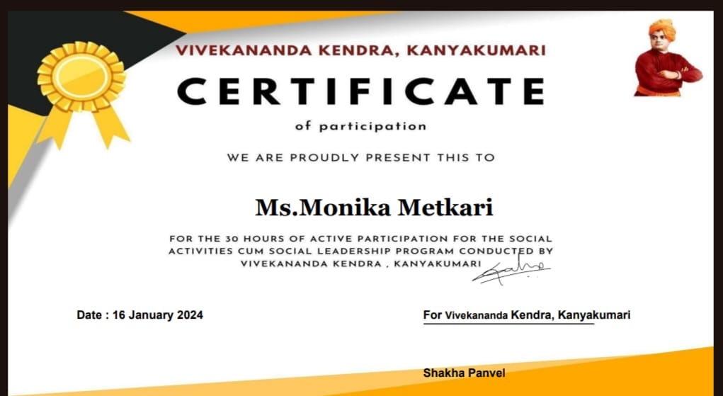
Ms. Shristi Choudhary

