STUDENT LIFESTYLE,
MENTAL HEALTH, AND STRESS
  - A publication-ready statistical analysis of 100,000 student records
DESCRIPTIVE STATISTICS • T-TEST • PEARSON CORRELATION • MULTIPLE LINEAR REGRESSION
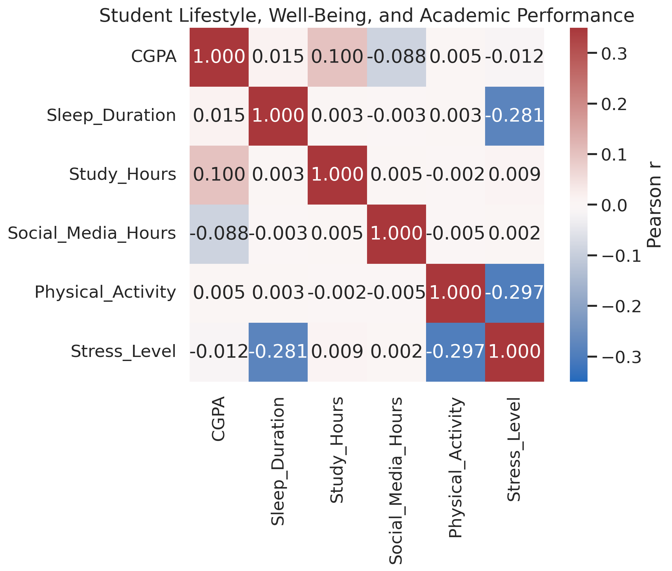
Final hybrid report
Integrating the original SPSS-centered research framework with effect-size interpretation, practical implications, and portfolio-quality visual communication.
Prepared: October 5, 2026

Executive Summary
- The analysis preserves the original research problem and four-stage workflow: descriptive statistics, mean comparison, Pearson correlation, and multiple linear regression, with stress as the principal modeled outcome.
- Sleep duration and physical activity showed the clearest associations with stress. Both correlations were negative (r = −.281 and r = −.297, respectively), and both retained nearly identical standardized effects in the adjusted model (β = −.280 and β = −.296).
- The regression model was statistically significant, F(4, 99,995) = 4,999.786, p < .001, but explained 16.7% of stress variation (R² = .167). Thus, the model identifies meaningful population-level patterns while leaving most individual variation unexplained.
- Gender did not meaningfully differentiate stress. Female and male means were both 4.13; t(99,998) = −0.365, p = .715, with an estimated Cohen’s d of approximately −0.002—effectively zero.
- Study hours had a statistically detectable but practically negligible association with stress (r = .009; β = .009). Social-media hours were unrelated to stress in both bivariate and adjusted analyses (r = .002; β = .000).
- Because N = 100,000, very small effects can generate low p-values. Interpretation therefore prioritizes effect magnitude, explained variance, and decision relevance over statistical significance alone.
- All results are observational and cross-sectional. They support association and prediction, not causal claims about the effects of sleep, exercise, study, or social-media behavior.
Decision-oriented takeaway
Sleep and physical activity are the most credible lifestyle markers of lower stress in this dataset. They are useful targets for population-level wellness programming, but the modest R² and nonexperimental design rule out deterministic or causal conclusions.

Table of Contents
Executive Summary 2
Table of Contents 2
1. Research Problem and Core Research Question 3
1.1 Research Questions 3
2. Analytical Framework and Methodology 3
2.1 Interpretive Standards 3
3. Data Overview and Measurement Context 4
4. Descriptive Statistics 4
5. Independent-Samples T-Test: Stress Level by Gender 4
6. Bivariate Correlation Analysis (Pearson) 5
7. Multiple Linear Regression Predicting Stress Level 6
8. Integrated Findings by Research Question 7
9. Professional Interpretation and Recommendations 7
10. Limitations and Ethical Caveats 7
11. Conclusion 8
Appendix A. Full Correlation Matrix 8
Appendix B. Reporting Notes 8

1. Research Problem and Core Research Question
Core research question. “To what extent do students’ digital and academic lifestyles—including sleep duration, study hours, and social media usage—affect their mental health (stress levels and depression), and do demographic differences such as gender moderate these patterns?”
Analytical emphasis. The available SPSS outputs primarily support prediction and explanation of stress level. Depression remains part of the broader mental-health framing, but no new unrequested outcome model is introduced. Gender is examined through the original mean-comparison analysis; a formal interaction term was not reported and therefore moderation is not claimed.

1.1 Research Questions
- What are the distributions, central tendencies, and variability of the principal demographic, academic, lifestyle, and mental-health variables?
- Do mean stress levels differ between female and male students?
- What are the direction and strength of the linear relationships between sleep duration, study hours, social-media usage, physical activity, and stress?
- To what extent do sleep duration, study hours, social-media usage, and physical activity jointly predict student stress levels?

2. Analytical Framework and Methodology
To address the core research question, the original structured four-stage statistical workflow was retained:
Stage | Method | Purpose
1 | Descriptive Statistics | Establish baseline distributions, central tendencies, and variability for continuous and categorical variables.
2 | Mean Comparison Tests (Independent Samples T-Test & ANOVA) | Evaluate whether statistically and practically meaningful differences exist across demographic subgroups regarding stress, sleep, and lifestyle metrics. The reported inferential output available for the focal stress analysis is the independent-samples t-test by gender.
3 | Bivariate Correlation Analysis (Pearson Correlation) | Map the direction and strength of linear relationships between daily lifestyle habits and psychological well-being.
4 | Multiple Linear Regression | Estimate the unique predictive association of sleep, study, social-media use, and physical activity with stress while holding the remaining predictors constant.

2.1 Interpretive Standards
- P-values are reported as evidence against a null hypothesis, not as measures of importance.
- Effect sizes are emphasized: Pearson’s r for bivariate association, Cohen’s d for the gender comparison, standardized β coefficients for relative adjusted effects, and R² for model explanatory power.
- Given N = 100,000, even near-zero effects may become statistically significant. Practical interpretation therefore distinguishes statistical detectability from substantive magnitude.
- The data are observational and cross-sectional. Regression coefficients are predictive associations and must not be interpreted as causal effects.
- Pearson correlation and ordinary least squares regression assume linear relationships; the t-test assumes independent groups. Regression also assumes independent errors, approximately constant residual variance, and adequate model specification.
Large-sample caution
A small p-value may reflect sample size rather than a useful effect. For example, study hours correlated only r = .009 with stress—less than one-tenth of one percent shared variance—despite p = .006.

3. Data Overview and Measurement Context
The analysis contains 100,000 student records. The exploratory report indicates complete records, no duplicate Student_ID values, and 11 variables. Student_ID functions solely as an identifier and is excluded from inferential analysis.
Measurement note. No formal data dictionary was supplied. Sleep duration, study hours, and social-media usage are interpreted as hours; physical activity as minutes; CGPA as a 1.56–4.00 scale; and stress level as a numeric score. These interpretations should be confirmed with the data owner before publication or policy use.
Categorical variable | Distribution
Gender | Male: 50,120; Female: 49,880
Department | Science: 20,071; Engineering: 20,057; Arts: 19,998; Medical: 19,964; Business: 19,910
Depression | False: 89,938 (89.9%); True: 10,062 (10.1%)

4. Descriptive Statistics
Variable | N | Mean | SD | Min | Median | Max
Age (years) | 100,000 | 21.009 | 2.000 | 18.00 | 21.00 | 24.00
CGPA | 100,000 | 2.898 | 0.532 | 1.56 | 2.90 | 4.00
Sleep duration | 100,000 | 6.996 | 1.499 | 3.00 | 7.00 | 12.00
Study hours | 100,000 | 4.510 | 1.976 | 0.00 | 4.50 | 12.80
Social-media hours | 100,000 | 3.503 | 1.487 | 0.00 | 3.50 | 10.00
Physical activity | 100,000 | 74.353 | 43.367 | 0.00 | 74.00 | 149.00
Stress level | 100,000 | 4.132 | 1.424 | 2.00 | 4.00 | 10.00

The typical student was approximately 21 years old, slept 7.0 hours, studied 4.5 hours, used social media for 3.5 hours, completed about 74 minutes of physical activity, and reported a stress score of 4.13. Broad ranges—especially for study, social media, physical activity, and stress—indicate substantial behavioral heterogeneity. The large sample yields highly precise mean estimates, but precision should not be confused with practical importance.

5. Independent-Samples T-Test: Stress Level by Gender
An independent-samples t-test evaluated whether mean stress differed between female and male students. Female students had a mean stress level of 4.13 (SD = 1.427), and male students also had a mean of 4.13 (SD = 1.422). Levene’s test was nonsignificant, F = 1.527, p = .217, supporting the equal-variance result. The mean difference was not statistically significant, t(99,998) = −0.365, p = .715.
Comparison | Female M (SD) | Male M (SD) | t | df | p | Estimated d
Stress level | 4.13 (1.427) | 4.13 (1.422) | −0.365 | 99,998 | .715 | ≈ −0.002

Effect-size interpretation. Using the test statistic and group sizes, Cohen’s d is approximately −0.002. This is effectively zero and confirms that the nonsignificant result is not masking a meaningful gender difference. In this sample, gender does not provide a useful basis for differentiating average stress.
Scope note. This t-test assesses a mean difference, not statistical moderation. A formal moderation claim would require interaction terms (for example, Gender × Sleep Duration) in a regression model; such terms were not included in the supplied SPSS model.

6. Bivariate Correlation Analysis (Pearson)
Pearson product–moment correlations were computed to assess linear relationships between lifestyle variables and stress (N = 100,000).
Variable vs. stress | r | p | r² | Interpretation
Sleep duration | −.281 | < .001 | 7.9% | Small-to-moderate negative association; longer sleep corresponds to lower stress.
Study hours | .009 | .006 | < 0.1% | Statistically detectable but practically negligible positive association.
Social-media hours | .002 | .539 | < 0.1% | No statistically or practically meaningful linear association.
Physical activity | −.297 | < .001 | 8.8% | Largest bivariate association; greater activity corresponds to lower stress.

Sleep and physical activity showed the clearest stress relationships. Their negative signs indicate that higher values were associated with lower stress. By contrast, study time and social-media use contributed little to understanding stress at the bivariate level. Importantly, the r² values are descriptive shared-variance summaries and do not establish direction of influence or causation.
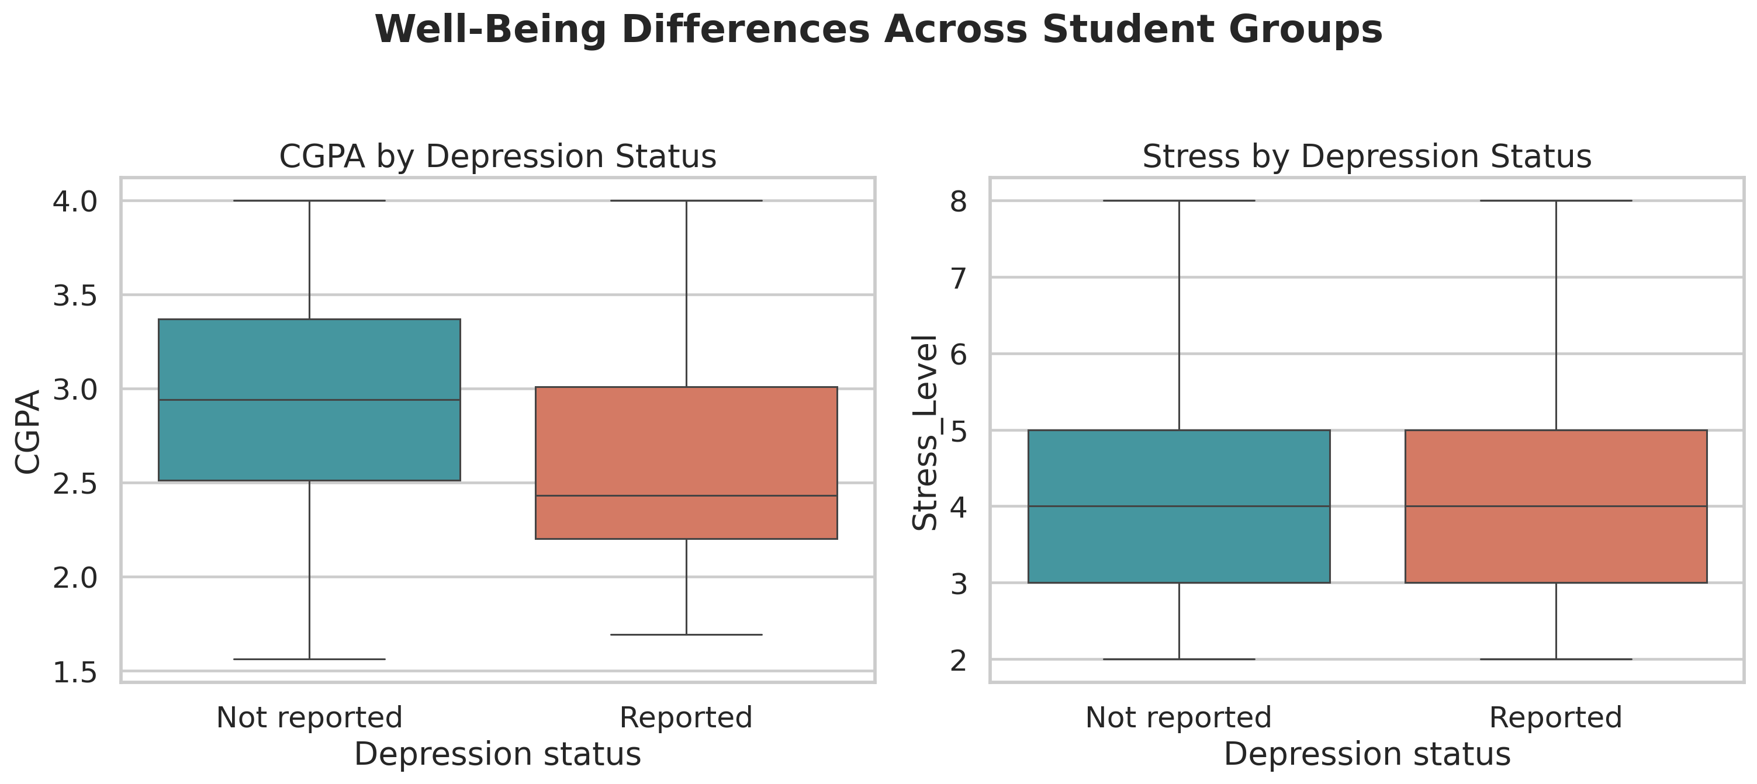
Figure 1. Correlation heatmap for academic, lifestyle, and stress variables. Darker cells indicate stronger linear relationships.
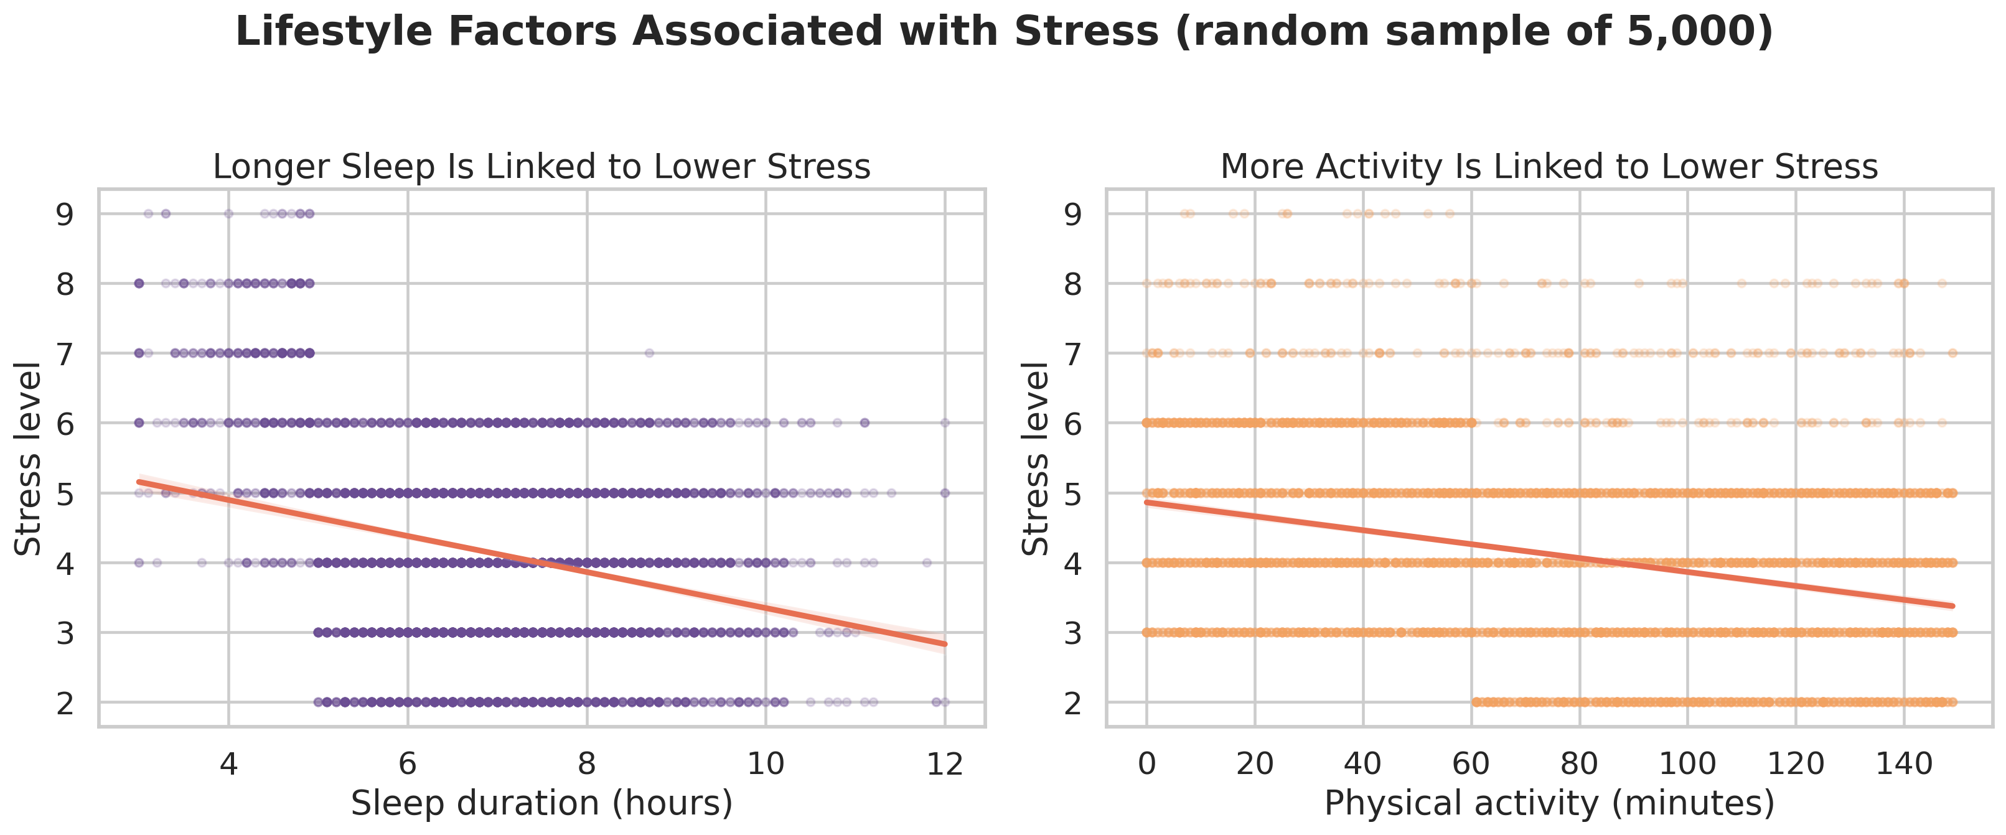
Figure 2. Lifestyle–stress scatter plots with fitted regression lines. The downward slopes summarize population associations; wide scatter shows substantial individual variability.

7. Multiple Linear Regression Predicting Stress Level
A multiple linear regression model predicted stress level from sleep duration, study hours, social-media usage, and physical activity. The model was statistically significant, F(4, 99,995) = 4,999.786, p < .001, and explained 16.7% of the variance in stress, R² = .167.
Model statistic | Result | Interpretation
N | 100,000 | Very high statistical power; trivial effects may be detectable.
F test | F(4, 99,995) = 4,999.786, p < .001 | The predictor set improves fit over an intercept-only model.
R² | .167 | The model explains 16.7% of observed stress variation.
Unexplained variance | 83.3% | Most individual stress variation lies outside the four lifestyle predictors.
Multicollinearity | All VIF = 1.000 | No evidence that predictor overlap destabilized coefficients.

Predictor | Standardized β | p | Practical interpretation
Physical activity | −.296 | < .001 | Strongest adjusted predictor; greater activity was associated with lower stress.
Sleep duration | −.280 | < .001 | Nearly equal adjusted effect; longer sleep was associated with lower stress.
Study hours | .009 | .002 | Extremely small positive effect; statistically significant but not practically important.
Social-media hours | .000 | .899 | No independent predictive contribution in this model.

Relative effect magnitude. Physical activity and sleep duration dominated the model. Their standardized coefficients were roughly 31–33 times the magnitude of the study-hours coefficient, while social-media hours contributed essentially nothing after adjustment. Because the coefficients are standardized, they can be compared directly across predictors measured in different units.
Model utility. R² = .167 represents meaningful but limited explanatory power for a behavioral model. It is sufficient to identify broad population patterns, but it is not strong enough for deterministic individual prediction. Factors such as financial pressure, academic workload, social support, prior mental-health history, housing, employment, and measurement quality may account for additional variation.
Practical-versus-statistical significance
The study-hours result illustrates why p-values cannot stand alone: β = .009 is statistically significant at p = .002, yet its magnitude is negligible. Sleep and physical activity are more decision-relevant because they combine strong evidence with materially larger standardized effects.

8. Integrated Findings by Research Question
Research question | Finding | Conclusion
RQ1: What are the sample’s baseline characteristics? | Students averaged 7.0 hours of sleep, 4.5 study hours, 3.5 social-media hours, 74 minutes of activity, and stress of 4.13. | The sample contains substantial lifestyle variation suitable for relational analysis.
RQ2: Does stress differ by gender? | Female and male means were identical to two decimal places; p = .715; d ≈ −.002. | No meaningful average gender difference was observed.
RQ3: Which lifestyle factors correlate with stress? | Physical activity (r = −.297) and sleep (r = −.281) were the strongest correlates. | Higher activity and longer sleep were associated with lower stress.
RQ4: Which factors uniquely predict stress? | Physical activity (β = −.296) and sleep (β = −.280) remained dominant; R² = .167. | The adjusted model supports their relative importance, but most stress variance remains unexplained.

9. Professional Interpretation and Recommendations
Prioritize balanced sleep and activity initiatives. The two largest and most consistent associations suggest that wellness programs should emphasize sleep hygiene, schedule design, accessible physical activity, and barriers to participation.
Avoid overstating study-time and social-media findings for stress. Study time had a negligible effect and social-media use had none in the focal model. Broad claims that these variables drive stress are not supported by the supplied analyses.
Do not segment stress support by gender alone. The gender effect was effectively zero. Support should be needs-based rather than justified by an average male–female difference in this dataset.
Use the model for population insight, not individual diagnosis. R² = .167 means the model is informative at an aggregate level but leaves 83.3% of stress variation unexplained. It should not be treated as a clinical screening or individual risk engine.
Strengthen future data collection. Add theoretically important predictors, validated scales, sampling information, and longitudinal measurement. Repeated observations would improve temporal interpretation, while experimental or quasi-experimental designs would be needed for stronger causal inference.

10. Limitations and Ethical Caveats
- Cross-sectional observational data cannot establish that sleep or physical activity causes lower stress; reverse causation and unmeasured confounding are plausible.
- The source materials do not document the sampling design, institution(s), response process, or population frame, limiting claims of external generalizability.
- Units and measurement definitions were inferred because no formal data dictionary was provided. Stress and depression measures should not be interpreted clinically without validation.
- Self-reported lifestyle variables may be affected by recall bias, social-desirability bias, and measurement error.
- The model tests linear additive relationships. Nonlinearity, thresholds, interactions, and subgroup-specific patterns were not evaluated in the supplied workflow.
- Formal gender moderation was not tested. A nonsignificant t-test does not show that gender cannot modify a lifestyle–stress relationship.
- The extremely large sample makes small departures from the null statistically detectable; effect sizes and explanatory power should govern substantive conclusions.
- Predictive associations should not be used to stigmatize students or make high-stakes individual decisions.

11. Conclusion
The analysis provides a coherent answer to the original research question while retaining the requested SPSS-centered workflow. Student stress was most consistently associated with sleep duration and physical activity: both showed small-to-moderate negative correlations and remained the dominant standardized predictors in the multiple regression. Study hours were statistically detectable but practically negligible, social-media usage did not predict stress, and average stress did not differ meaningfully by gender. The overall model explained 16.7% of stress variation, indicating useful population-level insight but substantial unexplained heterogeneity.
The central methodological lesson is that large-sample inference must be interpreted through effect size. With N = 100,000, p-values alone can make trivial associations appear important. A publication-ready interpretation therefore emphasizes standardized coefficients, Cohen’s d, shared variance, R², model limitations, and the distinction between association and causation.

Appendix A. Full Correlation Matrix
Variable | CGPA | Sleep | Study | Social media | Activity | Stress
CGPA | 1.000 | .015 | .100 | −.088 | .005 | −.012
Sleep duration | .015 | 1.000 | .003 | −.003 | .003 | −.281
Study hours | .100 | .003 | 1.000 | .005 | −.002 | .009
Social-media hours | −.088 | −.003 | .005 | 1.000 | −.005 | .002
Physical activity | .005 | .003 | −.002 | −.005 | 1.000 | −.297
Stress level | −.012 | −.281 | .009 | .002 | −.297 | 1.000

Appendix B. Reporting Notes
- Values were reproduced from the two supplied documents; no raw dataset was available for re-estimation.
- The estimated Cohen’s d for stress by gender was derived from the reported t statistic and group sizes and is presented as an approximation.
- The original research framing includes depression and ANOVA within the broader workflow. The focal supplied SPSS outputs reported here primarily concern stress, the gender t-test, Pearson correlations, and the four-predictor stress regression. No additional unrequested inferential tests were introduced.
- Recommended publication visuals are included: a labeled correlation heatmap and scatter plots with fitted regression lines. For formal journal submission, figures should be regenerated directly from the raw data with confidence bands, axis units, and an explicit note on overplotting or sampling.

