KLE Society's

KLE Technological University



**Open Ended (OE) Assessment Report**

**On**

**IMPORTING AND EXPORTING SYSTEM**

**Object Oriented Programming (20ECSC204)  
Object Oriented Programming Lab (20ECSP203)**

**Submitted by**

| **Name** | **Roll no** | **SRN** |
| --- | --- | --- |
| G Shirisha | 228 | 01fe21bcs157 |
| Neha Bhat | 236 | 01fe21bcs194 |
| **Team Number: 12** | | |

**Faculty In-charge:**

Mr. Manjunath Gonal

**SCHOOL OF COMPUTER SCIENCE & ENGINEERING**

**Academic year 2022-23**

1. Introduction

1.1 Overview of the problem Statement:

The Import Export System keeps account of the transaction of goods and other supplies that are being imported or exported. Our project is a mini replica of Import Export System. It replicates the process involved in exporting goods to the foreign country, forex exchange and payment method with error handling mechanism.

1.2 Features of Application:

The application includes

a. Warehouse details

b. Exporter details

c. Importer Details

d. Generate Invoice

2. Design

2.1 Class Diagram:

List of Classes:

* Resource
* Goods
* Spices
* Items
* Warehouse
* Exporter
* Importer
* Modes
* Exception
* Currency Exchange
* Invoice

UML: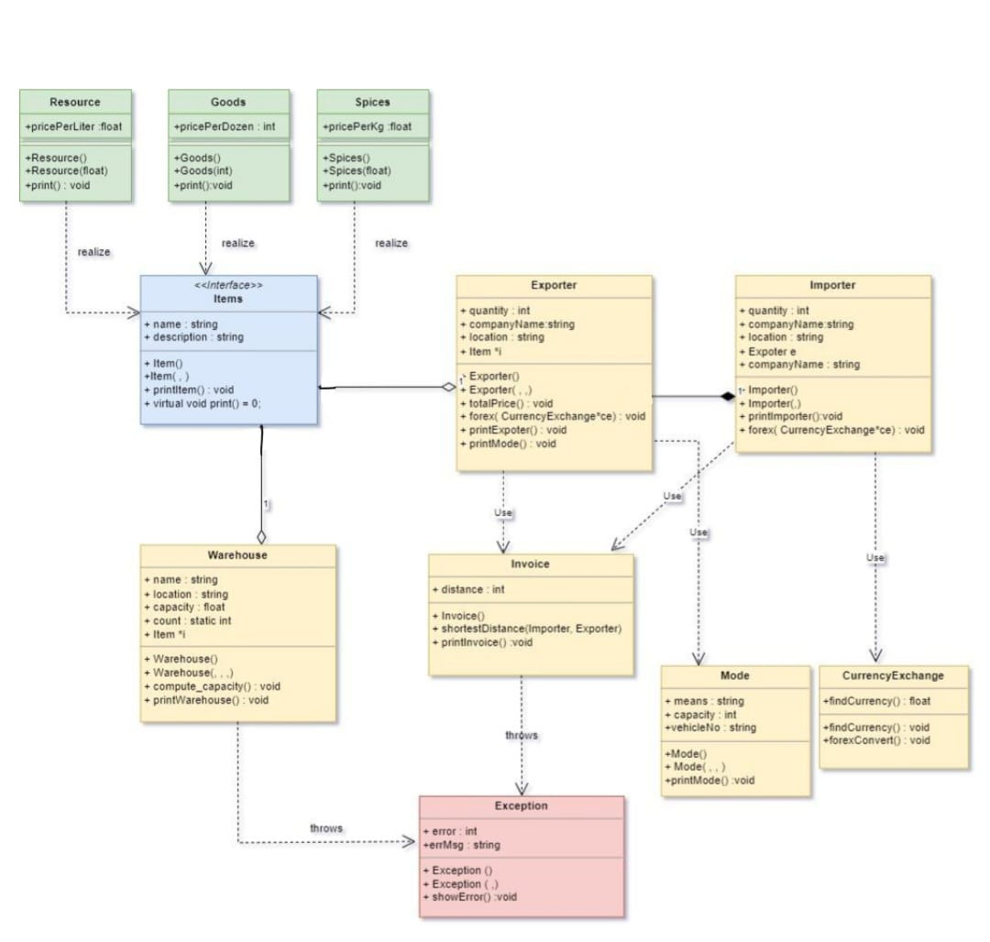

Builder

4. Implementation

4.1 Results:

