**CHAPTER 1**

**INTRODUCTION**

# **Motivation:**

The main reason why we opt this design is: Spiritual intelligence is the science of human energy management that clarifies and in the era of bad situation in which everywhere there is a panic like situation and according to the World Health Organization Social Distancing will be proven to be the only solution. It is used to track humans' position in an outdoor environment based on sensors is proposed. With the help of artificial intelligence, this novel smart device is handy for maintaining a social distancing as well as detecting covid symptom patients and thereby safety. In these covid environments, where everyone is conscious about their safety it is the idea. Most of the time, people on the roadside watched their front but were not able to look after what is going on behind them. The device will give alert to the person if someone in the critical range of six feet around him. The method is reasonably accurate and can be very useful in maintaining social distancing. The sensor model used is described, and the expected errors in distance estimates are analyzed and modeled.

This technique is used for portable electronic devices, such as smartphones, tablets, smartglasses, and smartwatches, to measure and analyze the distance between a user and other people. For example, a portable electronic device can be used to detect potential deviations from recommended social distancing using a radar sensor. In aspects, the portable electronic device, using an on-device machine-learned model, evaluates measured data to generate appropriate alerts for the user.



Fig:1 Social Distancing

**Scope:**

As we need to maintain social distancing of at least 1-1.5 meter from the people to slow the spread of disease by stopping chains of transmission of COVID-19 and preventing new ones from appearing.

**Objective:**

* In this project, I’m going to design a device which is use to help maintaining social distance using Arduino, Ultrasonic sensor and buzzer.
* It contains an ultrasonic sensor, microcontroller and a buzzer HC-SR04 ultrasonic sensor (US) is used for measuring distance from body to object. And this measured signal by ultrasonic sensor is sent to the microcontroller

**Design and Development of Product:**

Design of product

Fig-2:design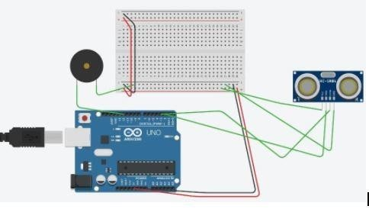

**Purchasing information:**

We have purchased the components needed for building our project they are:

**Arduino board**

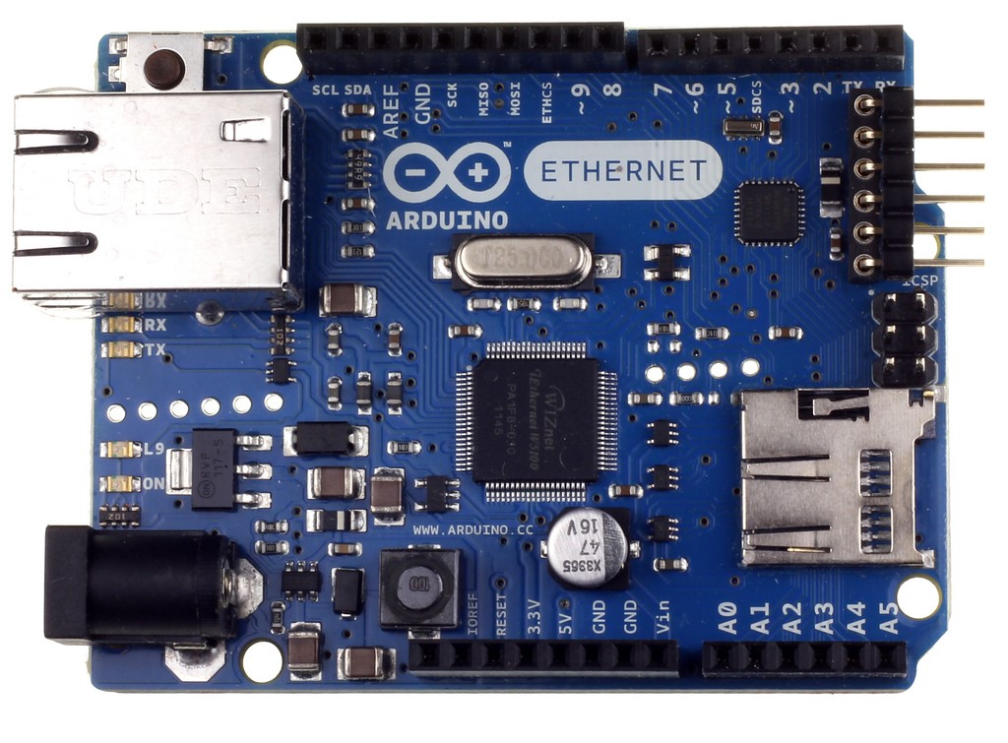

**Ultrasonic sensor**

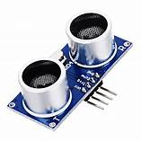

**Buzzer**

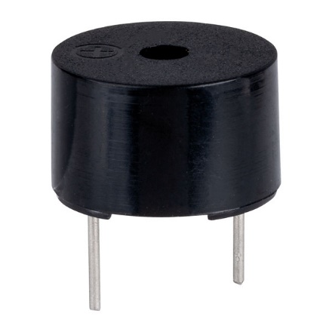

**Bread board**

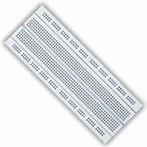

|  |  |
| --- | --- |
| **NAME OF THE COMPONENT** | **COST (IN RUPEES)** |
| Arduino uno | 585 |
| Ultrasonic sensor | 120 |
| Buzzer | 70 |
| Bread board | 120 |
| Power supply | 20 |

# **Development Process:**

After the purchase of all the components we started developing the product by assembling them according to the design we have, then by loading the program code into the Arduino board we have checked the functionality of the product.

Declare global variables echo and trigger as integer,distance as float and duration as long data typed

Open setup()function

Define pin numbers and open serial monitor

Close the setup function

Give values for digital pin trigger is low and delay it for 2 sec

Distance=(duration*0.034)/2

Print the distance in serial monitor using function serialprintln()

(N0)

Use digitalwrite()

Function buzzer does not ring

(Yes)

Use digitalwrite() function buzzer starts ringing

if

Serialprintln()

**Final Product and Results:**

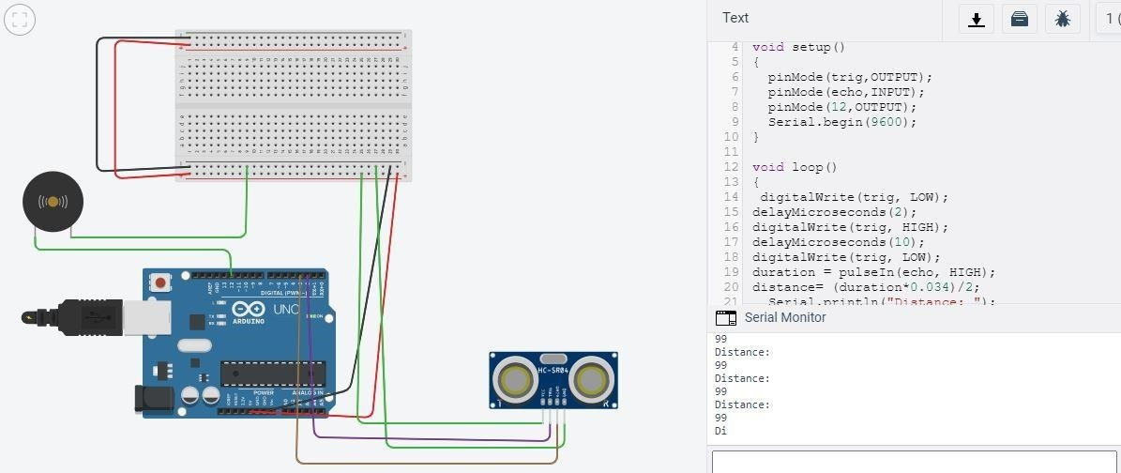

**CONCLUSION**

By taking the help of tinker cad software using Arduino social distancing device is done. Technology can play a crucial role in facilitating social distancing. The system described here uses the most commonly used components. A simple, but easy to wear device will help the community at large, in fighting against novel coronavirus. As we need to maintain social distancing of at least 1-1.5 meter from the people It is a smart wearable device which can be used for maintaining social distancing from people. It contains an ultrasonic sensor, microcontroller and a buzzer. HC-SR04 ultrasonic sensor (US) is used for measuring distance from body to object. And this measured signal by ultrasonic sensor is sent to the microcontroller. The program/ code is already uploaded in the microcontroller.

The condition implemented in the code is that when the distance is greater than 1 meter the condition goes true and the electric buzzer starts blowing. And on other side if the distance is less than 1meter the other condition goes true and electric buzzer will not blow this time.

**REFERENCES**

1. www.create.arudino.cc

[Author: Mohamm](http://www.ijeat.org/)adsohail

1. www.ijeat.org

Author: Dr. Abhiruchipassi