Weekly Status Report: Apr 27 – May 1, 2026
Shirish Inamdar
TA / Lab Support Specialist
Northern Virginia Community College
Supervisor: Prof. Mun-Wai Hon

Overview
This week focused on setting up a working OpenVPN tunnel between two Linux VMs in VMware - Kali Linux as the server and Linux Mint(as the client, both running on a NAT network. The lab covered PKI setup, certificate generation, server and client configuration, file transfer, and verifying the encrypted tunnel with a ping test.
OpenVPN is an open-source tool that creates a secure, encrypted tunnel between two machines over a network. A VPN tunnel means all traffic between the two machines is encrypted
OpenVPN Lab - Kali (Server) + Linux Mint(Client)
Environment - VMware NAT
Both VMs were set up on VMware with NAT networking so they can communicate on the same subnet.
Server (Kali Linux): 192.168.147.131
Client (Linux Linux Mint(Client)): 192.168.147.130
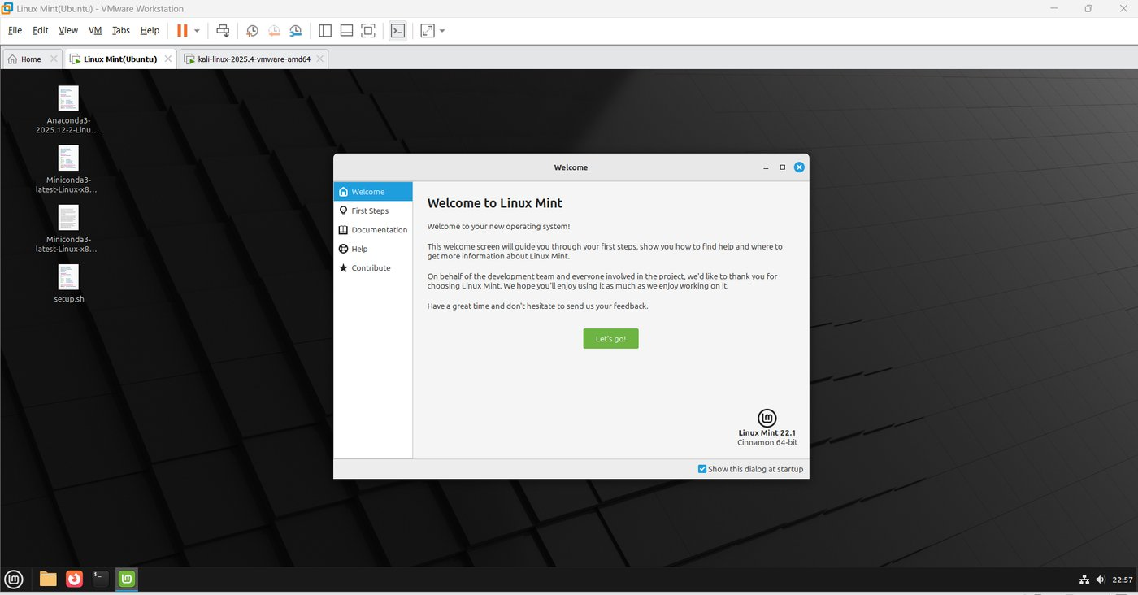
Figure 1 - Linux Linux Mint(Client) VM (client) running in VMware.
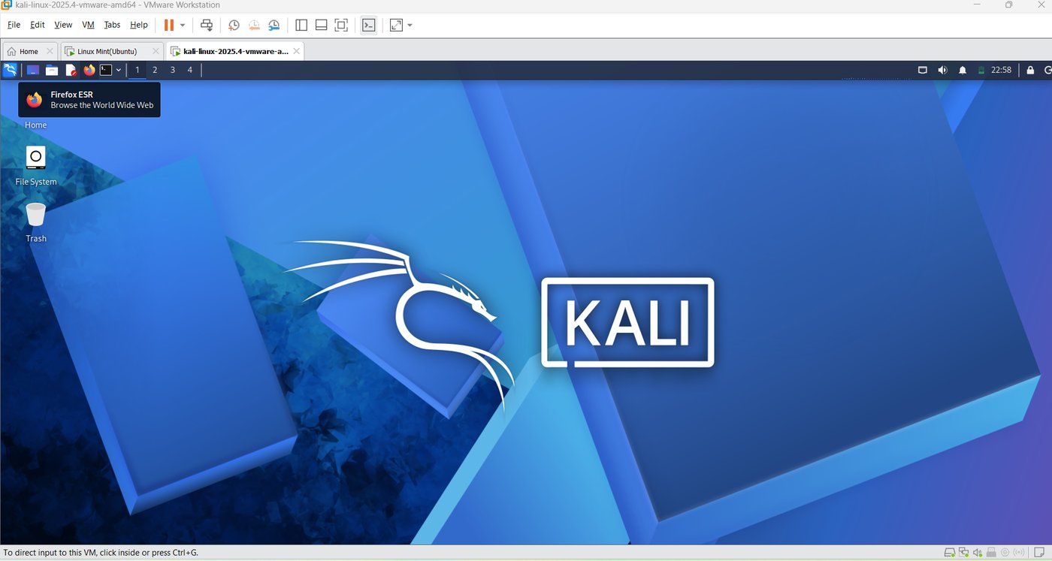
Figure 2 - Kali Linux VM (server) running in VMware.
Step 1 - Install OpenVPN & Easy-RSA on Both Machines
Ran apt update and upgrade on both machines, then installed openvpn and easy-rsa.
easy-rsa is a tool that helps create and manage certificates. Think of certificates like digital ID cards - they prove that the machine connecting to the VPN is actually who it claims to be.
#sudo apt-get update && sudo apt-get upgrade
#apt update && apt install -y openvpn easy-rsa
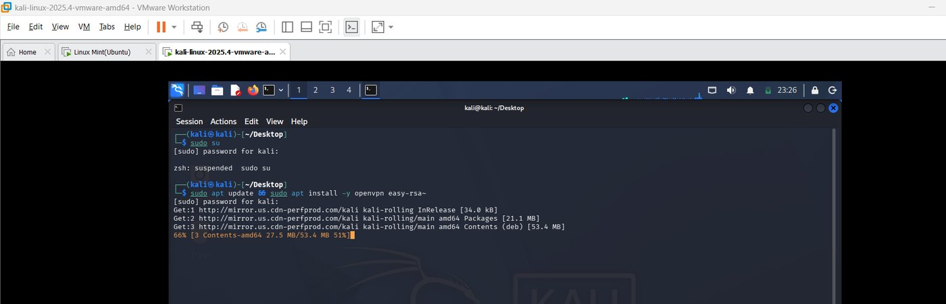
Figure 3 - apt update running on Kali.
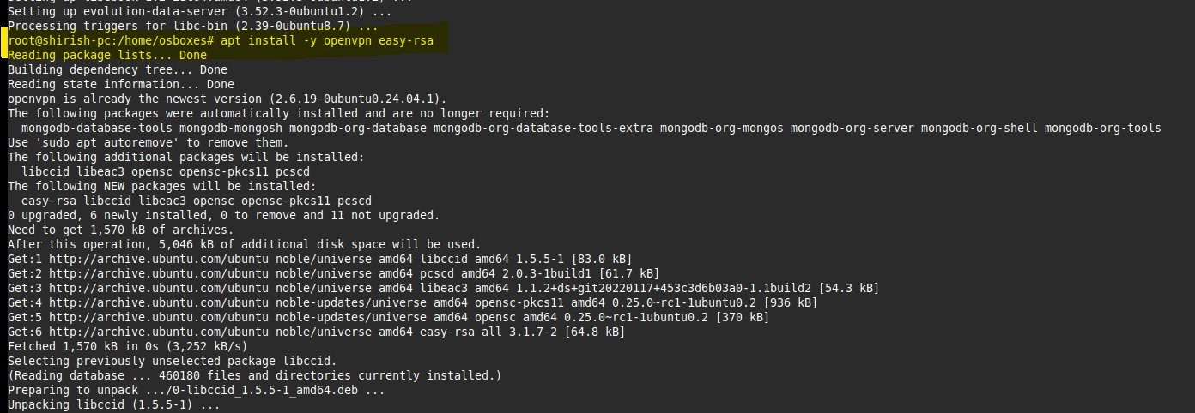
Figure 4 - apt update running on Linux Linux Mint(Client).
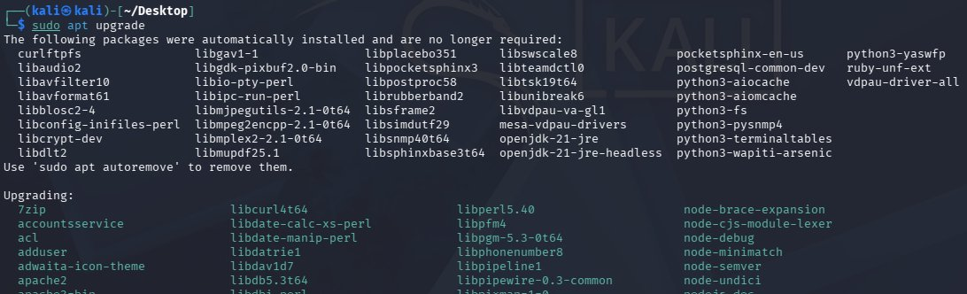
Figure 5 - OpenVPN and Easy-RSA installation completed.
Step 2 - Build the PKI on the Server (Kali)
Set up the certificate authority, generated server cert, DH parameters, and TLS auth key.
#make-cadir ~/openvpn-ca && cd ~/openvpn-ca
./easyrsa init-pki
./easyrsa build-ca nopass
./easyrsa gen-req server nopass
./easyrsa sign-req server server
./easyrsa gen-dh
openvpn --genkey secret ta.key
Note: At prompts for server/client name: just hit Enter. When asked to confirm details: type yes.
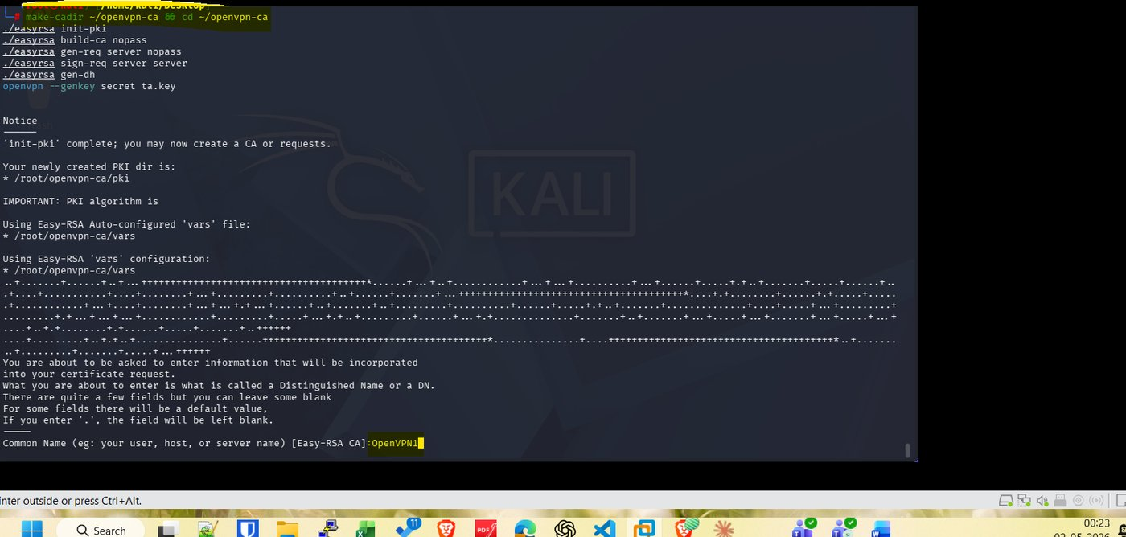
Figure 6 - PKI initialized and CA built on Kali.
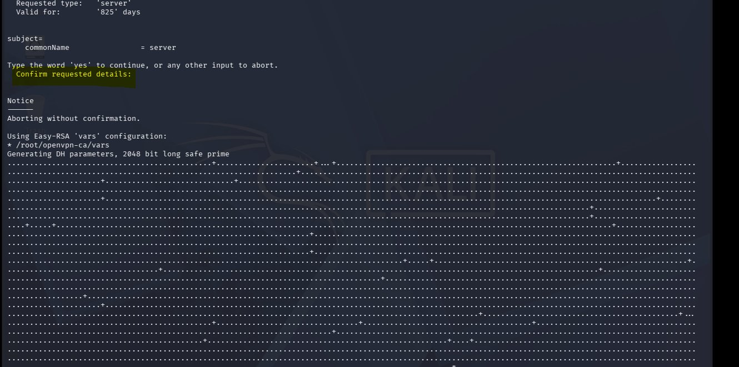
Figure 7 - Server certificate signed and DH parameters generated.
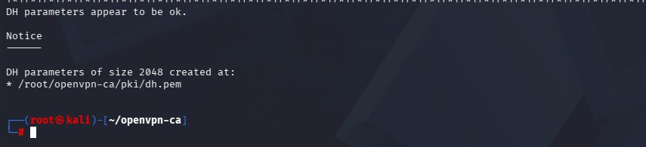
Figure 8 - TLS auth key generated.
Step 3 - Generate Client Certificate
Generated a separate certificate for the client machine. Each device that connects to the VPN needs its own certificate.
#./easyrsa gen-req client1 nopass
#./easyrsa sign-req client client1
Note: At prompts: hit Enter for name, type yes to confirm.
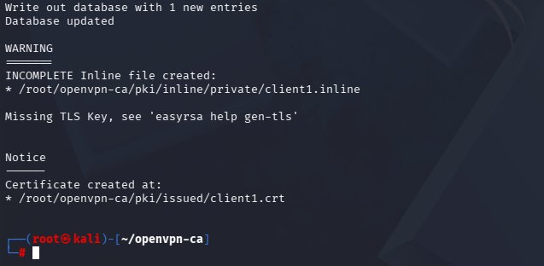
Figure 9 - client1 certificate request and signing completed.
Step 4 - Create server.conf on Kali
Created /etc/openvpn/server.conf with the server settings. This file tells OpenVPN where to find the certificates, which port to listen on, what IP range to give to VPN clients, and what encryption to use.
#nano /etc/openvpn/server.conf
port 1194
proto udp
dev tun
ca /root/openvpn-ca/pki/ca.crt
cert /root/openvpn-ca/pki/issued/server.crt
key /root/openvpn-ca/pki/private/server.key
dh /root/openvpn-ca/pki/dh.pem
tls-auth /root/openvpn-ca/ta.key 0
server 10.8.0.0 255.255.255.0
keepalive 10 120
cipher AES-256-CBC
persist-key
persist-tun
status /var/log/openvpn-status.log
verb 3
Save and exit with Ctrl+X, then Y.
Port 1194 UDP is the default OpenVPN port. The server 10.8.0.0 line means VPN clients will get IP addresses in the 10.8.0.x range - this is a virtual subnet separate from the physical network. AES-256-CBC is the encryption algorithm - it is the same standard used by banks and governments.
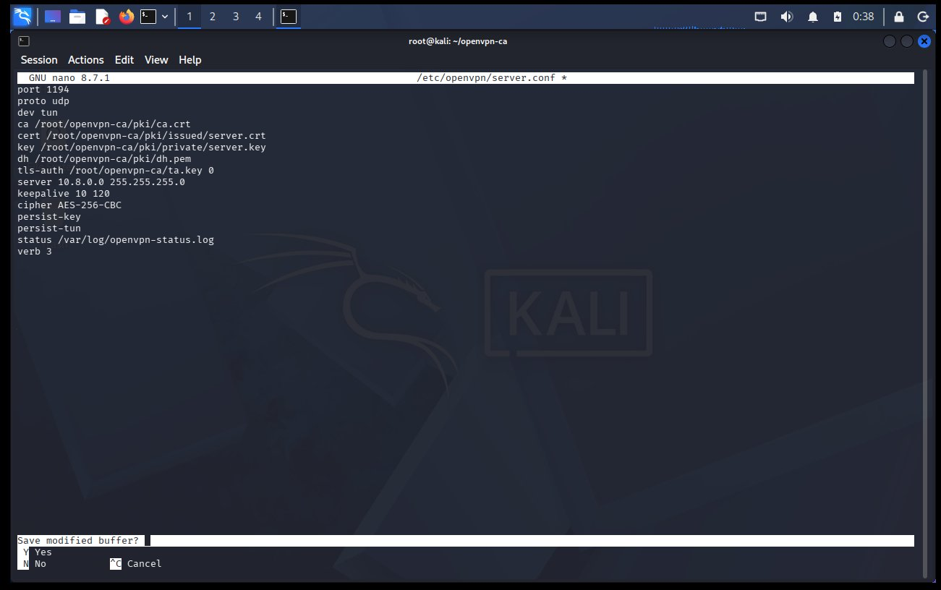
Figure 10 - server.conf saved in nano on Kali.
Step 5 - Enable IP Forwarding & Start OpenVPN Server
IP forwarding allows the server to pass traffic between the VPN tunnel and the regular network. Without this, packets coming in through the VPN have nowhere to go.
#echo 'net.ipv4.ip_forward=1' | sudo tee -a /etc/sysctl.conf
sudo sysctl -p
sudo systemctl start openvpn@server
sudo systemctl enable openvpn@server
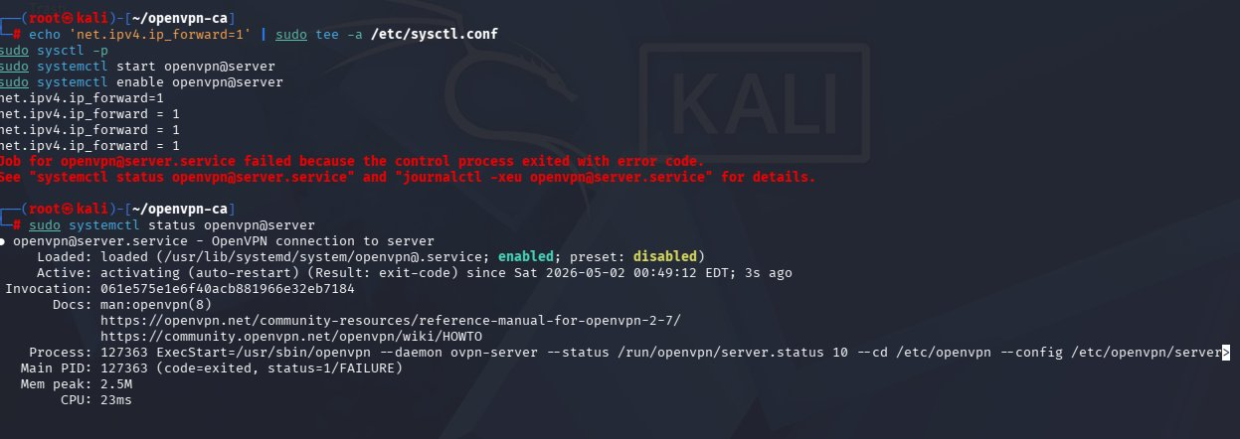
Figure 11 - IP forwarding enabled and OpenVPN server service started.
Step 6 - Transfer Certificates from Kali to Linux Mint(Client)
The client machine needs a copy of the CA cert, its own certificate, its private key, and the ta.key. These were served from Kali using Python's built-in HTTP server and downloaded on Linux Mint(Client) through the browser.
This is a common quick method for transferring files between two machines on the same network - Python starts a temporary web server in whatever folder you run it from, and the other machine downloads from it like any website. In a real environment you would use SCP or a more secure method.
#cd /tmp
cp /root/openvpn-ca/pki/ca.crt .
cp /root/openvpn-ca/pki/issued/client1.crt .
cp /root/openvpn-ca/pki/private/client1.key .
cp /root/openvpn-ca/ta.key .
python3 -m http.server 8080
On Linux Mint(Client), open a browser and go to http://192.168.147.131:8080 - download all 4 files and save them to /home/osboxes/.
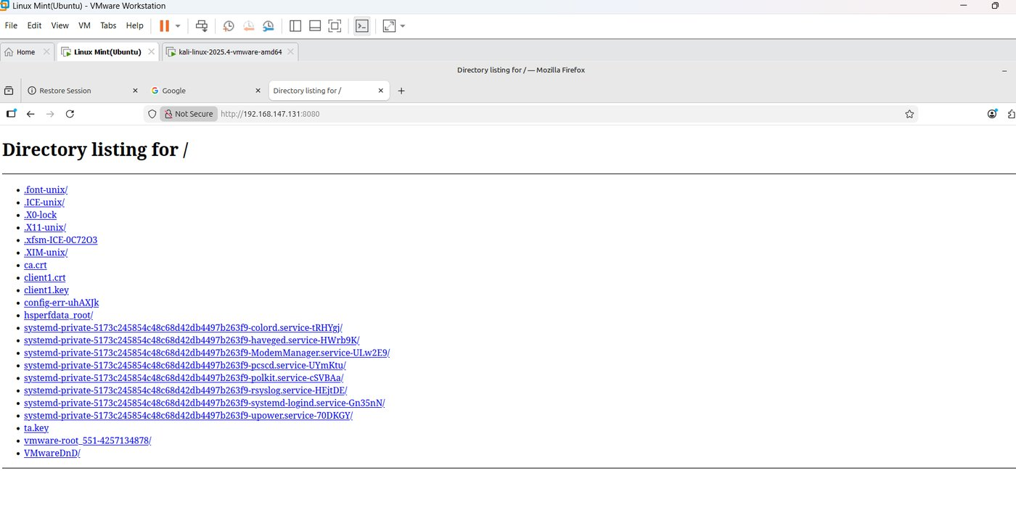
Figure 12 - Files staged in /tmp and Python HTTP server running on Kali.
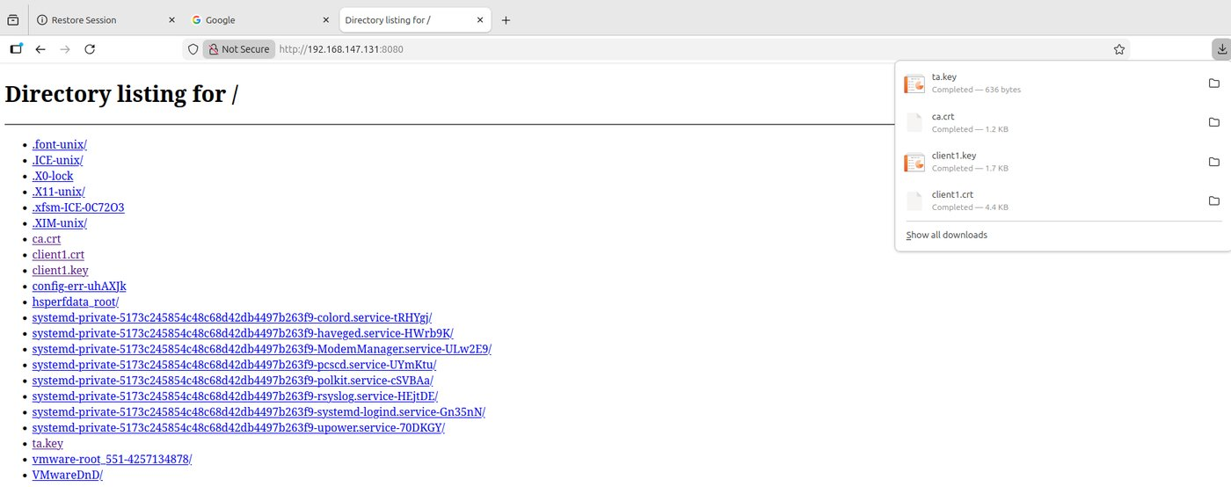
Figure 13 - Linux Mint(Client) browser downloading certificate files from Kali's HTTP server.
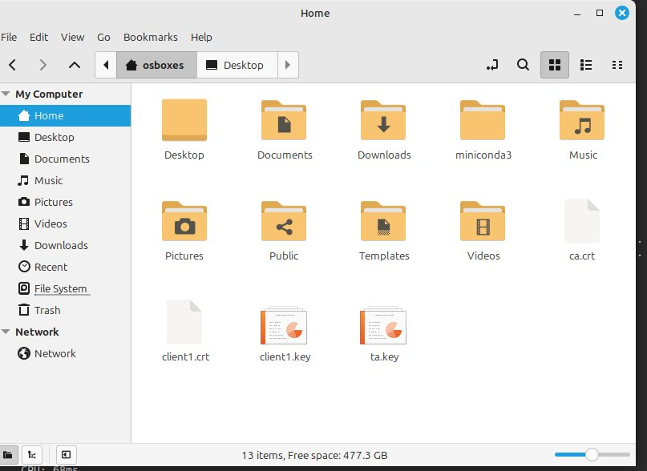
Figure 14 - Certificate files downloaded to Linux Linux Mint(Client).
Step 7 - Create client.ovpn on Linux Mint(Client)
Created the client config file on Linux Mint(Client). This tells OpenVPN on the client side where the server is, which certs to use, and what settings to match the server with.
#nano /home/osboxes/client.ovpn
client
dev tun
proto udp
remote 192.168.147.131 1194
resolv-retry infinite
nobind
ca ca.crt
cert client1.crt
key client1.key
tls-auth ta.key 1
cipher AES-256-CBC
verb 3
The remote line points to the Kali server IP and port. The tls-auth line uses 1 on the client side (vs 0 on the server) - this is just how OpenVPN distinguishes which end is which for the TLS key.
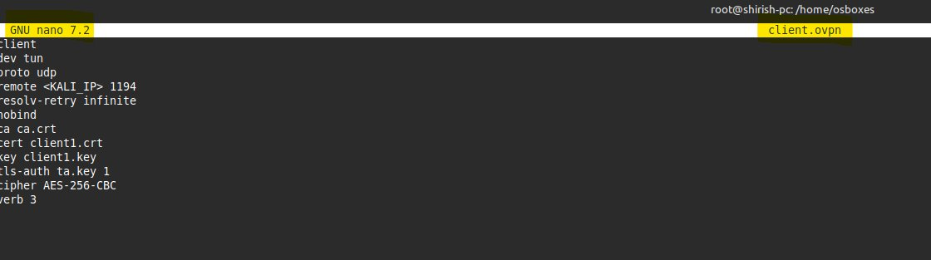
Figure 15 - client.ovpn file created on Linux Linux Mint(Client).
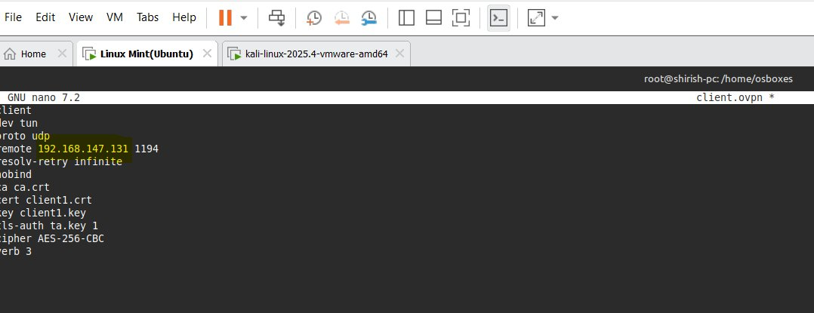
Figure 16 - client.ovpn contents verified in terminal.
Step 8 - Connect & Verify the VPN Tunnel
Ran openvpn on Linux Mint(Client) with the client config. The tunnel came up and Linux Mint(Client) was assigned VPN IP 10.8.0.2 by the server.
#sudo openvpn --config client.ovpn
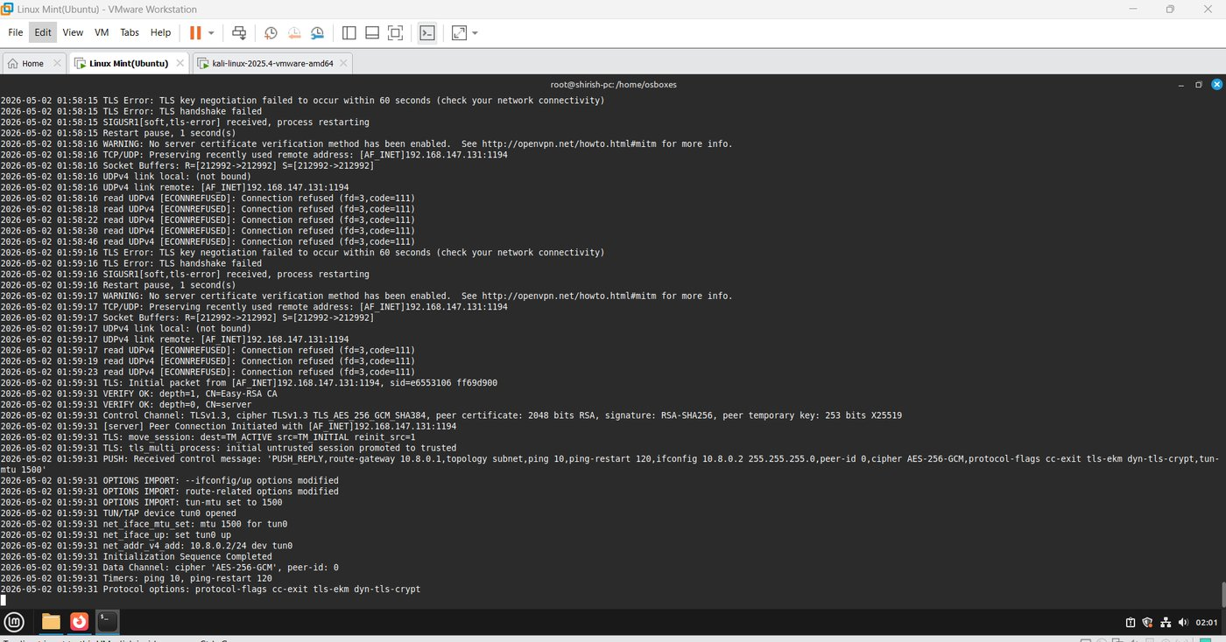
Figure 17 - OpenVPN connecting on Linux Mint(Client), handshake and certificate verification in progress.
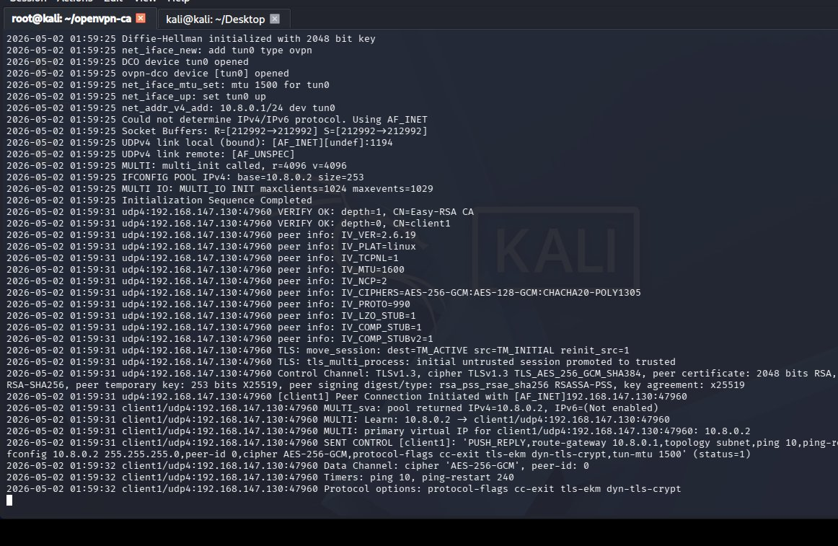
Figure 18 - Tunnel up: VERIFY OK, Peer Connection Initiated, Linux Mint(Client) assigned 10.8.0.2, AES-256-GCM active.

Test - Ping Through the VPN
Pinged Kali's VPN IP (10.8.0.1) from Linux Mint(Client) to confirm the encrypted tunnel is working in both directions.
When Linux Mint(Client) pings 10.8.0.1, it recognizes that IP belongs to the VPN tunnel and hands the packet to OpenVPN. OpenVPN encrypts it and sends it over the physical network to Kali. Kali decrypts it, responds, and sends an encrypted reply back. Getting replies means the tunnel is up, authentication worked, and encryption is running in both directions.
#ping 10.8.0.1
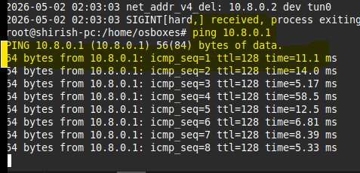
Figure 19 - Successful ping to 10.8.0.1 confirming the VPN tunnel is live and encryption is working.

Future Work
- Arrangement of Reston equipment and perhaps arrival of the manassas AWS equipment.
- Started with EC Council Strom Kit for Raspberry pi basic cybersecurity projects.
- The allocated equipment will be strategically planned to support AI-driven SOC capabilities and advanced security use case and malware detonation chamber.
- Juniper switches will be configured to enable network segmentation, monitoring, and realistic enterprise-grade traffic scenarios.
- Finalizing a structured agenda with time-based phases covering hands-on activities including crimping, CPU assembly, , and a CTF competition.
- AA449 will accommodate workstations and PCs, while AA426 is planned to eventually host the malware detonation chamber (currently at the conceptual stage).
- Started with Pfsense firewall and Metasploitable configuration and will be installed soon and will be connected to Dell PowerEdge 2950 server.
- Studying and implementing the timeline analysis from the wireshark SANS GCFA documentation.
- Supporting students with appointments with lab sessions/tutoring for cybersecurity labs and other course projects as well.
- Building an AI Security Operations Center on Campus and specialized lab setups for IT and cybersecurity courses, including malware analysis, forensics investigations, red/blue team CTF exercises, CISCO networking practice, and high-performance AI sandbox workstations.
- Continue with Malware analysis exercises with Wireshark and Autopsy.

