Weekly Status Report: Feb 23 – Feb 27, 2026
Shirish Inamdar
TA / Lab Support Specialist
Northern Virginia Community College
Supervisor: Prof. Mun-Wai Hon

Pfsense Firewall : Installation
Pfsense is an open-source firewall and router operating system based on FreeBSD, designed to manage and secure network traffic. It provides features like stateful packet filtering, VPN (IPsec/OpenVPN/WireGuard), VLAN support, intrusion detection, and traffic shaping through a web-based interface. It can be deployed on bare metal hardware or as a virtual machine to act as a secure gateway between internal networks and the internet.
We will install pfSense on VMware using its ISO image to build and configure a virtual firewall that simulates a real-world network security gateway for hands-on learning and testing.
Download ISO image from official source.
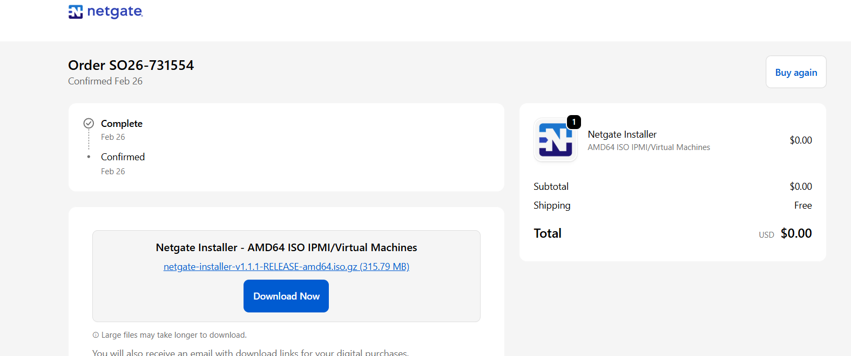
extract this downloaded .rar file and you will get the iso image file.
VMWare workstation pfsense Installation:
1. Create a virtual machine. Select Typical.
2. Selected your pfsense ISO image.
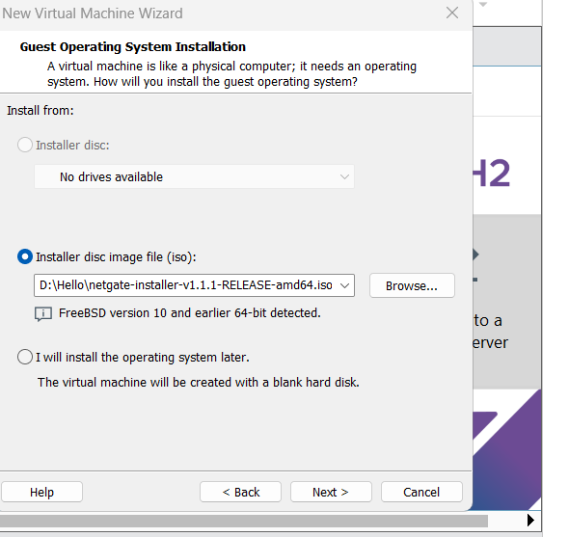
3.Name your virtual machine- PFsense- Fw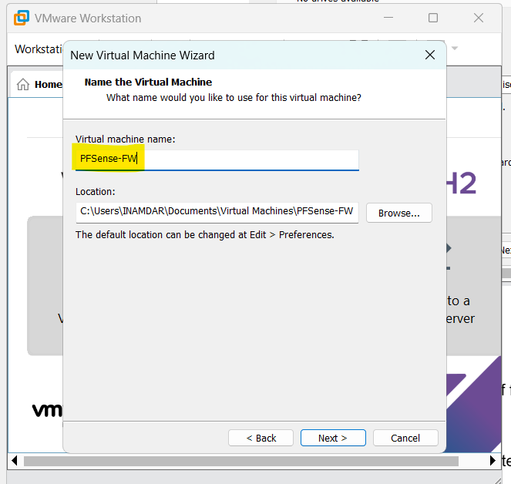
4. Keep the size as 50GB.
5.Memory-8GB
6. Processors – 2
7. Add another NAT
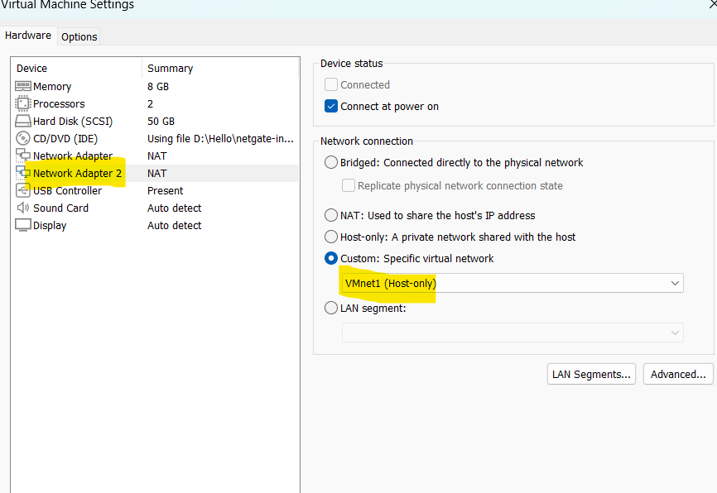
Note: Network Adapter 2 and Another host needs to be in the same hostonly interface.
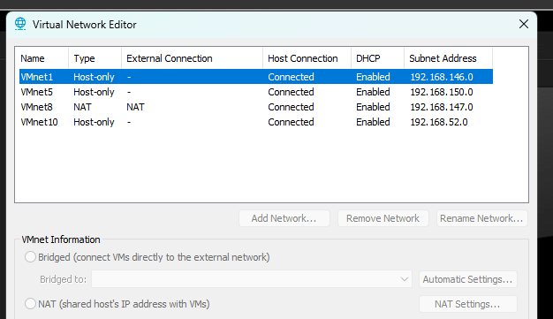
Few Installations steps to go through:
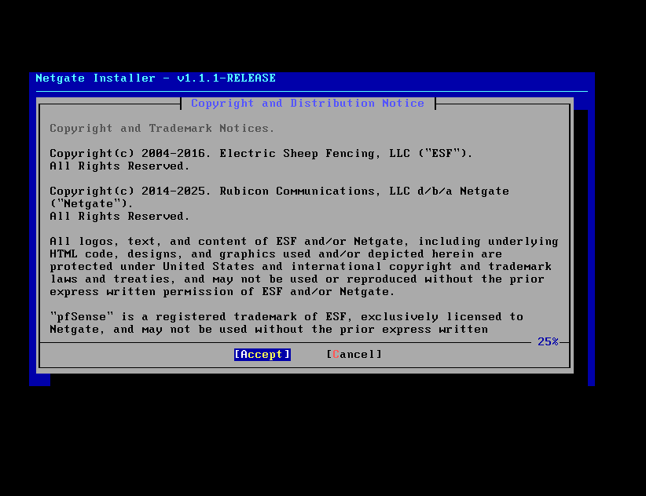
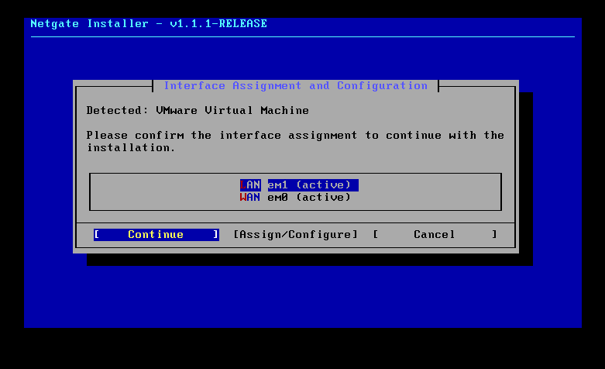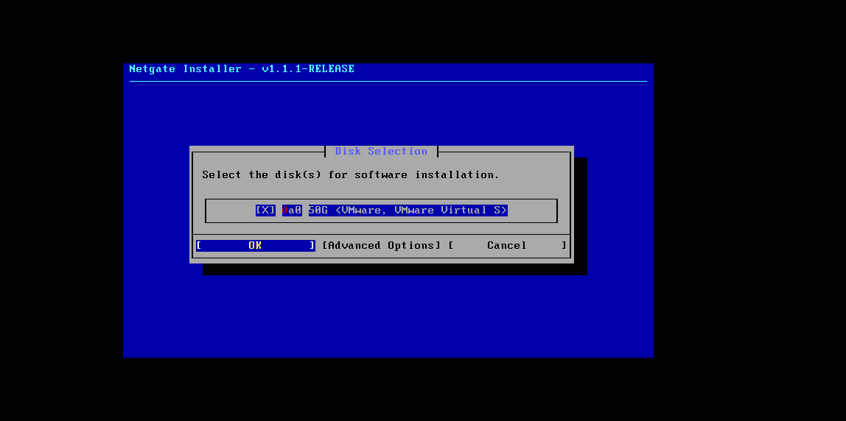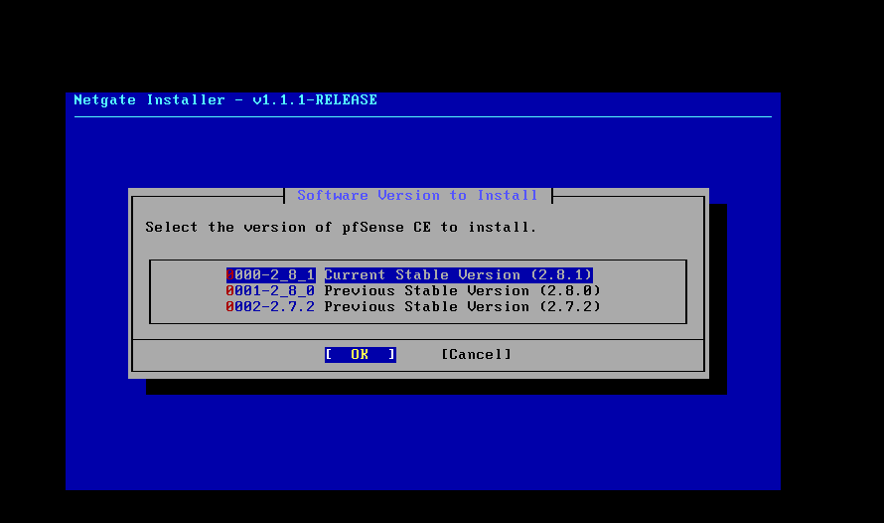

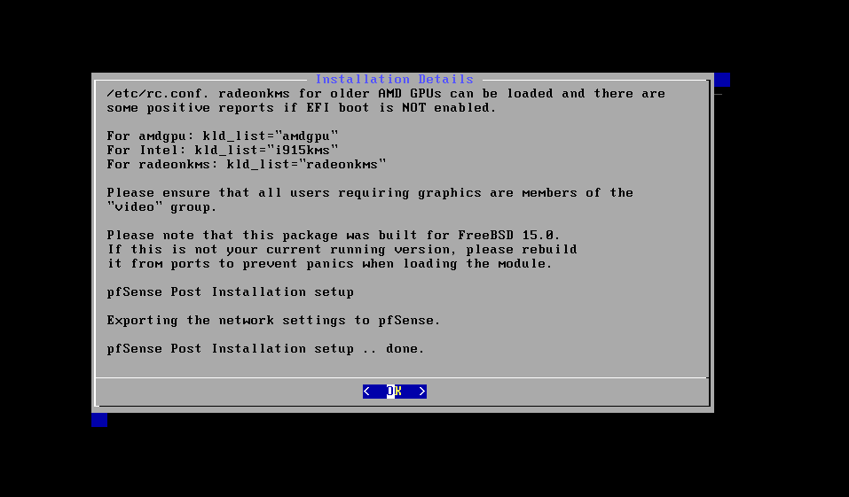

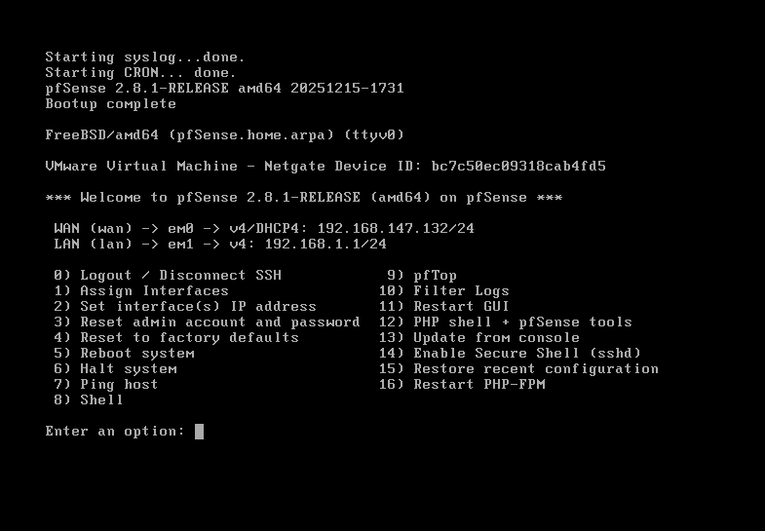

We will make the other machine Host-only ubuntu
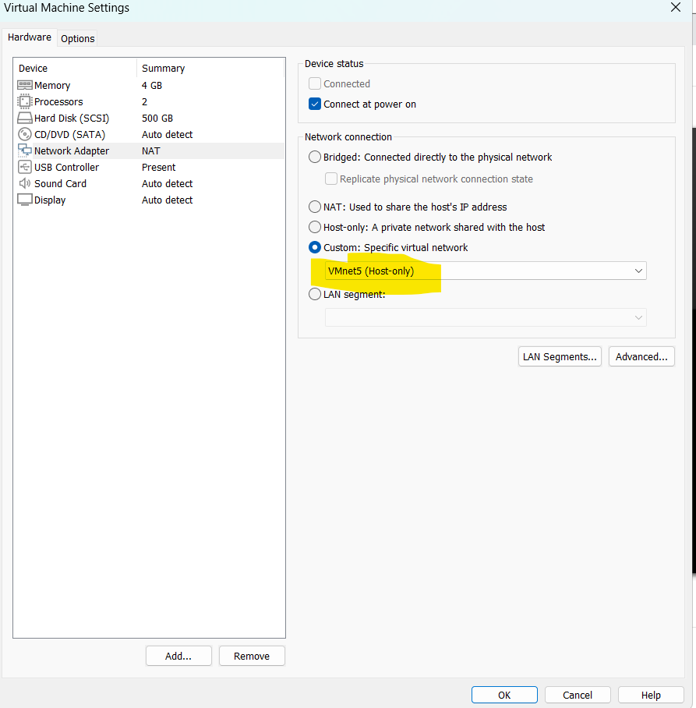
I have the another machine for Ubuntu and we will use that as host to configure firewall.
To enter into the GUI of pfsense: Enter 192.168.150.1 in URL
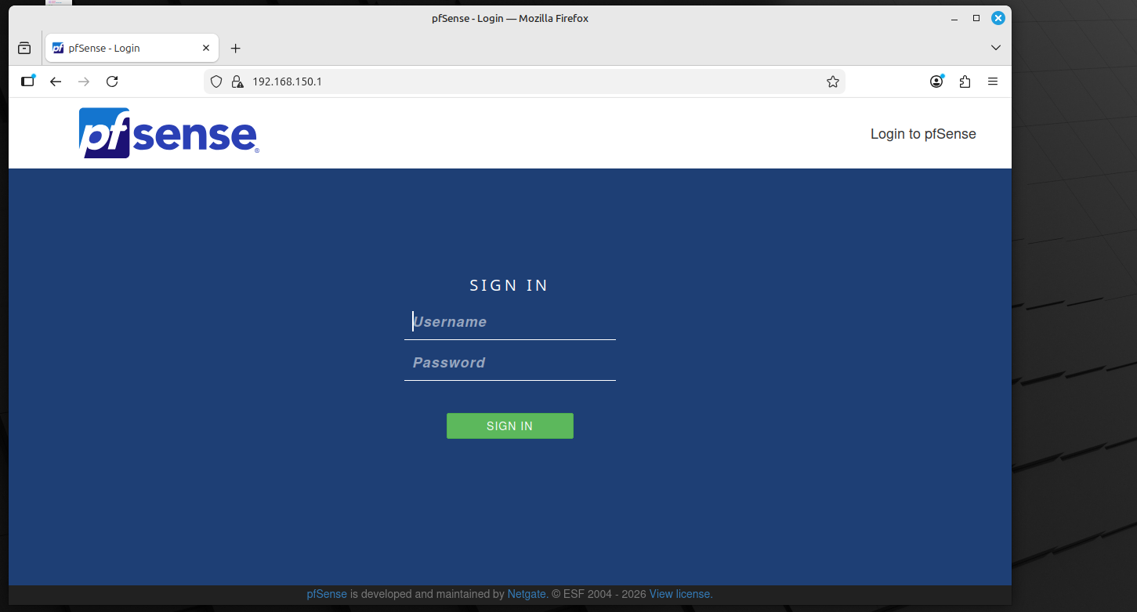

Username – admin
Password- pfsense
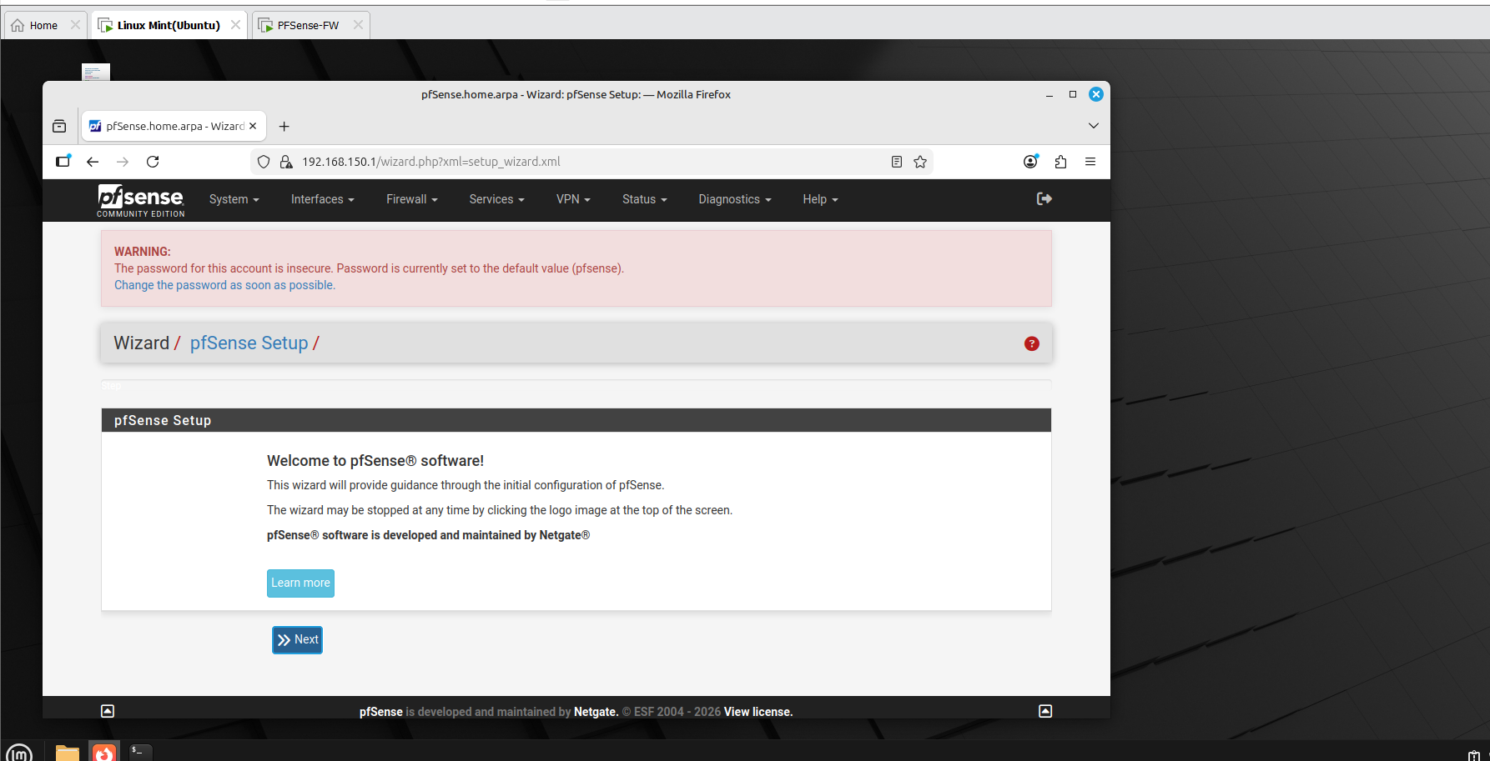
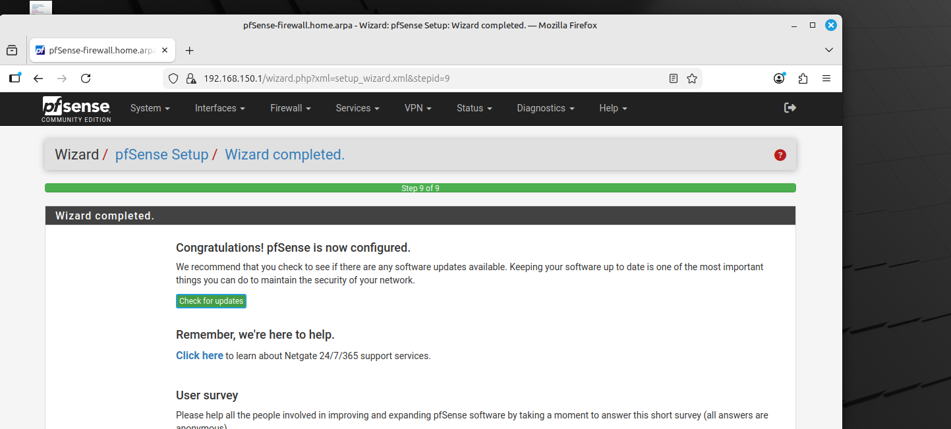
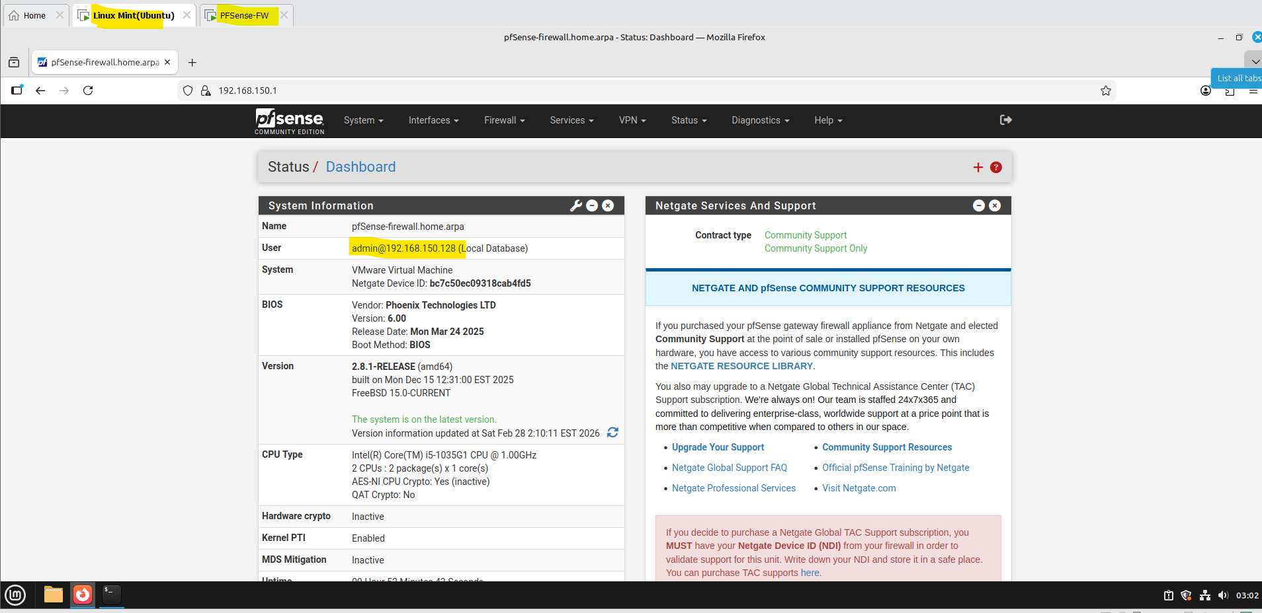
Pfsense is now configured and we will be doing more hands on labs from this.
Future work:
- Started with selection of few project and Flipper zero demonstration presentation.
- AA449 will accommodate workstations and PCs, while AA426 is planned to eventually host the malware detonation chamber (currently at the conceptual stage).
- The secure lab network design is being updated to include the requested equipment (routers, switches, PCs, and laptops) and refinements. The revised version will be completed and shared shortly.
- Started with Pfsense firewall and Metasploitable configuration and will be installed soon and will be connected to Dell PowerEdge 2950 server.
- Forensic Data Acquisition - Hardware Write Blockers. Experimenting with Tableau section of working with write blockers.
- Studying and implementing the timeline analysis from the wireshark SANS GCFA documentation.
- Supporting students with appointments with lab sessions/tutoring for cybersecurity labs and other course projects as well.
- Building an AI Security Operations Center on Campus and specialized lab setups for IT and cybersecurity courses, including malware analysis, forensics investigations, red/blue team CTF exercises, CISCO networking practice, and high-performance AI sandbox workstations.
- Continue with Malware analysis exercises with Wireshark and Autopsy.

