Weekly Status Report: Feb 09 – Feb 14, 2026
Shirish Inamdar
TA / Lab Support Specialist
Northern Virginia Community College
Supervisor: Prof. Mun-Wai Hon

Network-Based Intrusion Detection System (Snort) on Kali Linux
Snort is a network-based Intrusion Detection System (NIDS) used to monitor network traffic in real time and detect malicious activity such as port scans, brute-force attempts, malware communication, and policy violations. Snort operates by capturing packets, decoding protocols, applying preprocessing, and evaluating traffic against defined detection rules.
Snort Deployment and Configuration
Environment Setup
- Started with a Kali Linux virtual machine
- Network interface configured to monitor traffic from the lab network.
Installation and Initial Configuration
- Install Snort
$sudo apt-get install snort -y
- The network interface was configured in promiscuous mode. -192.168.147.131/24
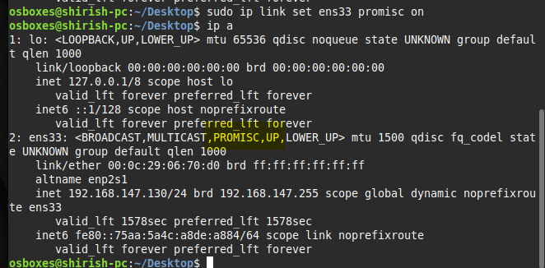
$sudo ip link set eth0 promisc on
This puts the network interface eth0 into promiscuous mode.
When promiscuous mode is enabled, eth0 will accept all network packets it sees, not just packets that are:
- Addressed to its own MAC address
- Broadcast packets
- Multicast packets

- Edit configuration file
$ sudo nano /etc/snort/snort.conf
The HOME_NET variable was modified to reflect the protected subnet (192.168.147.0/24).
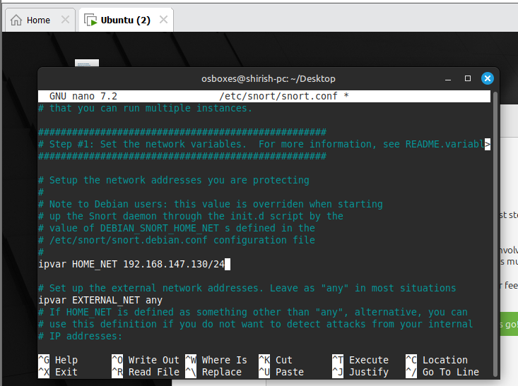
- Snort Rules
Snort rules define the action to take when traffic matches the rule
Structure: Action Protocol Source → Destination (Options)
Action:Defines what Snort should do when traffic matches.
Common actions:
- alert : Generate alert
- log : Log packet
- pass : Ignore traffic
- drop : Drop packet (IPS mode)
- reject : Drop + notify sender

Protocol:
Specifies traffic type: tcp, udp, icmp, ip
Rule: Any ICMP packet sent from anywhere to your internal network.
alert icmp any any -> $HOME_NET any (msg:"Ping Detected!"; sid:100001; rev:1;)
Breakdown:
alert
Generate an alert when rule matches.
icmp
Apply rule to ICMP traffic.
any any
Match any source IP and any source port.
->
Traffic flowing toward destination.
$HOME_NET any
Destination must be inside protected internal network (any port).

(msg:"Ping Detected!"; sid:100001; rev:1;)
msg : Alert message shown in logs
sid:100001 : Unique Snort ID (custom rule range usually starts above 100000)
rev:1 : First revision of this rule

5. For The local rules file was modified to include custom detection rules.

$ sudo nano /etc/snort/rules/local.rules
This file was used to define custom detection rules.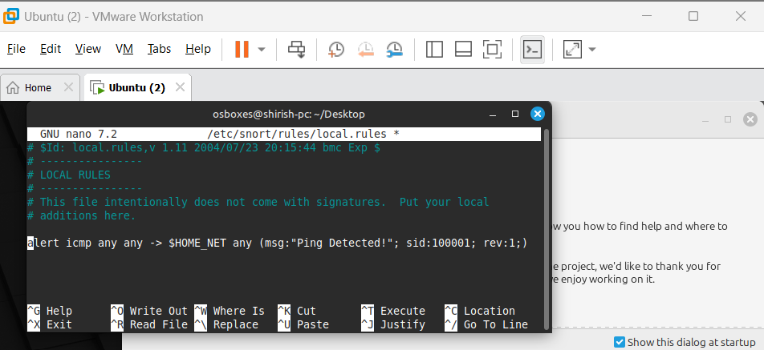

$sudo snort -q -l /var/log/snort -i ens33 -A console -c /etc/snort/snort.conf
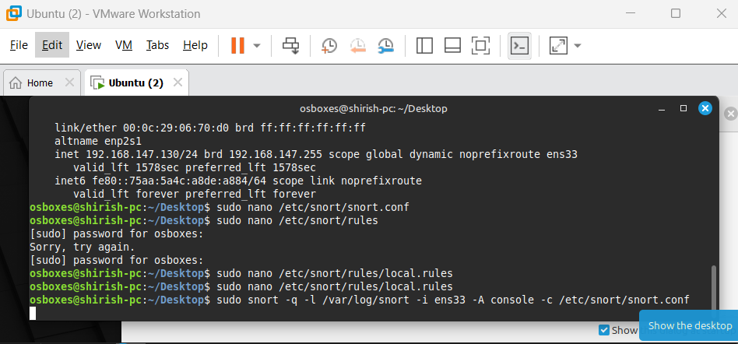
This command starts Snort to monitor live network traffic on ens33, apply detection rules from the configuration file, display alerts on the screen, and log them to /var/log/snort.
To do this we need any different machine to ping to this virtual ubuntu machine.

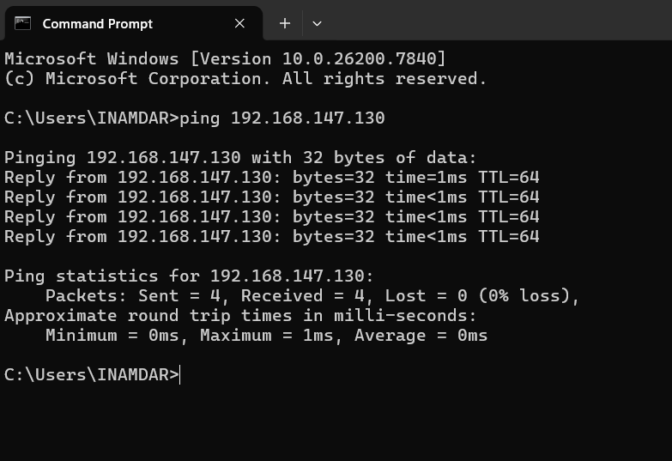

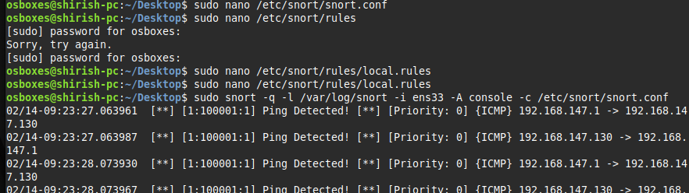
The alert was successfully generated, confirming proper rule functionality.
Port Scan Detected
An additional demonstration of port scan detection was conducted using the Kali system (192.168.147.131) to perform an Nmap scan against the Ubuntu host (192.168.147.130), where the Snort NIDS was actively monitoring network traffic. The following rule was added to the Snort configuration to detect repeated SYN packets indicative of reconnaissance activity:
alert tcp any any -> $HOME_NET any (flags:S; threshold:type threshold, track by_src, count 5, seconds 10; msg:"Possible Port Scan Detected"; sid:100002; rev:1;)
Once the rule was applied and Snort was restarted, the system successfully generated alerts upon detecting the scan, confirming effective port scan detection within the lab environment.

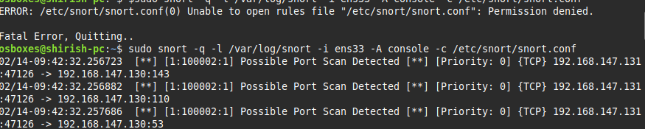

Key Points:
- Additional routers and switches will be stored in DCO storage temporarily until Phase 1/HVAC work is completed.
- Documentation of usage/need for the routers, switches, desktops and machines with respect to courses is under progress.
- AA449 will accommodate workstations and PCs, while AA426 is planned to eventually host the malware detonation chamber (currently at the conceptual stage).

Future work:
- The secure lab network design is being updated to include the requested equipment (routers, switches, PCs, and laptops) and refinements. The revised version will be completed and shared shortly.
- Started documenting the Dell PowerEdge Servers and configurations of honeypot, Snort server for malware analysis.
- Started with Pfsense firewall and Metasploitable configuration and will be installed soon and will be connected to Dell PowerEdge 2950 server.
- Forensic Data Acquisition - Hardware Write Blockers. Experimenting with Tableau section of working with write blockers.
- Studying and implementing the timeline analysis from the wireshark SANS GCFA documentation.
- Supporting students with appointments with lab sessions/tutoring for cybersecurity labs and other course projects as well.
- Building an AI Security Operations Center on Campus and specialized lab setups for IT and cybersecurity courses, including malware analysis, forensics investigations, red/blue team CTF exercises, CISCO networking practice, and high-performance AI sandbox workstations.
- Continue with Malware analysis exercises with Wireshark and Autopsy.

