Weekly Status Report: Feb 02 – Feb 06, 2026
Shirish Inamdar
TA / Lab Support Specialist
Northern Virginia Community College
Supervisor: Prof. Mun-Wai Hon

Host based IDS Tripwire in Kali Linux Installation
Tripwire is a host based Intrusion Detection System for Linux. Tripwire monitors Linux system to detect and report any unauthorized changes to the files and directories. Once the baseline is created, tripwire monitors and detects, which file is changed, what is changed , who changed it , and when it was changed . If the changes are legitimate, you can update the tripwire database to accept these changes.
Started with Linux kali machine
1. Install and create site key and local passphrase:
$sudo apt-get install tripwire
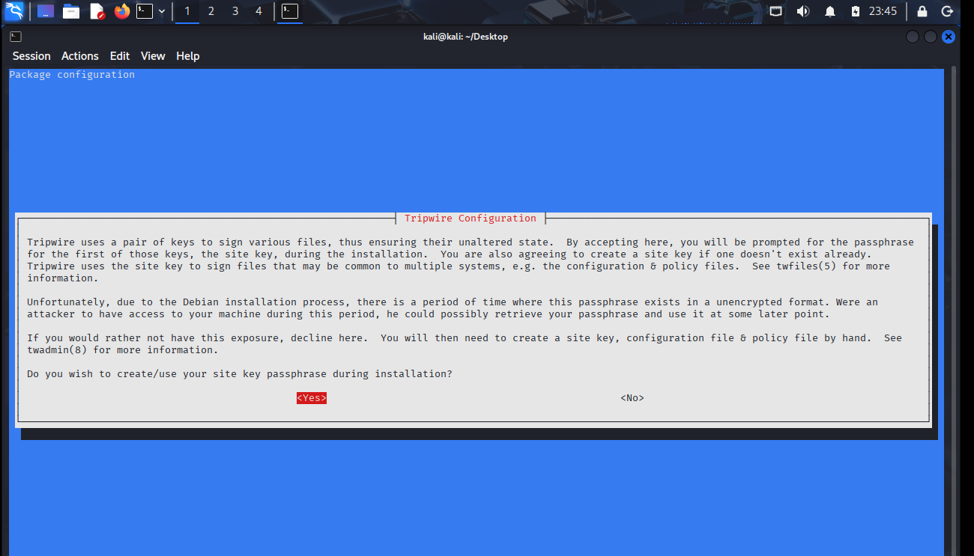
abcd- sitekey passphrase and 1234 as local key passphrase
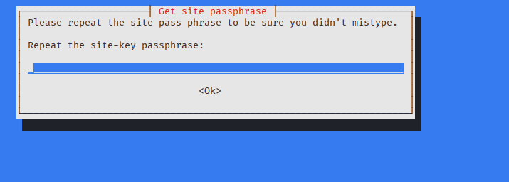
2. Create keys and initialize database:-
cd /etc/tripwire

Generate config:
twadmin -m F -c tw.cfg -S site.key twcfg.txt
and enter your passphrase which is abcd
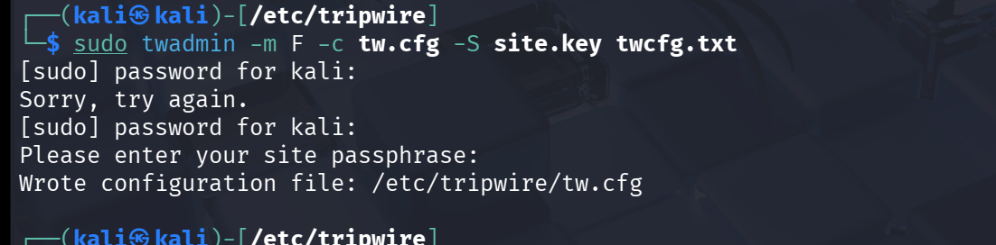
We will also look at the twpol.txt configuration file here. Anything which is not commented out is monitoring phase.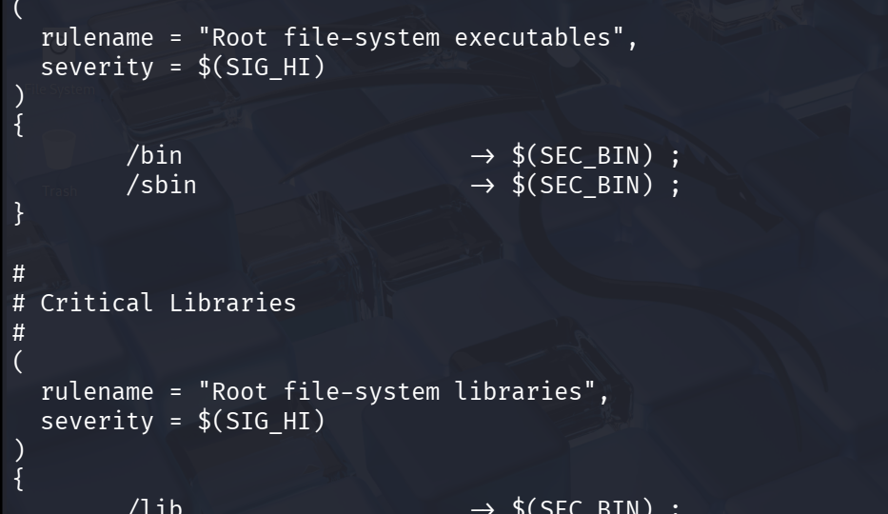
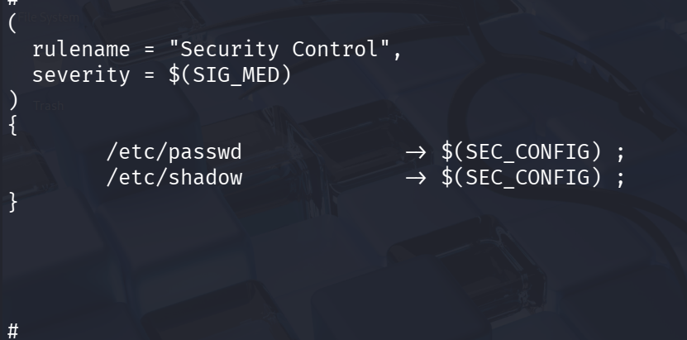
Next run the following commands to create the tripwire policy file and the tripwire database:
$sudo twadmin --create-polfile --cfgfile ./tw.cfg --site-keyfile ./site.key ./twpol.txt
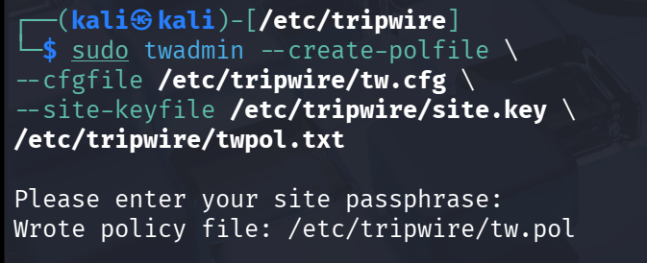
for database:
$sudo tripwire --init --cfgfile /etc/tripwire/tw.cfg --polfile /etc/tripwire/tw.pol --site-keyfile /etc/tripwire/site.key --local-keyfile /etc/tripwire/ubuntu-local.key
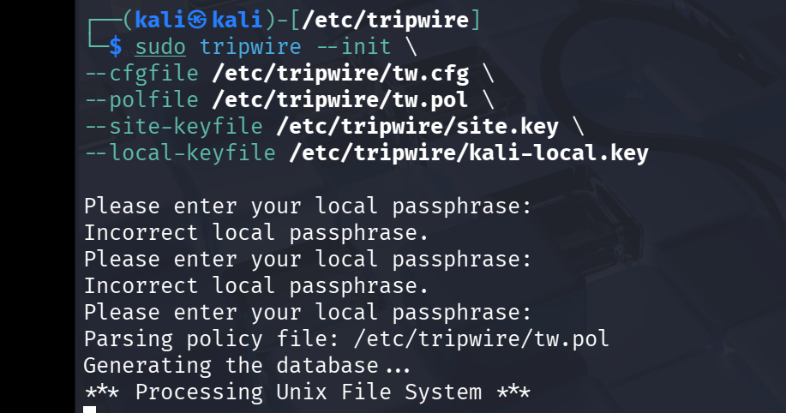

This has created the tripwire integrity database, which contains the filesystem snapshot or baseline. This will then be used as a reference point for all file integrity verifications.
3. Run a Tripwire Filesystem Check
For observation and as an example to test if out policy for File Integrity is working , For file /etc/passwd we will change the owner to newly created user shirish with a command : in etc folder,
$ sudo chown shirish:shirish passwd
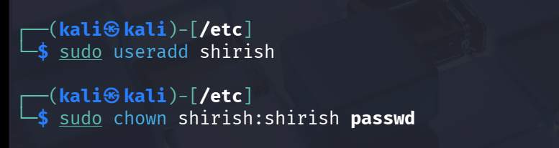
We will also go to /tmp folder and change the ownership of one of the files.
$sudo chown shirish:shirish VMwareDnD
Next run a filesystem integrity check with Tripwire
$sudo tripwire –check
and we see the tripwire report for any file modifications is present or not. 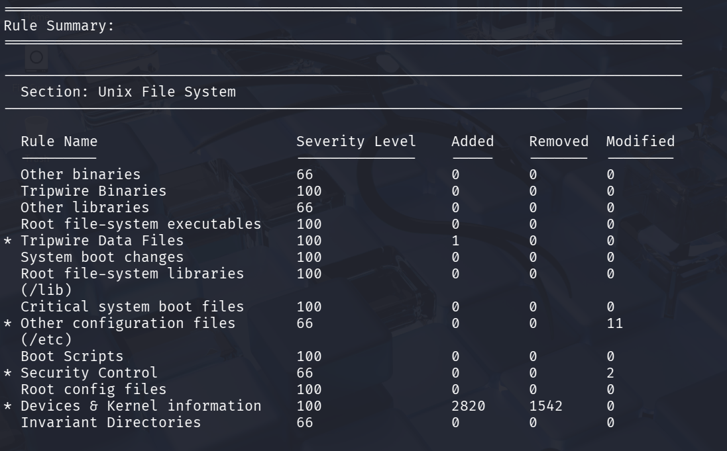 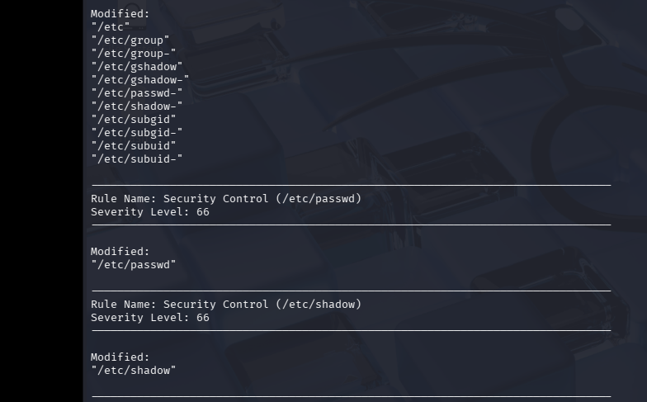
Also we can see that our file /etc/passwd was modified here as well in the reporṭ but not /tmp file because we are not set a watchlist enabled to that in twpol.txt file.
Key Points:
- Additional routers and switches will be stored in DCO storage temporarily until Phase 1/HVAC work is completed.
- Documentation of usage/need for the routers, switches, desktops and machines with respect to courses is under progress.
- AA449 will accommodate workstations and PCs, while AA426 is planned to eventually host the malware detonation chamber (currently at the conceptual stage).

Future work:
- The secure lab network design is being updated to include the requested equipment (routers, switches, PCs, and laptops) and refinements. The revised version will be completed and shared shortly.
- Started documenting the Dell PowerEdge Servers and configurations of honeypot, Snort server for malware analysis.
- Started with Pfsense firewall and Metasploitable configuration and will be installed soon and will be connected to Dell PowerEdge 2950 server.
- Forensic Data Acquisition - Hardware Write Blockers. Experimenting with Tableau section of working with write blockers.
- Studying and implementing the timeline analysis from the wireshark SANS GCFA documentation.
- Supporting students with appointments with lab sessions/tutoring for cybersecurity labs and other course projects as well.
- Building an AI Security Operations Center on Campus and specialized lab setups for IT and cybersecurity courses, including malware analysis, forensics investigations, red/blue team CTF exercises, CISCO networking practice, and high-performance AI sandbox workstations.
- Continue with Malware analysis exercises with Wireshark and Autopsy.

