Ophcrack : Password Cracking
Ophcrack is a tool used to recover Windows passwords by cracking their hashes, not by guessing passwords directly.
Windows stores passwords as LM or NTLM hashes in the SAM database, not in plain text. Ophcrack extracts these hashes and compares them against rainbow tables—precomputed lists that map common hashes back to their original passwords. If a match exists, the password is recovered quickly.
It works best on weak or common passwords and requires offline access (usually via a bootable USB).

For this the target machine I used is Dell Precision M70 containing Win XP OS.
I had the bootable drive which contained ISO of ophcrack for Win XP and 7.
- First, I created a user named IETNOVA with limited permissions and gave password as : computer
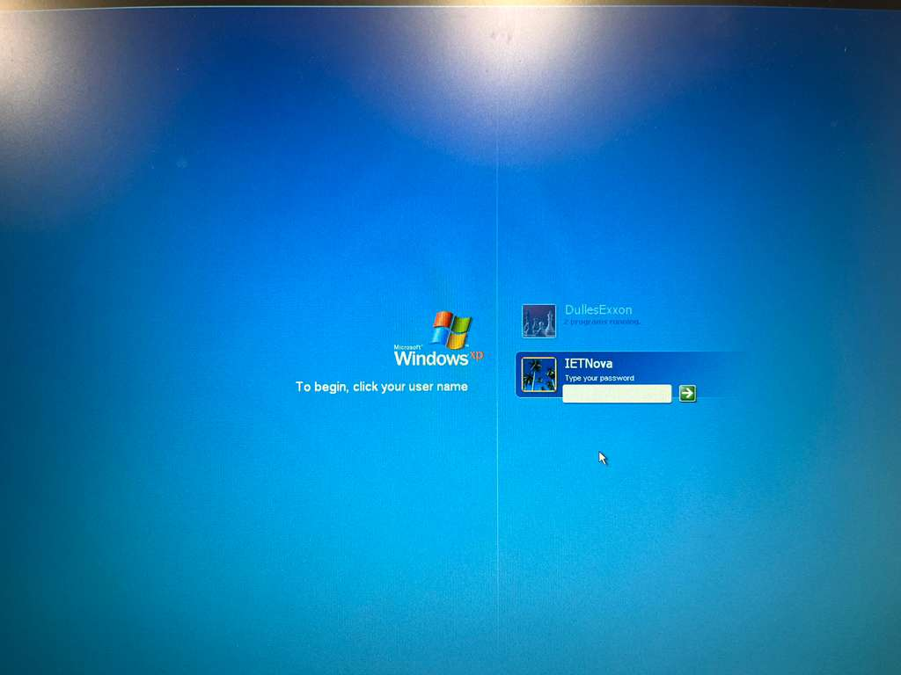

- Next was to boot from USB drive to change setup in BIOS: USB Storage device.
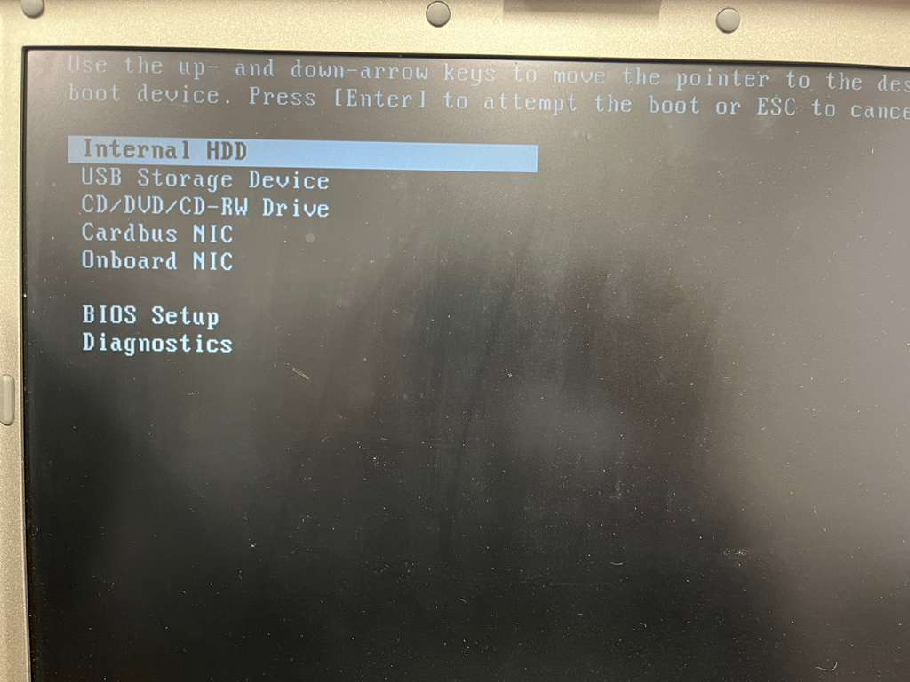
- The initial screen of ophcrack and after this the setup was began for finding all the users and cracking them.
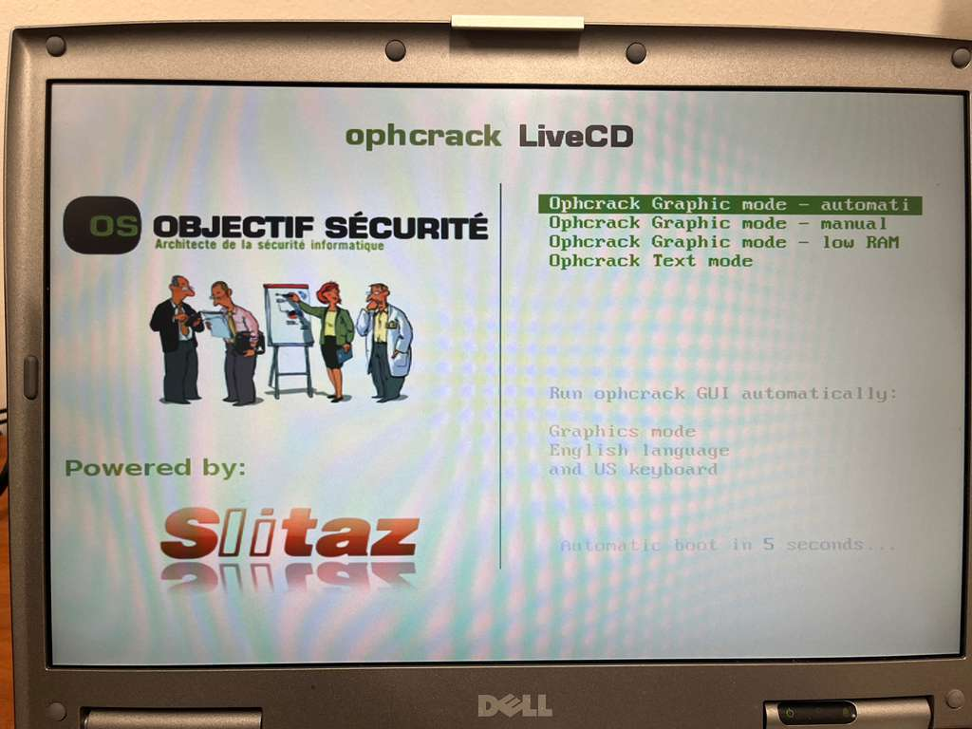
Ophcrack successfully located the Windows SAM database at C:\WINDOWS\system32\config\SAM and extracted the user account hashes. Using pre-loaded rainbow tables, it recovered the plaintext password "computer" for the user IETNova in just over five minutes.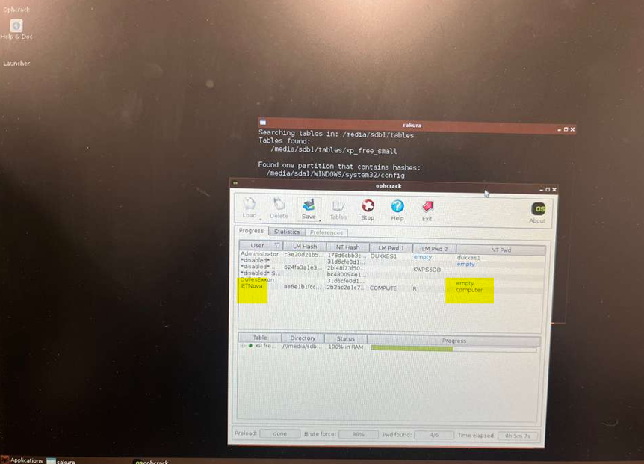
Key Points:
- Additional routers and switches will be stored in DCO storage temporarily until Phase 1/HVAC work is completed.
- Updated diagrams of the lab setup are being prepared and will be shared shortly.
- AA449 will accommodate workstations and PCs, while AA426 is planned to eventually host the malware detonation chamber (currently at the conceptual stage).

