Weekly Status Report: March 16 – March 20, 2026
Shirish Inamdar
TA / Lab Support Specialist
Northern Virginia Community College
Supervisor: Prof. Mun-Wai Hon

Overview
This week's work focused on three main tasks:
- Installing and verifying the Apache HTTP Server on an Ubuntu system using the apt package manager.
- Creating a custom website directory and writing a basic HTML page to serve via Apache.
- Configuring a VirtualHost file to route a custom domain to the new site, enabling multi-site hosting on a single server.
- Completing the Flipper Zero ppt presentation.

Installing Apache on Ubuntu
The first step was to update the package index and install Apache using Ubuntu's built-in package manager. This ensures all dependencies are resolved automatically and the latest stable release is installed.

The following two commands were run in sequence:
sudo apt update
sudo apt install apache2

After the installation completed, the Apache service started automatically. To verify the server was running correctly, the server's IP address( your IP address check via $ifconfig) was entered into a web browser. The default Apache welcome page loaded successfully, confirming the web server was operational.
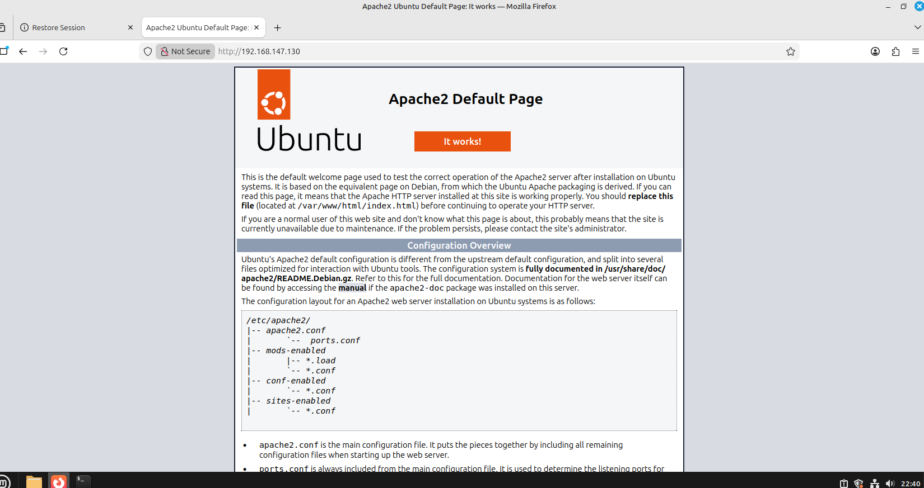
Figure 1 — Default Apache welcome page confirming successful installation on Ubuntu.
The Apache service status can be checked at any time with: sudo systemctl status apache2
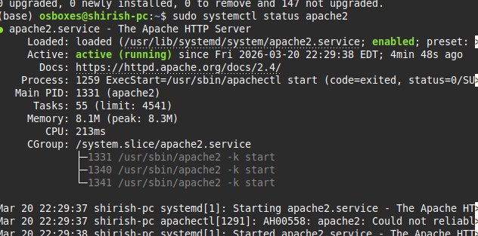

Creating the Website Directory & HTML Page
By default, Apache serves content from /var/www/html. For this setup, a new directory was created under /var/www/ to host a separate site. This keeps the default Apache site untouched and demonstrates multi-site capability.

Creating the Directory
A new folder was created for the site using the following command:
sudo mkdir /var/www/gci/

Writing the HTML Page
The terminal was navigated into the new directory and the nano text editor was used to create an index.html file:
cd /var/www/gci/
sudo nano index.html

The following HTML was written into the file and saved:
<html>
<head>
<title> Northern Virginia Community College </title>
</head>
<body>
<p> I'm running this website on an Ubuntu Server!</p>
</body>
</html>
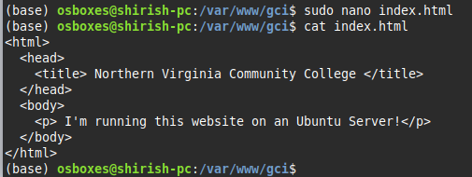
Figure 2 — index.html file created in /var/www/gci/ using the nano text editor.

Setting Up the VirtualHost Configuration File
Apache stores available site configurations in /etc/apache2/sites-available/. The default configuration file was used as a base and copied to a new file named gci.conf to match the subdomain being configured.

Navigating to the Config Directory
cd /etc/apache2/sites-available/

Copying the Default Config
sudo cp 000-default.conf gci.conf

Editing the Config File
The new file was opened for editing with: sudo nano gci.conf

Three directives were added or updated inside the file:

1. ServerAdmin — set to a contact email so users can reach the administrator if Apache encounters an error:
ServerAdmin yourname@example.com

2. DocumentRoot — updated to point to the new site directory:
DocumentRoot /var/www/gci/

3. ServerName — added as a new line (not present in the default file) to tell Apache which domain maps to this VirtualHost:
ServerName gci.example.com

The file was saved and nano was exited using Ctrl+O, Enter, then Ctrl+X.
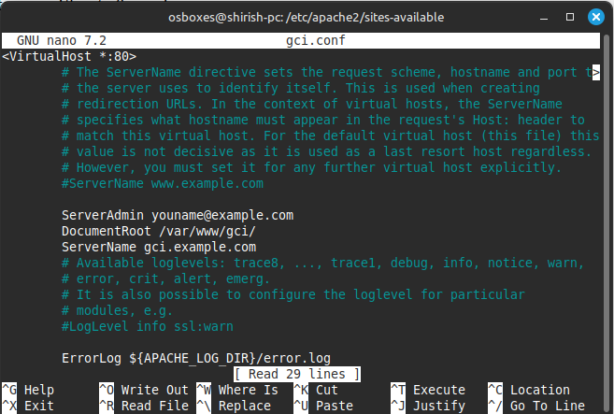
Figure 3 — gci.conf VirtualHost configuration file with ServerAdmin, DocumentRoot, and ServerName directives configured.

Activating the VirtualHost & Reloading Apache
The a2ensite utility was used to activate the new configuration file:
sudo a2ensite gci.conf

The terminal confirmed the site was enabled and prompted to reload Apache. The reload command was run to apply the changes:
sudo service apache2 reload
The terminal confirmed the site was enabled and prompted to reload Apache. The reload command was run to apply the changes:
sudo service apache2 reload
Next Step, edit your hosts file. This fakes DNS locally on your own machine only.
sudo nano /etc/hosts
Add this line at the bottom (replace with your actual server IP):
192.168.x.x gci.example.com
To verify the result, the hostname gci.example.com was entered into a browser. The custom HTML page loaded correctly, confirming the VirtualHost was routing traffic to the right directory.
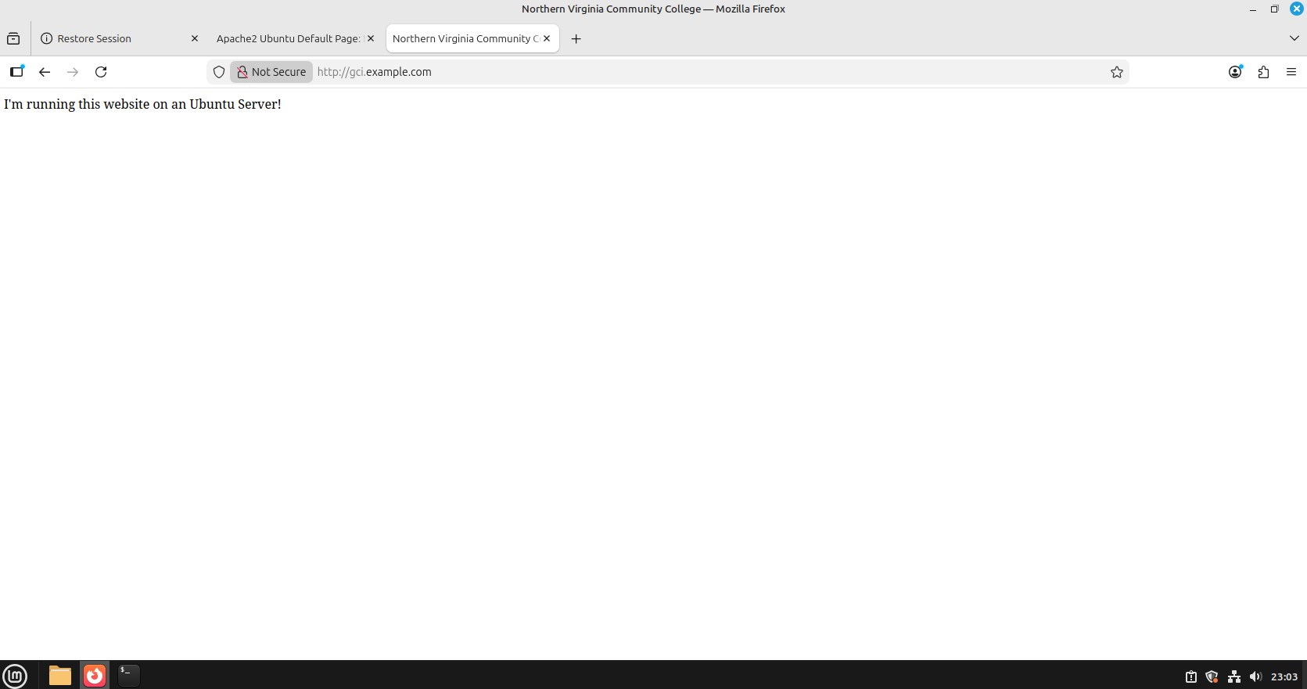

Figure 4 — Browser showing the custom website hosted at gci.example.com after VirtualHost activation.

Future Work
- AA449 will accommodate workstations and PCs, while AA426 is planned to eventually host the malware detonation chamber (currently at the conceptual stage).
- The secure lab network design is being updated to include the requested equipment (routers, switches, PCs, and laptops) and refinements. The revised version will be completed and shared shortly.
- Started with Pfsense firewall and Metasploitable configuration and will be installed soon and will be connected to Dell PowerEdge 2950 server.
- Forensic Data Acquisition - Hardware Write Blockers. Experimenting with Tableau section of working with write blockers.
- Studying and implementing the timeline analysis from the wireshark SANS GCFA documentation.
- Supporting students with appointments with lab sessions/tutoring for cybersecurity labs and other course projects as well.
- Building an AI Security Operations Center on Campus and specialized lab setups for IT and cybersecurity courses, including malware analysis, forensics investigations, red/blue team CTF exercises, CISCO networking practice, and high-performance AI sandbox workstations.
- Continue with Malware analysis exercises with Wireshark and Autopsy.

