Weekly Status Report: Feb 16 – Feb 20, 2026
Shirish Inamdar
TA / Lab Support Specialist
Northern Virginia Community College
Supervisor: Prof. Mun-Wai Hon

Part 1 - Cuckoo Sandbox : Installation
We will be preparing a complete environment for Cuckoo Sandbox, which includes installing essential system libraries, databases like MongoDB and PostgreSQL, and managing Python versions using Anaconda.

This setup ensures that Cuckoo can run safely in isolated environments, execute and monitor suspicious files or URLs, collect detailed malware behavior data, and store results in a database for analysis. We are building the full foundation needed to perform automated, secure malware testing.

1. Ubuntu Machine and Install all libraries
Essential dependencies like libffi, libssl, and swig are needed for Python modules and secure operations in Cuckoo.
sudo apt update
sudo apt install libffi-dev libssl-dev libjpeg-dev zlib1g-dev swig
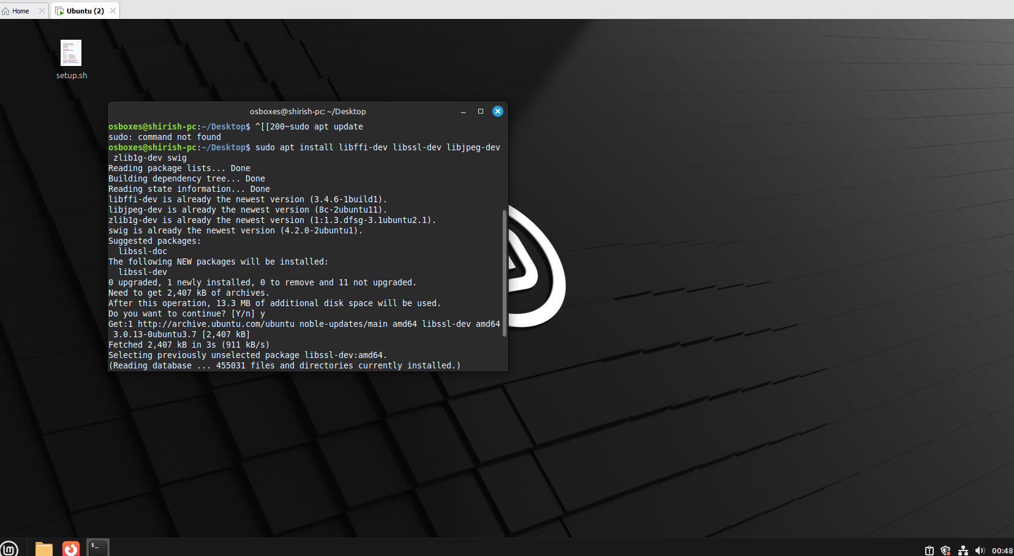
2. Install MongoDB on Linux Mint 22.1 (Based on Ubuntu 24.04)
MongoDB acts as a database backend for storing analysis results. Installing and enabling it ensures Cuckoo can save and query data.
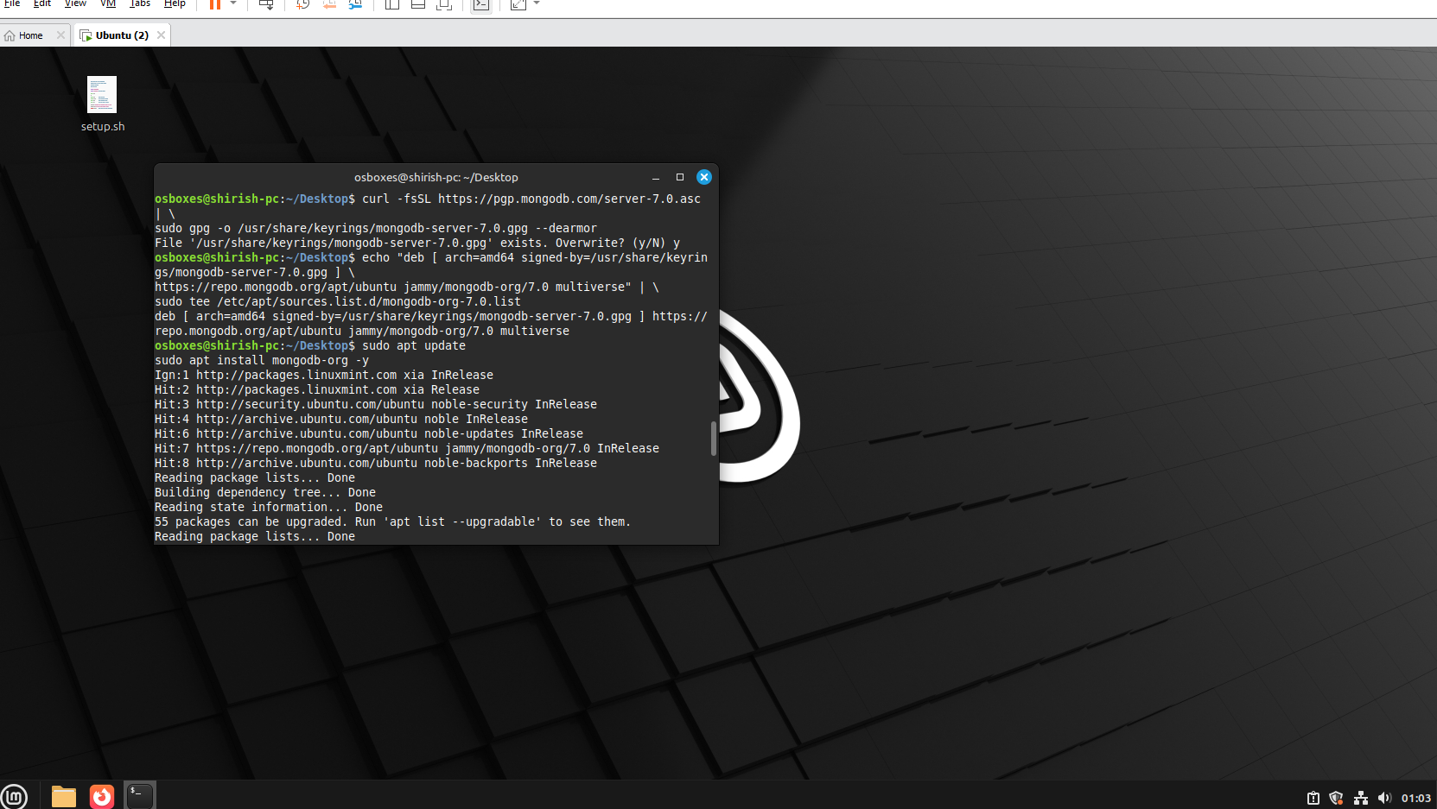
Install required tools
sudo apt update
sudo apt install curl gnupg -y

Import MongoDB GPG key
curl -fsSL https://pgp.mongodb.com/server-7.0.asc | \
sudo gpg -o /usr/share/keyrings/mongodb-server-7.0.gpg --dearmor

Add MongoDB repository (use jammy repo)
echo "deb [ arch=amd64 signed-by=/usr/share/keyrings/mongodb-server-7.0.gpg ] \
https://repo.mongodb.org/apt/ubuntu jammy/mongodb-org/7.0 multiverse" | \
sudo tee /etc/apt/sources.list.d/mongodb-org-7.0.list
Update and install
sudo apt update
sudo apt install mongodb-org -y
Start MongoDB
sudo systemctl start mongod
sudo systemctl enable mongod
sudo systemctl status mongod
3. Install PostgreSQL
Optional for advanced Cuckoo features, especially if you want to use PostgreSQL instead of SQLite for VM metadata and reporting.
sudo apt install postgresql libpq-dev -y
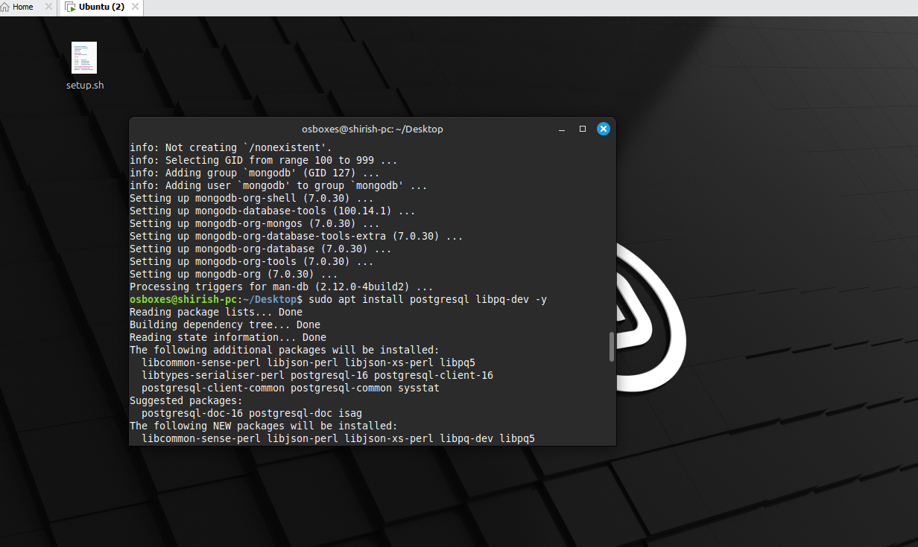
We need Anaconda and Python because Cuckoo Sandbox is built on Python and requires specific versions and libraries to run correctly. Anaconda allows us to create isolated Python environments, so Cuckoo can use the exact Python version it needs (like 2.7) without conflicting with the system Python or other software. It also simplifies managing dependencies and packages, ensuring a stable and controlled setup for malware analysis.
4. Download Anaconda Python 3.7 for Linux 64-bit
Run the bash script
curl -O https://repo.anaconda.com/archive/Anaconda3-2025.12-2-Linux-x86_64.sh
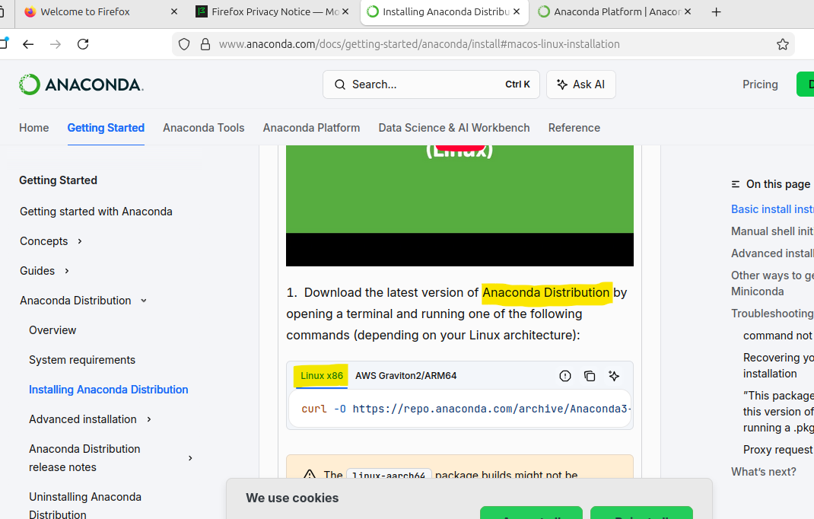
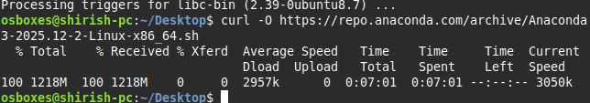

5. Update conda
Updates all packages and dependencies to ensure a stable, secure, and compatible environment for running Cuckoo Sandbox
conda update --all
wget https://repo.anaconda.com/miniconda/Miniconda3-latest-Linux-x86_64.sh
Do you wish to initialize Miniconda3?
Yes
~/miniconda3/bin/conda init bash
Then close the terminal completely and open a new one.
conda –version
Then type,
conda update conda
Yes to update packages
6. Add all version of python to anaconda environment
conda search python
conda install anaconda-navigator
Anaconda-navigator
Navigator GUI would open
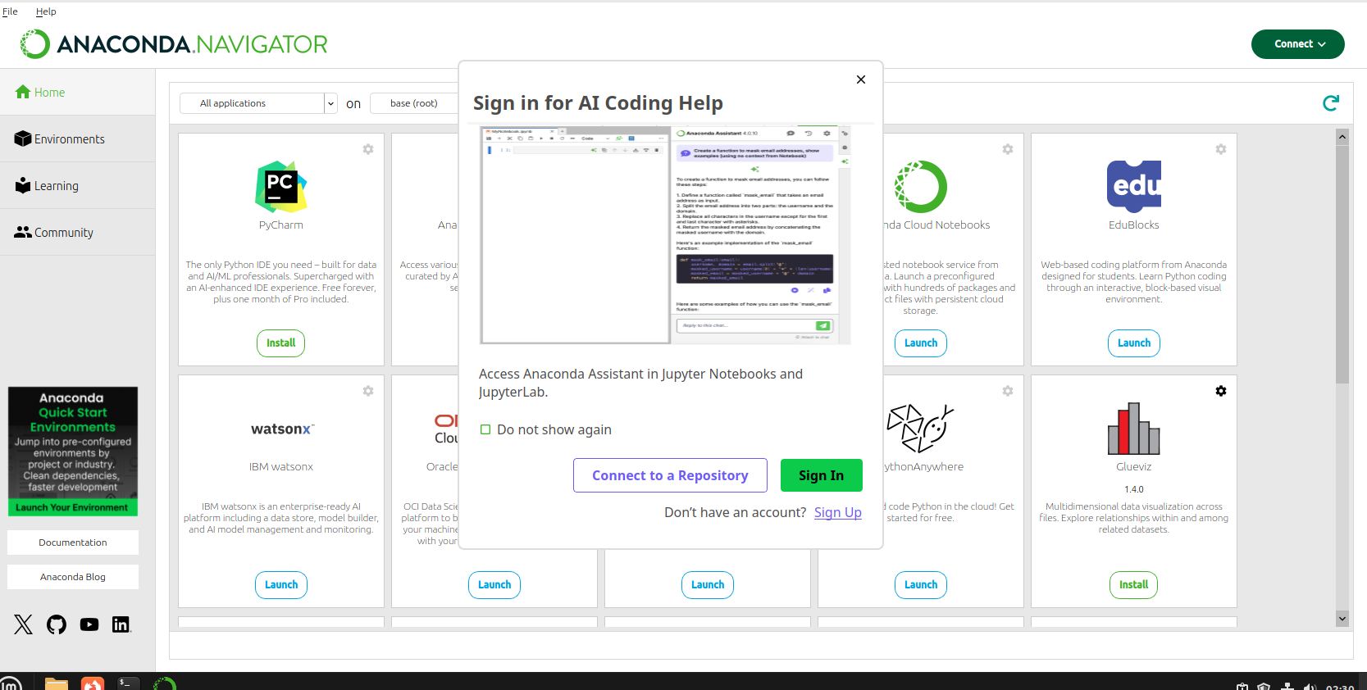
Create python 3.10 environment
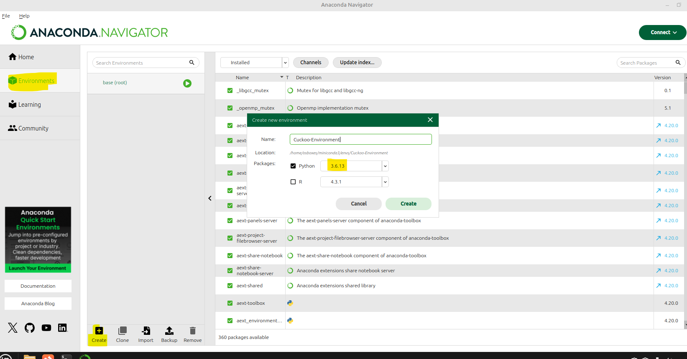
Enter into the environment( Cuckoo_Sandbox) by terminal
7. Install setuptools and cuckoo using pip
conda create -n cuckoo2 python=2.7
conda activate cuckoo2
pip install -U cuckoo
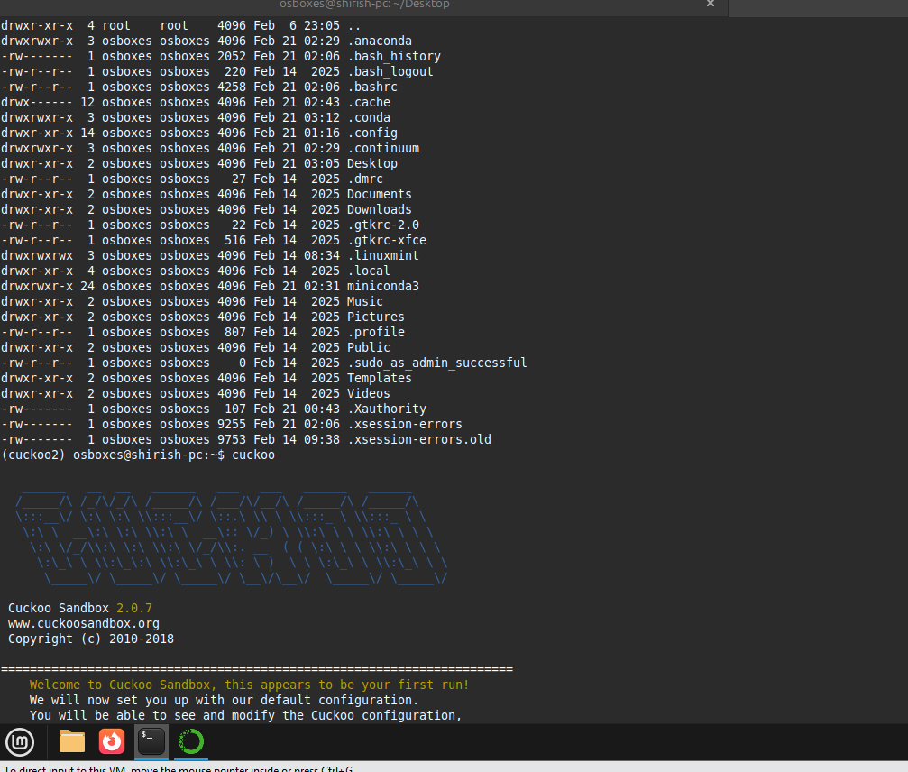
Type cuckoo to see if this is installed.

8. Cuckoo main configuration for general behavior analysis option
Cuckoo sandbox has configuration file cuckoo.conf to know where to store data, how to run VMs safely, and how to analyze malware properly.

9. Enable mongodb = yes in reporting.conf before run cuckoo webserver
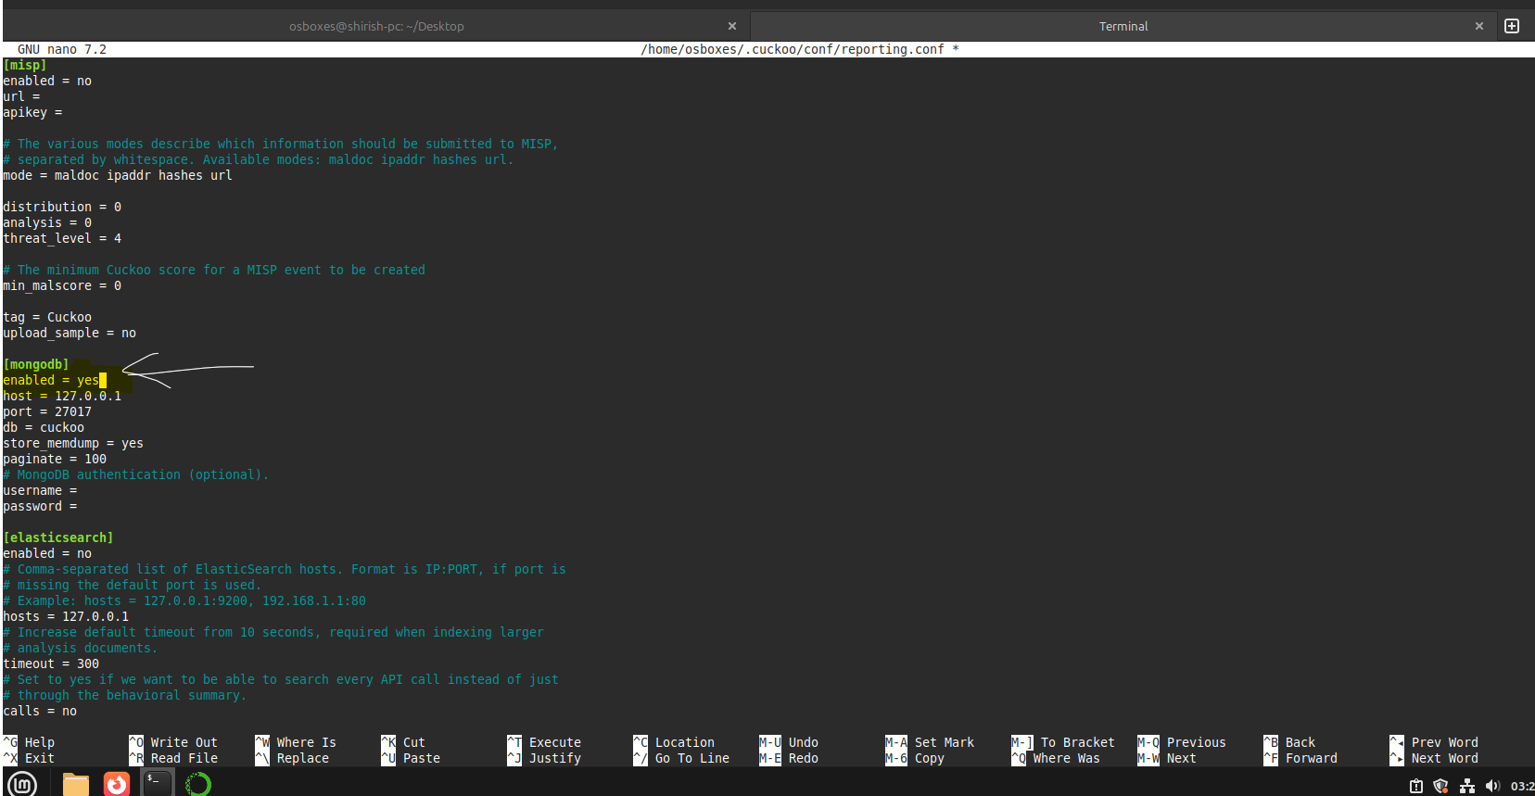
Next part will be more of Adding the file in GUI of Cuckoo Sandbox and malware analysis. UI had few error while opening but will be covered in next part.
Future work:
- Started documenting project for Hacking with Raspberry Pi project and Flipper zero demonstration.
- AA449 will accommodate workstations and PCs, while AA426 is planned to eventually host the malware detonation chamber (currently at the conceptual stage).

- The secure lab network design is being updated to include the requested equipment (routers, switches, PCs, and laptops) and refinements. The revised version will be completed and shared shortly.
- Started with Pfsense firewall and Metasploitable configuration and will be installed soon and will be connected to Dell PowerEdge 2950 server.
- Forensic Data Acquisition - Hardware Write Blockers. Experimenting with Tableau section of working with write blockers.
- Studying and implementing the timeline analysis from the wireshark SANS GCFA documentation.
- Supporting students with appointments with lab sessions/tutoring for cybersecurity labs and other course projects as well.
- Building an AI Security Operations Center on Campus and specialized lab setups for IT and cybersecurity courses, including malware analysis, forensics investigations, red/blue team CTF exercises, CISCO networking practice, and high-performance AI sandbox workstations.
- Continue with Malware analysis exercises with Wireshark and Autopsy.

