Weekly Status Report: March 02 – March 06, 2026
Shirish Inamdar
TA / Lab Support Specialist
Northern Virginia Community College
Supervisor: Prof. Mun-Wai Hon

Overview: Hands-on activity with the Flipper Zero
Key milestones included receiving the SD card, installing firmware, and exploring several built-in features including Infrared (IR) control and NFC scanning.

2. Hardware & Firmware Setup

2.1 SD Card Received & Installed
Upon receiving the SD card, it was formatted and inserted into the Flipper Zero. The device recognized it immediately and prompted for firmware installation.

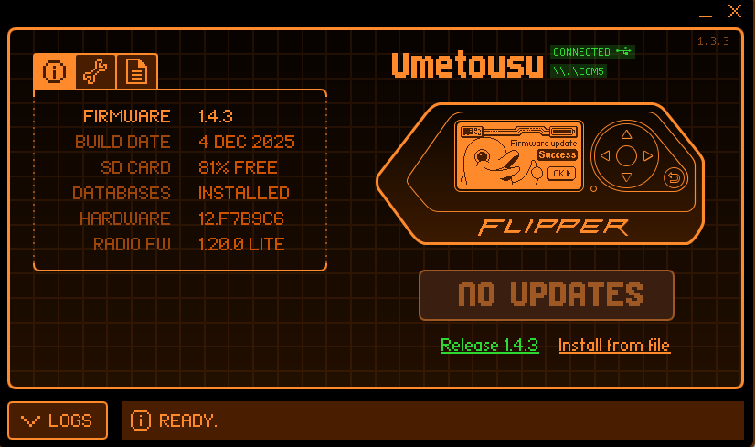
Figure 1 – SD card detection on Flipper Zero
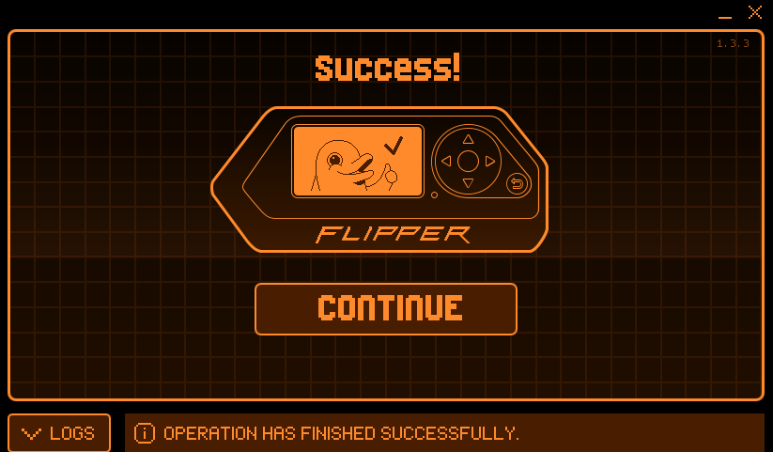
Figure 2 – Firmware installation in progress

2.2 Firmware Installation
The latest official firmware was flashed successfully via the qFlipper desktop application. Post-install, the device rebooted and all modules were confirmed operational.

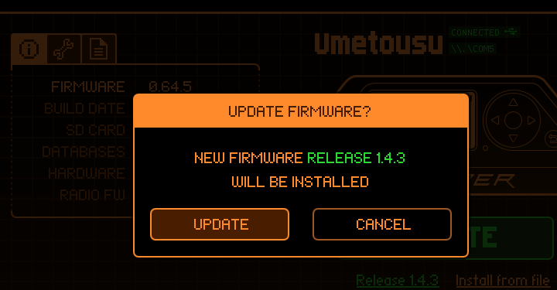
Figure 3 – Firmware version confirmed after install
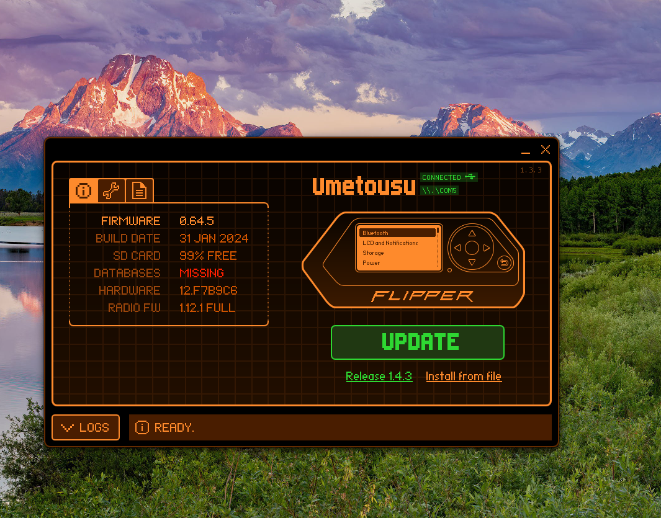
Figure 4 – Flipper Zero main menu post-firmware
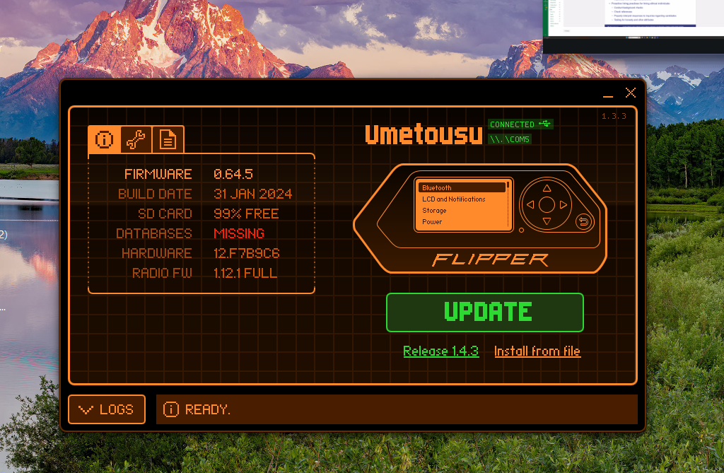
Figure 5 – File system view on SD card
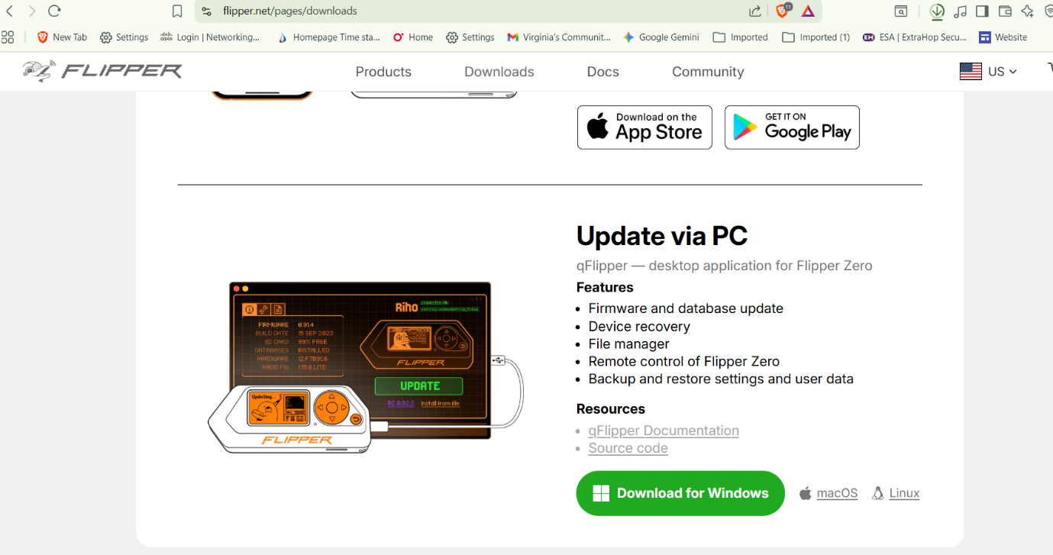
Figure 6 – Settings and system info screen

3. Infrared (IR) Feature
The Infrared module on the Flipper Zero offers a powerful set of options for controlling IR-enabled devices. The following capabilities were explored this week:

3.1 Projector Control
The Flipper Zero was used to successfully control a projector using the Universal Remote feature. IR signals were sent and the projector responded to power, input switching, and volume commands.

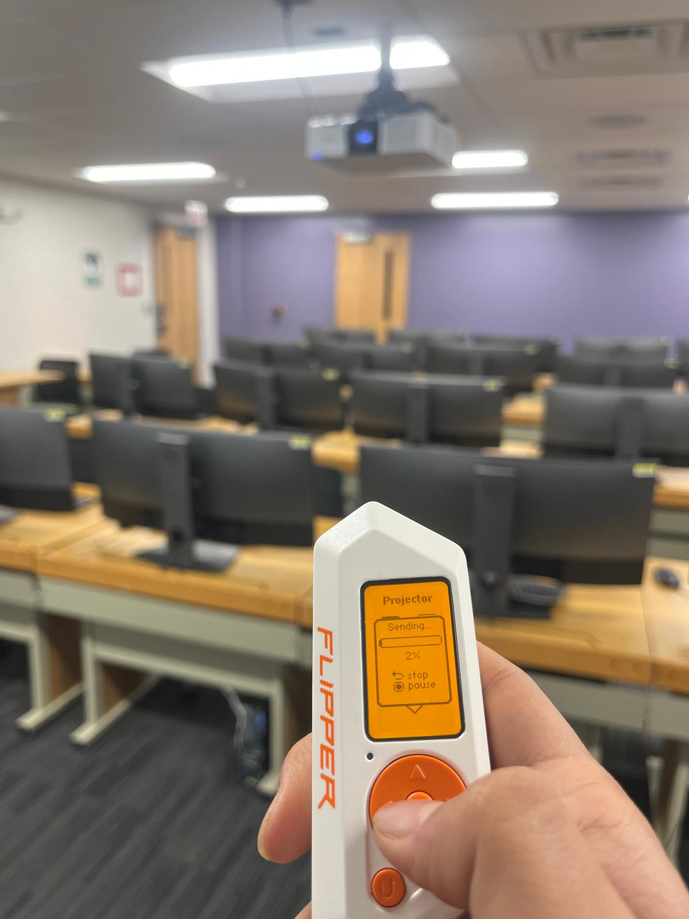
Figure 7 – Flipper Zero sending IR signal to projector
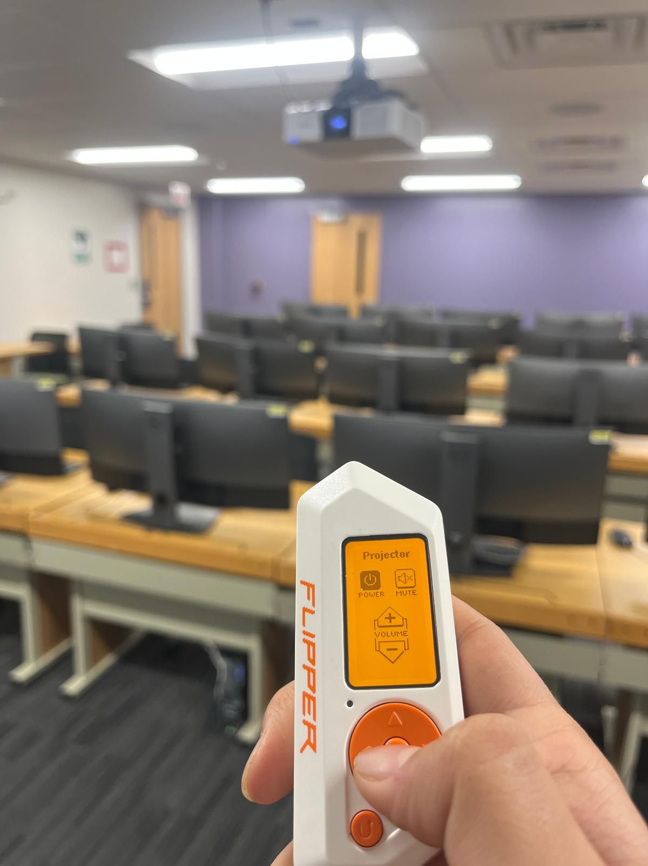
Figure 8 – Projector responding to IR command
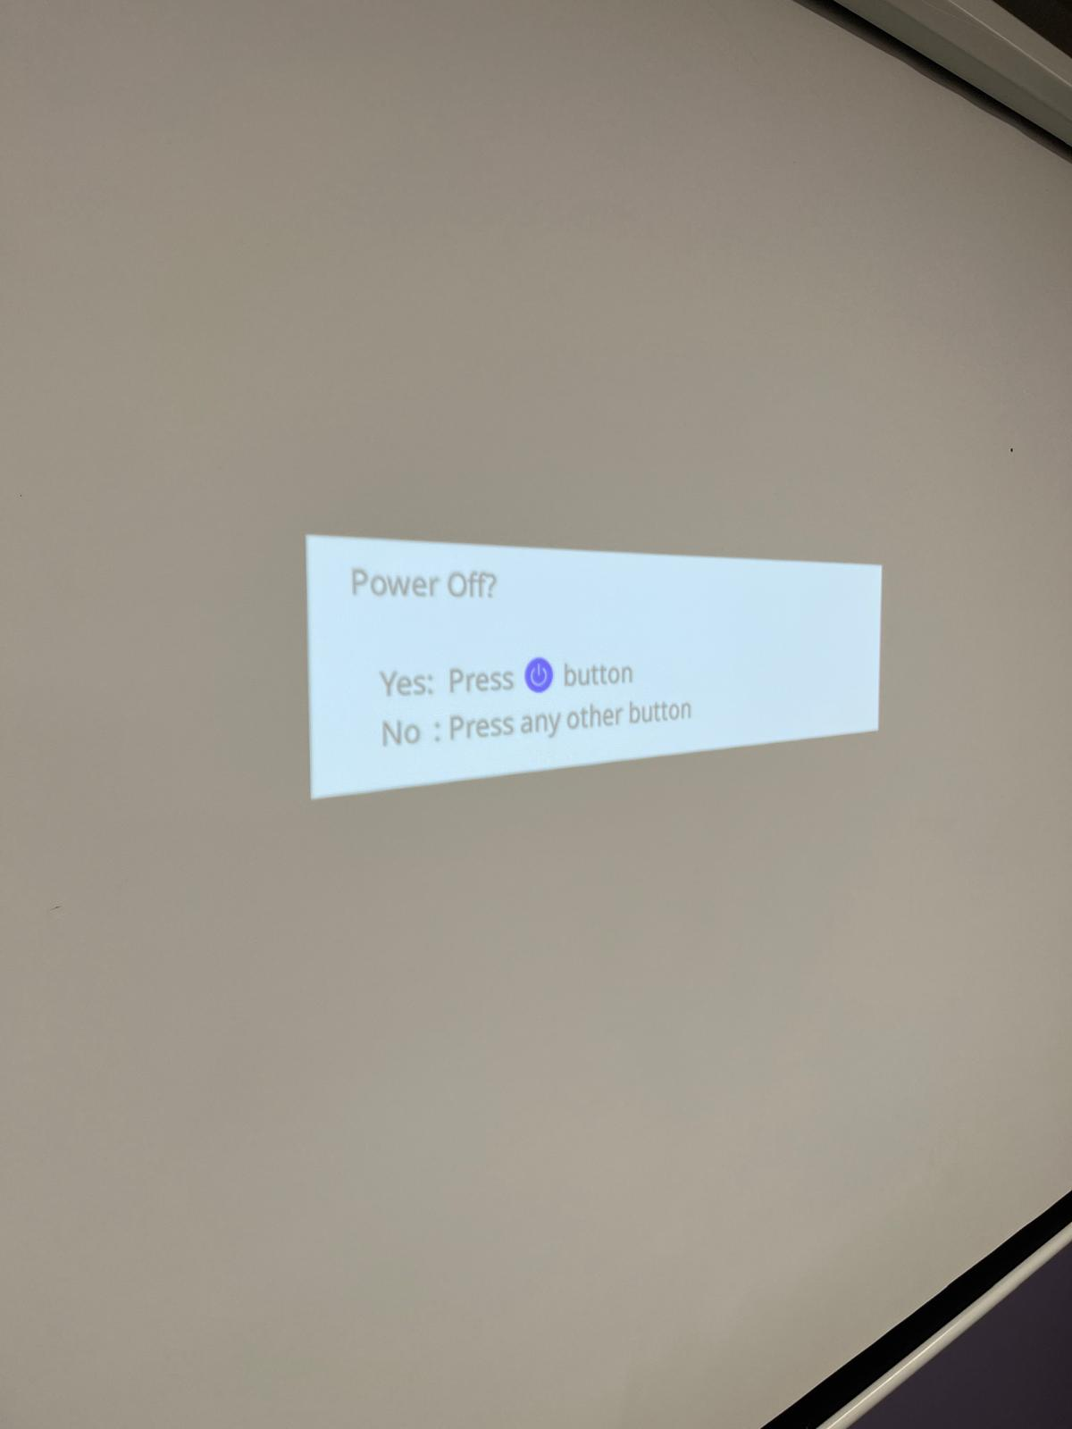
Figure 9 – IR remote interface on Projector Screen

3.2 TV Control
The same process was applied to a TV. The Flipper Zero successfully sent IR commands and the TV responded to all tested functions, including power toggle, volume, and channel control.

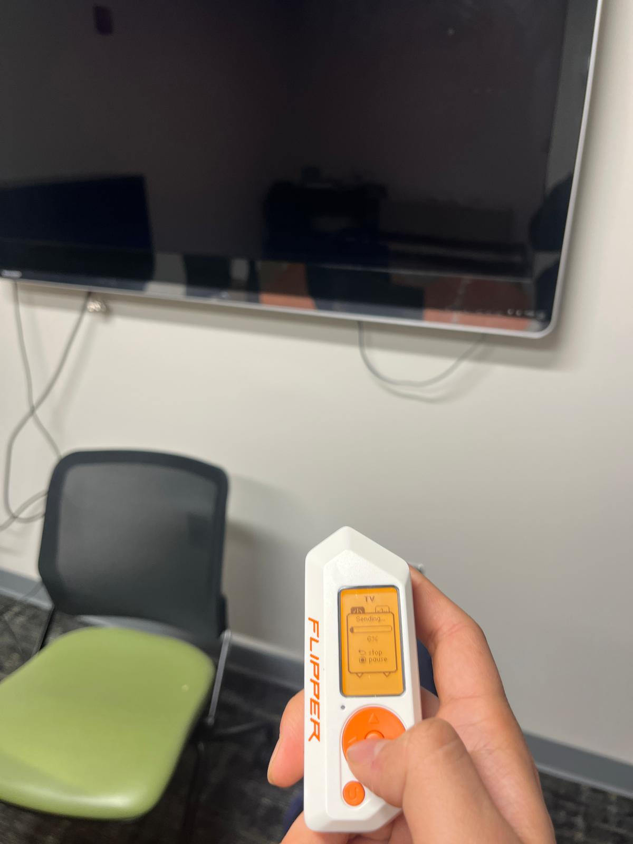
Figure 10 – TV control via Flipper Zero IR module

4. NFC Feature
The Flipper Zero supports reading, saving, and emulating NFC cards. A test scan was performed as a demonstration; however, the card data was not saved as this was purely exploratory.

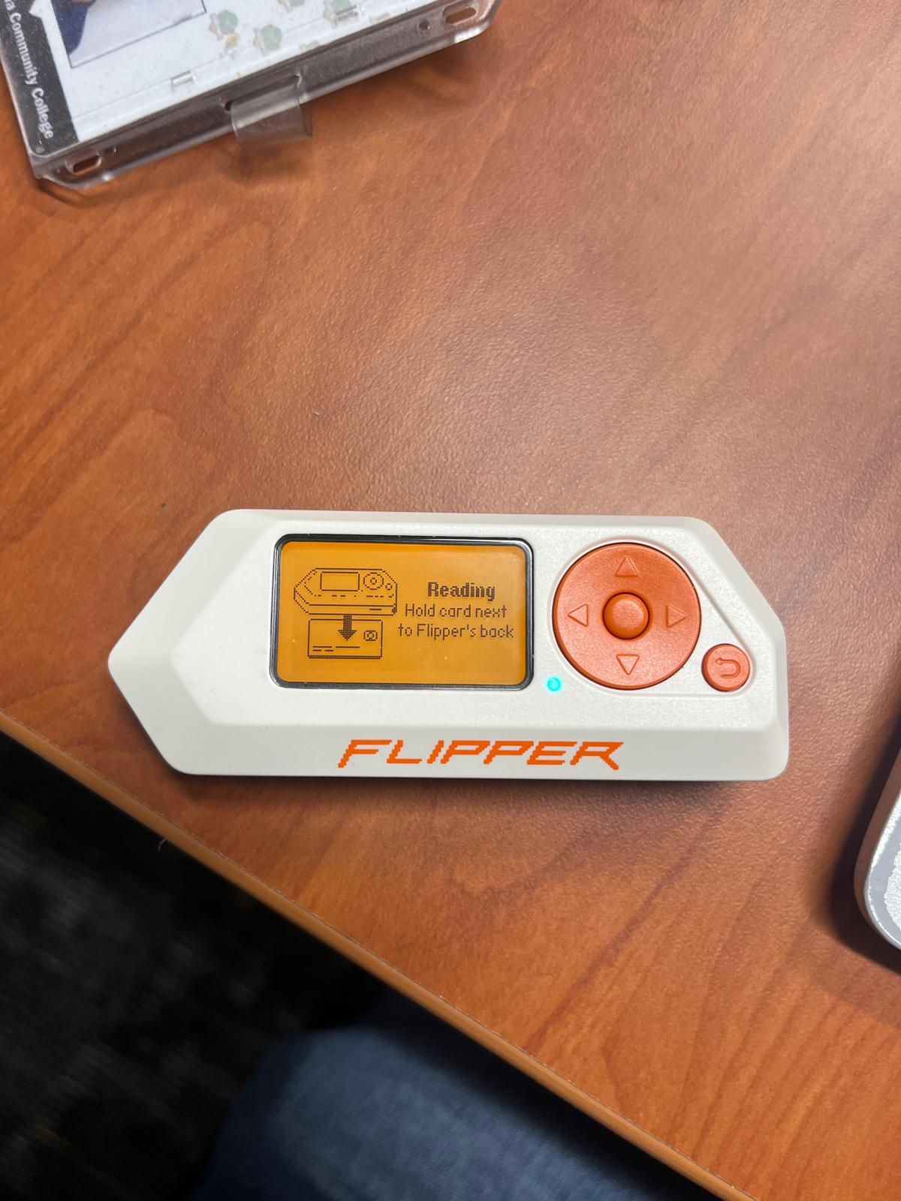
Figure 11 – NFC scan in progress
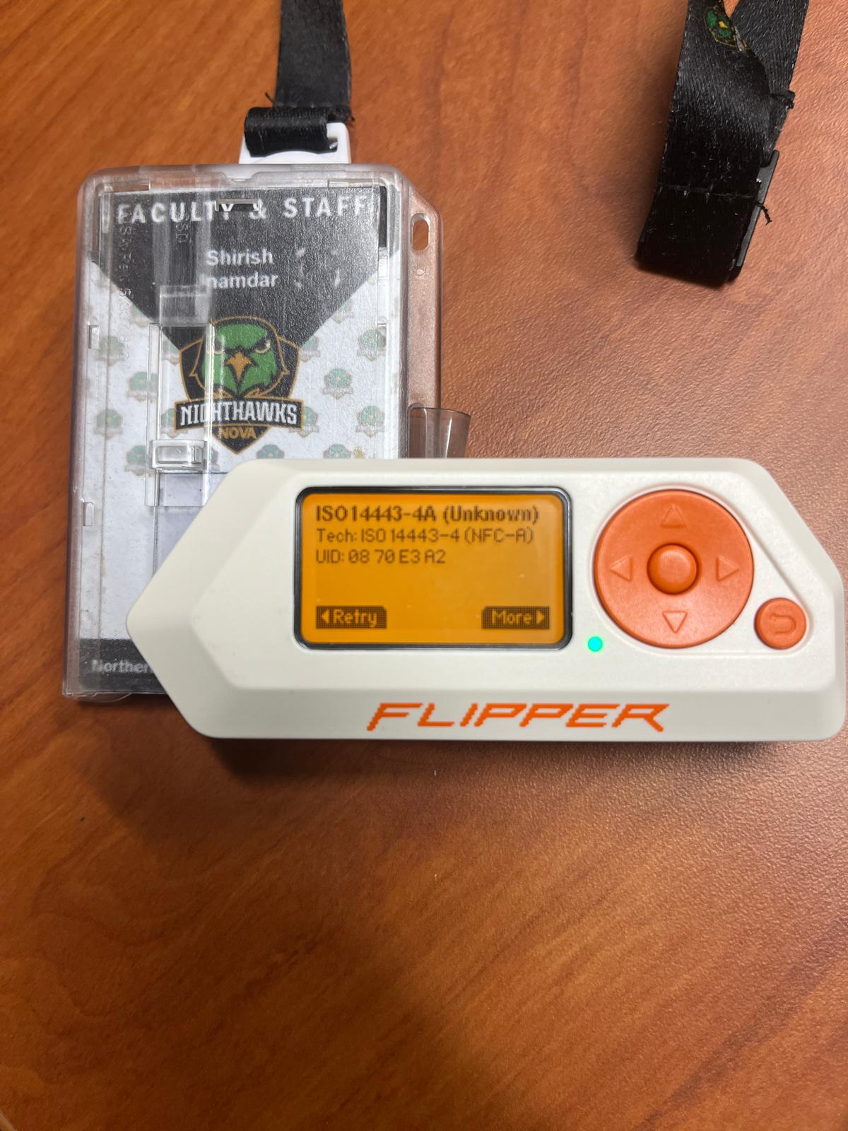
Figure 12 – NFC card details displayed (not saved)

Note: This NFC scan was performed as an example only. No card data was retained or saved to the device.

Future work:
- Started with selection of few project and Flipper zero demonstration presentation.
- AA449 will accommodate workstations and PCs, while AA426 is planned to eventually host the malware detonation chamber (currently at the conceptual stage).
- The secure lab network design is being updated to include the requested equipment (routers, switches, PCs, and laptops) and refinements. The revised version will be completed and shared shortly.
- Started with Pfsense firewall and Metasploitable configuration and will be installed soon and will be connected to Dell PowerEdge 2950 server.
- Forensic Data Acquisition - Hardware Write Blockers. Experimenting with Tableau section of working with write blockers.
- Studying and implementing the timeline analysis from the wireshark SANS GCFA documentation.
- Supporting students with appointments with lab sessions/tutoring for cybersecurity labs and other course projects as well.
- Building an AI Security Operations Center on Campus and specialized lab setups for IT and cybersecurity courses, including malware analysis, forensics investigations, red/blue team CTF exercises, CISCO networking practice, and high-performance AI sandbox workstations.
- Continue with Malware analysis exercises with Wireshark and Autopsy.

