Weekly Status Report: March 09 – March 13, 2026
Shirish Inamdar
TA / Lab Support Specialist
Northern Virginia Community College
Supervisor: Prof. Mun-Wai Hon

Overview
This week's work focused on three main tasks:
- Unboxing, powering up, and assessing the EC-Council STORM cybersecurity toolkit a Raspberry Pi-based mobile security tool kit to check its current OS version and determine whether an update was needed.
- Completing a full hardware inventory of NVCC-donated equipment located in room IET AL AA427 Any issues identified during the inventory process were resolved with my assistance.
- Beginning hands-on Metasploit lab work using a Kali Linux VM and a Metasploitable 2 target VM running in VMware Workstation, covering network reconnaissance and exploitation of a known vulnerability.

EC-Council STORM Kit Setup & Assessment
The first step was to unbox the EC-Council STORM Kit and inspect its physical label. The label contained all critical device information including the serial number (110352771262), the order number, the default login credentials (username: pi, password: storm2021), and confirmation that no expansion pack was included. This information was recorded before proceeding with powering on the device.
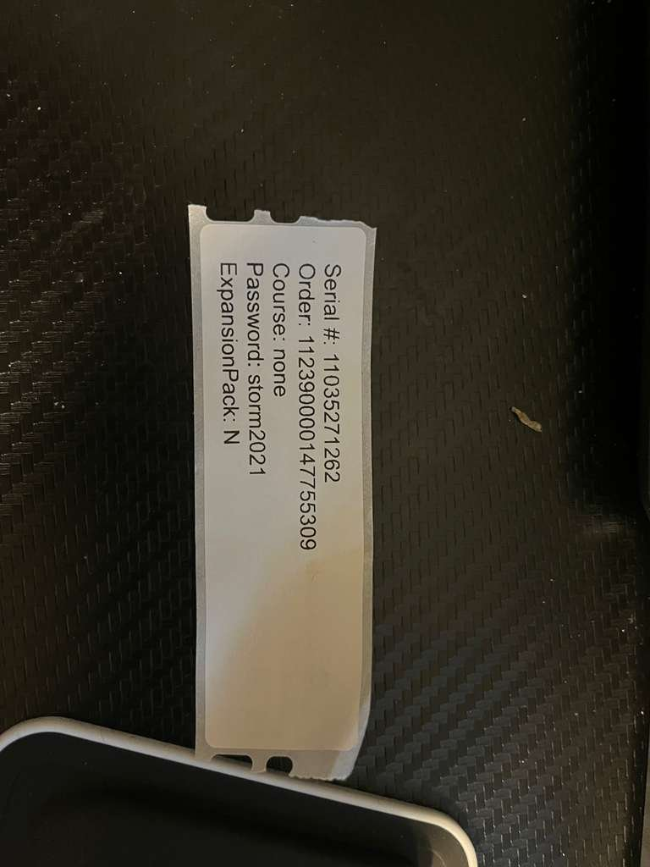
Figure 1 — EC-Council STORM Kit label showing serial number, order number, login credentials, and expansion pack status.
The device was then connected to a display and powered on. The Raspberry Pi login screen appeared, running the LXDE desktop environment on Raspbian. The username 'pi' was pre-selected and the password 'storm2021' from the label was entered to authenticate into the system.
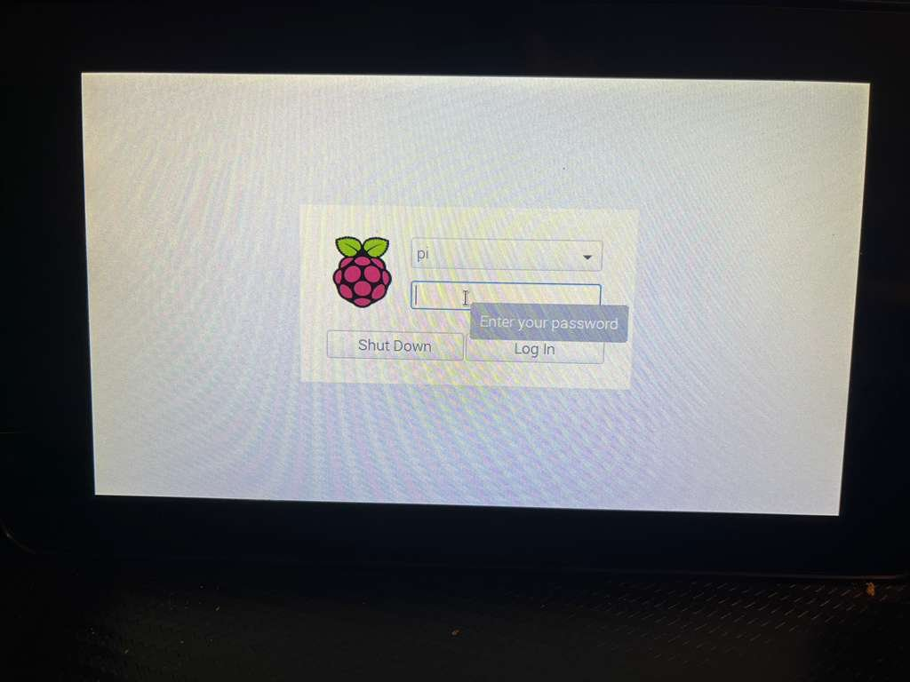
Figure 2 — Raspberry Pi login screen prompting for the password before accessing the STORM desktop environment.
After logging in successfully, the full physical workspace was set up with both a standard keyboard and the included flexible rubber keyboard connected to the Raspberry Pi. The STORM login screen was visible on the attached display, confirming the device was operational and ready for further configuration steps.
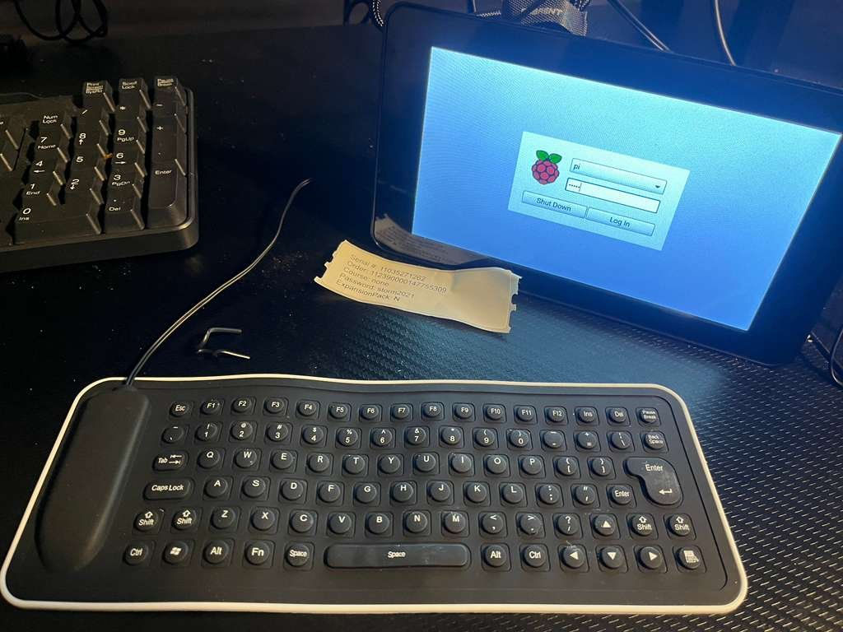
Figure 3 — Full physical setup showing the Raspberry Pi device, attached display with login screen, and keyboards connected.
To verify the exact operating system version running on the device, the terminal was opened and the command 'cat /etc/os-release' was executed. The output confirmed the device is running Raspbian GNU/Linux 10 (Buster). This information is important for determining compatibility with newer tools and assessing whether an OS upgrade to a more recent version of Raspberry Pi OS is required.
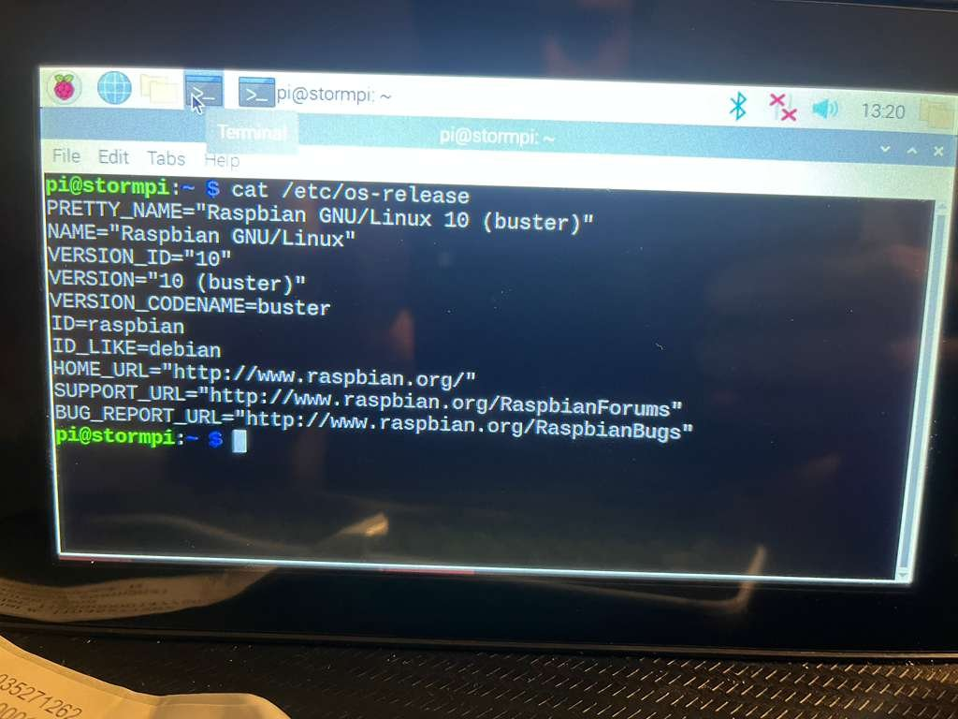

Figure 4 — Terminal output of 'cat /etc/os-release' confirming Raspbian GNU/Linux 10 (Buster) as the current OS version
When I checked cat /etc/os-release, it showed that the system is still running an older version. The kit is currently not connected to the internet, and it needs to be updated to the latest version.

NVCC Donation Inventory
In addition to the STORM kit work, a full inventory was initiated for the NVCC-donated hardware stored in room IET AL AA427. The inventory covered two categories of equipment: 20 units of the Dell OptiPlex 7090 SFF desktop computers and 20 units of the Dell Latitude 5420 laptops, bringing the total to 40 devices catalogued. Each unit was logged with its service tag, express service code, model, location, assigned user, and current status. Any issues found during the verification process such as unreadable or mismatched express service codes were flagged and subsequently cleared in coordination with work study. The inventory spreadsheet was updated as of March 10, 2026 and reflects the current state of all donated assets.

Metasploitable Lab : Penetration Testing Practice
Hands-on penetration testing lab work was begun using two virtual machines running in VMware Workstation: a Kali Linux VM as the attacker machine and a Metasploitable 2 VM as the intentionally vulnerable target. This lab environment is used for practicing ethical hacking and offensive security techniques in a safe, isolated network.(Host-Only)

Identifying the Target IP Address
The Metasploitable 2 VM was booted and logged into with the default credentials. The command 'ip a' was run to identify the machine's IP address on the local network. The target was confirmed to be reachable at IP address 192.168.146.130 on the eth0 interface, which would be used as the target for all subsequent scanning and exploitation activity.
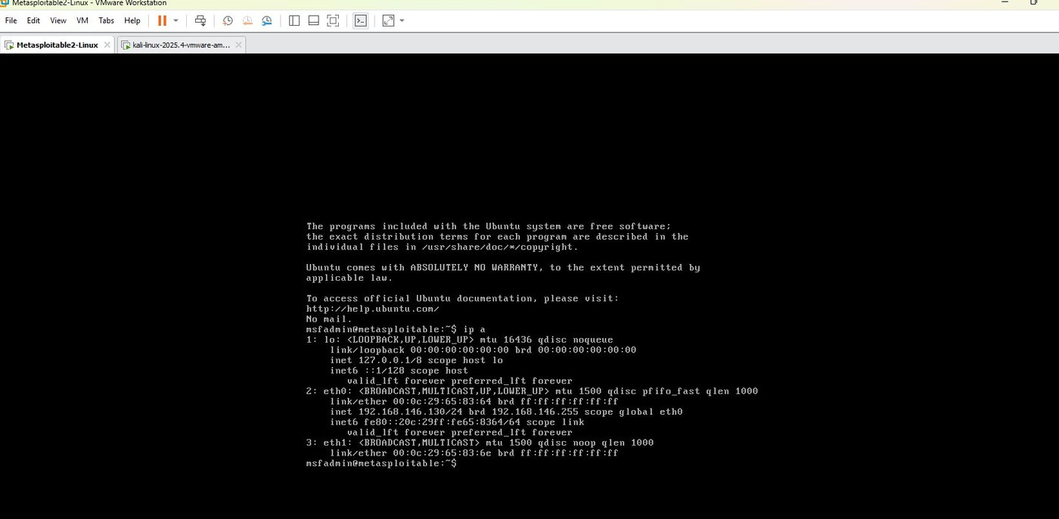
Figure 6 — Metasploitable 2 VM showing the output of 'ip a', confirming the target IP address as 192.168.146.130.

Nmap Service Version Scan
From the Kali Linux VM, an Nmap service version scan was launched against the Metasploitable 2 target using the command 'sudo nmap -sV 192.168.146.130'. The scan completed and revealed a large number of open ports and running services. Notable findings included vsftpd 2.3.4 on port 21 (a version known to contain a backdoor vulnerability), OpenSSH on port 22, Apache HTTP on port 80, MySQL on port 3306, PostgreSQL on port 5432, VNC on port 5900, and many others. This reconnaissance step provided a full picture of the attack surface available on the target machine.
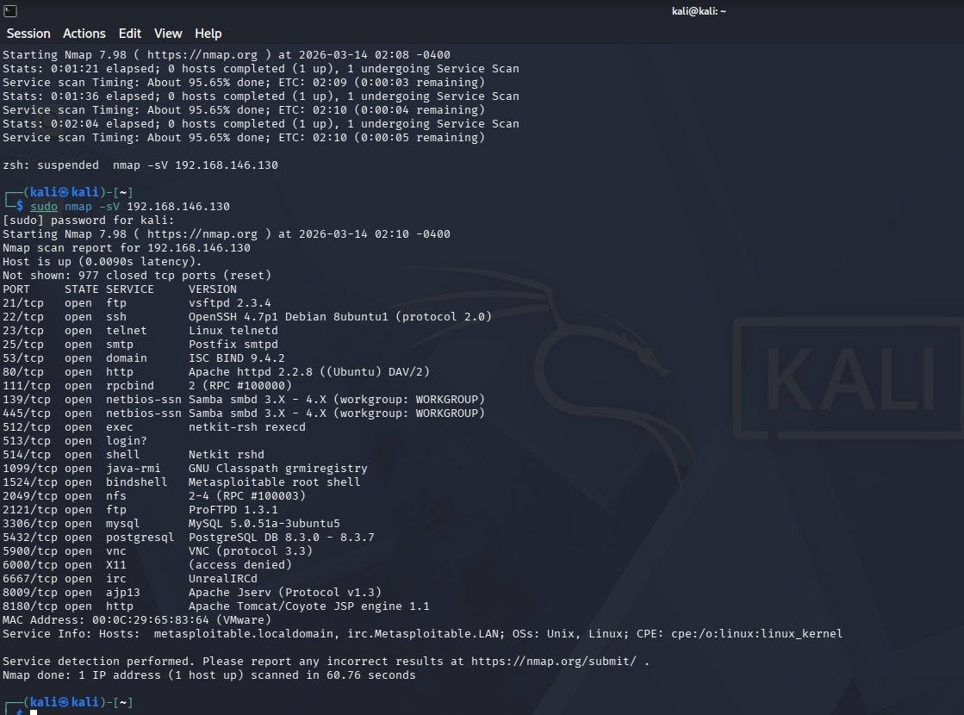
Figure 7 — Nmap -sV scan results against 192.168.146.130, revealing all open ports and service versions including the vulnerable vsftpd 2.3.4.

Launching Metasploit Framework
Metasploit's msfconsole is the primary interface for selecting, configuring, and launching exploit modules against target systems.
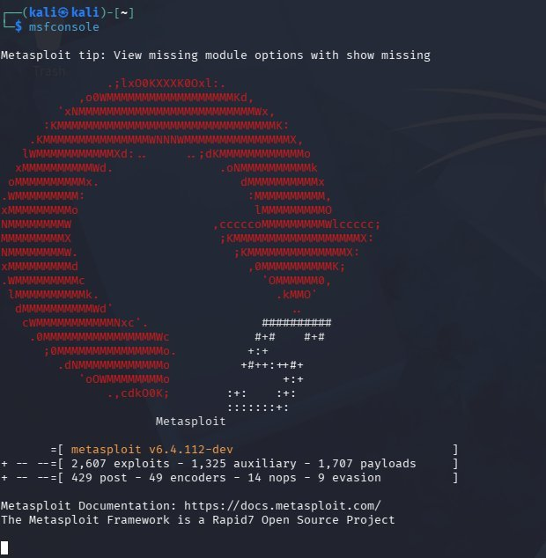
Figure 8 — Metasploit Framework msfconsole successfully launched on Kali Linux, showing version 6.4.112-dev and available module counts.

Exploiting the vsftpd 2.3.4 Backdoor
The vsftpd 2.3.4 backdoor exploit module (exploit/unix/ftp/vsftpd_234_backdoor) was selected using 'use 1' after searching for vsftpd modules. The output confirmed UID 0 (root) and GID 0 (root), meaning full administrative access to the Metasploitable 2 system was achieved. Running 'ls' and 'hostname' commands confirmed the shell was operating on the metasploitable target filesystem.
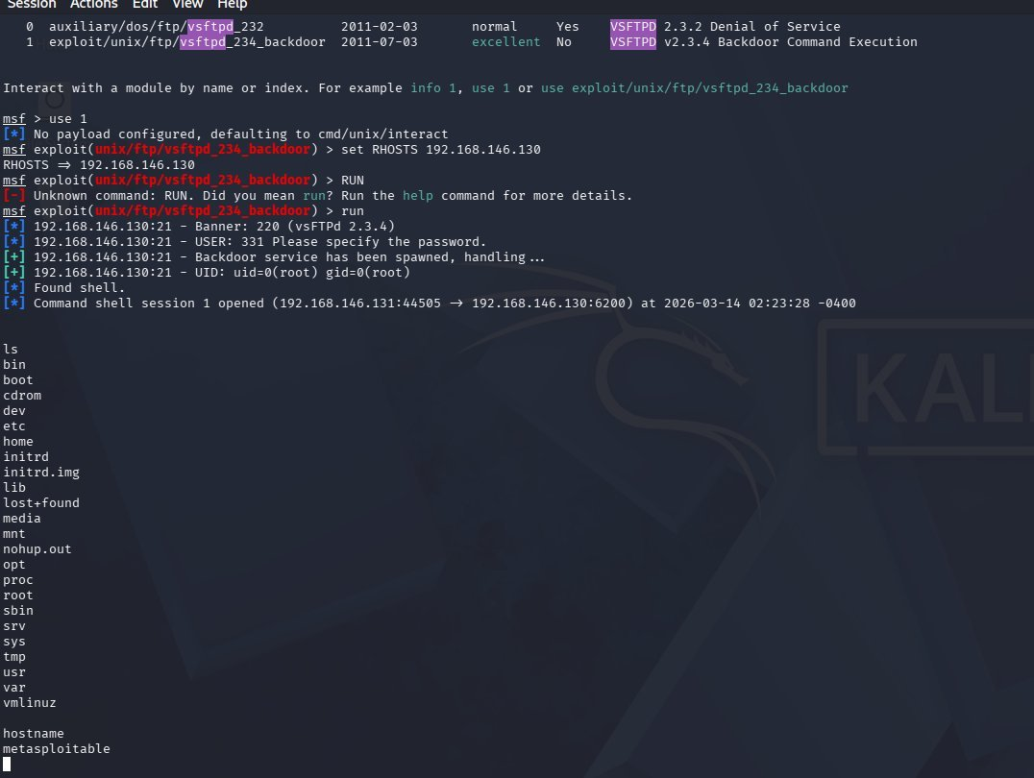
Figure 9 — Metasploit vsftpd_234_backdoor exploit successfully executed, resulting in a root shell on the Metasploitable 2 target at 192.168.146.130.
Future work:
- Started with selection of few project and Flipper zero demonstration presentation.
- AA449 will accommodate workstations and PCs, while AA426 is planned to eventually host the malware detonation chamber (currently at the conceptual stage).
- The secure lab network design is being updated to include the requested equipment (routers, switches, PCs, and laptops) and refinements. The revised version will be completed and shared shortly.
- Started with Pfsense firewall and Metasploitable configuration and will be installed soon and will be connected to Dell PowerEdge 2950 server.
- Forensic Data Acquisition - Hardware Write Blockers. Experimenting with Tableau section of working with write blockers.
- Studying and implementing the timeline analysis from the wireshark SANS GCFA documentation.
- Supporting students with appointments with lab sessions/tutoring for cybersecurity labs and other course projects as well.
- Building an AI Security Operations Center on Campus and specialized lab setups for IT and cybersecurity courses, including malware analysis, forensics investigations, red/blue team CTF exercises, CISCO networking practice, and high-performance AI sandbox workstations.
- Continue with Malware analysis exercises with Wireshark and Autopsy.

