Contents

**PHP Project** 2

Architecture 2

Steps 3

Account and Billing 4

Billing Preference 4

Budget Alerts 4

Network resources 6

VPC 6

Internet Gateway 6

VPC Main Router Table -Public Route table 7

Subnets 2 Public and 2 Private 7

Nat Gateways -2 in 2 public subnets 8

Private routing table 9

Database 10

DB Subnet Group 10

DB Instance 10

DB Security Group 11

Appserver 12

EC2 12

EC2 Instance 13

EC2 AMI Image 14

Launch Config 14

Autoscaling Group – ELB, TARGET GROUP/CW Alarm, SNS 15

Autoscaling Group – Target Group 17

Autoscaling Group – TARGET GROUP/CW Alarm 17

Autoscaling Group –SNS 18

Autoscaling Group – ELB 18

CDN 19

# **PHP Project**

## Architecture

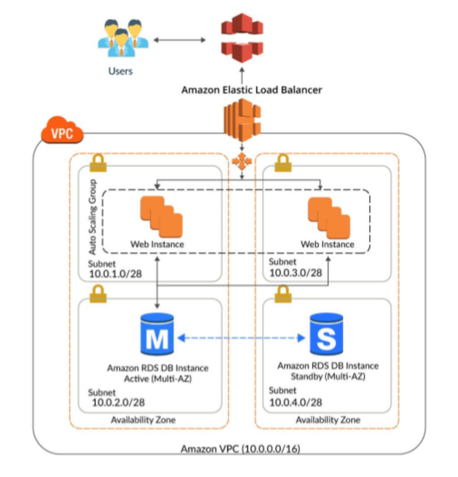

## Steps

Create below infrastructure

**AWS account and credentials**

1. AWS account
2. Key pair for AWS account
3. Enable Budget to receive notification

**Networking resources**

1. VPC
2. Internet gateway
3. VPC with IG attached to main router table -public route table
4. Subnets: 2 Public Subnets for Elastic Load Balancer and Auto scaling web server group, 2 - Private subnet with Nat gateway got RDS
5. Nat gateway
6. Private Route table

**Database**

1. RDS

**Appserver**

1. EC2
2. Launch Configuration
3. Autoscaling group – ELB, Target Group and SNS are automatically created.
4. ELB
5. Target group
6. SNS
7. Cloud Front

**Note**: Delete all resources as soon as your work is over. Remember to delete EBS or storage and RDS snapshots.

## Account and Billing

<https://console.aws.amazon.com/billing/home#/bills?year=2021&month=3>

### Billing Preference

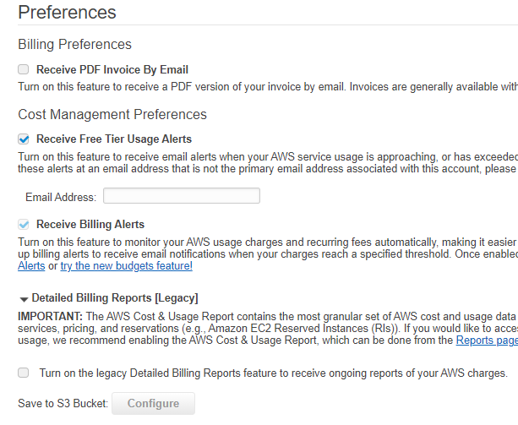

### Budget Alerts

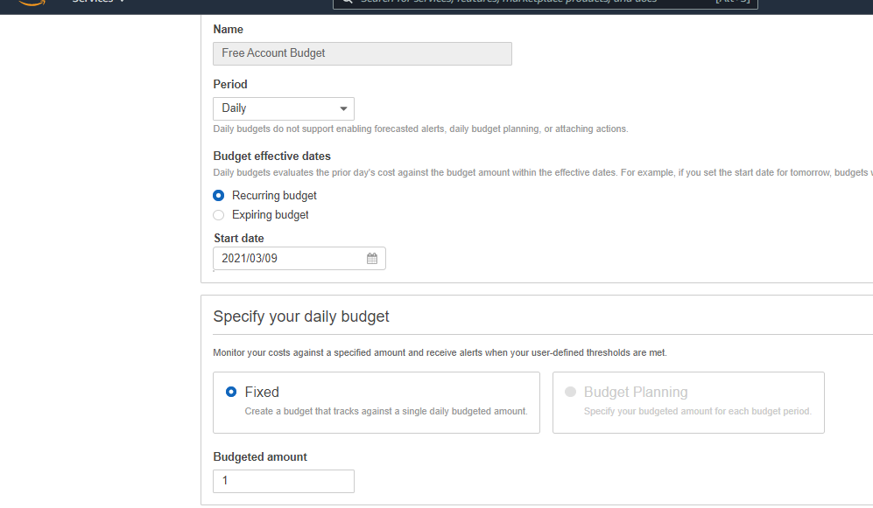

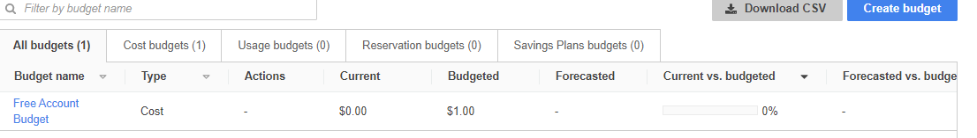

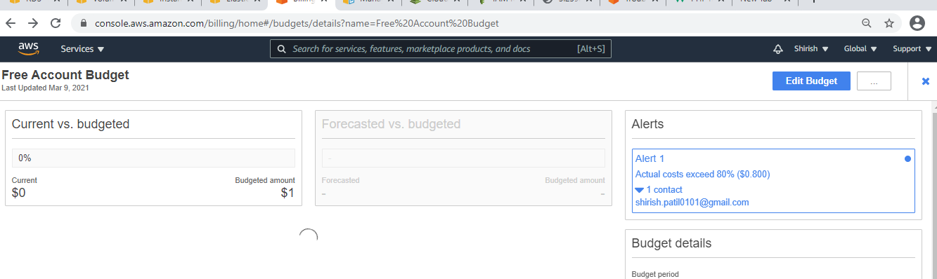

## Network resources

### VPC

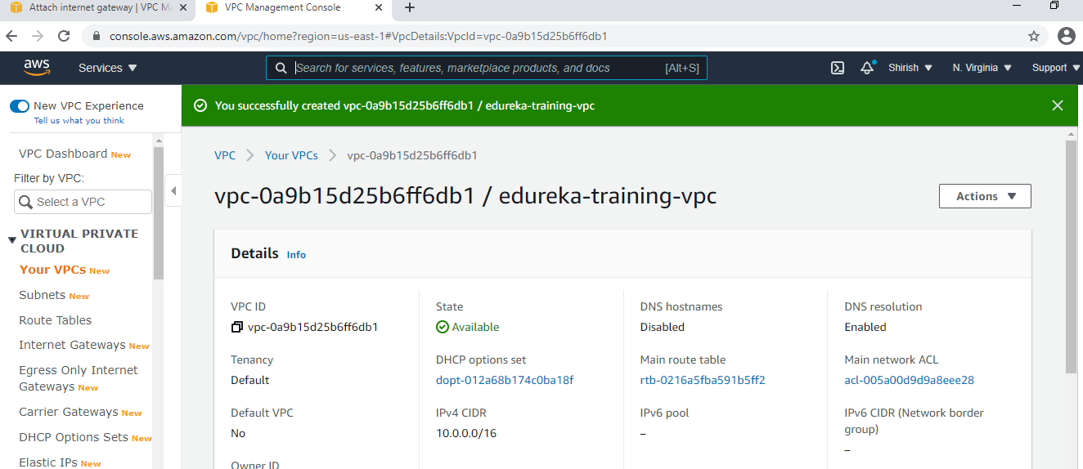

### Internet Gateway

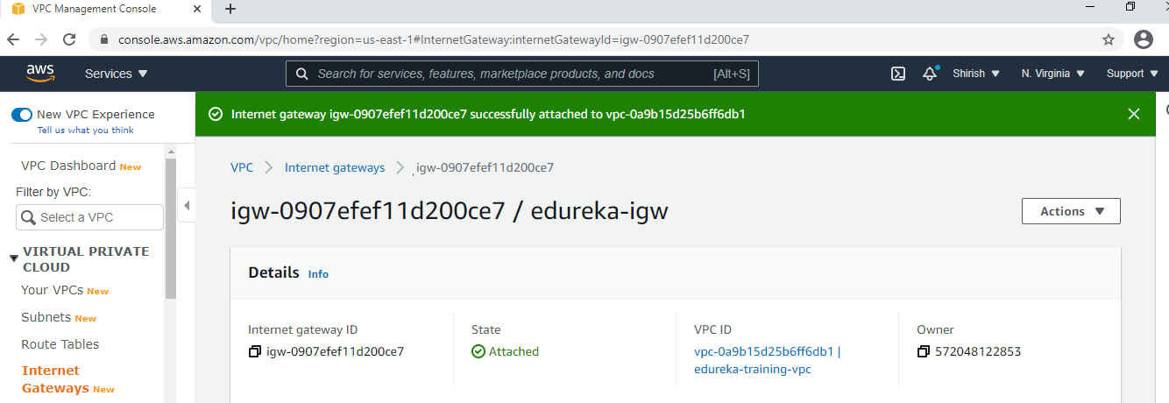

### VPC Main Router Table -Public Route table

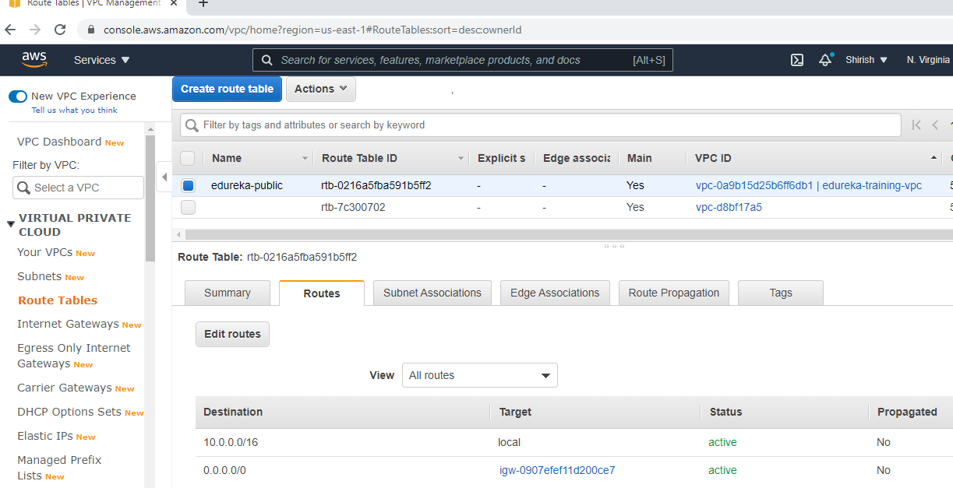

### Subnets 2 Public and 2 Private

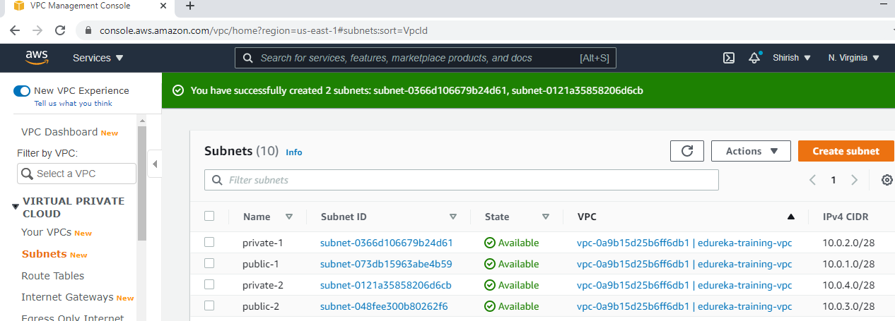

### Nat Gateways -2 in 2 public subnets

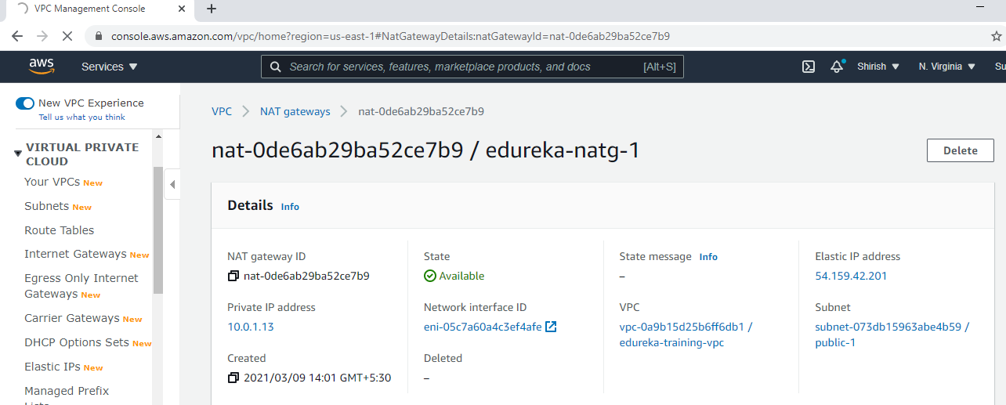

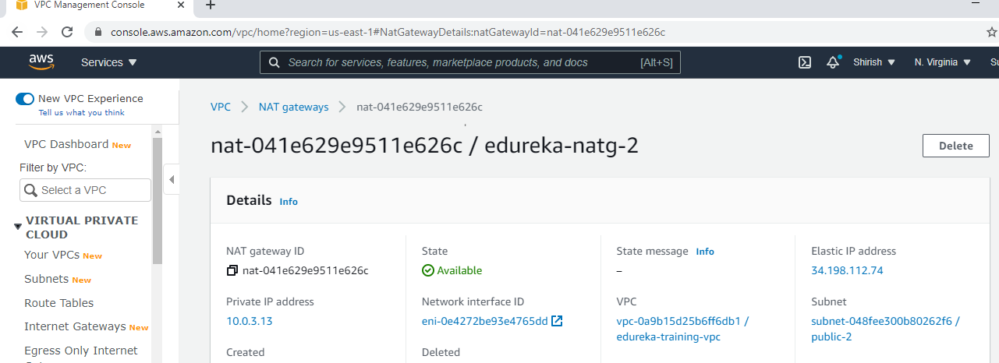

### Private routing table

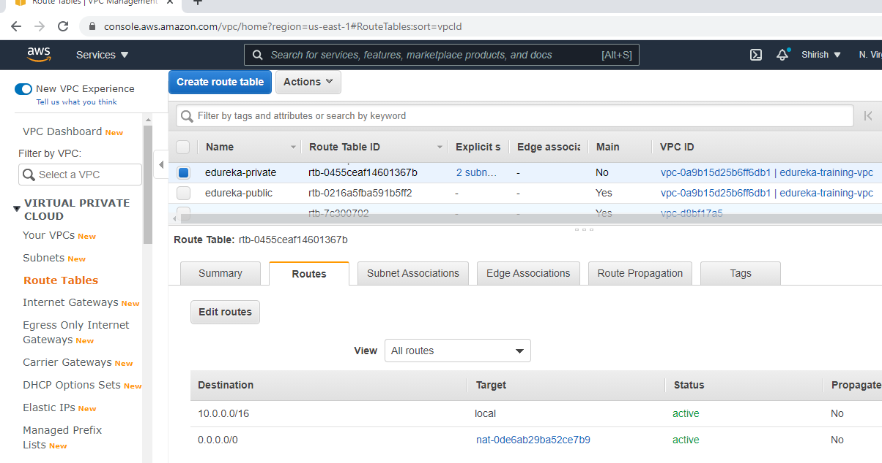

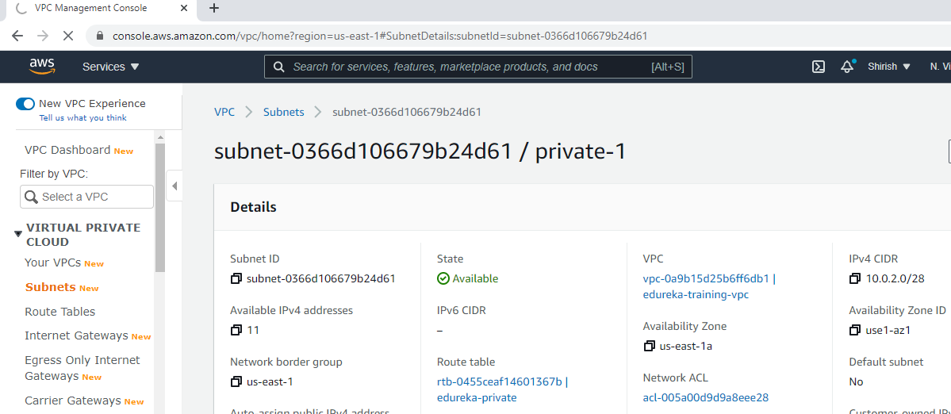

## Database

### DB Subnet Group

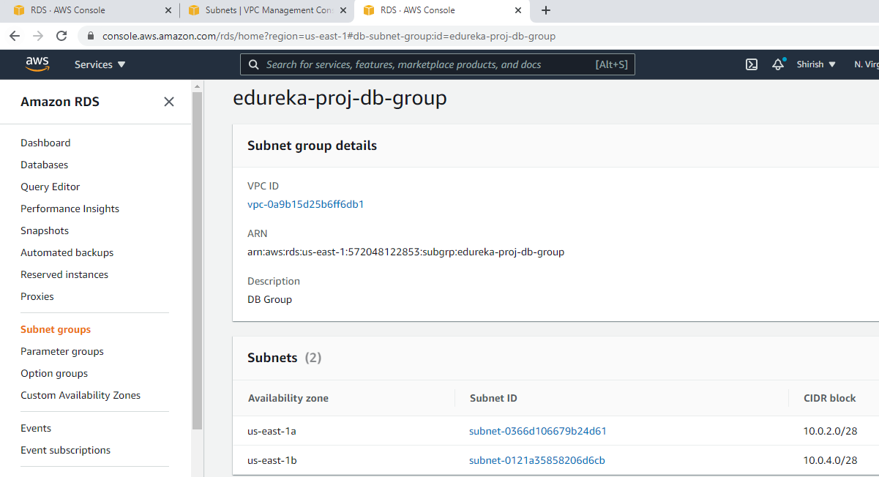

### DB Instance

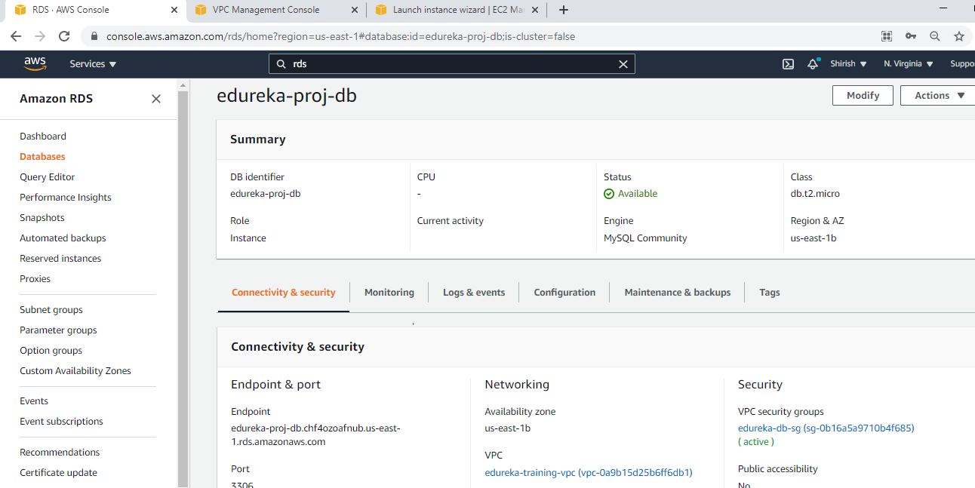

### DB Security Group

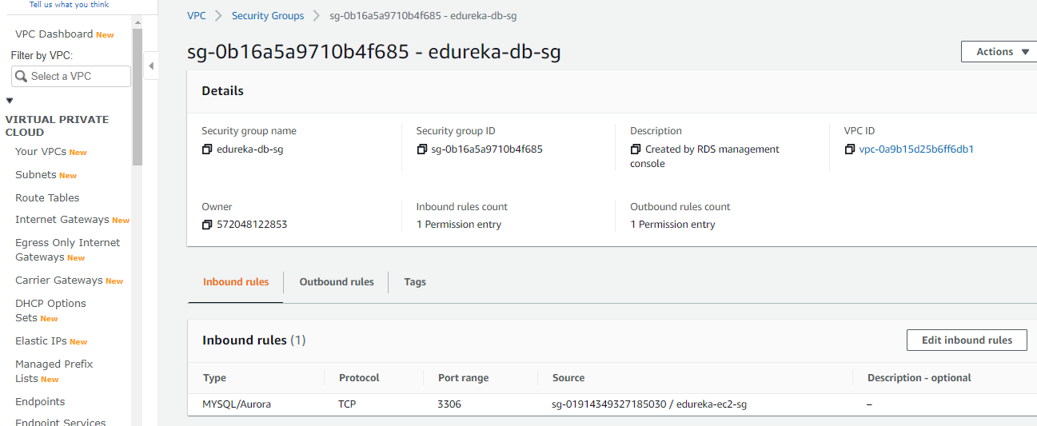

## Appserver

### EC2

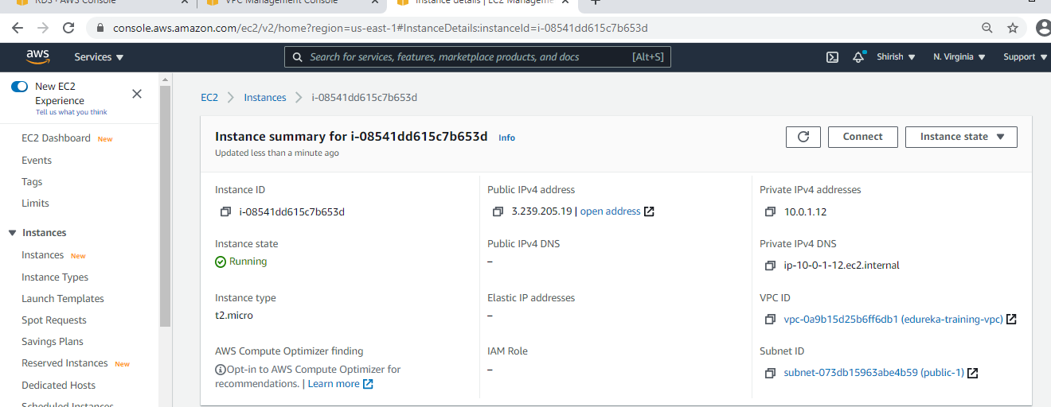

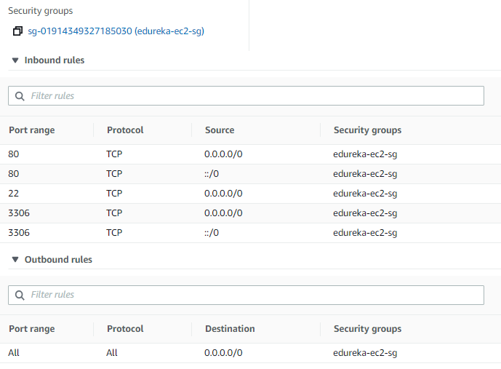

### EC2 Instance

sudo yum install httpd

sudo systemctl start httpd.service

sudo systemctl enable httpd.service

sudo yum install php php-mysql

sudo yum remove php php-mysql

sudo amazon-linux-extras install php7.2

sudo systemctl restart httpd.service

sudo su

cd /var/www

mkdir inc

cd inc

touch dbinfo.inc

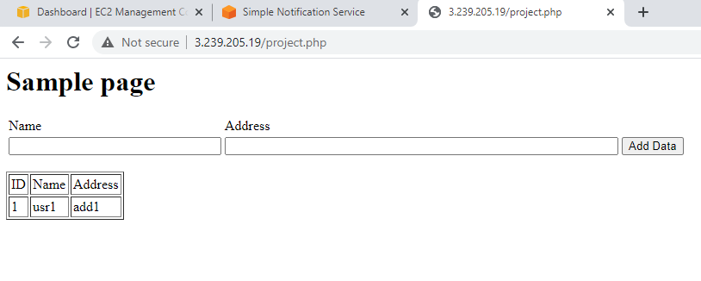

### EC2 AMI Image

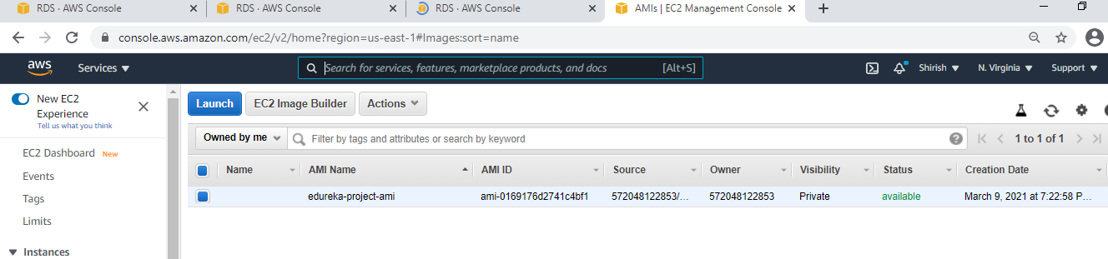

### Launch Config

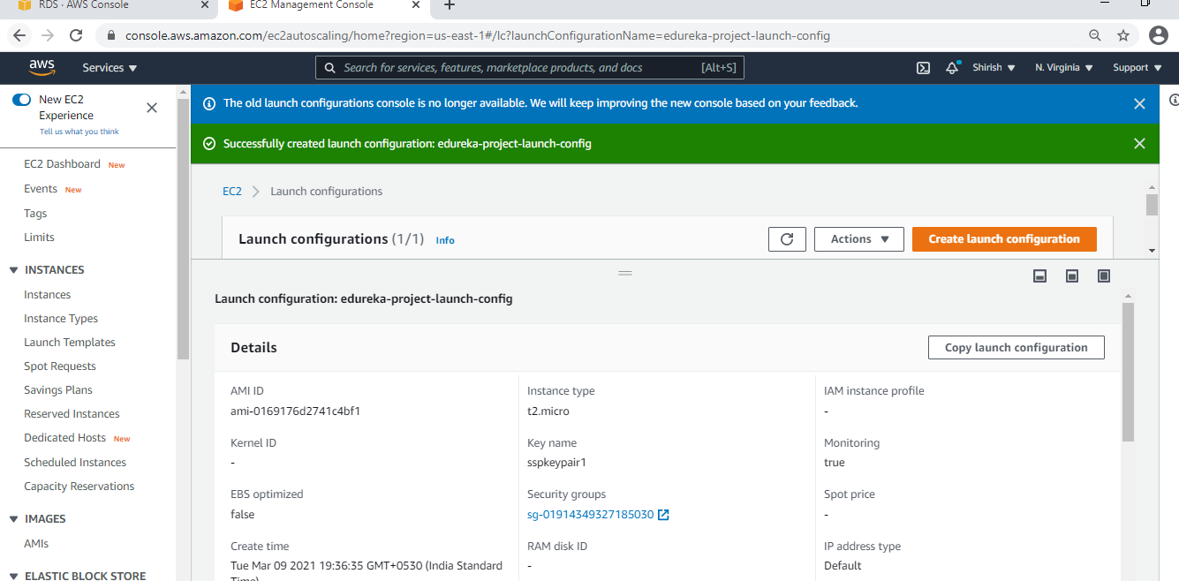

### Autoscaling Group – ELB, TARGET GROUP/CW Alarm, SNS

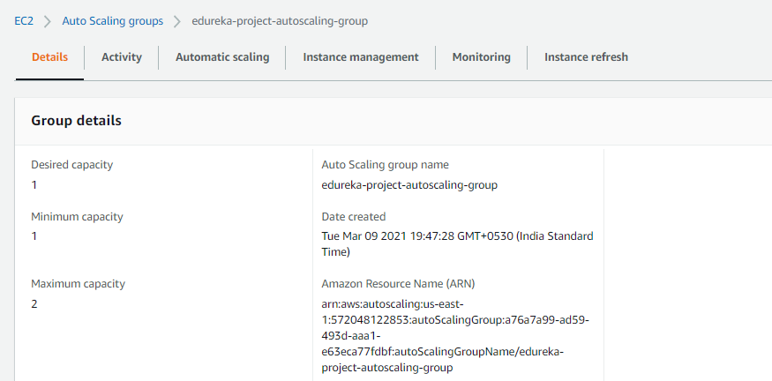

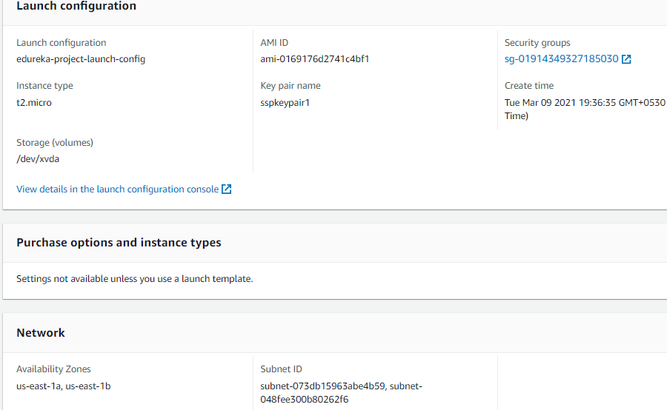

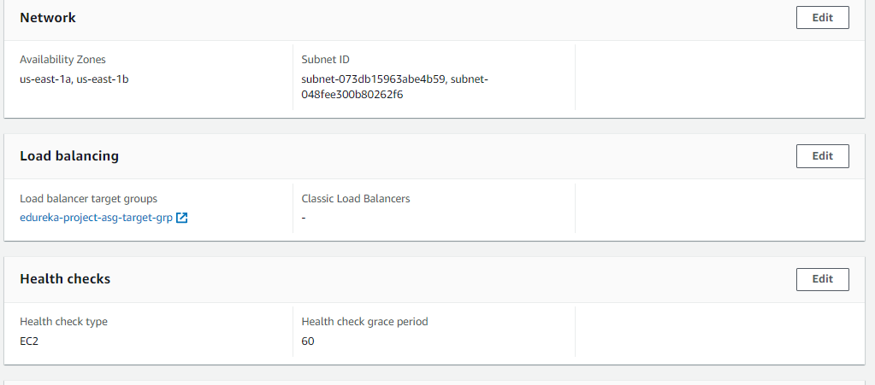

Two instances- one is original other is created by ASG

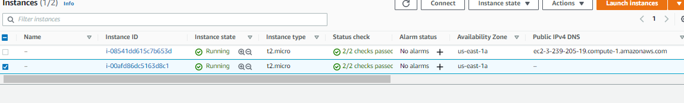

### Autoscaling Group – Target Group

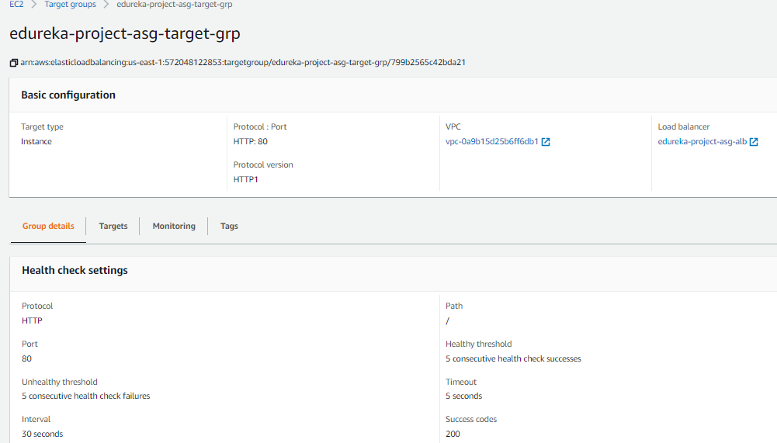

### Autoscaling Group – TARGET GROUP/CW Alarm

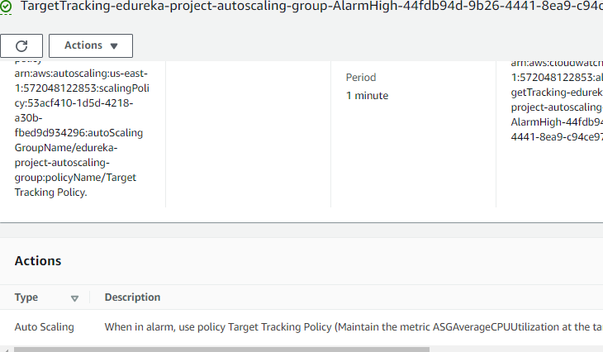

### Autoscaling Group –SNS

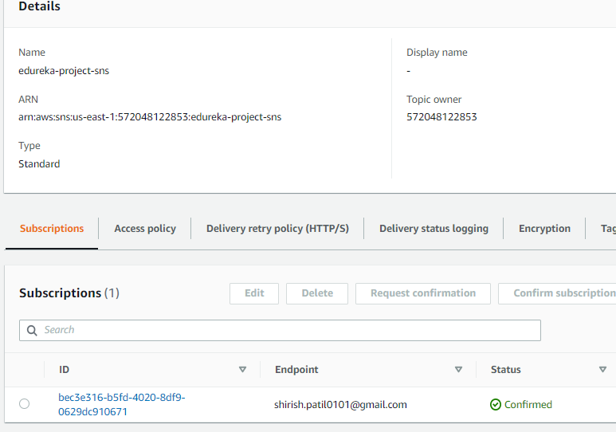

### Autoscaling Group – ELB

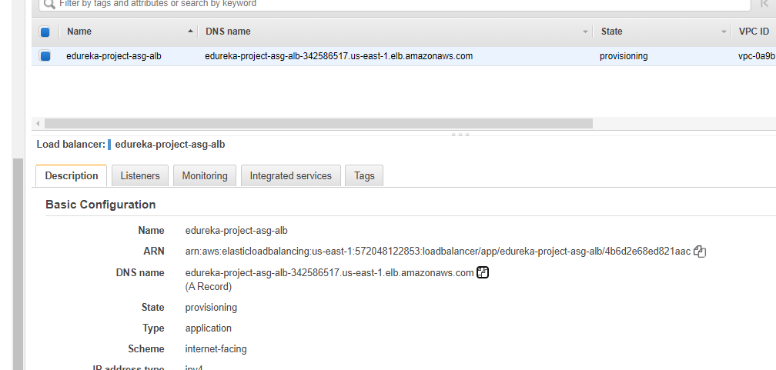

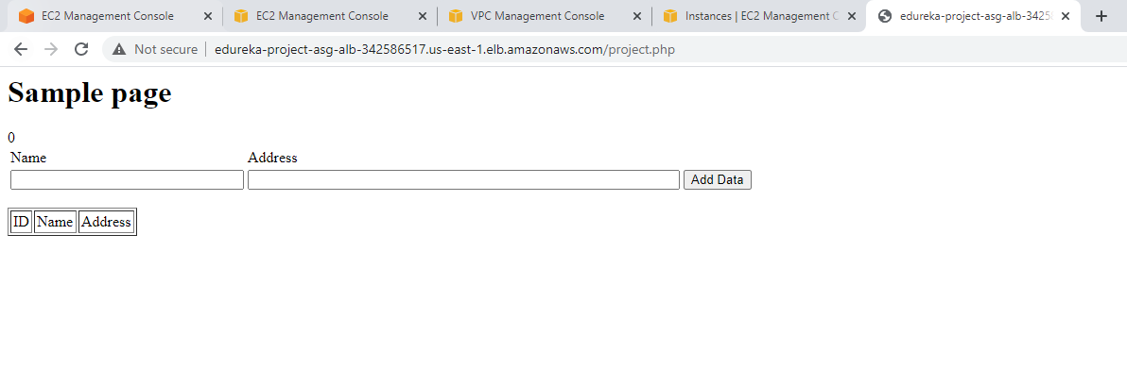

### CDN

