**Step 1:** Checkout the project and select Development, Offshore-devin eclipse

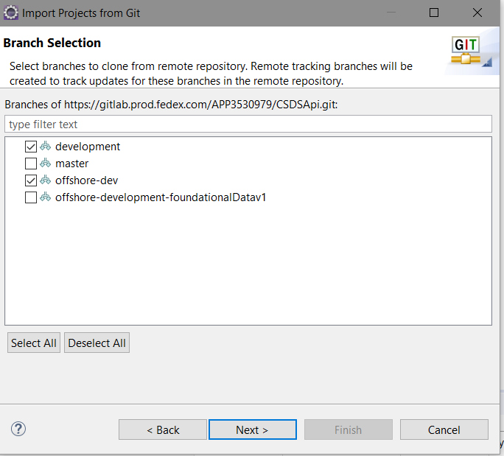

**Step 2:** Point the Eclipse project to “Offshore-dev” using below command in Git Bash

**“git checkout offshore-dev"**

**Step 3:** Use below command to pull the code from “Development” to “Offshore-Dev”

**“git merge development”**

**Step 4:** If want to revert the “Development” to “Offshore-dev” changes use below command

**“git merge –abort"**

**Step 5: If any conflict, fix that conflict line changes using eclipse**

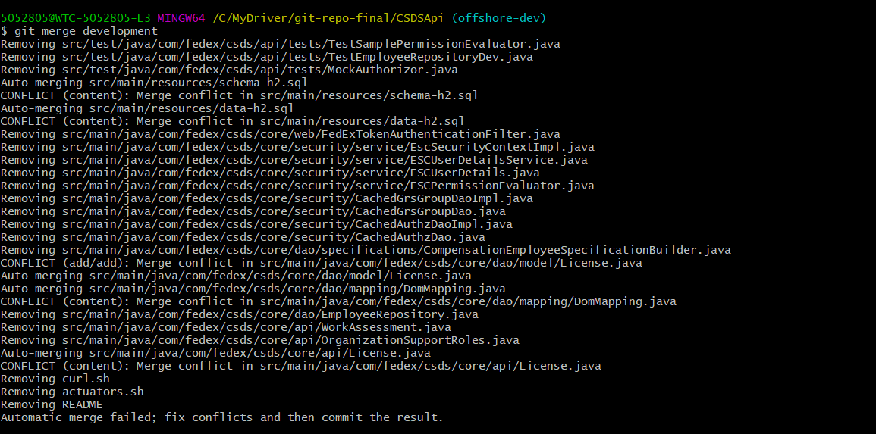

Syncronize workspace

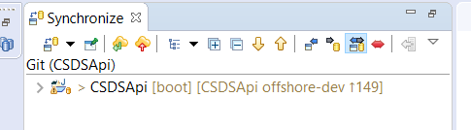

Configure “development” branch for syncronize

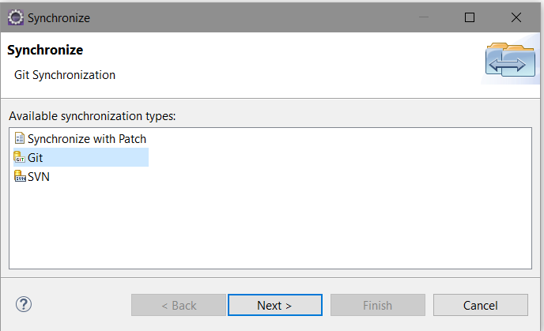

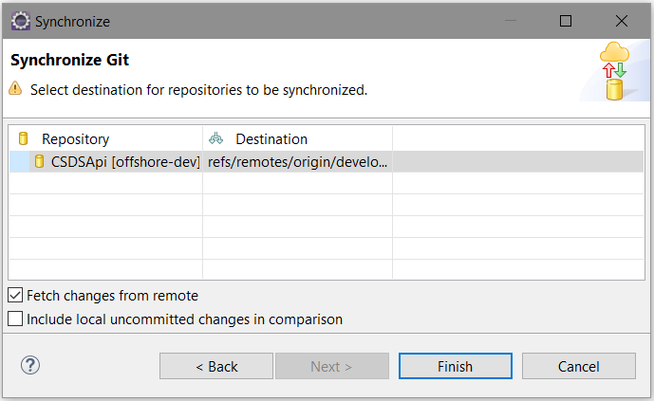

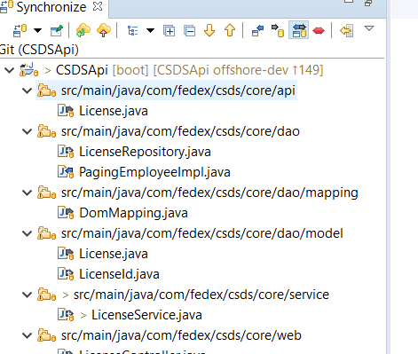

Step 6: If got conflict again, after did modify conflict changes, then use below command

**“git merge --strategy-option ours development”**

**Step 7:** Check eclipse in out error display. If it’s not push the code to “offshore-dev” using below command

**“git push origin offshore-dev"**

**Git Additional Command**

1) Commit the changes to local

**git commit -m "Development and Offshoredev conflict changes"**

2) Push the changes to Remote

**“git push origin offshore-dev"**

3) Check the git local code status

**“git status”**

4) Add the modify files

**“git add –A"**