AEM Guide:-

# Setting up AEM in your local machine:-

### Prerequisites

Steps

1. Ensure [Java](https://downloads.experiencecloud.adobe.com/content/software-distribution/en/general.html) is installed.
   * Prefer [Java JDK 11](https://experience.adobe.com/#/downloads/content/software-distribution/en/general.html?1_group.propertyvalues.property=.%2Fjcr%3Acontent%2Fmetadata%2Fdc%3AsoftwareType&1_group.propertyvalues.operation=equals&1_group.propertyvalues.0_values=software-type%3Atooling&orderby=%40jcr%3Acontent%2Fjcr%3AlastModified&orderby.sort=desc&layout=list&p.offset=0&p.limit=14) for AEM 6.5+
   * [Java JDK 8](https://www.oracle.com/technetwork/java/javase/downloads/index.html#JDK8) for AEM versions prior to AEM 6.5
2. Get a copy of the [AEM QuickStart Jar and a license.properties](https://helpx.adobe.com/experience-manager/6-5/sites/deploying/using/deploy.html#GettingtheSoftware).
3. Create a folder structure on your computer like the following:
4. ~/aem-sdk
5. /author
6. /publish

Copy

1. Rename the QuickStart JAR to ***aem-author-p4502.jar*** and place it beneath the /author directory. Add the ***license.properties*** file beneath the /author directory.
2. Make a copy of the QuickStart JAR, rename it to ***aem-publish-p4503.jar*** and place it beneath the /publish directory. Add a copy of the ***license.properties*** file beneath the /publish directory.
3. ~/aem-sdk
4. /author
5. + aem-author-p4502.jar
6. + license.properties
7. /publish
8. + aem-publish-p4503.jar
9. + license.properties

Copy

1. Double-click the ***aem-author-p4502.jar*** file to install the **Author** instance. This will start the author instance, running on port **4502** on the local computer.

### Download Apache Maven

Steps

1. Download [Apache Maven](https://maven.apache.org/download.cgi)
2. Install [Apache Maven](https://maven.apache.org/install.html) and ensure that the installation has been added to your command-line PATH.
   * macOS users can install Maven using [Homebrew](https://brew.sh/)
3. Verify that **Maven** is installed by opening a new command line terminal and executing the following:
4. $ mvn --version
5. Apache Maven 3.3.9
6. Maven home: /Library/apache-maven-3.3.9
7. Java version: 1.8.0_111, vendor: Oracle Corporation
8. Java home: /Library/Java/JavaVirtualMachines/jdk1.8.0_111.jdk/Contents/Home/jre
9. Default locale: en_US, platform encoding: UTF-8

Copy

1. Add the **adobe-public** profile to your Maven [settings.xml](https://maven.apache.org/settings.html) file in order to automatically add **repo.adobe.com** to the maven build process.
2. Create a file named settings.xml at ~/.m2/settings.xml if it doesn’t exist already.
3. Add the **adobe-public** profile to the settings.xml file based on [the instructions here](https://repo.adobe.com/).

A sample settings.xml is listed below. *Note, the naming convention of settings.xml and the placement beneath the user’s .m2 directory is important.*

<settings xmlns="<https://maven.apache.org/SETTINGS/1.0.0>"

xmlns:xsi="<https://www.w3.org/2001/XMLSchema-instance>"

xsi:schemaLocation="<https://maven.apache.org/SETTINGS/1.0.0>

<https://maven.apache.org/xsd/settings-1.0.0.xsd>">

<profiles>

<!-- ====================================================== -->

<!-- A D O B E P U B L I C P R O F I L E -->

<!-- ====================================================== -->

<profile>

<id>adobe-public</id>

<activation>

<activeByDefault>true</activeByDefault>

</activation>

<properties>

<releaseRepository-Id>adobe-public-releases</releaseRepository-Id>

<releaseRepository-Name>Adobe Public Releases</releaseRepository-Name>

<releaseRepository-URL><https://repo.adobe.com/nexus/content/groups/public></releaseRepository-URL>

</properties>

<repositories>

<repository>

<id>adobe-public-releases</id>

<name>Adobe Public Repository</name>

<url><https://repo.adobe.com/nexus/content/groups/public></url>

<releases>

<enabled>true</enabled>

<updatePolicy>never</updatePolicy>

</releases>

<snapshots>

<enabled>false</enabled>

</snapshots>

</repository>

</repositories>

<pluginRepositories>

<pluginRepository>

<id>adobe-public-releases</id>

<name>Adobe Public Repository</name>

<url><https://repo.adobe.com/nexus/content/groups/public></url>

<releases>

<enabled>true</enabled>

<updatePolicy>never</updatePolicy>

</releases>

<snapshots>

<enabled>false</enabled>

</snapshots>

</pluginRepository>

</pluginRepositories>

</profile>

</profiles>

<activeProfiles>

<activeProfile>adobe-public</activeProfile>

</activeProfiles>

</settings>

Copy

1. Verify that the **adobe-public** profile is active by running the following command:
2. $ mvn help:effective-settings
3. ...
4. <activeProfiles>
5. <activeProfile>adobe-public</activeProfile>
6. </activeProfiles>
7. <pluginGroups>
8. <pluginGroup>org.apache.maven.plugins</pluginGroup>
9. <pluginGroup>org.codehaus.mojo</pluginGroup>
10. </pluginGroups>
11. </settings>
12. [INFO] ------------------------------------------------------------------------
13. [INFO] BUILD SUCCESS
14. [INFO] ------------------------------------------------------------------------
15. [INFO] Total time: 0.856 s

Copy

If you do not see the **adobe-public** it is an indication that the Adobe repo is not properly referenced in your ~/.m2/settings.xml file. Please revisit the earlier steps and verify that the settings.xml file references the Adobe repo.

Tutorials related Information:-

**In the Adobe Portal, follow the below steps for basic understanding:-**

1) Once you are added in the Adobe service portal, login with your official mail id and ensure that you have successfully logged in with the below screenshot.

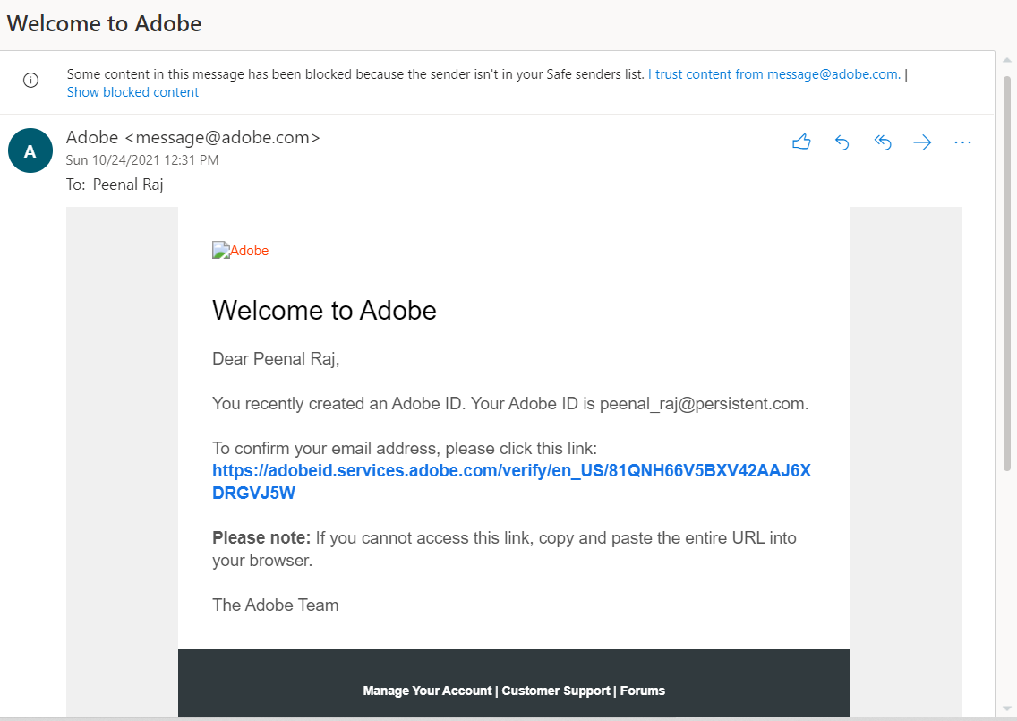

2) Click on the link in blue and you will be redirected to the following page

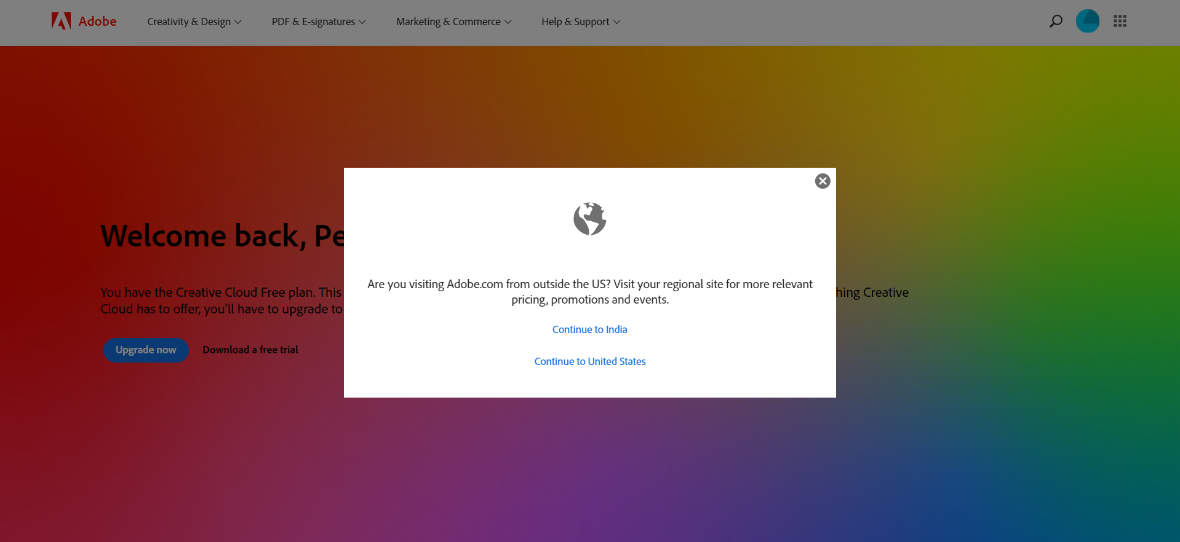

3)Click on “Continue in India” and will see the below page. You will find the option of ”Experience Cloud” in the top right hand side of accessing all applications tab as shown below:-

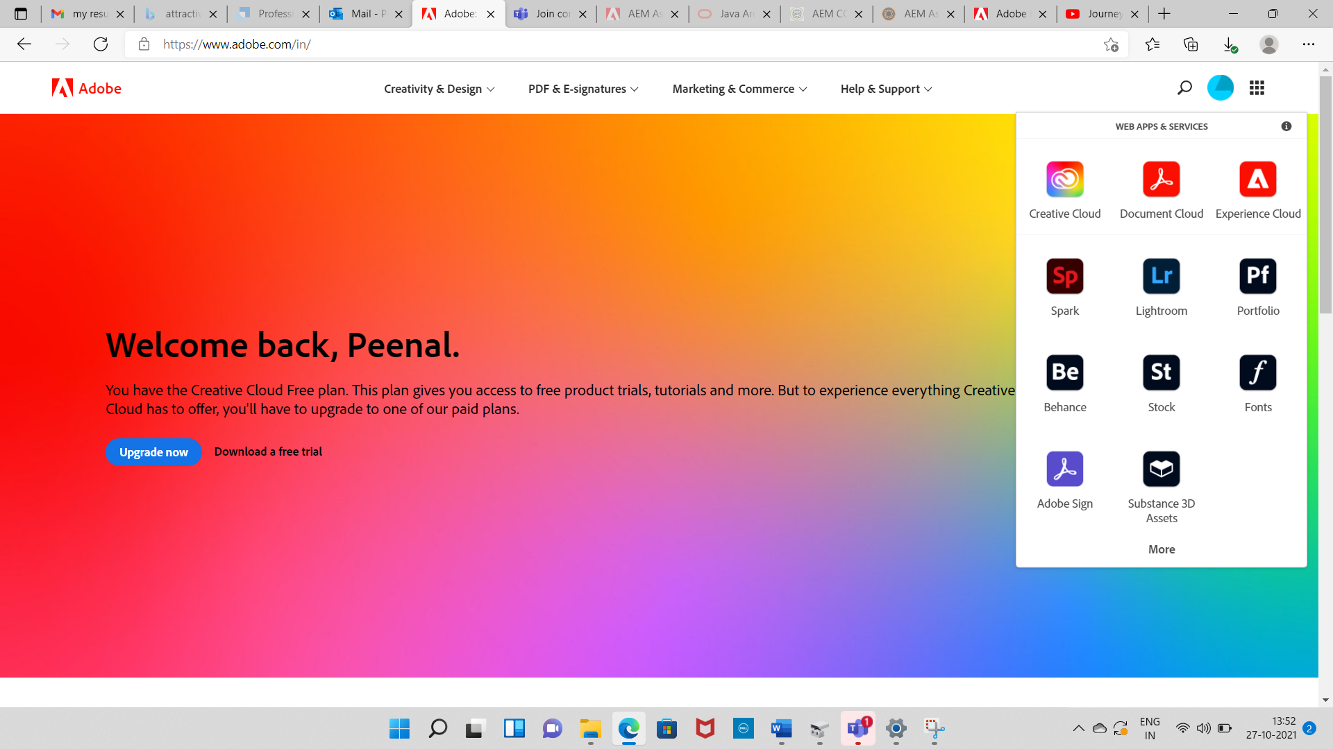

4) Click on the “Tutorials” link as shown in below:-

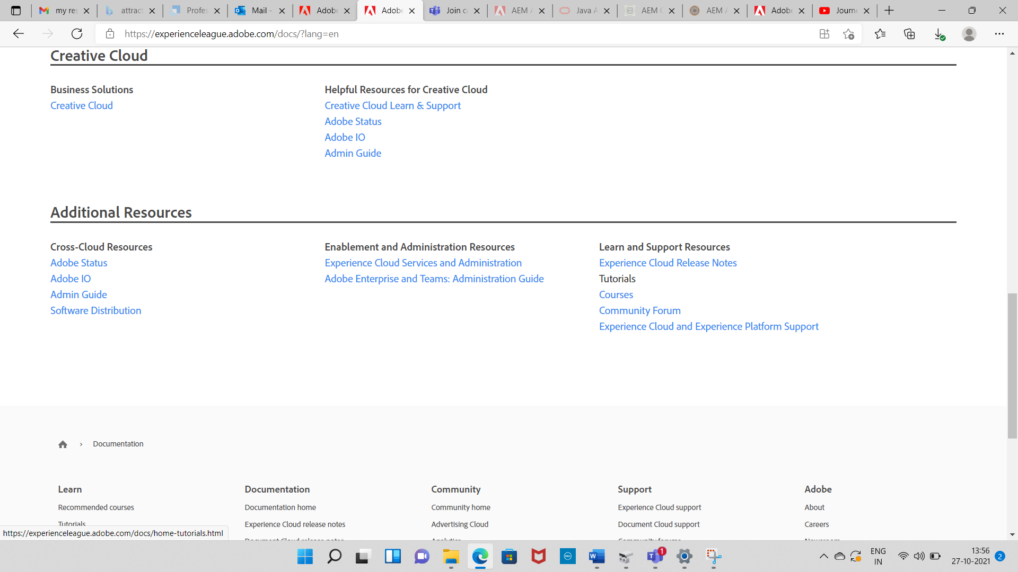

5) You can go through the tutorials for AEM Sites, AEM Forms for better understanding.

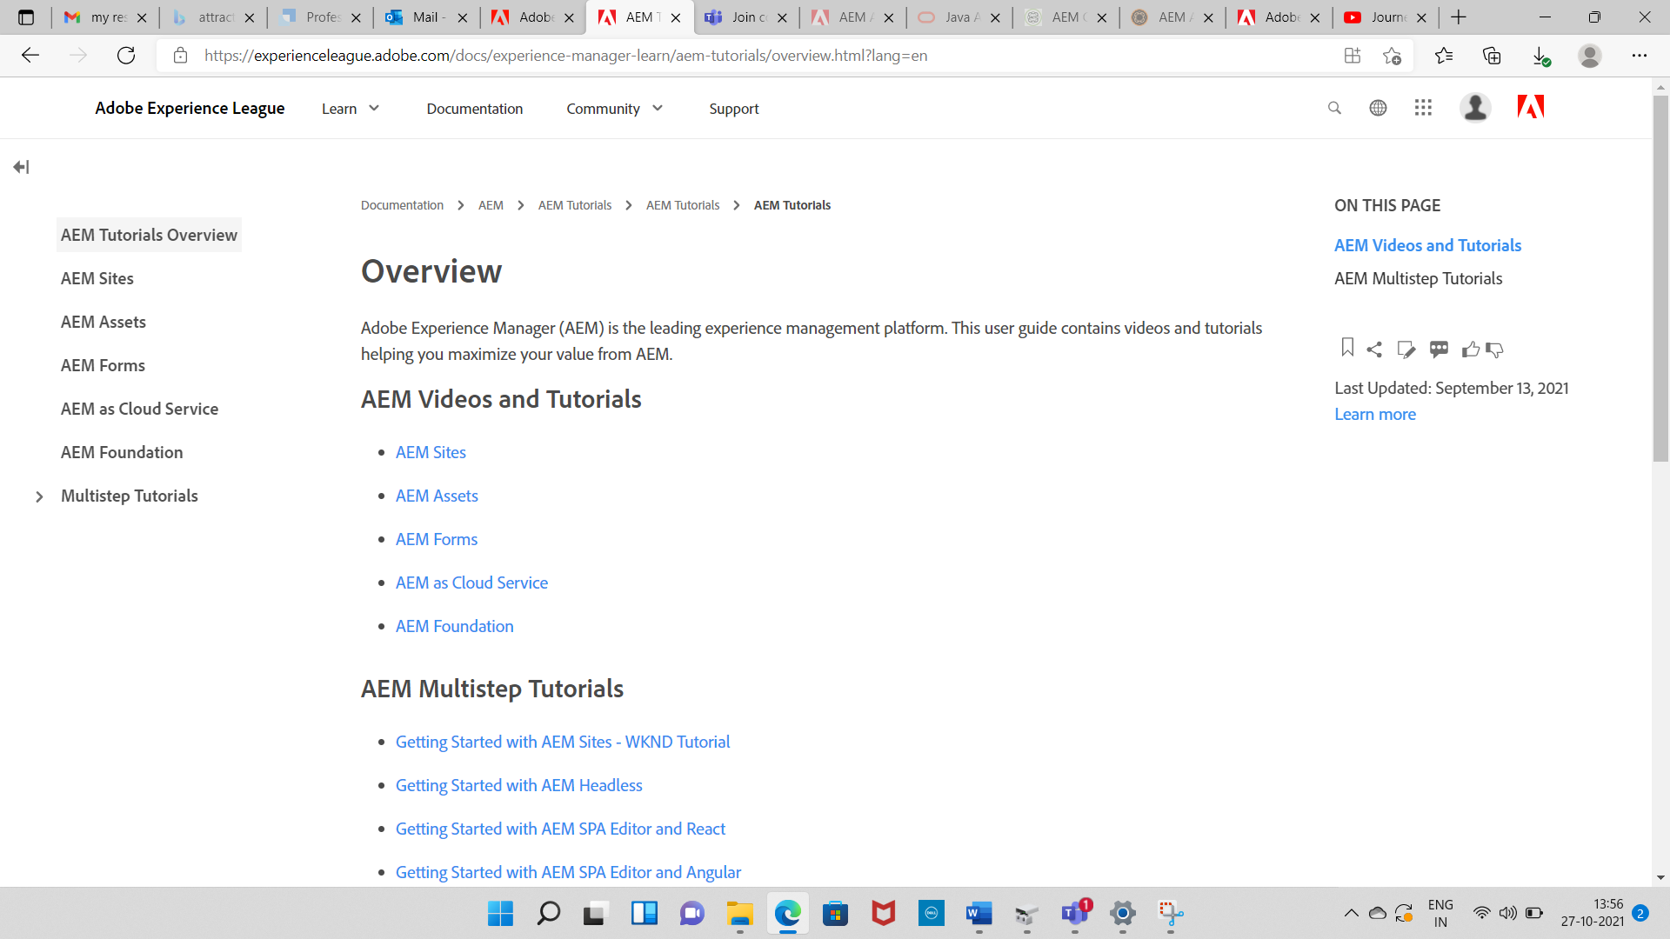

Some Useful Links for Understanding how AEM Works:-

Go through the links as below for understandin basics of AEM.

[Home Page - AEM Tutorials for Beginners (aem4beginner.blogspot.com)](https://aem4beginner.blogspot.com/home-page)

[AEM CQ5 Tutorial for Beginners | AEM CQ5 Tutorials](http://www.aemcq5tutorials.com/tutorials/aem-cq5-tutorial/)