# Data and Artificial Intelligence

# Cyber Shujaa Program

# Week 5 Assignment Data Visualization using Tableau

**Student Name:** Shirleen Nanetia Simon

**Student ID:** CS-DA01-25077

## Introduction

This week’s assignment focused on developing hands-on experience with Tableau, a leading Business Intelligence tool, by working on a real-world HR analytics project. The goal was to analyze employee data and design a compelling interactive dashboard that would help an HR manager gain both high-level insights and detailed views of employee records.  
  
The business objective was to:  
- Provide quick access to workforce demographics  
- Analyze income distribution and salary gaps  
- Facilitate data-driven decisions through visual storytelling  
  
By completing this project, I learned how to load and transform datasets, create calculated measures, and build visualizations that are both functional and informative.

## Tasks Completed

### **1. Understanding the Business Needs**

Reviewed the project brief and dataset provided in the Tableau HR Project. Identified key questions the HR manager would need answers to, such as employee distribution by gender, salary trends, and department-level insights.

### **2. Loading and Transforming Data**

Imported the provided Excel/CSV files into Tableau. Cleaned and structured the data using Tableau’s Data Interpreter and Data Pane. Standardized fields such as birthdate, city, department names, and education levels for consistency.

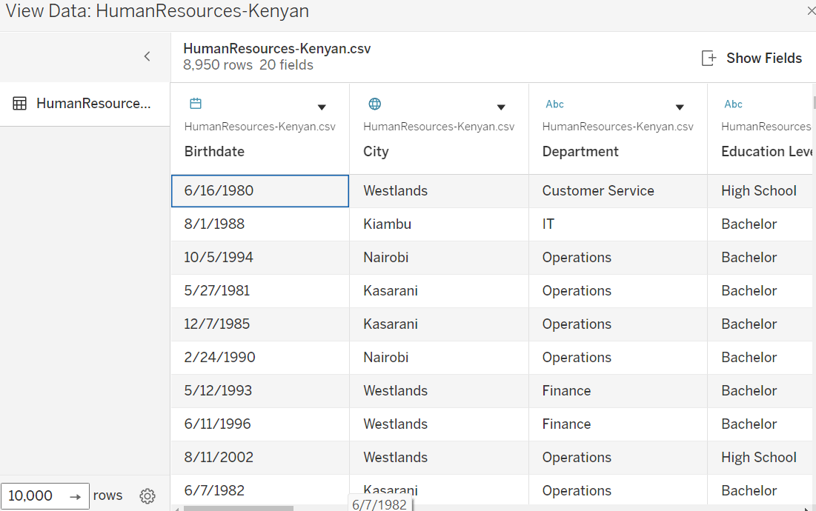

### **3. Creating Measures**

Developed custom fields such as:

* Gender ratio

Indicates the **proportion of males to females** (or vice versa) across the company.

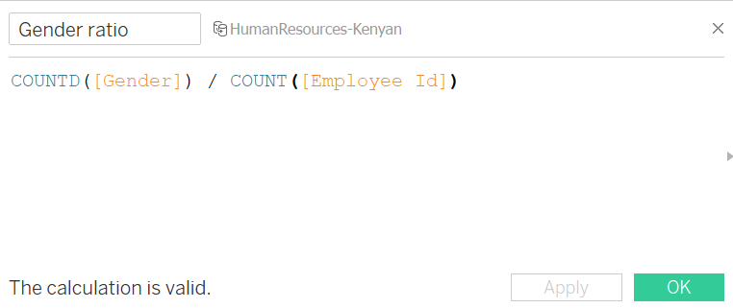

* Total employees

A simple but crucial measure showing the **total headcount** in the company or per department.

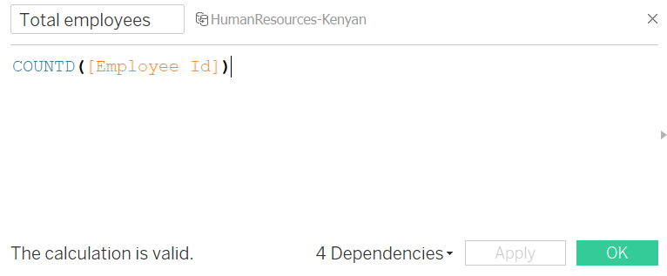

* Average salary

This measure shows the **mean salary across employees,** either overall or filtered by departments, gender, or roles.

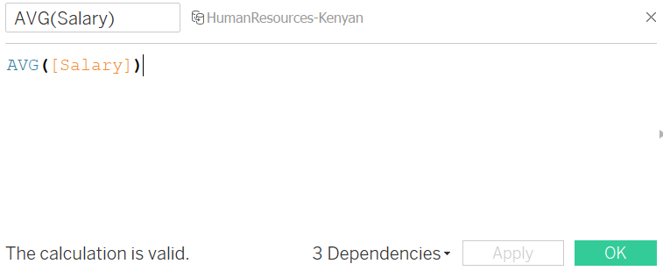

* Applied logic-based calculations for conditional formatting and trend analysis.

Eg. % female

This calculated measure shows the **percentage of female employees** in the organization. It is vital for analyzing **gender diversity** and inclusion across the company.

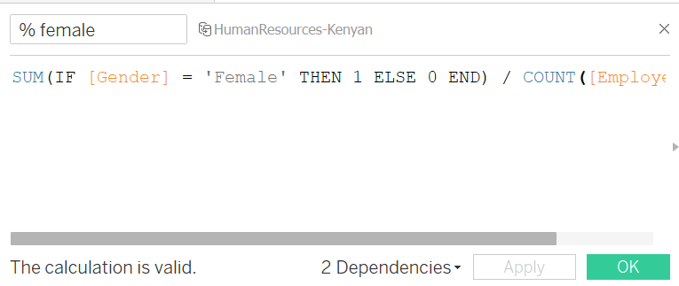

Eg. Income Level (Low, Medium, High)

Used to **categorize employee salaries** into meaningful brackets such as **Low, Medium, and High** to **analyze salary distribution** across departments.

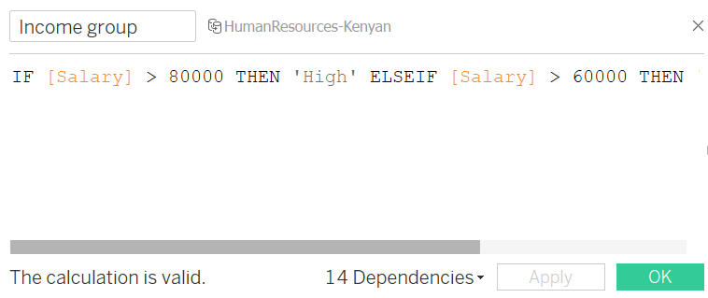

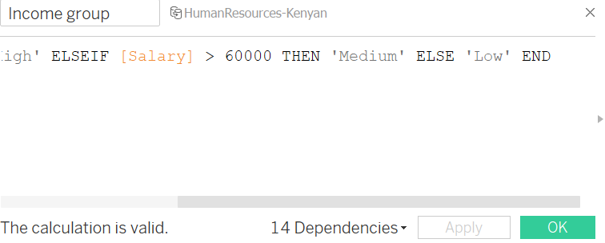

### **4. Building Visualizations**

Designed a wide variety of visual elements to represent the data:

* Horizontal bars (e.g., Average salary by state and city)

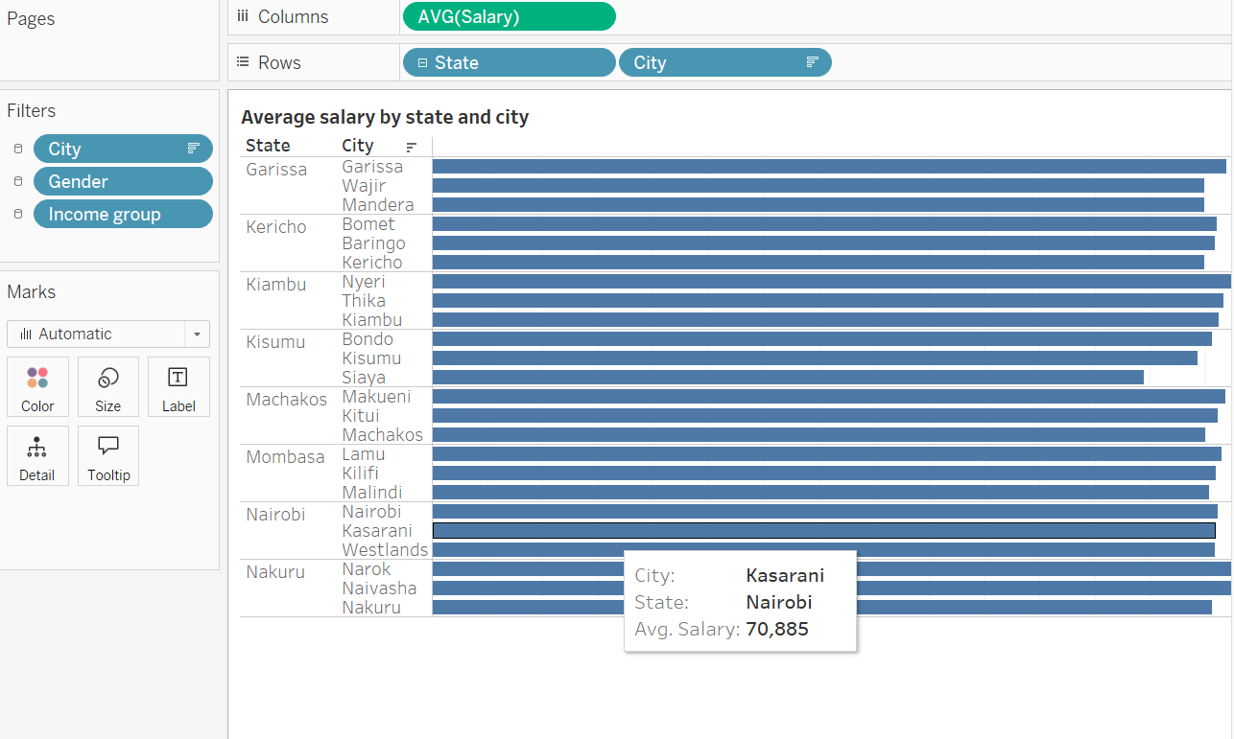

* Pie chart (e.g., Gender distribution)

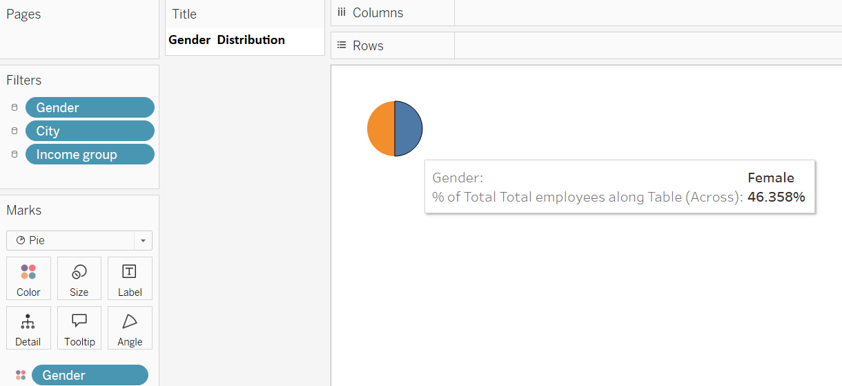

* Stacked bars (e.g., Salary by gender and department)

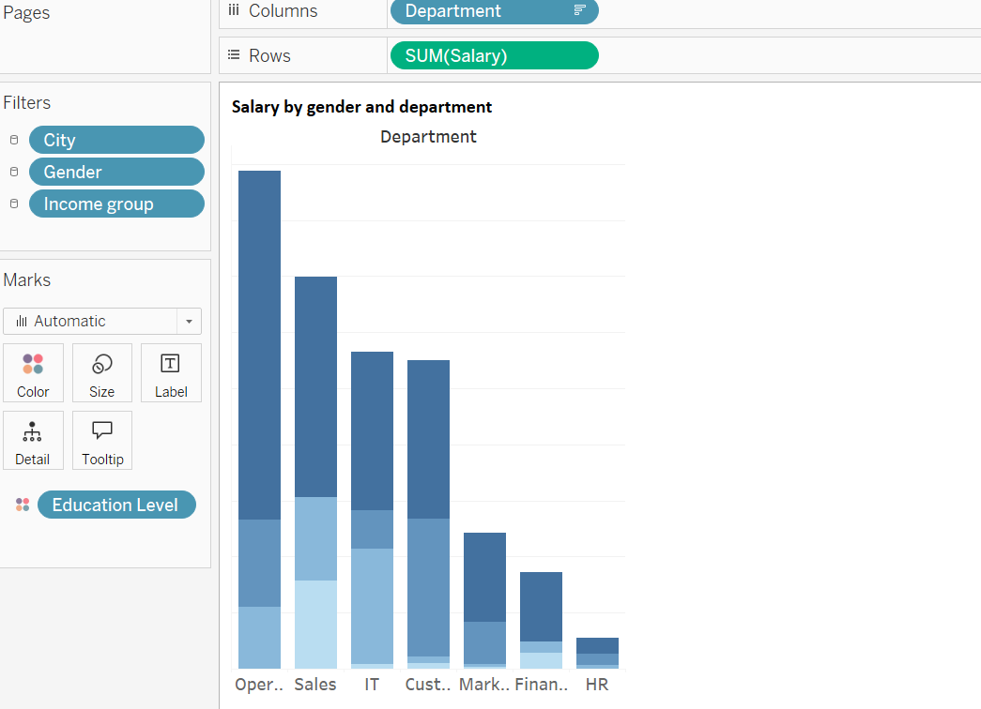

* Lines-discrete (e.g., Hiring date over time)

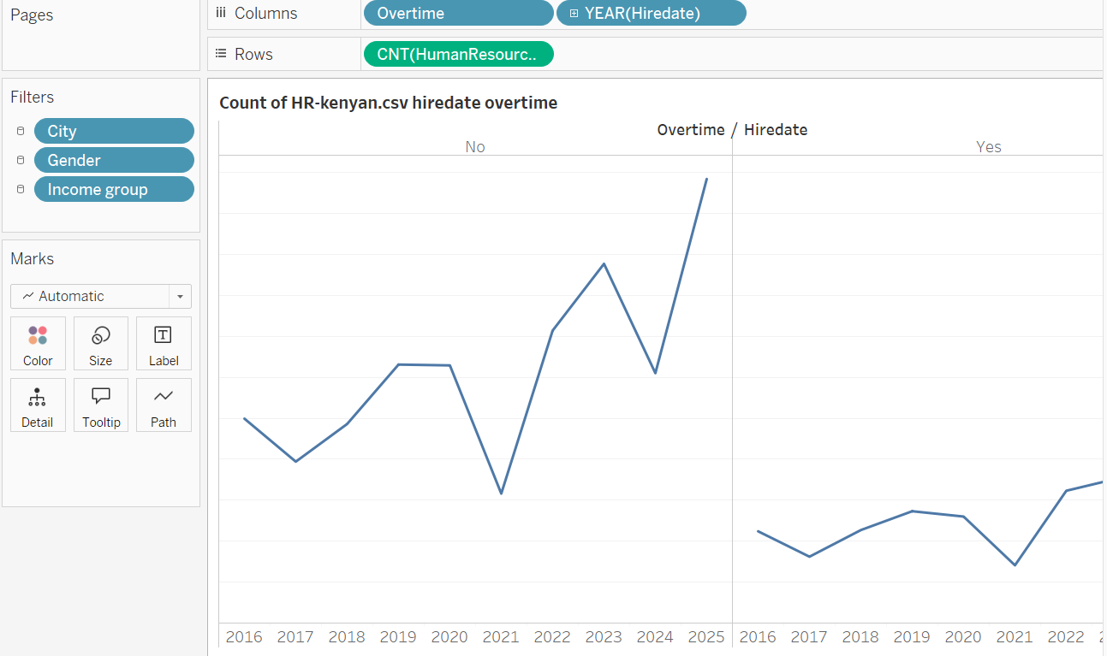

* Side by side circles (e.g., Age and Salary distribution)

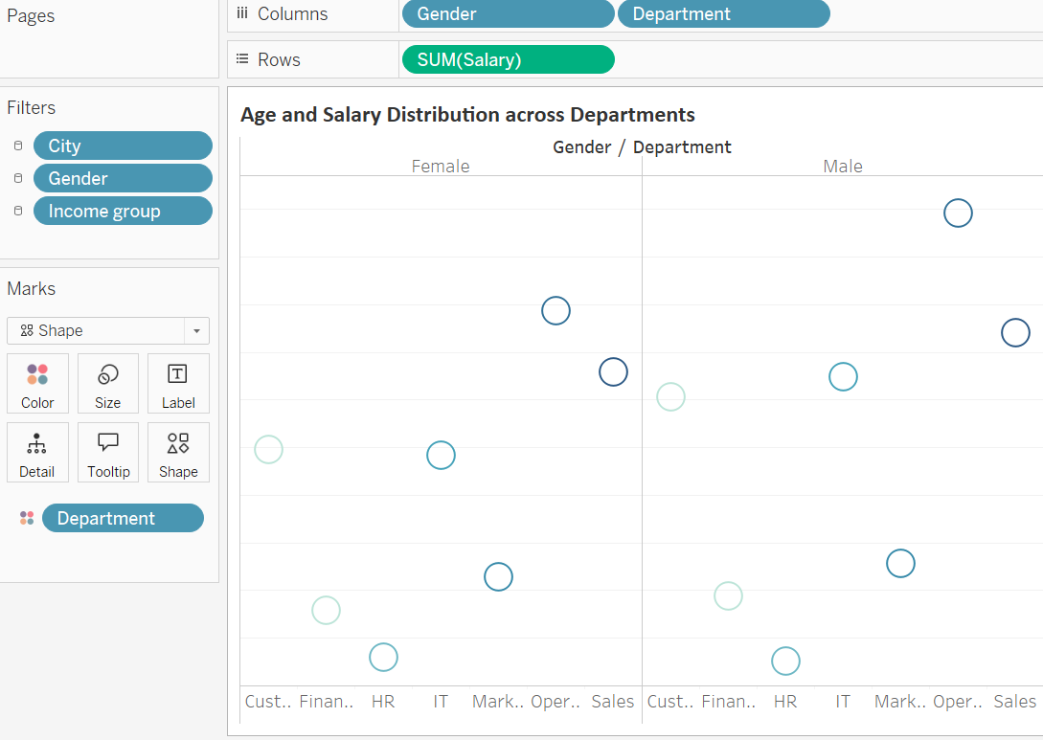

### **5. Developing an Interactive Dashboard**

Created a dashboard with three key sections:

* Overview: Average salary, gender ratio, etc.
* Demographics: Gender, education, and department distributions.
* Income Analysis: Salary distribution across departments, and genders.

Included an employee directory table with filters for:  
- Name, Department, Gender, Position, Salary, Education  
Added filters and action controls for easy navigation and interaction.

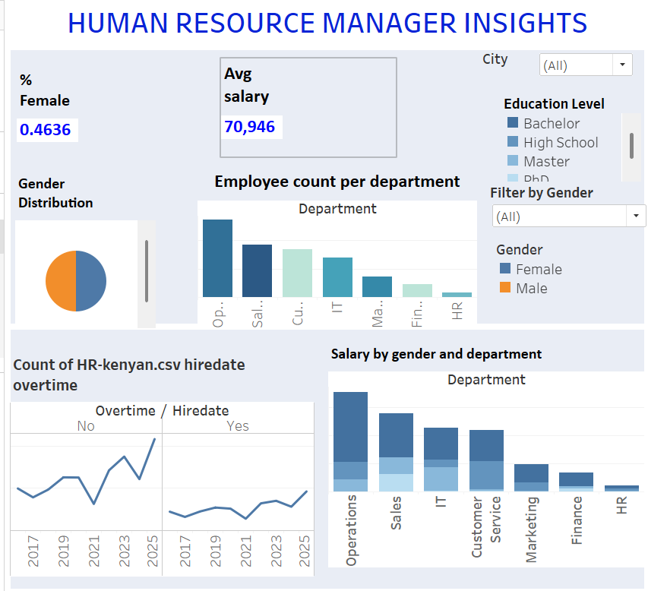

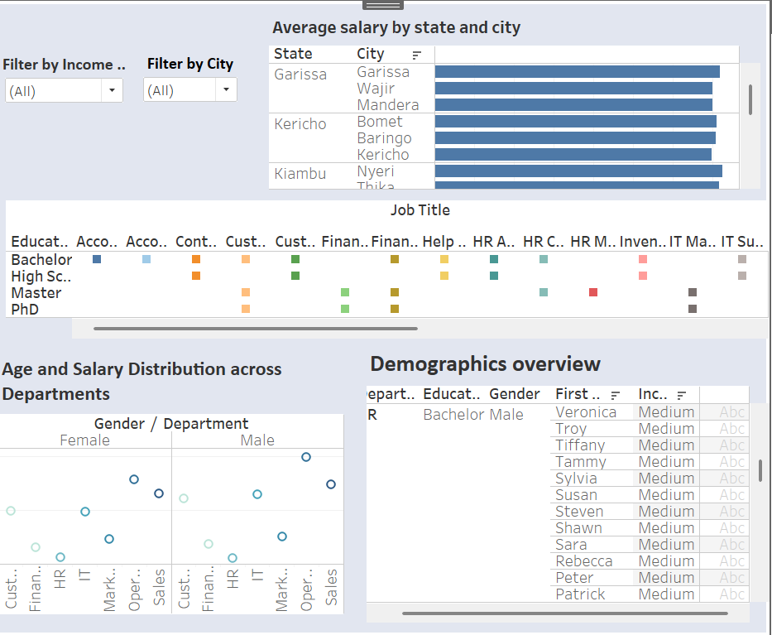

## Conclusion

This Tableau HR Analytics project was a valuable opportunity to sharpen my data visualization and storytelling skills. By transforming raw HR data into meaningful insights, I demonstrated my ability to meet business requirements through well-structured, interactive dashboards.  
  
This project highlights key competencies in:

* Data preparation and transformation
* Creating measures/calculated fields
* Designing effective, user-friendly visualizations