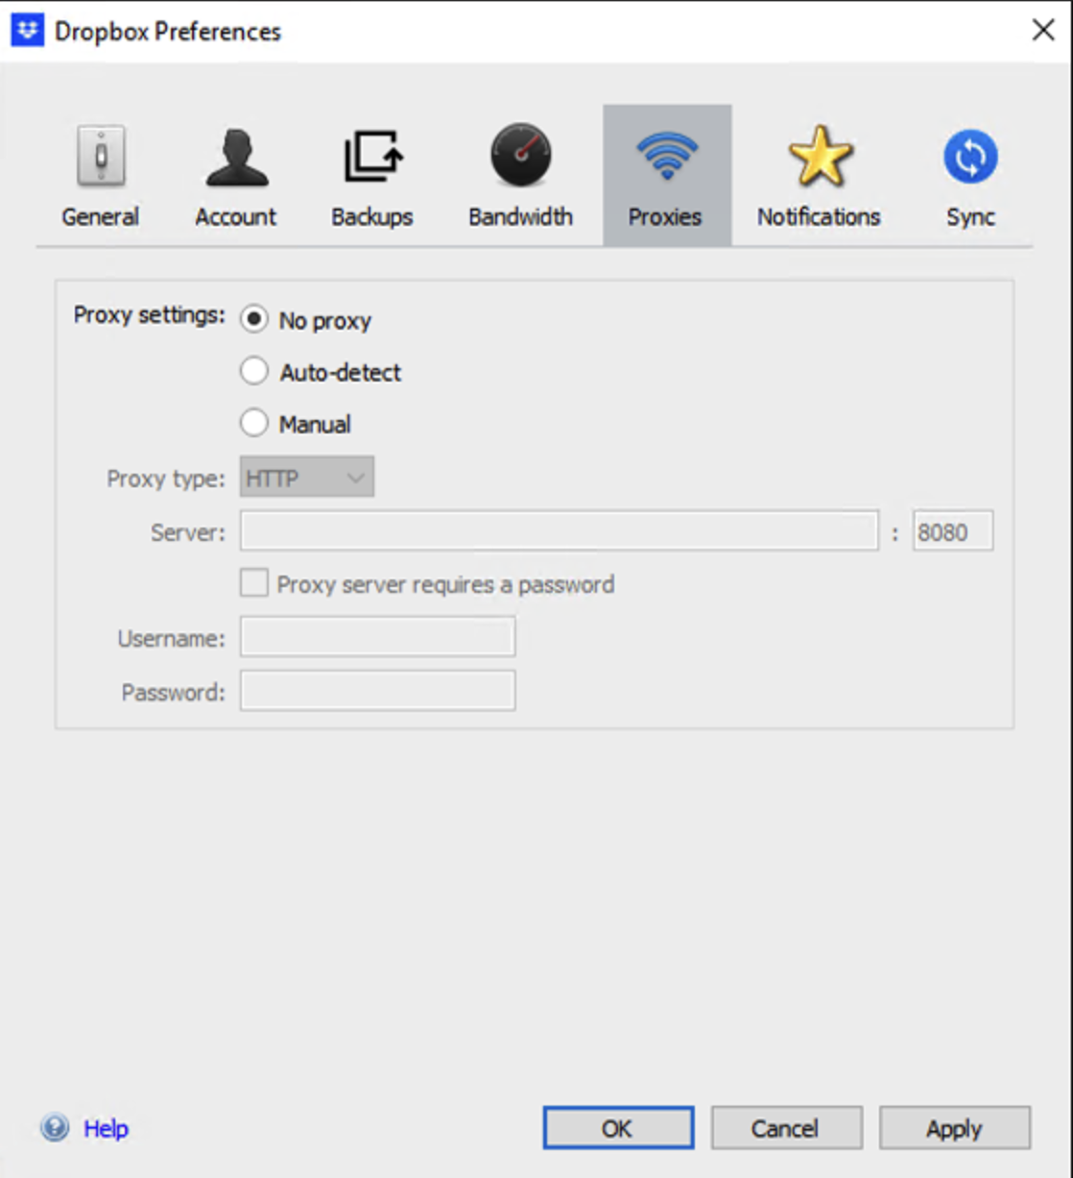fdasfsdfdassssssssssss186> <247:250> SESS=250, mem send len: 0 @<sendPendingData> @@<http2_io_session.cpp:797>
http.log.20231027.0079:06:36:09.002850 <D><370924:174:186> <247:250> used stack size: 464 @<SwapContextToTask> @@<TmTaskHandlerBase.cpp:97>
[root@swg-scanner-daemon-756cfd7475-q4wwp log]#
[root@swg-scanne swg-scanner-daemon-756cfd7475-q4wwp log]#
[root@swg-scanner-daemon-756cfd7475-q4wwp log]#
[root@swg-scanner-daemon-756cfd7475-q4wwp log]#
swg-scanner-daemon-756cfd7475-q4wwp log]#
[root@swg-scanner-daemon-756cfd7475-q4wwp log]#
[root@swg-scanner-daemon-756cfd7475-q4wwp log]#
swg-scanner-daemon-756cfd7475-q4wwp log]#
[root@swg-scanner-daemon-756cfd7475-q4wwp log]#
[root@swg-scanner-daemon-756cfd7475-q4wwp log]#
swg-scanner-daemon-756cfd7475-q4wwp log]#
[root@swg-scanner-daemon-756cfd7475-q4wwp log]#
[root@swg-scanner-daemon-756cfd7475-q4wwp log]#
swg-scanner-daemon-756cfd7475-q4wwp log]#
[root@swg-scanner-daemon-756cfd7475-q4wwp log]#
[root@swg-scanner-daemon-756cfd7475-q4wwp log]#
swg-scanner-daemon-756cfd7475-q4wwp log]#
[root@swg-scanner-daemon-756cfd7475-q4wwp log]#
[root@swg-scanner-daemon-756cfd7475-q4wwp log]#
swg-scanner-daemon-756cfd7475-q4wwp log]#
[root@swg-scanner-daemon-756cfd7475-q4wwp log]#
[root@swg-scanner-daemon-756cfd7475-q4wwp log]#
swg-scanner-daemon-756cfd7475-q4wwp log]#
[root@swg-scanner-daemon-756cfd7475-q4wwp log]#
[root@swg-scanner-daemon-756cfd7475-q4wwp log]#
r-daemon-756cfd7475-q4wwp log]#
[root@swg-scanner-daemon-756cfd7475-q4wwp log]#
[root@swg-scanner-daemon-756cfd7475-q4wwp log]# grep "<247:" http.log.20231027.0079 > shirley2
[root@swg-scanner-daemon-756cfd7475-q4wwp log]# vim shirley2
[root@swg-scanner-daemon-756cfd7475-q4wwp log]#
[root@swg-scanner-daemon-756cfd7475-q4wwp log]#
[root@swg-scanner-daemon-756cfd7475-q4wwp log]#
[root@swg-scanner-daemon-756cfd7475-q4wwp log]# vim shirley1
[root@swg-scanner-daemon-756cfd7475-q4wwp log]#
[root@swg-scanner-daemon-756cfd7475-q4wwp log]# vim shirley1
[root@swg-scanner-daemon-756cfd7475-q4wwp log]#
[root@swg-scanner-daemon-756cfd7475-q4wwp log]# grep "HTTP Header" shirley1
http.log.20231027.0078:06:33:50.768127 <D><365545:174:185> <253:255> HTTP Headers: @ onHeaderCompleted @<dbgLogHeaderLine> @@<IWSSHTTPParserImpl.cpp:660>
http.log.20231027.0078:06:33:50.863428 <D><365545:174:183> <253:255> HTTP Headers: @ doContentScan @<dbgLogHeaderLine> @@<IWSSHTTPParserImpl.cpp:660>
http.log.20231027.0078:06:33:50.926326 <D><365545:174:185> <253:255> HTTP Headers: @ sendHttpReqHeaders @<dbgLogHeaderLine> @@<IWSSHTTPParserImpl.cpp:660>
http.log.20231027.0078:06:33:52.097109 <D><365545:174:185> <253:255> HTTP Headers: @ onHeaderCompleted @<dbgLogHeaderLine> @@<IWSSHTTPParserImpl.cpp:660>
http.log.20231027.0078:06:33:52.104588 <D><365545:174:183> <253:255> HTTP Headers: @ doContentScan @<dbgLogHeaderLine> @@<IWSSHTTPParserImpl.cpp:660>
http.log.20231027.0078:06:33:52.114384 <D><365545:174:185> <253:255> HTTP Headers: @ sendHttpResponseHeaders @<dbgLogHeaderLine> @@<IWSSHTTPParserImpl.cpp:660>
http.log.20231027.0078:06:33:52.258466 <D><365545:174:185> <253:255> HTTP Headers: @ onHeaderCompleted @<dbgLogHeaderLine> @@<IWSSHTTPParserImpl.cpp:660>
http.log.20231027.0078:06:33:52.295540 <D><365545:174:185> <253:255> HTTP Headers: @ sendHttpReqHeaders @<dbgLogHeaderLine> @@<IWSSHTTPParserImpl.cpp:660>
http.log.20231027.0078:06:33:52.451161 <D><365545:174:185> <253:255> HTTP Headers: @ onHeaderCompleted @<dbgLogHeaderLine> @@<IWSSHTTPParserImpl.cpp:660>
http.log.20231027.0078:06:33:52.459210 <D><365545:174:185> <253:255> HTTP Headers: @ sfsdaf 方法撒旦法水电费 发撒多福多寿FSDFSDF

fsdfsdfsdafsadfsdf

发生的发生的发生的发生大发大沙发

FASDFASDFSADFADSFASDFSDF

