NIGHTINGALE
Care Note
A trust-first longitudinal collaboration system
72-hour candidate build | Working prototype | Synthetic data only
First-principles decision. Extraction and deterministic safety rules precede generation. A useful clinical card must answer what changed, why it matters, what to do next, and where the evidence lives.

Architecture and request path
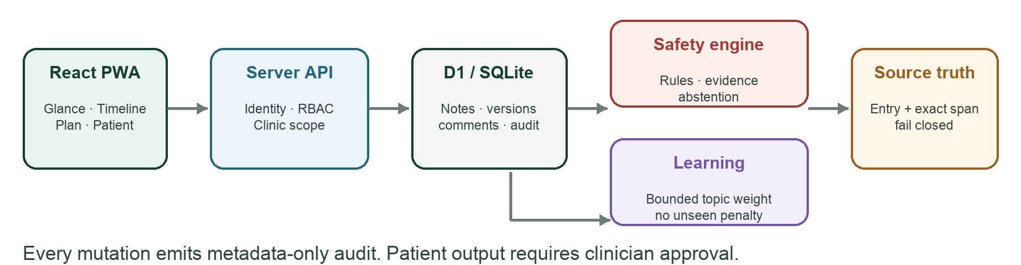
The client is a responsive Vinext/React PWA. Every read and mutation reaches one server API boundary that authenticates a fixed identity, scopes the clinic and patient, then checks role and immutable section ownership before D1 access. Cross-tab BroadcastChannel updates plus 15-second polling provide lightweight near-real-time collaboration; version checks remain the consistency authority.
GLANCE | PROVENANCE | CONCURRENCY | PATIENT
what · why · next | entry + exact span | expected_version → 409 | human-approved only

Data model and core workflows
D1 stores durable product state. AI notes are entries—not privileged truth—and remain distinct by `author_role=system`, type and source session. Full section snapshots make audit and revert deterministic within the build window.
Object | Links / invariant | Purpose / trust control
Entries / AI_Scribed_Notes | Patient; author role/id; type; source_id | Longitudinal source record. AI doctor, nurse and patient session types remain distinct.
Comments | Entry or CareSection; author; mentions; assignee | Internal threads with resolve/unresolve. Patient API never selects them.
CareSections / Versions | Patient + unique section key; version parent | Role-owned clinician/staff sections. Every edit/revert appends a full snapshot.
Highlights / Provenance | Highlight → source Entry + [start,end) | Risk reason, evidence and importance resolve to exact source text; invalid spans fail closed.
HighlightFeedback | Clinic + topic + action + bounded weight | Accept +4, pin/manual +6, reject −3; aggregate is clamped to −6…+8.
Tasks / Conflicts | Task → source Entry; conflict → prior + new Entry | Unresolved work stays prominent. Medication/dosage contradictions remain open until review.
PatientSummaries | Patient + source Entry IDs + approval state | Drafts are withheld. Only clinician-approved summaries cross the patient boundary.
SourceSegments / AuditLogs | Session + timestamp/speaker/confidence; actor metadata | Trace AI notes to source segments; log who/what/version without note bodies.

Importance, evidence and learning
Rule-first score. score = min(100, max(category safety floor, recency + rule risk + unresolved task + clinician confirmation + bounded learning)). Floors: allergy 94; medication/dosage 88; open task 74.
Evidence, not model confidence. Evidence = 55% source coverage + 45% source quality. ≥80 strong; ≥60 moderate; ≥40 limited; <40 abstain. The UI exposes the inputs, exact source and correction controls.
Feedback hazards. Unseen items receive zero—not negative—feedback, reducing exposure bias. Care-team fatigue cannot suppress protected clinical classes because learning never overrides safety floors.

Security, evaluation and scope decisions
Control | Implementation | Failure behaviour
RBAC + clinic scope | Server maps token → identity/role/clinic; every action checks role, clinic and section owner. | Cross-clinic is 404; wrong-role write is 403; same-section stale write is 409.
PHI redaction | Names, IC/ID and phones are removed before the optional model boundary; residual-risk detector measures uncertainty. | Possible remaining name or long digit run → HTTP 422 abstention; no model call.
Patient-facing safety | Only `approved` patient summaries are queried; clinician is the sole approver. | Drafts, raw AI and internal comments are absent, not merely hidden.
Transport / storage | Cloudflare deployment supplies TLS and encryption at rest; D1 binding is server-only. | Prototype must not be used for real PHI; no secrets or external model keys exist.

Hybrid storage / decay policy
Hot retains full fidelity (<90 days, score ≥70, protected class, unresolved or clinician-confirmed). Warm retains an indexed summary plus source (<365 days or score ≥40). Cold is a reversible compression candidate. Age alone never removes allergies, medication/dosage facts, unresolved tasks or confirmed risks; the prototype never irreversibly deletes.

How we know when a number is wrong
Signal | What it is | How wrong is detected | What happens
Risk | Deterministic class/floor, not free-form model label. | Compare rule triggers to source; conflict visible. | Preserve floor; require clinician review.
Evidence | Defined coverage/quality equation. | Missing/invalid span or score <40. | Fail closed / abstain; show source gap.
Redaction | Recall-sensitive deterministic detectors. | Residual names/digit runs; labelled test set failure. | No model call; human privacy review.
Learning | Bounded topic weight, clinic-local. | Offline ranking regression or critical-class drop. | Clamp/disable learner; floors remain.

Verified quality gates
TESTS | WARM P50 | WARM P95 | TARGET
13 passed | 6.49 ms | 8.57 ms | ≤300 ms · met
Method: 10 warmups + 200 sequential HTTP requests to the clinic-scoped Glance endpoint on local macOS, Vinext dev and local D1/Miniflare. This excludes WAN/TLS, cold starts and production concurrency; it supports the warm-path implementation claim, not a production SLA.

Trade-offs and remaining scope
Identity. Fixed synthetic demo tokens make all four roles reproducible; production must replace them with a managed identity-to-clinic/role directory behind workspace/SIWC authentication.
Ambient capture. The PWA demonstrates transcript intake, labels, timing, confidence, redaction, abstention and provenance without calling ASR/LLM. Real noisy diarization, overlap and multilingual terminology are architectural follow-ons.
Validation. The prototype is a safety argument with executable tests—not validated medical software. Production needs labelled extraction/redaction sets, prospective ranking evaluation, monitoring and clinical governance.

