## Storyboard for : As a student I wish to alert the lecturer that I need help

Index.php

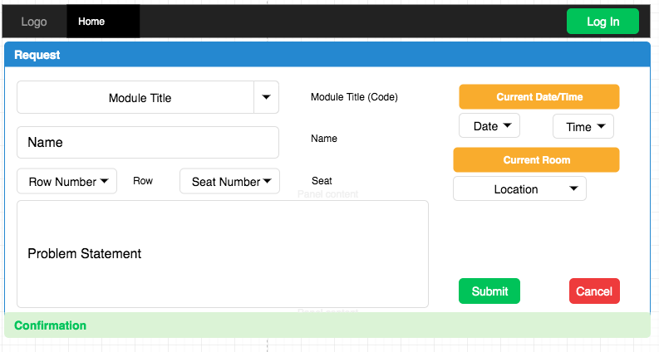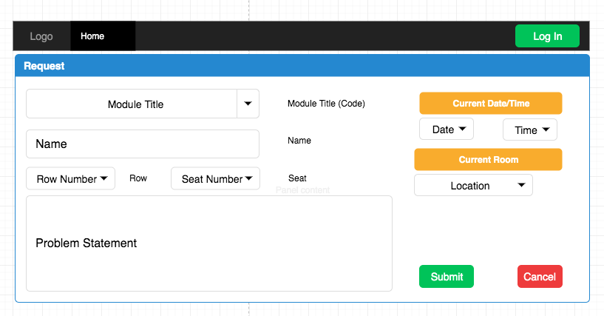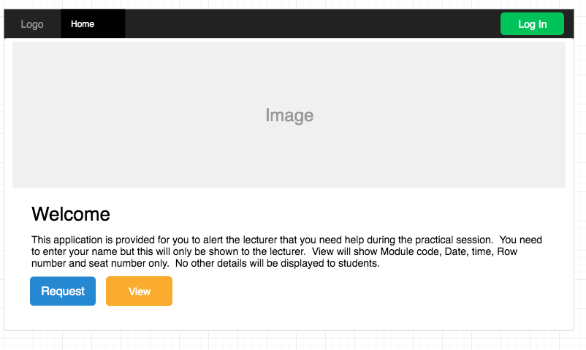

Request confirmation/Message

Request.php