108-1資料結構 第一次小考 答案

1. (1) An algorithm is a finite set of instructions that accomplished a particular task (3%)

(2) input, output, definiteness, finiteness, effectiveness (3%)

(3) An ADT is a data type that is organized in such a way that the specification of the objects and the operations on the objects is separated from 1.the representation of the object. 2.the implementation of the operations (3%)

2. (6%)

|  |  |  |
| --- | --- | --- |
|  | space | time |
| 2D Array | O(rows * cols) | O(rows * cols) |
| Transpose a Matrix | O(elements) | O(cols * elements) |
| Fast Transpose Matrix | O(elements+MAX_COL) | O(col+elements) |

3.

Table2 (2%)

|  |  |  |  |  |  |
| --- | --- | --- | --- | --- | --- |
| 0 | 1 | 2 | 3 | 4 | 5 |
| 3 | 1 | 2 | 1 | 0 | 1 |

Table3 (3%)

|  |  |  |  |  |  |
| --- | --- | --- | --- | --- | --- |
| 0 | 1 | 2 | 3 | 4 | 5 |
| 1 | 4 | 5 | 7 | 8 | 8 |

4. (3%) (3%)

able_1 Table_2

|  |  |  |  |  |  |  |  |  |
| --- | --- | --- | --- | --- | --- | --- | --- | --- |
|  | row | col | value |  |  | row | col | value |
| a[0] | 6 | 6 | 11 |  | b[0] | 6 | 6 | 11 |
| a[1] | 0 | 1 | 13 |  | b[1] | 0 | 1 | 8 |
| a[2] | 0 | 4 | 9 |  | b[2] | 0 | 2 | 5 |
| a[3] | 1 | 0 | 8 |  | b[3] | 0 | 5 | 2 |
| a[4] | 1 | 2 | -9 |  | b[4] | 1 | 0 | 13 |
| a[5] | 2 | 0 | 5 |  | b[5] | 1 | 3 | 7 |
| a[6] | 2 | 5 | -7 |  | b[6] | 2 | 1 | -9 |
| a[7] | 3 | 1 | 7 |  | b[7] | 2 | 4 | 8 |
| a[8] | 4 | 2 | 8 |  | b[8] | 3 | 5 | 18 |
| a[9] | 4 | 4 | 1 |  | b[9] | 4 | 0 | 9 |
| a[10] | 5 | 0 | 2 |  | b[10] | 4 | 4 | 1 |
| a[11] | 5 | 3 | 18 |  | b[11] | 5 | 2 | -7 |

5.(a)top— (4%)

(b) top++ (4%)

6.(1)ABC*+DE/- (5%)

(2)-+A/-BCD/E*FG (3)A+(B*C)/(E-2)*F

(4)(A+B)/(C-D)*E (5)/*+A-BCD*F+GH

7. (6%)

O() > O(n!) > O() > O($2^{n}$) > O() > O() > O(nn) > O(n*log $n^{2}$*) > O(n*log*n) >O(2n) > O(n) > O() > O(1)

8. (5%)

(1) O(*log*n)

(2) 

(3) 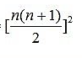

(4) O ()

(5) O ()

9. (6%)

n-1

10.

(1)(a)no (1%)

(b)no (1%)

(c)no (1%)

(2)1234,2134,3214,1243,2143,3241,1324,2341,3421,1342,2314,4321,1432,2431 (3%)

11.(1) (3%)

euts

(2) O(1) (5%)

12.

(1) (1%)

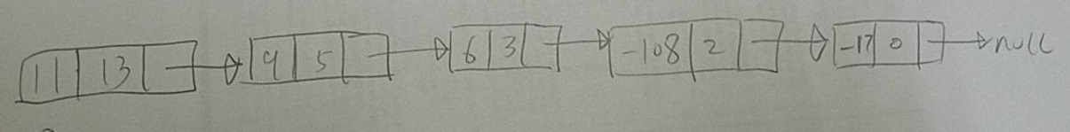

(2)

(a) (3%)

sum = a->coef + b->coef;

if (sum)

attach (sum , a->expon , &rear);

a = a->link ;

b = b->link;

break;

(b) (3%)

attach(a->coef,a->expon,&rear);

a = a->link;

13.

(a) (4%)

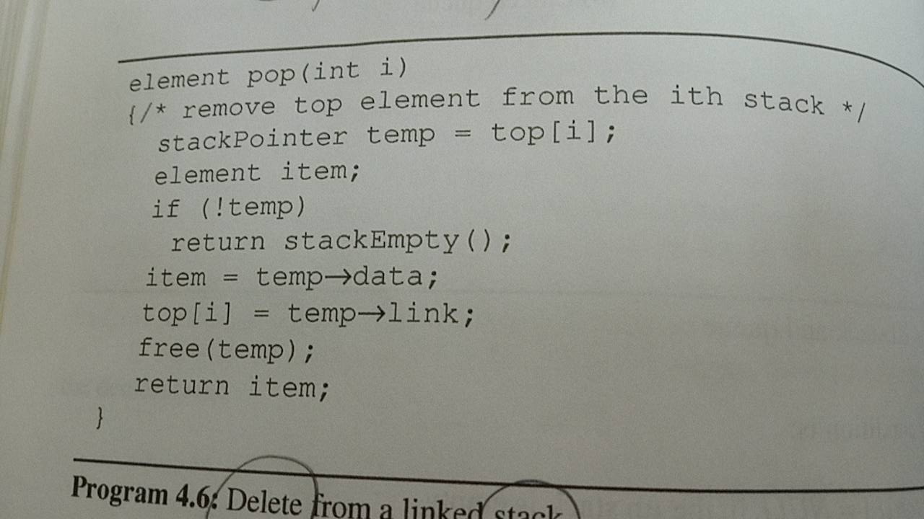

(b) (4%)

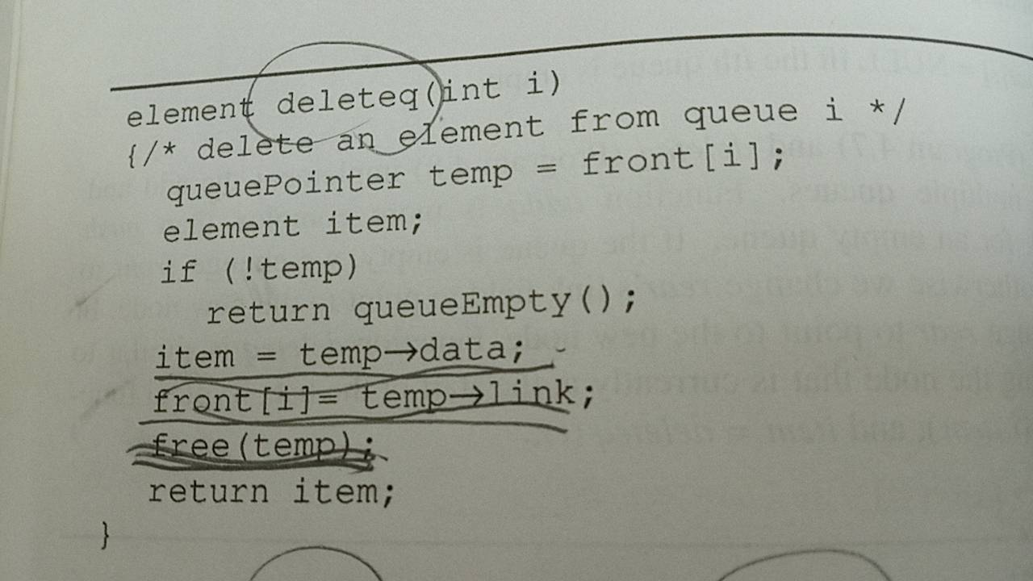

14.

(a) current->next = previous; (2%)

(b) previous = current; (2%)

(c) current = preceding; (2%)

(d) preceding = preceding->next; (2%)

15. (7%)

