**Homework #1**

Name: Student ID: Assigned Date: 2021-10-05

1. In this exercise we introduce one of our running examples of a relational database schema. The database schema consists of four relations, whose schemas are:

Product(maker, model, type)

PC(model, speed, ram, hd, price)

Laptop(model, speed, ram, hd, screen, price)

Printer(model, color, type, price)

The Product relation gives the manufacturer, model number and type (PC, laptop, or printer) of various products. We assume for convenience that model numbers are unique over all manufacturers and product types; that assumption is not realistic, and a real database would include a code for the manufacturer as part of the model number. The PC relation gives for each model number that is a PC the speed (of the processor, in gigahertz), the amount of RAM (in megabytes), the size of the hard disk (in gigabytes), and the price. The Laptop relation is similar, except that the screen size (in inches) is also included. The Printer relation records for each printer model whether the printer produces color output (true, if so), the process type (laser or ink-jet, typically), and the price. Write the following declarations:

1. A suitable schema for relation Product.
2. A suitable schema for relation PC.
3. A suitable schema for relation Laptop.

(a) CREATE TABLE Product(

maker varchar(255),

model int UNIQUE,

type varchar(255)

);

(b) CREATE TABLE PC(

model int NOT NULL PRIMARY KEY,

speed float,

ram int,

hd int,

price int

);

(c) CREATE TABLE Laptop(

model int NOT NULL PRIMARY KEY,

speed float,

ram int,

hd int,

screen float,

price int

);

2. This exercise builds upon the products schema of Exercise 1. Recall that the database schema consists of four relations, whose schemas are:

Product(maker, model, type)

PC(model, speed, ram, hd, price)

Laptop(model, speed, ram, hd, screen, price)

Printer(model, color, type, price)

Some sample data for the relation Product is shown in Fig. 2.1. Sample data for the other three relations is shown in Fig. 2.2. Manufacturers and model numbers have been “sanitized”, but the data is typical of products on sale at the beginning of 2021.

Write expressions of relational algebra to answer the following queries. You may use the linear notation (e.g., 𝜋, 𝜎, etc.) if you wish. For the data of Figs. 2.1 and 2.2, show the result of your query. However, your answer should work for arbitrary data, not just the data of these figures.

1. What PC models have a speed of at least 3.00?
2. Which manufacturers make laptops with a hard disk of at least 100GB?
3. Find the model number and price of all products (of any type) made by manufacturer B.

(a)

(b)

(c)

* 1. 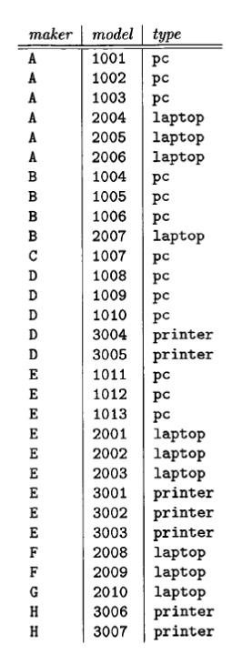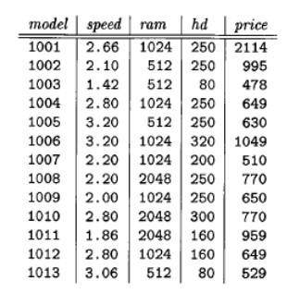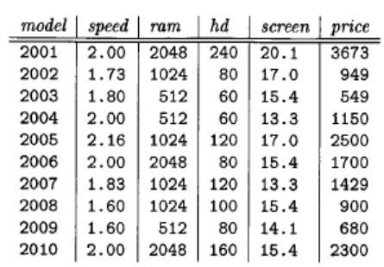Sample data for relation PC

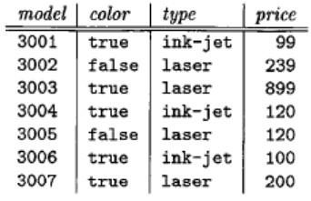

* 1. Sample data for relation Laptop

Figure 2.1: Sample data for Product

* 1. Sample data for relation Printer

Figure 2.2: Sample data for relations of Exercise 2

3. Express the following constraints about the relations of Exercise 1, reproduced here:

Product(maker, model, type)

PC(model, speed, ram, hd, price)

Laptop(model, speed, ram, hd, screen, price)

Printer(model, color, type, price)

You may write your constraints either as containments or by equating an expression to the empty set. For the data of Exercise 2, indicate any violations to your constraints.

(a) A PC with a processor speed less than 2.00 must not sell for more than $500. (b) A laptop with a screen size less than 15.4 inches must have at least a 100 Gigabyte hard disk or sell for less than $1000.

(c) No manufacturer of PC’s may also make laptops.

(a) $σ_{speed < 2.00 ˄ price > 500}\left(PC\right)$

(b) $σ_{screen < 15.4 ˄ (hd < 100 ˄ price ≥ 1000)}\left(Laptop\right)$

(c) ${{(п}_{maker}(σ}_{PC.model = Product.model}\left(PC×Product\right)))∩{{(п}_{maker}(σ}_{Laptop.model = Product.model}\left(Laptop×Product\right)))$