**Homework #2**

Name:王思正 Student ID: 4108056004 Assigned Date: 2021-10-19

1. Write the following queries, based on our running movie database example

Movies(title, year, length, genre, studioName, producerC#)

StarsIn(movieTitle, movieYear, starName)

MovieStar(name, address, gender, birthdate)

MovieExec(name, address, cert#, netWorth)

Studio(name, address, presC#)

in SQL.

* 1. Find all the stars that appeared either in a movie made in 1980 or a movie with “Love” in the title. (6%)
  2. Find all executives worth at least $10,000,000. (6%)
  3. Find all the stars who either are male or live in Malibu (have string Malibu as a part of their address). (6%)

(a)

( select starName

from StarsIn

where movieYearear = 1980 or movieTitle like “%Love%”)

except(select starName

from StarsIn

where movieYearear = 1980 and movieTitle like “%Love%”)

(b)

select name

from MovieExec

where MovieExec.netWorth >= 10,000,000

(c)

(select name

from MovieStar

where MovieStar.gender = “male” or MovieStar.address = “Malibu”)

except (select name

from MovieStar

where MovieStar.gender = “male” and MovieStar.address = “Malibu”)

1. Using the database schema of our running movie example

Movies (title, year, length, genre, studioName, producerC#)

StarsIn (movieTitle, movieYear, starName)

MovieStar (name, address, gender, birthdate)

MovieExec (name, address, cert#, netWorth)

Studio (name, address, presC#)

Write the following queries in SQL.

* 1. Who were the male stars in *Titanic*? (8%)
  2. Which stars appeared in movies produced by MGM in 1995? (8%)
  3. Who is the president of MGM studios? (8%)
  4. Which movies are longer than *Gone With the Wind*? (8%)
  5. Which executives are worth more than Merv Griffin? (8%)

(a)

select ms.name

form StarsIn as si, MovieStar as ms

where si.movieTitle = “Titanic” and si.starName = ms.name and ms.gender = “male”

(b)

select starname

from StarsIn

where movieTitle in ( select m.title

from Movies as m, Studio as s

where m.studioName = s.name and m.year = 1995 and s.name = “MGM”)

(c)

select presC#

from Studio

where name = “MGM”

(d)

select title

from Movies

where length > all ( select length

from Movies

where title = “Gone With the Wind”)

(e)

select name

from MovieExec

where netWorth > ( select netWorth

from MovieExec

where name = “Merv Griffin”)

1. Write the following queries, based on the database schema

Product(maker, model, type)

PC(model, speed, ram, hd, price)

Laptop(model, speed, ram, hd, screen, price)

Printer(model, color, type, price)

You should use at least one subquery in each of your answers and write each query in two significantly different ways (e.g., using different sets of the operators **EXISTS, IN, ALL**, and **ANY**).

* 1. Find the printers with the highest price. (6%)
  2. Find the model number of the item (PC, laptop, or printer) with the highest price. (6%)
  3. Find the maker(s) of the PC(s) with the fastest processor among all those PC’S that have the smallest amount of RAM. (6%)

(a)

select *

from Printer

where price >= all(select price

from Printer)

select *

from Printer

where price in (select max(price)

from Printer)

(b)

select model

from Product

where model in( ( select model

from PC

where price = (select max(price)

from PC))

union ( select model

from Laptop

where price = (select max(price)

from Laptop))

union ( select model

from Printer

where price = (select max(price)

from Printer))

)

select model

from Product

where model in ( select model

from PC

where price = (select max(price)

from PC))

or model in ( select model

from Laptop

where price = (select max(price)

from Laptop))

or model in ( select model

from Printer

where price = (select max(price)

from Printer))

(c)

select maker

from Product

where model in (select model

from PC

where speed in ( select (max)speed

from PC

where ram in (select min(ram)

from PC)))

select maker

from Product

where model in (select model

from (select *

from PC

where ram = (select min(ram)

from PC) as PC_minram

where speed = (select max(speed)

from PC_minram)

1. Write the following queries, based on the database schema of Exercise 3, and evaluate your queries using the sample data in Fig. 4.

* 1. Find the average speed of PC’s. (6%)
  2. Find the average price of PC’s and laptops made by manufacturer “D.” (6%)

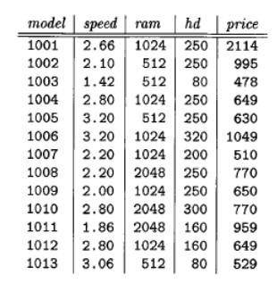

* + 1. Sample data for relation PC

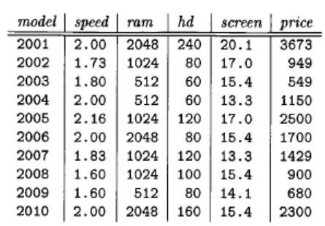

* + 1. Sample data for relation Laptop

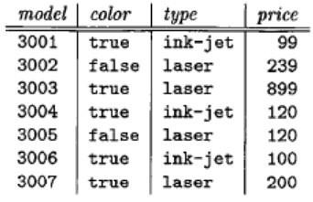

* + 1. Sample data for relation Printer

Figure 4: Sample data for relations of Exercise 4

(a)

select avg(speed)

from PC

(b)

select avg(AVG_price)

from ( (select avg(price) as AVG_price

from PC) as P_price

union( (select avg(price) as AVG_price

from Laptop

where model in ( select model

from Product

where maker=”D”) ) as L_price

)

select avg(AVG_price)

from Product

where model in ( ( select model, avg(price) as AVG_price

from PC)

union( select model, avg(price) as AVG_price

from Laptop

where model in ( select model

from Product

where maker=”D”) )

1. Write the following database modification, based on the database schema as follows:

Classes(class, type, country, numGuns, bore, displacement)

Ships(name, class, launched)

Battles(name, date)

Outcomes(ship, battle, result)

Describe the effect of the modifications on the data in Fig. 5.

* 1. Two of the three battleships of the Italian Vittorio Veneto class — Vittorio Veneto and Italia — were launched in 1940; the third ship of that class, Roma, was launched in 1942. Each had nine 15-inch guns and a displacement of

41,000 tons. Insert these facts into the database. (6%)

* 1. Delete from Ships all ship sunk in battle. (6%)

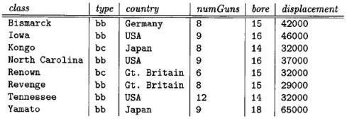

* + 1. Sample data for relation classes

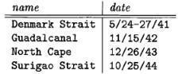

* + 1. Sample data for relation Battels

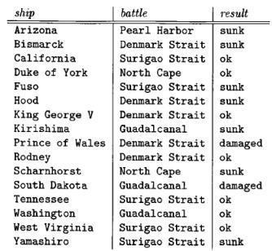

* + 1. Sample data for relation Outcomes

Figure 5: Sample data for relations of Exercise 5

(a)

insert into Classes

values(“Vittorio Vento”, “bb”, “Italian”, 9, 15, 41000)

insert into Ships

values(“Vittorio Vento”, “Vittorio Vento”,1940)

insert into Ships

values(“Italia”, “Vittorio Vento”,1940)

insert into Ships

values(“Roma”, “Vittorio Vento”,1942)

(b)

delete from Ships

where name in ( select name

from Outcomes

where result = “sunk”)