**Homework #4**

Name:王思正 Student ID:4108056004 Assigned Date: 2021-11-16

1. Write the following as triggers. In each case, disallow or undo the modification if it does not satisfy the stated constraint. The database schema is as follows:

Product(maker, model, type)

PC(model, speed, ram, hd, price)

Laptop(model, speed, ram, hd, screen, price)

Printer(model, color, type, price)

* 1. When making any modification to the Laptop relation, check that the average price of Laptops for each manufacturer is at least $1500. (15%)
  2. When inserting a new PC, laptop, or printer, make sure that the model number did not previously appear in any of PC, Laptop, or Printer. (15%)

(a)

CREATE TRIGGER avglaptop INSTEAD OF

UPDATE OF Laptop ON price

INSERT ON Laptop

DELETE ON Laptop

REFERENCING NEW TABLE AS newtable

REFERENCING OLD TABLE AS oldtable

REFERENCING ( SELECT AVG(price) AS avg_price, maker

FROM((Laptop EXCEPT oldtable) UNION newtable) NATURAL JOIN Product

GROUP BY maker) AS new_data

WHEN (ALL new_data.avg_price >= 1500)

BEGIN ATOMIC

DELETE FROM Laptop WHERE * IN oldtable

INSERT INTO Laptop (SELECT * FROM newtable)

END;

(b)

CREATE TRIGGER previousappear BEFORE INSERT ON Product

REFERENCING NEW TABLE AS newtable

REFERENCING ( SELECT COUNT(*) AS a_num

FROM newtable) AS a_model

REFERENCING (SELECT DISTINCT COUNT(*) AS d_num

FROM ( SELECT DISTINCT model

FROM newtable) ) AS d_model

WHEN (a_model.a_num – d_model.d_num = 0)

BEGIN ATOMIC

INSERT INTO Product (SELECT * FROM newtable)

END;

1. Design a database for a bank, including information about customers and their account. Information about a customer includes their name, address, phone, and Social Security number. Accounts have numbers, types (e.g., savings, checking) and balances. Also record the customer(s) who own an account. Draw the E/R diagram for this database. Be sure to include arrows where appropriate, to indicate the multiplicity of a relationship. (20%)
2. For your E/R diagrams of Exercise 3, do the following:
   1. Change your diagram so an account can have only one customer. (10%)
   2. Further change your diagram so a customer can have only one account. (10%)

2/3題一起寫

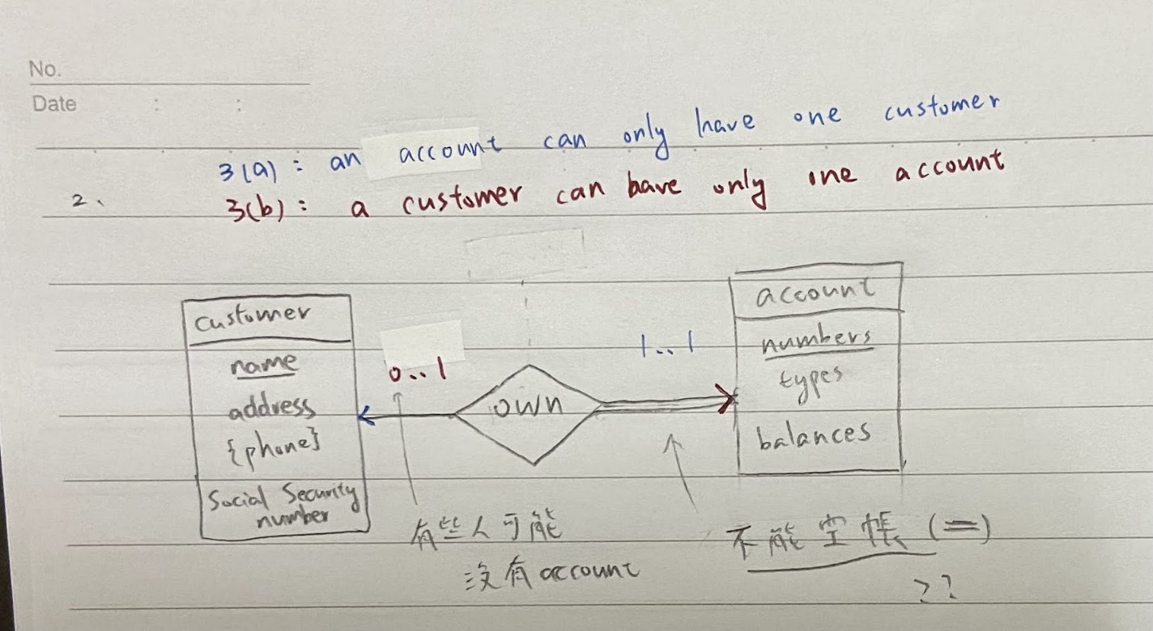

1. Convert the E/R diagram of Fig. 3 to a relational database schema. (30%)

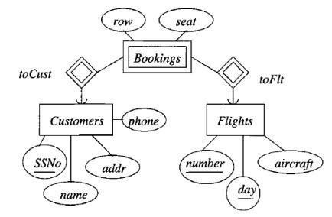

Figure 3: An E/R diagram about airlines

Customers(SSNo, name, addr, phone)

Flights(number, day, aircraft)

Bookings(row, seat, SSNo, number, day)