王思正4108056004

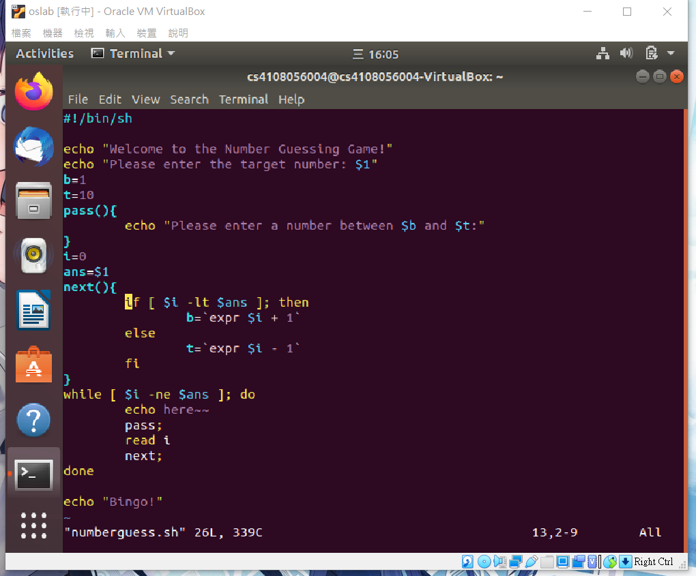

Echo read loop conditions function argument

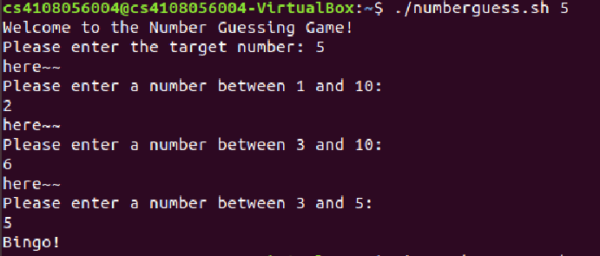

##here只是debug忘記刪了:P