TransitPH Dashboard — Technical Overview
Nov 3, 2026 · @das

Overview & architecture
The TransitPH Super Admin Dashboard is a single-page React app that talks straight to Firebase; there is no custom backend server. It reads and writes the same Firestore database as the TransitPH mobile app, so every moderation action here shows up in the app immediately.
Layer | Technology | Where
UI framework | React 19 + TypeScript, built with Vite 8 | src/main.tsx, src/App.tsx
Routing | react-router-dom 7 (all pages behind ProtectedRoute) | src/App.tsx
Data fetching / caching | TanStack React Query 5 | each page in src/pages
Data layer ("the API") | Firebase JS SDK 12: Firestore, Auth, Cloud Functions | src/lib/firestoreApi.ts, src/lib/firebase.ts
Maps | MapLibre GL 5 with OpenFreeMap "positron" tiles | src/components/RoutePreviewMap.tsx
Charts | Recharts 3 | src/pages/DashboardPage.tsx
UI kit | Radix UI primitives + Tailwind-style utilities, lucide icons | src/components/ui
Hosting | Vercel, with all paths rewritten to index.html | vercel.json
Pages: Dashboard (/), Users, Moderators, Routes, Posts, Announcements, Feedback, Settings, plus /login. Unknown paths redirect to /.
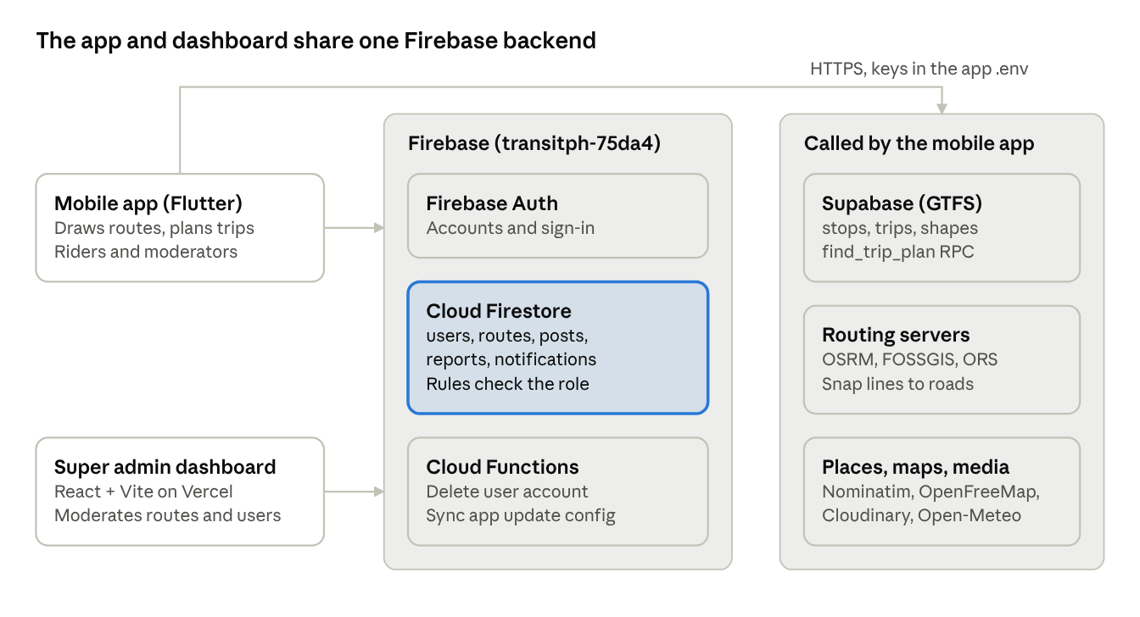
system architecture · 2 clients, Firebase, external services
Both clients read and write the same Firestore data directly; only the mobile app calls the transit, routing and media services.

APIs
The system has no REST server of its own. "The API" is three things: a typed data layer over Firestore in the dashboard, two Firebase Cloud Functions, and a set of free external map and routing services the mobile app calls.

Dashboard data layer (src/lib/firestoreApi.ts)
Every page calls these functions through React Query; none of them goes through a server. Each function maps raw Firestore documents into the typed models in src/types/models.ts and tolerates older field names (for example startLocation or from, approvalStatus or status, createdAt or timestamp).
Function | What it provides | Collections touched
getCurrentUserRole(uid) | The signed-in user's role, used to gate the whole dashboard | users
getUsers / updateUserRole / restrictUser / liftUserRestriction / setUserBanStatus | User list with computed status (active = seen in the last 15 min); role changes; restrict for 1 to 7 days; ban and unban | users
deleteUser(userId) | Calls the adminDeleteUserAccount Cloud Function; falls back to deleting only the users doc if the function is not deployed | users (+ function)
getRoutes | All routes, with contributor name and email joined from users | routes, users
updateRouteStatus(routeId, status, reviewerUid) | Approve or reject in a transaction; on first approval, increments contributor stats, unlocks achievements and badges, and sends an in-app notification | routes, users, users/{uid}/achievements, users/{uid}/badges, notifications
deleteRoute | Deletes a route | routes
getRouteReports / keepRouteReport / removeRouteReport | Live rider reports (expiresAt in the future); Keep pins one until 2100-01-01 | route_reports
getPosts / updatePostStatus / deletePost | Community posts; approving gives a post 3 days in the feed from now | posts
getFeedback / updateFeedbackStatus / deleteFeedback | Feedback and content reports; resolve or dismiss | feedbacks
getAnnouncements / createAnnouncement / updateAnnouncement / deleteAnnouncement | Announcements by type and audience; expired ones are hidden | announcements
subscribeDashboardStats | Live counts, 8-point growth charts and a 12-item activity feed, rebuilt on every Firestore change | users, routes, posts, feedbacks
getModeratorStats | Routes approved per moderator, deduplicated across dashboard approvals and the app's audit logs | users, routes, auditLogs (collection group)
Reads use a three-query fallback (ordered by createdAt, ordered by timestamp, and unordered, up to 500 docs each), merged by id and sorted newest first. This keeps documents that are missing one of the two date fields from disappearing.

Cloud Functions (transit-ph-beta/functions/index.js)
Function | Trigger | What it does
adminDeleteUserAccount | Callable (HTTPS) | Checks the caller is a superadmin and not deleting themselves, then deletes the user's posts, routes, feedbacks and notifications in batches of 450, the users doc, and the Firebase Auth account. Returns counts per collection.
syncUpdateCheckerToRemoteConfig | Firestore write on app_config/update_checker | Copies latest_version, update_url, force_update and update_message into Firebase Remote Config, which drives the app's update prompt.

External services used by the mobile app
Service | Used for | Key needed
Supabase (Postgres, GTFS tables stops, stop_times, trips, routes, shapes; RPC find_trip_plan) | Public transit network for trip planning | SUPABASE_URL, SUPABASE_ANON_KEY
OSRM demo server (router.project-osrm.org) | Snapping vehicle legs to roads (car profile) | No
FOSSGIS OSRM (routing.openstreetmap.de/routed-foot) | Walking paths and walk-distance tables | No
OpenRouteService (api.openrouteservice.org) | Road snapping that can avoid expressways; walking fallback | OPENROUTESERVICE_API_KEY
Nominatim (nominatim.openstreetmap.org) | Place search / geocoding | No
OpenFreeMap tiles | Base map in the app and the dashboard | No
Cloudinary | Image and video uploads for posts | CLOUDINARY_CLOUD_NAME, CLOUDINARY_UPLOAD_PRESET
Open-Meteo | Weather on the home screen (Asia/Manila) | No

Route drawing & generation
Routes are made two ways, both in the mobile app (transit-ph-beta). Riders draw community routes by hand on the Contribute screen; the Search screen generates trip plans automatically from transit data plus approved community routes. The dashboard only reviews and displays what the app saved.

1. Drawing a community route (Contribute screen)
A route is a list of steps (Walk, Jeepney, Bus, Train, Tricycle, FX/Van, Ferry) drawn on one continuous line. Key code: contribute_screen.dart, contribute_screen_map_editor.dart, routing_service.dart (snapToRoad, walkPath).
- The rider sets a start point, picks a transport mode, and taps the map. Each tap opens a step or extends the open one.
- Every tap is routed as its own short piece from the previous point, so a long ride follows the vehicle's real roads instead of whatever a router picks across one long jump.
- Each piece is snapped to roads by mode:
  - Walk: FOSSGIS walking server first, then OpenRouteService foot profile. Results are cached on the phone, so repeat walks work offline.
  - Vehicles: OpenRouteService car profile, which avoids expressways and tollways unless allowed (buses and FX/vans allow them by default; jeepneys and tricycles do not). If ORS fails or is rate-limited, it backs off for 60 s and OSRM is used instead.
  - If nothing answers, the piece is a straight line and the rider is told "Could not follow the roads here".
- Tapped points become control points. Dragging one, or a step boundary, re-routes only the pieces touching it; every other step keeps its exact line. Undo removes the last tapped point first.
- "Save step" asks for the step's details (instruction, actual fare, optional designated stops) and records stepBoundaries: the index in pathPoints where that step ends.
- On submit, the app checks every step has a valid fare and the rider typed start and end names, computes distance and time per step from the snapped line, and writes the route to Firestore with approvalStatus = pending. Edits reset it to pending, set isEdited and increment editCount. Each create or edit also writes an auditLogs entry.
- A moderator (in the app) or superadmin (in the dashboard) approves or rejects it. See Data model for the saved shape.

2. How the dashboard draws a route (RoutePreviewMap.tsx)
The dashboard redraws the saved line with MapLibre GL on OpenFreeMap tiles, matching the app's look.
- pathPoints is split into one segment per step using stepBoundaries: step i runs from boundaries[i-1] (or 0) to boundaries[i] (or the last point).
- Each segment becomes a GeoJSON LineString, drawn twice: an 8 px dark edge underneath and a 6 px line in the mode's colour (Walk green, Jeepney blue, Bus red, Train purple, Tricycle orange, FX/Van amber, Ferry light blue).
- Designated stops (Train steps, or steps set to board only at stops) are white circles with a name tooltip on hover.
- A green pin marks the start and a red pin the end; the map fits to the line's bounds.
Routes saved without a line show "No drawn line for this route".

3. Generating a trip plan (Search screen)
Key code: routing_service.dart (getRoute, getRouteAlternatives) and supabase_route_service.dart.
- Find stop candidates: up to 4 nearest GTFS stops within 0.5 km of origin and destination, widened to 1.5 km if either side has none. Real walking distances to up to 100 stops per end are fetched in one request from the walking server.
- Build a graph (cached for 45 s) of GTFS trips from Supabase plus approved community routes split per step. Edges are rides, transfers (stops within 0.6 km, 90 s penalty), boarding (180 s penalty) and walks (5 km/h; road distance or straight line x 1.3; walks over 400 m count double).
- Run Dijkstra on a background isolate. To get up to 3 different options, it repeats the search and adds a penalty to each used edge (45% of its weight), keeping only paths with a new set of rides. This approximates k-shortest paths without a full Yen's algorithm.
- Weigh edges by the chosen mode: Balanced uses real time; Fastest makes walks 3x and rides 0.5x; Budget weighs by fare; Community makes transit-feed rides 3x so rider routes win, and drops access walks over 20 minutes.
- Draw the chosen option: each ride leg uses the GTFS shape, the community route's own drawn path, or an OSRM snap through its stops; each walk uses walkPath. For jeepneys and tricycles, which can be hailed anywhere, the walk is joined to where it first meets the ride's road instead of the planner's stop.
- Fallbacks: no stops nearby gives a walk-only route; no transit connection gives an estimated direct ride. A walk with no real path is drawn dashed and marked as an estimate rather than drawn through buildings.

Authentication & admin access
Only accounts whose users/{uid}.role is "superadmin" can use the dashboard. Firebase Auth checks the password; the role check happens twice in the browser and again in Firestore security rules.
- The admin enters email and password and must tick the reCAPTCHA v2 checkbox. The site key comes from VITE_RECAPTCHA_SITE_KEY; without it, Google's always-pass test key is used.
- signInWithEmailAndPassword runs. The dashboard then reads the user's role. A valid account that is not a superadmin is signed straight back out and counted as a failed attempt.
- Failed attempts are stored in localStorage. 5 failures within an hour lock the form for 1 hour. Network errors do not use up an attempt. Every attempt resets the captcha.
- On success, ProtectedRoute lets the admin into the app. On every reload, onAuthStateChanged re-reads the role; anyone without the superadmin role is sent to /login.
The real enforcement is server-side. firestore.rules (in transit-ph-beta) defines isSuperAdmin(), isModerator() and isStaff() by reading the caller's users document. Fields such as role, isBanned, status and restrictedUntil can only be changed by staff. The adminDeleteUserAccount function repeats the superadmin check before deleting anything.
Known limits: the 5-attempt lockout and the captcha live in the browser only, so a script calling Firebase Auth directly bypasses both. The captcha token is not verified on a server.

Data model
All app and admin data lives in one Firestore database (project transitph-75da4). Transit network data (GTFS) lives separately in Supabase and is read-only to the app.

Firestore collections
Collection | Holds | Key fields | Who writes
users/{uid} | Accounts and profiles | role (user, moderator, superadmin), status, isBanned, restrictedUntil, routesContributed, contributionCount, badges, achievements, preferences.routeApprovalUpdates | Rider (own profile); staff for role and ban fields
users/{uid}/achievements, /badges | Gamification progress | progress, isUnlocked, unlockedAt / earnedAt | App and dashboard on route approval
routes/{routeId} | Community routes | startLocation, endLocation, contributorId, approvalStatus, steps[], pathPoints[], stepBoundaries[], eta, price, distance, distanceMeters, upvotes, downvotes, views, feedbackSummary, isEdited, editCount, reviewedBy | Contributor creates as pending; staff approve or reject
routes/{id}/auditLogs | History of a route | action (route_created, route_updated, moderator_approved, correction_merged), actorId, meta | App
routes/{id}/routeVotes, /routeViews, /routeFeedback | Per-user votes, views and accuracy feedback | keyed by userId | Riders
route_reports | Rider reports on a road (e.g. closure) | routeId, routeLabel, type, description, path (max 300 points), expiresAt (max 25 h), kept | Riders create; staff keep or remove
posts (+ comments) | Community feed | userId, content (max 500 chars), images, moderationStatus, isFlagged, expiresAt | Riders; staff moderate
feedbacks | App feedback and content reports | type (feedback or report), status, message, reason, postId | Riders create; staff resolve
notifications | In-app notifications | userId, type (e.g. route_approved), routeId, message, isRead | App and dashboard
announcements | Broadcasts | title, message, type (info, warning, critical), targetAudience, isActive, scheduledAt, expiresAt | Dashboard
app_config/update_checker | App version gate | latest_version, update_url, force_update, update_message | Dashboard / console; synced to Remote Config
quick_route_links, quick_routes, route_cache, locations | Shareable route links, cached routes, saved places |  | App

A route's geometry
- steps: an ordered list. Each step has mode, instruction, details, actualFare, startTime, endTime, is24_7, optional boarding (anywhere or designated), stops [{lat, lng, name, pickup, dropoff}] and controlPoints (the tapped points used for re-editing).
- pathPoints: one continuous polyline [{lat, lng}] covering the whole route.
- stepBoundaries: for each step, the index in pathPoints where it ends. Step 1 is pathPoints[0..b0], step 2 is pathPoints[b0..b1], and so on. Older routes saved without boundaries cannot be split per step, so they are not used by the trip planner.

Supabase (GTFS)
Tables stops, stop_times, trips, routes and shapes, plus an RPC find_trip_plan(origin_stop_id, dest_stop_id) used as a fallback planner. Stop times are fetched in chunks of 100 IDs, 6 requests in parallel, which was measured at 0.9 s versus 4.9 s for large paged requests.

Other processes, configuration & deployment

Route approval side effects
Approving a route for the first time does more than flip its status. In one Firestore transaction the dashboard sets approvalStatus = approved, clears isEdited and stamps reviewedBy and reviewedAt. It then increments the contributor's routesContributed and contributionCount. At 10 approved routes it unlocks the route_pioneer achievement and contributor badge; at 50, community_hero. Finally it writes a notification unless the contributor turned off preferences.routeApprovalUpdates. A failed notification is logged and never undoes the approval. Re-approving an already approved route does none of this.

User moderation
- Restrict: 1 to 7 days (capped), stored as restrictedUntil. Restricted and banned users can still read but cannot post, comment, add routes or file reports; this is enforced by notBanned() in Firestore rules.
- Status shown in the dashboard: banned and restricted come from the user doc; otherwise a user is active if seen in the last 15 minutes, else offline.
- Delete: the adminDeleteUserAccount function removes the user's content, profile and Auth account.

Configuration
Setting | Where | Notes
Firebase web config | src/lib/firebase.ts | Public by design; security comes from Firestore rules
VITE_RECAPTCHA_SITE_KEY | .env (git-ignored) / Vercel env | Without it, Google's test key is used and every captcha passes
Mobile app keys | transit-ph-beta .env | OPENROUTESERVICE_API_KEY, SUPABASE_URL, SUPABASE_ANON_KEY, CLOUDINARY_CLOUD_NAME, CLOUDINARY_UPLOAD_PRESET, QUICK_ROUTE_BASE_URL

Build & deploy
- Dashboard: npm run dev for local work; npm run build runs tsc then vite build into dist/. Deployed on Vercel; vercel.json rewrites every path to index.html so client-side routes work on refresh.
- Firebase (from transit-ph-beta): firebase.json deploys Cloud Functions (functions/), Firestore rules and indexes, Storage rules, and Hosting for quick-route share links (/q/** to quick.html).

Open questions
- Is a real reCAPTCHA site key set in Vercel production?
- Is adminDeleteUserAccount deployed? If not, deleting a user from the dashboard only removes the profile doc, leaving the Auth account and content behind.

