# Installing Anaconda, Tensorflow and others

1. Download the environment-cpu.yml to an appropriate location on your computer.
2. Install Anaconda from <https://www.anaconda.com/download/>
3. Open Anaconda Navigator and select “Environments”.

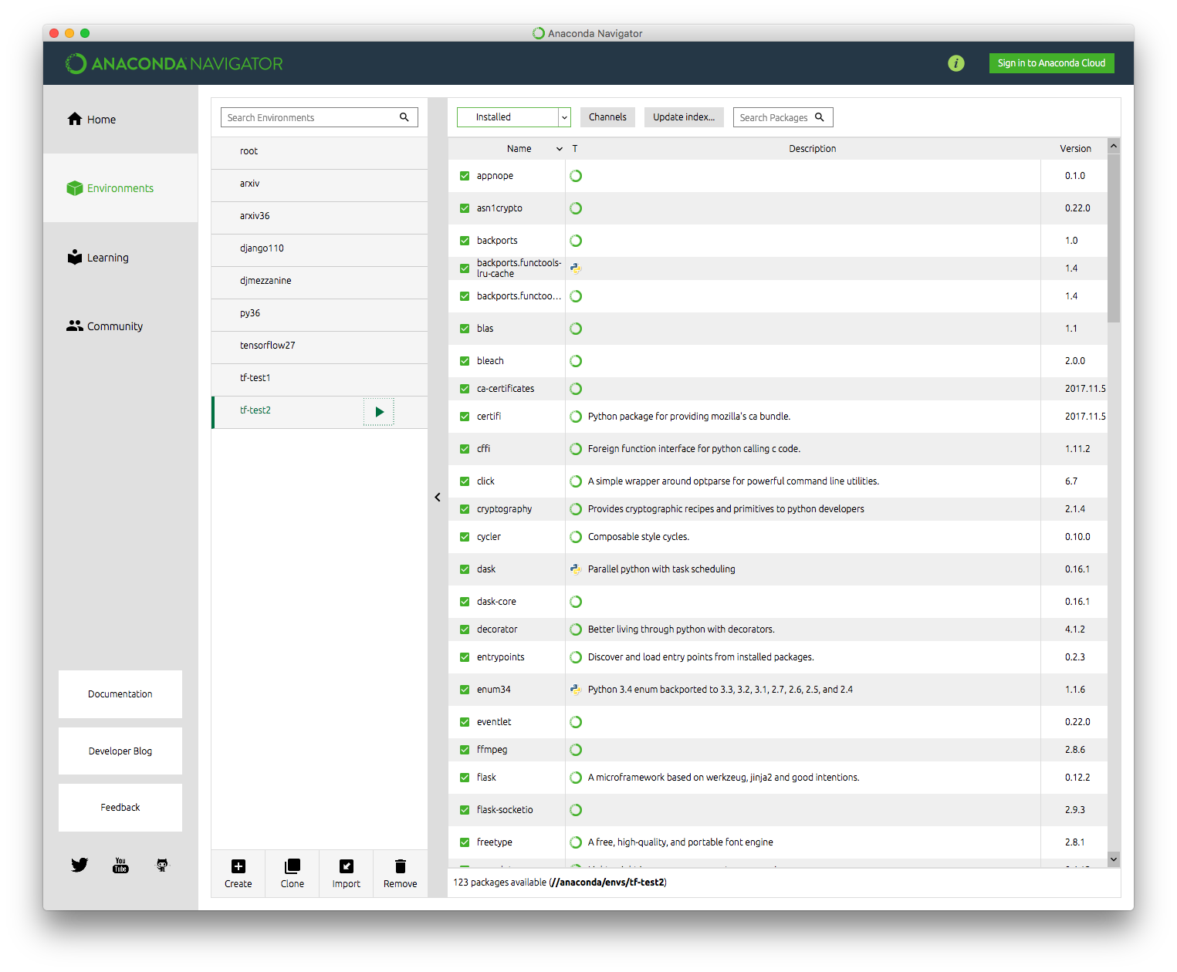

1. Click on the “Import” button at the bottom of the center column.

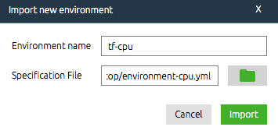

1. In the window that pops up, type “tf-cpu” for Environment name and select the environment-cpu.yml for Specification file and then click “Import”.
2. The environment setup and downloading of modules will begin. This process will take around 5 minutes. Once complete, you will see the new environment that you just created listed in the center column.
3. Click the icon next to the name “tf-cpu” in the center column. This will pop up the following window.

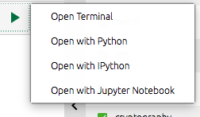

1. Then click “Open with Jupyter notebook”. This will open a browser session where you can navigate to the Jupyter notebook that you are interested in.

In the future, you need to open Anaconda Navigator and then follow instruction in steps 7 and 8.

**Accessing Tensorboard**

1. Open Anaconda Navigator and then follow instruction in steps 7 from previous section.

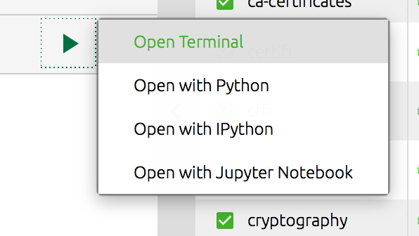

1. Click “Open Terminal”. This will open a command line terminal.
2. In the command line, use ‘cd’ to change to the directory that contains the log folder created by Tensorflow.
3. Then type the command, “tensorboard --logdir=./logs” to launch Tensorboard. This will launch a local web server at port 6006. If you do not wish to cd to the directory, you can alternately provide the full path to logdir option.
4. Go to your favorite browser and visit the page, “localhost:6006”.

