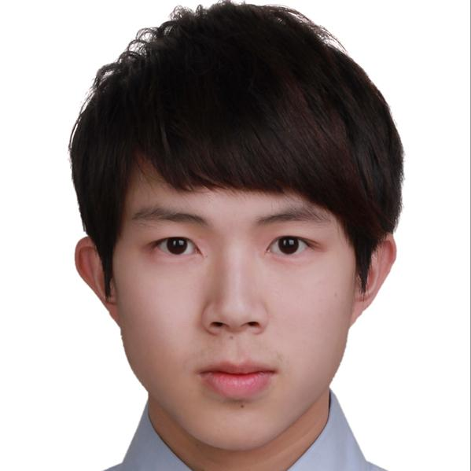

Chen Chi Yun

+886-923-799-033

[shironchen@gmail.com](mailto:shironchen@gmail.com)

Jiaxing St., Xinyi Dist.,

Taipei City 110, Taiwan (R.O.C.)

Objectives:

Seeking a challenging software engineering position in an organization that rewards dedication and proficiency in ios development and systems architecture.

Educational Background:

Tamkang University

No.151, Yingzhuan Rd., Tamsui Dist., Taipei City 251, Taiwan(R.O.C.)

Bachelor degree in International Business

Graduated on June 28, 2017

GPA: 3.3/4

Work Experiences:

Sales Assistance Intern

Young Sun Develop Co.

Taipei City,

* Maintain the relationship with dentists in Taiwan
* Translate foreign product catalog to Chinese.
* Email with Brazil for importing new products.
* Cooperate with Japanese on a weekly exhibition.

Junior iOS Developer

Cybilltek Software Inc.

Phlilppines, Quezon City,

* Develop online-betting applications for iPhones and iPads.
* Cooperate with six members in mobile app team in English.
* Following senior iOS developer design pattern to refactor old features.
* Reviews defects with Quality Assurance team, and takes the lead on investigating hard to debug and solve problems.

Junior iOS Developer

Pklotcorp Inc.

Taipei City,

* Develop parking solution application for iPhones and Carplays
* Involved in a fast-growth team as fifteen member
* Assists the senior iOS developer in analysis, design, development, and performance optimization of iOS application.
* Work closely with Product Development teams to improve consistency and timing of releases
* Works with Project Manager and User Interface designer to prioritize, define and size new features
* Integrate Continuous Integration/Continuous Deployment (CI/CD) in development

Contract iOS Developer

Future Sync Ltd.

Taipei City

* Develop shopping-cart applicaitons for iPhones and iPads
* Develop prototypes and proofs-of-concept as needed during the planning and design stages of projects
* Work with cross-functional team members to clarify requirements, define functional specs, develop technical solutions and provide accurate level of effort estimates for new projects

Senior iOS Developer

Bwiel lnc.

Taipei City

* Develop chat and web-based applications for iPhones and iPads
* Writes product specifications and design documentation for assigned system components. Organizes review and/or release of documentation when required
* Establishing automatic development tools, and frameworks/libraries that the group will use for development
* Passion for iOS development, love to develop and stay up to date with latest developments in and around iOS