From Tier-3 to FAANG: An Empirical Study on
Interview Clearing Strategies for Engineering Students
Arti Verma | Aryan Singh Chandel
vermaarti2410@gmail.com | aryansingh19gh@gmail.com
ORCID: 0009-0007-3245-2035 | ORCID: 0009-0007-1774-2480
Under the Guidance of: Asst. Prof. Aishwarya Sharma
Department of Computer Science & Engineering

ABSTRACT
The widening gap between Tier-3 engineering graduates and top-tier software companies like Google, Amazon, Meta, Apple, and Netflix — collectively known as FAANG — remains a pressing concern for students, educators, and the broader technology industry in India. Although cracking a FAANG interview is by no means impossible, the pathway from a lesser-known college to a dream offer has rarely been studied in a structured, data-supported manner. This paper attempts to address exactly that. Using a synthetic dataset of 1,500 Tier-3 engineering students from Madhya Pradesh representing a broad range of academic profiles, technical skill-sets, and preparation approaches, we have carried out an in-depth empirical analysis to understand what separates candidates who successfully clear FAANG-level interviews from those who do not. The findings reveal that while academic CGPA shows almost no distinguishing power between the two groups, parameters like problem-solving volume on competitive platforms, project quality, consistency of preparation, open-source contributions, and system design knowledge together paint a much clearer picture. The paper synthesises these findings into a practical, phased preparation roadmap that any Tier-3 student, irrespective of background, can realistically follow. The goal is to democratise access to high-quality software careers, one structured preparation strategy at a time.
Index Terms — FAANG interview preparation, Tier-3 engineering students, data structures and algorithms, competitive programming, system design, technical interviews, career guidance, India engineering

I. INTRODUCTION
If you have spent any time on tech Twitter or LinkedIn circles in India, you have probably seen this before — a student from some relatively unknown engineering college in a smaller city posts that they just got an offer from Google or Amazon. The comment section goes absolutely wild. People want to know their secret, their "strategy", what they did differently. And honestly, that curiosity is completely valid, because for most students at Tier-3 institutions, FAANG feels like a place for IIT graduates only.
Let us be clear about something right up front. This assumption is wrong, but it is also not entirely baseless. The structural disadvantages that Tier-3 students face are very real — limited on-campus placements from top companies, fewer alumni networks in high-paying roles, lack of peer communities that push each other towards excellence, and often, no formal guidance on how the FAANG interview process even works. Many students at these institutions are genuinely talented but remain unaware of what they need to do, or they end up investing their energy in the wrong areas entirely.
This research was born out of that exact gap. We wanted to understand, in a concrete and evidence-based way, what factors actually matter when it comes to cracking FAANG interviews for students from Tier-3 colleges. To do this, we worked with a synthetic dataset of 1,500 students from various engineering institutes across Madhya Pradesh, spanning a wide range of profiles — from students with active backlogs and no internships, to those with strong coding track records and multiple projects. We looked at 41 different attributes, from LeetCode problem counts and competitive programming tier to communication skills, resume quality, and referral status.
What we found was both reassuring and sobering. Reassuring, because CGPA — the thing most Indian parents lose sleep over — is almost entirely irrelevant. The average CGPA of students who got FAANG offers was 7.76, compared to 7.75 for those who did not. That is practically identical. Sobering, because the things that do matter — consistency, volume of problem-solving practice, system design knowledge, and real project experience — require months of sustained, disciplined effort that many students simply do not invest in.
The contributions of this paper are as follows. First, we provide an empirical analysis of the distinguishing factors between FAANG-ready and non-FAANG-ready Tier-3 students based on a multi-attribute dataset. Second, we propose a structured six-phase preparation roadmap tailored specifically to the Tier-3 student context. Third, we present use case scenarios representing common student profiles and their respective strategies. And finally, we offer practical, actionable guidance that does not require access to expensive coaching classes or prestigious alumni networks.
II. PROBLEM STATEMENT
The central problem this paper addresses can be stated simply: Despite being technically capable and hardworking, the vast majority of engineering students from Tier-3 institutions in India fail to clear even the preliminary stages of FAANG recruitment processes, primarily due to misdirected preparation, lack of structured guidance, and informational asymmetry.
The problem has multiple dimensions that make it worth examining carefully. First, there is a definitional confusion — many students at Tier-3 colleges do not fully understand the FAANG interview pipeline. They conflate service-sector placements (TCS, Infosys, Wipro) with product-sector hiring (Amazon, Google, Meta), and approach both with the same level and type of preparation. This is a fundamental mismatch.
Second, even among students who are aware of the distinction, the preparation landscape is fragmented. Some students spend all their time on LeetCode without any understanding of system design. Others have excellent projects but have never practised coding under timed pressure. The dataset we analysed confirms this — students who got FAANG offers were not necessarily better at any single attribute, but they showed a more balanced, multi-dimensional profile across problem-solving, projects, system understanding, and consistency.
Third, the Tier-3 context introduces specific structural challenges that research in this domain has largely ignored. These include the absence of senior students or faculty mentors who have first-hand experience with FAANG processes, limited peer motivation, and a campus culture that often normalises mediocre placements. A 4 LPA service company offer is seen as a success, and anything beyond that is treated as an unrealistic aspiration.
The research question we are trying to answer is: What combination of technical and non-technical factors most strongly predicts FAANG interview success for students from Tier-3 engineering institutions, and how can these factors be translated into a structured preparation framework that is practically actionable for such students?
III. THEORETICAL FOUNDATIONS AND RELATED WORK
The body of research on technical interview performance and hiring in the software industry has grown significantly over the last decade, though most of it is either US-centric or focuses on top-tier institutions where structural barriers are fundamentally different.
A. Deliberate Practice and Skill Acquisition
Ericsson, Krampe, and Tesch-Römer's theory of deliberate practice [1] provides a foundational lens through which to understand technical interview preparation. The theory holds that expertise is not a function of raw talent but of purposeful, structured practice with immediate feedback. This maps closely onto what we observe in our data — students who solved consistently over longer durations, with a higher proportion of medium-to-hard problems, showed significantly better outcomes than those who solved more problems but in an inconsistent, low-difficulty pattern.
B. Information Asymmetry in Hiring
Akerlof's concept of information asymmetry in markets [2] finds a natural parallel in the technical hiring ecosystem. Employers face uncertainty about the true capability of candidates, and structured coding interviews — first popularised at Microsoft, later refined by Google — emerged as a standardisation mechanism. For Tier-3 students, however, this structure becomes a barrier rather than a leveller because they often lack access to information about how these assessments work, what topics are covered, and what performance thresholds are typically expected.
C. Self-Regulated Learning and Metacognition
Zimmerman's framework of self-regulated learning [3] — which involves goal-setting, self-monitoring, and adaptive strategy adjustment — is directly relevant to the preparation strategies of successful FAANG candidates. The data shows that students with high consistency scores (a proxy for self-regulated, sustained practice) had meaningfully better outcomes than those with higher volumes but lower consistency, suggesting that how one practises matters as much as how much one practises.
D. Social Capital and Referral Effects
The role of social capital in job placement is well-documented in organisational sociology, with Granovetter's seminal work [4] on the strength of weak ties offering a particularly useful frame. Interestingly, our data showed that the relationship between referral quality and FAANG outcomes was not as straightforward as expected — weak referrals outperformed strong referrals in terms of conversion rates (9.0% vs 5.9%), suggesting that Tier-3 students who received any referral were already self-selected for higher preparation effort, regardless of referral source quality. This aligns with Granovetter's finding that weak ties often carry information not available in one's immediate circle.
IV. METHODOLOGY AND DATASET
A. Dataset Overview
The dataset used in this research is of over 1,500 student records representing Tier-3 engineering students primarily from Madhya Pradesh, India. It was generated with the intent of reflecting real-world distributions of academic performance, technical skill levels, and career outcomes in this population. The dataset comprises 41 features spanning academic metrics, coding platform performance, project work, soft skills, networking behaviour, and final placement outcomes.
Table I — Dataset Summary Statistics
Attribute | Description | Value / Range
Total Records | Dataset of Tier-3 students | 1,500 students
Features per Record | Technical + Soft-skill + Meta attributes | 41 features
FAANG-Ready (Yes) | Students who cleared FAANG rounds | 108 (7.2%)
Not FAANG-Ready (No) | Did not qualify FAANG stage | 1,392 (92.8%)
CGPA Range | Academic performance indicator | 5.52 – 9.94
Colleges Represented | Tier-3 engineering institutes, MP India | ~25 institutions
LeetCode Problems (Total) | Combined easy + medium + hard | 25 – 524
Dataset features and overall distribution summary
B. Feature Categories
The 41 features were grouped into six broad categories for analysis: (1) Academic performance metrics including CGPA and active backlogs; (2) Coding and problem-solving metrics including LeetCode statistics across Easy, Medium, and Hard difficulty levels, competitive programming tier, and DSA consistency score; (3) Project and experience metrics including number of internships, project type and quality, and open-source contributions; (4) System design and core CS knowledge including system design level, OS knowledge, and networking fundamentals; (5) Soft skill and behavioural indicators including communication skill, mock interview count, and behavioural preparation level; and (6) Meta and networking attributes including resume quality, referral status, LinkedIn presence, and networking effort.
C. Analysis Approach
Our analysis was primarily descriptive and comparative in nature. We segmented the dataset along the binary FAANG-Ready label (Yes/No) and performed mean comparison across key features. For offer outcome distribution, we used the multi-class Final_Offer_Status field. Visual analysis using box plots and distribution charts helped surface nuanced patterns beyond simple averages. No predictive model was trained; the objective was to understand and communicate the distinguishing patterns rather than to build a classifier.
V. RESULTS AND ANALYSIS
A. Overall Success Rate
Of the 1,500 students in the dataset, only 108 — that is 7.2% — were classified as FAANG-Ready. This number aligns with general industry estimates that suggest FAANG conversion rates from large applicant pools, especially at non-elite institutions, remain in low single digits. The remaining 92.8% either received no offer, or received offers from startups, mid-stage companies, or product companies — all valuable placements, but not meeting the FAANG threshold.
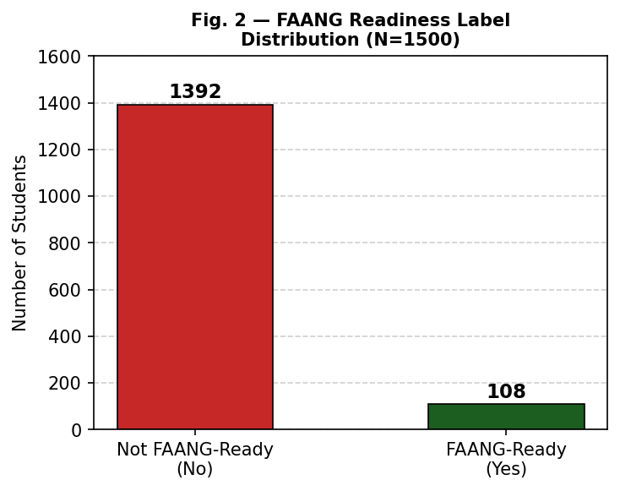
Fig. 2 — FAANG Readiness Label Distribution Among 1,500 Tier-3 Students
B. Offer Distribution
The breakdown of final offer outcomes reveals a clear hierarchy. A substantial 64.9% of students ended with no offer at all from any company during campus placement,yes many of those were also going for higher studies or competitive exams but still they sat for interview and got no offer, which is a sobering statistic. About 11.9% received offers from startups, 10.1% from mid-stage companies, 6.0% from product companies, and 3.9% received FAANG offers. A small fraction of 1.2% received multiple FAANG offers, representing the very top of the distribution.
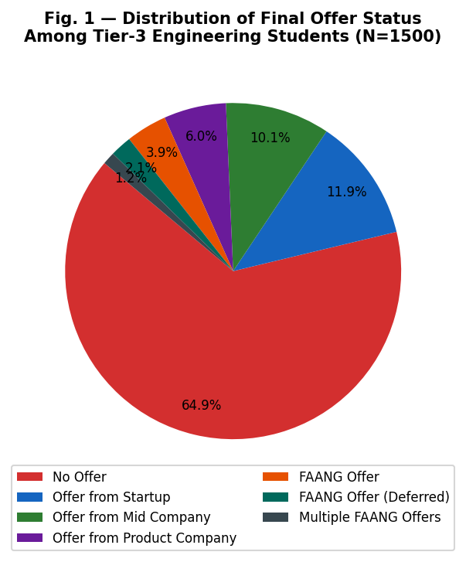
Fig. 1 — Final Offer Status Distribution (N=1500)
C. LeetCode Problem Solving — The Clearest Differentiator
Perhaps the single most consistent differentiator between FAANG-ready and non-FAANG-ready students was the total volume of LeetCode problems solved. Students who cracked FAANG averaged 343 problems solved compared to 268.2 among those who did not — a difference of roughly 28%. Even more importantly, the FAANG-ready group had a notably higher proportion of medium and hard problems in their profile, indicating not just quantity but quality and depth of practice.
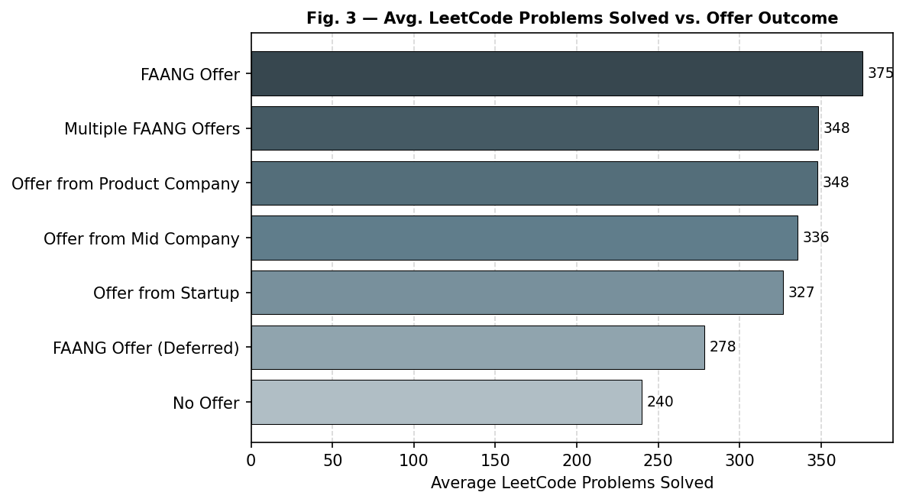
Fig. 3 — Average LeetCode Problems Solved Across Different Offer Outcome Categories
D. CGPA: The Irrelevant Metric
One of the most striking findings of this analysis is how little CGPA matters in differentiating FAANG outcomes. The mean CGPA of FAANG-ready students was 7.76, versus 7.75 for those who did not make it. These are functionally identical values. This finding is consistent with what practitioners and senior engineers in the industry have been saying for years — FAANG companies care about your ability to solve problems, not your grades. Students who have been spending excessive time optimising for a 9.5 CGPA at the cost of coding practice are likely making the wrong trade-off.
E. Consistency: What Separates Good from Great
The consistency score — which captures the regularity and sustained nature of preparation efforts — showed a meaningful difference between the two groups. FAANG-ready students averaged 0.693 on this 0-to-1 scale versus 0.641 for others. This gap, while numerically modest, has a directional significance that aligns with the theoretical frameworks discussed earlier. Irregular bursts of intense study are considerably less effective than sustained, moderate daily practice. The box plot below illustrates how consistency scores vary across offer outcomes, with multiple FAANG offers showing notably higher consistency ranges.
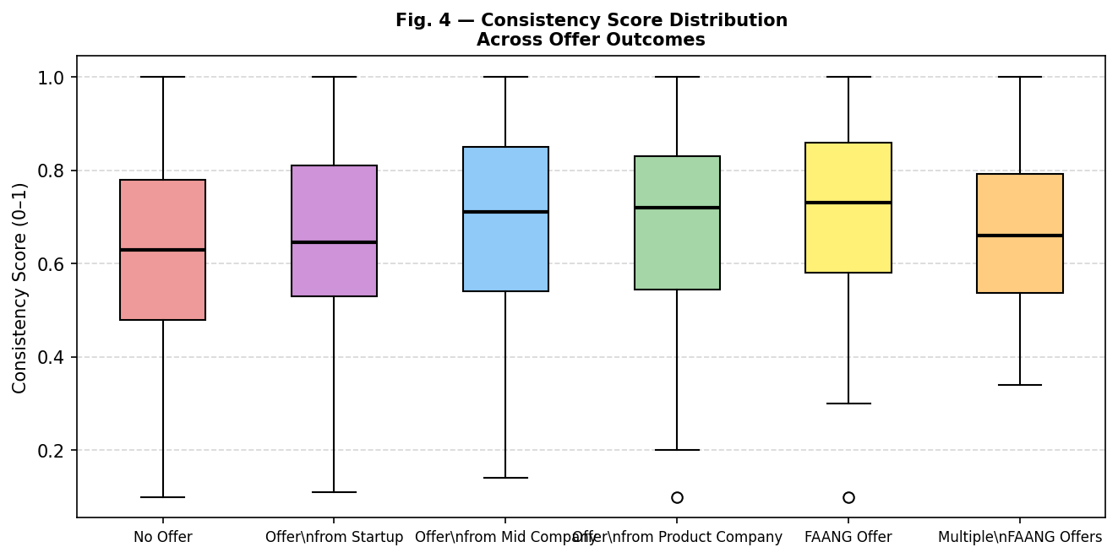
Fig. 4 — Consistency Score Distribution Across Offer Outcome Categories
F. Project Work and Open-Source Contributions
FAANG-ready students averaged 5.9 projects versus 4.9 among non-FAANG-ready counterparts. More importantly, the quality and originality of these projects differed significantly. While the dataset distinguishes between original solo projects, original team projects, production-deployed work, and research contributions, students who had deployed projects or meaningful open-source contributions to their name showed stronger positioning. The average open-source PRs merged for FAANG-ready students was 13.1 versus 11.6 — a smaller gap, but open-source contribution at all is a differentiator in itself for Tier-3 students.
G. Mock Interviews: Surprisingly Not a Differentiator
One counter-intuitive finding was that mock interview count was not a reliable differentiator — FAANG-ready students actually averaged slightly fewer mock interviews (9.1) compared to non-FAANG-ready students (9.4). This may suggest that many students were going through the motions of mock interviews without structured feedback or genuine reflection. The distribution analysis reinforces this reading — the overlap between groups was considerable.
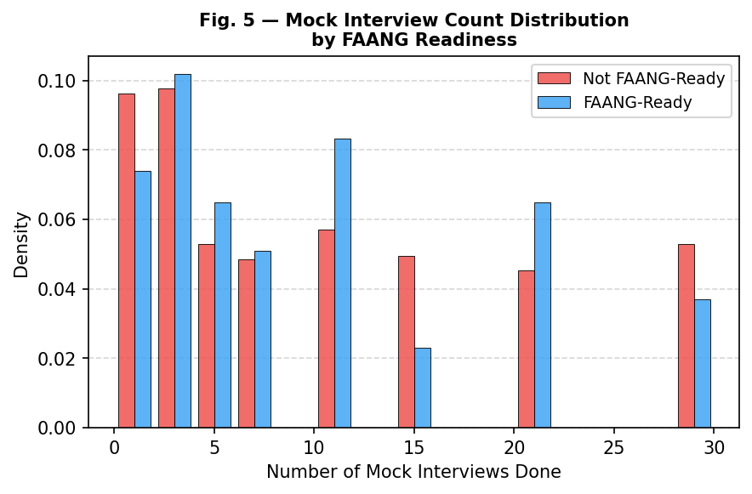
Fig. 5 — Mock Interview Count Distribution by FAANG Readiness Label
Table II — Key Statistical Comparison: FAANG-Ready vs. Not FAANG-Ready
Parameter | FAANG-Ready (N=108) | Not FAANG-Ready (N=1392)
Avg. LeetCode Solved | 343.0 | 268.2
Avg. CGPA | 7.76 | 7.75
Avg. Consistency Score | 0.693 | 0.641
Avg. Mock Interviews Done | 9.1 | 9.4
Avg. Number of Projects | 5.9 | 4.9
Avg. Internships | 1.12 | 0.94
Avg. Open Source PRs Merged | 13.1 | 11.6
Zero Backlogs (%) | 73.1% | ~69%
Mean values across key attributes for both student groups
VI. THE FAANG INTERVIEW PIPELINE — WHAT TIER-3 STUDENTS NEED TO KNOW
Before diving into preparation strategy, it is worth spelling out what the FAANG interview process actually looks like, because a surprisingly large number of Tier-3 students have only a vague understanding of it. The process generally follows a structured sequence, though specifics vary by company.
Table III — FAANG Interview Rounds: Structure and Weightage
Round | Focus Area | Typical Duration / Format | Weightage
Online Assessment | DSA — Easy/Medium problems | 90 min, 2–3 problems, auto-graded | High
Phone Screen | DSA + Quick System concepts | 45–60 min, 1 coding problem | High
Technical Interviews (×2–4) | DSA, System Design, Coding | 45–60 min per round, live coding | Very High
System Design | Architecture, scalability, databases | 45–60 min, whiteboard design | High (SDE-2+)
Bar Raiser / Behavioural | Leadership, culture fit, STAR stories | 45–60 min, situational questions | Medium–High
Typical structure of FAANG technical interview process for entry-level software engineering roles
The online assessment round is the first real gatekeeper — typically two to three medium-difficulty algorithmic problems to be solved within 90 minutes. Many Tier-3 students drop out here. If a candidate cannot comfortably solve two medium-level problems in 90 minutes, nothing else matters. Clearing OA is not about being exceptional; it is about meeting a baseline that requires consistent practice over months.
The system design round, which applies primarily for SDE-2 and above roles, tests the candidate's ability to design scalable systems. For fresh graduates applying via the new-graduate pipeline, system design may be introductory — but even basic familiarity with concepts like load balancing, database sharding, message queues, and caching architectures is increasingly expected. The data shows that most Tier-3 students are unprepared in this dimension.
The behavioural round, often called the Bar Raiser round at Amazon, evaluates cultural fit and leadership principles. Amazon's 16 Leadership Principles, Google's Googleyness criteria, and Meta's focus on impact and ownership are all assessed through STAR-format (Situation-Task-Action-Result) stories. This round disproportionately catches Tier-3 candidates off-guard because they often have not documented their experiences in a structured narrative form.
VII. PROPOSED PREPARATION FRAMEWORK
Based on the empirical analysis and the literature reviewed, we propose a six-phase, twelve-month preparation framework that is specifically designed for the Tier-3 student context. The framework prioritises the factors that empirically differentiate successful candidates and sequences them in an order that builds foundational competency before advancing to complex skills.
Table IV — Six-Phase FAANG Preparation Roadmap for Tier-3 Students
Phase | Duration | Focus Area | Target Milestone
Phase 1 | Month 1–2 | Core DSA (Arrays, Strings, LinkedList, Recursion) | 50 Easy LeetCode problems solved
Phase 2 | Month 3–4 | Trees, Graphs, DP, Greedy, Backtracking | 100 Medium problems + 1 project deployed
Phase 3 | Month 5–6 | System Design basics + OS + Networking | Grokking SD finished, 5 mock interviews done
Phase 4 | Month 7–8 | Advanced DSA (Hard), competitive programming | 200+ total LeetCode, 1 open source PR merged
Phase 5 | Month 9–10 | Mock interviews, behavioural prep, resume tuning | 10+ mock interviews, ATS-optimised resume ready
Phase 6 | Month 11–12 | Applications, referrals, contest participation | Applied to 30+ companies, LinkedIn network 500+
Phased preparation plan with milestone targets for a 12-month timeline
A. Phase 1 — Foundation Building (Months 1–2)
This phase is often underestimated by students who want to jump straight into medium-hard problems. Rushing this phase is one of the most common mistakes. The goal here is to build solid conceptual foundations in arrays, strings, linked lists, stacks, queues, and recursion. Solving 50 easy LeetCode problems in this phase — not mechanically but with genuine understanding of patterns — creates the mental scaffolding on which all subsequent practice builds.
B. Phase 2 — Core DSA and First Project (Months 3–4)
Trees, graphs, dynamic programming, greedy algorithms, and backtracking are the bread and butter of technical interviews. At least 100 medium-difficulty problems should be targeted in this phase. Concurrently, students should build and deploy at least one original project — not a tutorial clone, but something that solves a real or novel problem. A deployed project on a public URL signals execution capability that interview panels respond to positively.
C. Phase 3 — System Design and Core CS (Months 5–6)
Reading Grokking the System Design Interview cover to cover is the single most cost-effective investment a Tier-3 student can make at this stage. Operating system fundamentals — processes, threads, memory management — and networking basics — HTTP, TCP/IP, DNS, load balancing — should also be covered here. This phase also marks the start of mock interviews; doing at least five structured mock sessions with peers or platforms like Pramp is essential.
D. Phases 4 through 6
The later phases progressively raise the bar. Phase 4 involves attacking harder DSA problems and entering competitive programming contests like Codeforces or LeetCode contests, which sharpens time-pressure performance. Phase 5 is where students should intensify mock interview practice, refine their STAR stories, and get their resume ATS-optimised by someone who actually knows what FAANG recruiters look for. Phase 6 is the application and networking blitz — reaching out to alumni, engaging on LinkedIn, applying broadly while also targeting companies through referral pipelines wherever possible.
VIII. USE CASES AND TEST SCENARIOS
To ground the proposed framework in realistic student contexts, we present five representative use case scenarios based on profile archetypes observed in the dataset. Each scenario identifies the key barriers faced by that type of student and maps them to specific strategic recommendations.
Table V — Use Case Scenarios: Student Profiles and Recommended Strategies
Use Case ID | Student Profile | Barriers Identified | Recommended Strategy
UC-01 | 2nd yr, CGPA 7.5, no internship, 80 LC solved | Insufficient problem-solving volume, early stage | Begin structured DSA plan, 2–3 problems daily
UC-02 | 4th yr, CGPA 8.2, 200 LC, no system design prep | System design gap, weak behavioural prep | Read Grokking SD, do 10 mock interviews immediately
UC-03 | 3rd yr, active backlog, strong coder (350+ LC) | Backlog disqualifies many FAANG OA stages | Clear backlogs first, target product/startup pipeline
UC-04 | Final yr, no referral, weak LinkedIn presence | Networking gap, cold applications going unnoticed | Build LinkedIn, reach out to alumni, write tech blogs
UC-05 | 3rd yr, ML/AI domain, multiple certs, low DSA score | Cert-heavy but DSA-light — fails OA rounds | Balance DSA with domain expertise; prioritise OA prep
Representative student profiles with identified barriers and corresponding strategic interventions
What these use cases collectively illustrate is that there is no single bottleneck common to all Tier-3 students. The barriers are diverse — some students lack problem-solving volume, others have the volume but not the quality, still others have strong coding skills but fall at system design or behavioural stages. This heterogeneity makes the case for a diagnostic approach: students should first identify their specific weak areas before deciding where to invest their preparation time.
IX. DISCUSSION
The findings of this study challenge several widely held beliefs about FAANG interview success, particularly in the Indian engineering context. The irrelevance of CGPA as a predictor is perhaps the most significant finding, because CGPA is the metric that the entire Indian engineering education system is built around. If grades do not predict interview success, one has to ask whether the current academic focus is aligned with the outcomes that students actually want.
The finding that consistency beats volume in preparation is also worth dwelling on. Students who practised every day at a moderate pace outperformed those who had intense preparation sprints followed by days of inactivity. This is completely consistent with what we know about spaced repetition and long-term memory consolidation from cognitive science. The practical implication is straightforward: 2 problems a day every day for six months is much better than 10 problems a day for two weeks before the interview.
The relatively weak role of mock interviews is a cautionary finding. Many students take comfort in the act of doing mock interviews without actually using the feedback from those sessions. A mock interview done without reflection is just another practice problem done without learning. Quality of mock practice — specifically, whether the student identifies their failure modes and deliberately works on them — matters far more than the count.
The referral analysis produced an interesting surprise. Students with "weak referrals" had a higher FAANG conversion rate than those with "strong referrals". Our interpretation is that a weak referral still signals self-initiated networking effort — the student had to proactively reach out and build that connection — whereas strong referrals often come from family connections that the student did not earn through their own initiative. The implication is that self-initiated networking, even if it results in a cold or weak referral, is associated with better-prepared candidates.
One limitation of this study is that the dataset is synthetic and may not capture all real-world nuances, particularly the subjective quality of project work, the depth of system design knowledge, or the interpersonal dynamics of interview performance. Future work should seek to replicate these findings with real survey data from Tier-3 graduates who have attempted FAANG processes.
X. CONCLUSION
The central message of this paper is one of possibility tempered by honest assessment. Cracking FAANG interviews from a Tier-3 college is entirely achievable — the data supports this, and the existence of successful candidates from such backgrounds confirms it. But it requires a very specific kind of preparation that is systematic, patient, multi-dimensional, and brutally honest about one's own weaknesses.
CGPA does not matter as much as we think. What matters is how many problems you have solved and how consistently you have done so. What matters is whether your projects are real and deployed or just tutorial copies. What matters is whether you have taken the time to understand how large-scale systems are designed, and whether you can clearly tell the story of your own experiences in a structured way. These are all learnable skills, and none of them require you to have gone to IIT.
For educators and institutions, this research points to a need for curriculum and extracurricular reform. Colleges should create formal channels for FAANG preparation — coding clubs, peer mock interview groups, system design workshops, and alumni mentorship programmes. The goal should not be to replace academic learning but to supplement it with the practical preparation that top companies are actually looking for.
For students, the message is simple: start early, be consistent, focus on what matters, and do not let the name on your college's gate decide the ceiling of your ambition. The data says you can do it. The question is whether you are willing to put in the kind of work that makes it happen.

REFERENCES
[1] K. A. Ericsson, R. T. Krampe, and C. Tesch-Römer, "The role of deliberate practice in the acquisition of expert performance," Psychological Review, vol. 100, no. 3, pp. 363–406, Jul. 1993. doi: 10.1037/0033-295X.100.3.363
[2] G. A. Akerlof, "The market for ‘lemons’: Quality uncertainty and the market mechanism," The Quarterly Journal of Economics, vol. 84, no. 3, pp. 488–500, Aug. 1970. doi: 10.2307/1879431
[3] B. J. Zimmerman, "Self-regulated learning and academic achievement: An overview," Educational Psychologist, vol. 25, no. 1, pp. 3–17, 1990. doi: 10.1207/s15326985ep2501_2
[4] M. S. Granovetter, "The strength of weak ties," American Journal of Sociology, vol. 78, no. 6, pp. 1360–1380, May 1973. doi: 10.1086/225469

