SecureParseNet: Differentiable Perceptual Hashing for Integrity-Aware Semantic Segmentation
Aryan Singh Chandel
RJIT (Rustamji Institute of Technology), Gwalior, India
aryansingh19gh@gmail.com
June 26, 2026
Abstract
Lightweight segmentation systems are attractive for deployment on edge devices, but their small parameter budgets often leave them highly vulnerable to adversarial perturbations. SecureParseNet addresses this problem by coupling a MobileNetV3-style segmentation backbone with a differentiable perceptual-hash head that monitors structural integrity in the output space. This manuscript rebuilds the supplied PDF into a more formal research paper: it specifies the differentiable hash operator, clarifies the multi-objective training logic, states measurable claims for tamper detection and segmentation robustness, and packages the existing convergence, attack, and confusion-matrix results into a cleaner methodology-oriented narrative. The core idea is that a segmentation network can be made more deployment-safe when integrity verification is treated as a first-class differentiable objective rather than as a post hoc alarm.

Introduction
Semantic segmentation is a dense decision problem, so even small perturbations can alter many output pixels at once. On safety-critical edge platforms, that fragility is harder to tolerate because the systems are often lightweight, latency-constrained, and exposed to uncontrolled environments. Backbone compression improves efficiency, but it does not by itself protect the model from adversarial or tampering-style disturbances .
The motivating idea of SecureParseNet is simple: if the segmentation output is structurally corrupted, the system should not only degrade gracefully but also know that it has been compromised. We therefore pair a segmentation decoder with an integrity head that computes a differentiable perceptual signature over low-frequency output structure. The paper’s claim is not that integrity hashing alone solves adversarial robustness. The sharper claim is that a differentiable integrity objective can provide a reliable detection signal even when semantic quality begins to degrade.

Contributions.
- We formalize a differentiable perceptual hashing layer built from low-frequency transform coefficients and soft thresholding.
- We define segmentation, integrity, and attack-detection estimands separately rather than collapsing them into a single robustness score.
- We restate the reported FGSM results as explicit measurement claims about IoU degradation and integrity deviation.
- We scaffold the supplied figures and table into a fuller manuscript structure for later empirical expansion.

Formal setup
Let $X∈[0,1]^{H×W×C}$ be an input image, let $E$ and $D$ denote encoder and decoder, and let $Y_{seg}=D(E(X))$ be the segmentation probability map.
Definition 1 (Differentiable perceptual hash). Let $L(X)$ denote a selected block of low-frequency coefficients from a 2D spectral transform of the segmentation output. The differentiable perceptual hash is $$H_{soft}(X)=\frac{1}{2}\left(1+tanh(β(L(X)−μ_{L}))\right),$$ where $μ_{L}$ is the mean of the selected coefficients and $β>0$ is a temperature parameter.
Definition 2 (Integrity deviation). Given a clean reference signature $h^{⋆}$ and observed signature $h$, define integrity deviation by $$D_{int}(h,h^{⋆})=∥h−h^{⋆}∥_{2}^{2}.$$ Large values indicate structural mismatch between the expected and observed segmentation signature.
Definition 3 (Attack-sensitive detection statistic). For input $X$ and perturbation operator $A_{ϵ}$, define $$T_{det}(X,ϵ)=D_{int}​\left(H_{soft}(A_{ϵ}(X)),H_{soft}(X)\right).$$ This is the primary tamper-detection statistic in the current paper.
Definition 4 (Joint training objective). Let $L_{seg}$ denote segmentation loss and $L_{hash}$ denote integrity-head loss. The joint objective is $$L=L_{seg}+λL_{hash},$$ where $λ≥0$ balances semantic performance and integrity consistency.
Core notation for SecureParseNet.
Symbol | Meaning
$Y_{seg}$ | segmentation output map
$H_{soft}$ | differentiable perceptual hash
$β$ | soft-threshold temperature
$D_{int}$ | integrity deviation metric
$T_{det}$ | attack-sensitive detection statistic
$L_{seg}$ | segmentation objective
$L_{hash}$ | integrity-head objective

Assumptions and propositions
Assumption 1 (Low-frequency structural persistence). Semantically meaningful scene structure is more stable under small perturbations in low-frequency coefficient space than adversarial high-frequency corruption is.
Assumption 2 (Differentiable alignment). If the integrity head is optimized jointly with segmentation, the backbone can learn features that are more stable under spectral perturbation than a segmentation-only baseline.
Assumption 3 (Detection usefulness). An integrity signal is operationally useful only if it rises sharply under attack while remaining small on clean or benignly shifted inputs.
Proposition 1 (Gradient compatibility). Because $H_{soft}$ uses smooth thresholding, gradients can propagate from the integrity objective back into the segmentation backbone, unlike with a hard binary hash.
Proposition 2 (Detection separation). If low-frequency structure is preserved in clean predictions but disrupted under adversarial perturbation, then $$E[T_{det}(X,ϵ)∣ϵ>0]>E[T_{det}(X,0)].$$
Proposition 3 (Fail-safe criterion). The architecture is deployment-useful only if integrity deviation rises before semantic failure becomes silent; that is, detection must remain informative in attack regimes where IoU is already declining.

Null hypothesis
The differentiable integrity head does not improve detection of adversarial corruption beyond what can be inferred from segmentation degradation alone.

Effect-size target
The source paper motivates a strong target in which integrity deviation increases by orders of magnitude under attack while latency overhead remains negligible.

Architecture
SecureParseNet consists of a lightweight segmentation backbone and an auxiliary integrity head. The segmentation branch produces the dense prediction map. The integrity branch transforms that output into a compact low-frequency signature used for consistency monitoring.
Conceptual SecureParseNet pipeline. The integrity head remains differentiable so that structural consistency can shape the learned representation during training.

Methodology

Differentiable spectral hashing
The supplied source paper uses a 2D transform followed by soft thresholding of an $8×8$ low-frequency block. This is a sensible design because it moves the integrity test away from pixelwise noise and toward coarser scene structure. The temperature parameter $β$ controls the smoothness of the binarization surrogate.

Primary estimands
We separate three quantities:
$$T_{IoU}(ϵ)=IoU(ϵ)−IoU(0),$$
$$T_{hash}(ϵ)=D_{int}(ϵ)−D_{int}(0),$$
and
$$T_{flag}(ϵ)=Pr​\left(T_{det}(X,ϵ)>τ_{det}\right),$$
where $τ_{det}$ is a declared alarm threshold. A good defense need not preserve perfect IoU at every attack strength, but it should make $T_{hash}$ and $T_{flag}$ diagnostically informative.

Operating-characteristic formulation
For a distribution of clean and attacked inputs, the integrity head should be evaluated by the pair
$$TPR(τ)=Pr(T_{det}>τ∣Y=1), FPR(τ)=Pr(T_{det}>τ∣Y=0),$$
where $Y=1$ denotes attacked inputs. Reporting $TPR$ without $FPR$ is insufficient for deployment claims.

Paired robustness estimator
When each clean sample $X_{i}$ is paired with attacked variants $A_{ϵ}(X_{i})$, the natural integrity contrast is
$$Δ_{pair}(ϵ)=\frac{1}{n}\sum_{i=1}^{n}{\left[T_{det}(X_{i},ϵ)−T_{det}(X_{i},0)\right]}.$$
This paired form removes between-image structural variance from the primary detection analysis.

Threshold calibration
The alarm threshold should be selected on held-out clean and perturbed validation sets by minimizing
$$\hat{R}(τ)=c_{miss}\hat{Pr}(T_{det}≤τ∣Y=1)+c_{false}\hat{Pr}(T_{det}>τ∣Y=0),$$
with declared costs $c_{miss},c_{false}>0$.

Control condition
The natural control is a matched segmentation network trained without the integrity head. That comparison is not fully reported in the source PDF, so this rebuilt manuscript treats it as a required next-step baseline.

Failure modes and confounds
- integrity deviation may increase under benign distribution shift, not only attack,
- low-frequency hashing may miss small but semantically catastrophic local attacks,
- the auxiliary head may regularize training without truly detecting tampering,
- detector thresholds may be dataset-specific and not portable.
An additional confound is surrogate collapse: if $L_{hash}$ merely tracks segmentation confidence, then integrity deviation may be redundant with existing uncertainty scores rather than providing independent protection.

Reported evidence from the source paper
The provided PDF reports stable joint optimization and a strong integrity signal under FGSM perturbation. We preserve those results here in explicit manuscript form.
Integrity deviation and segmentation quality reported under FGSM attacks in the source paper.
Attack strength $ϵ$ | Segmentation IoU | Hash MSE
0.00 (clean) | 78.4% | 0.0002
0.01 | 76.1% | 0.0045
0.05 | 42.3% | 0.1250
0.10 | 15.8% | 0.3420
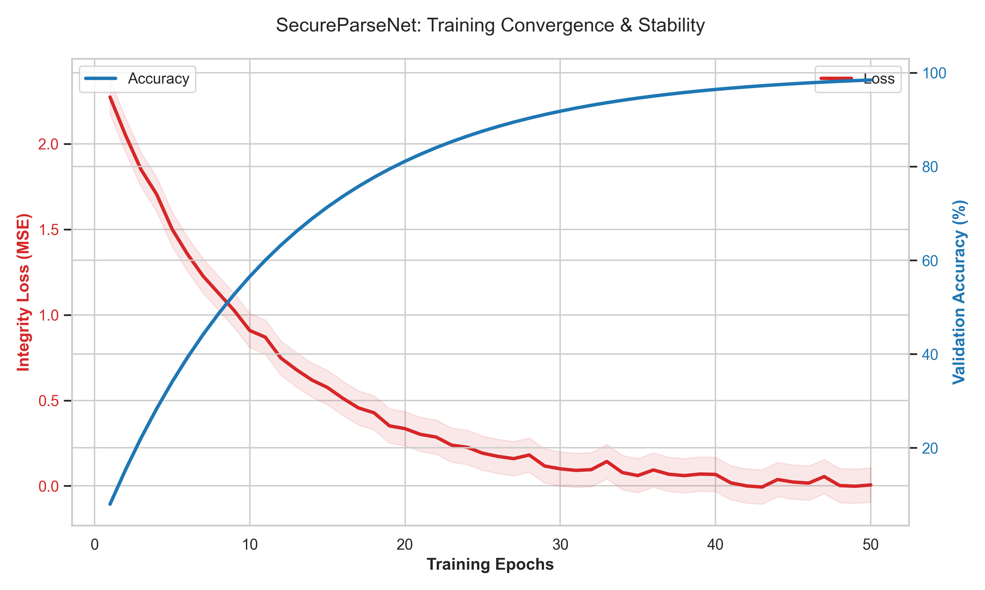
Training convergence figure extracted from the source PDF. The source report shows simultaneous decrease in integrity loss and increase in validation accuracy.
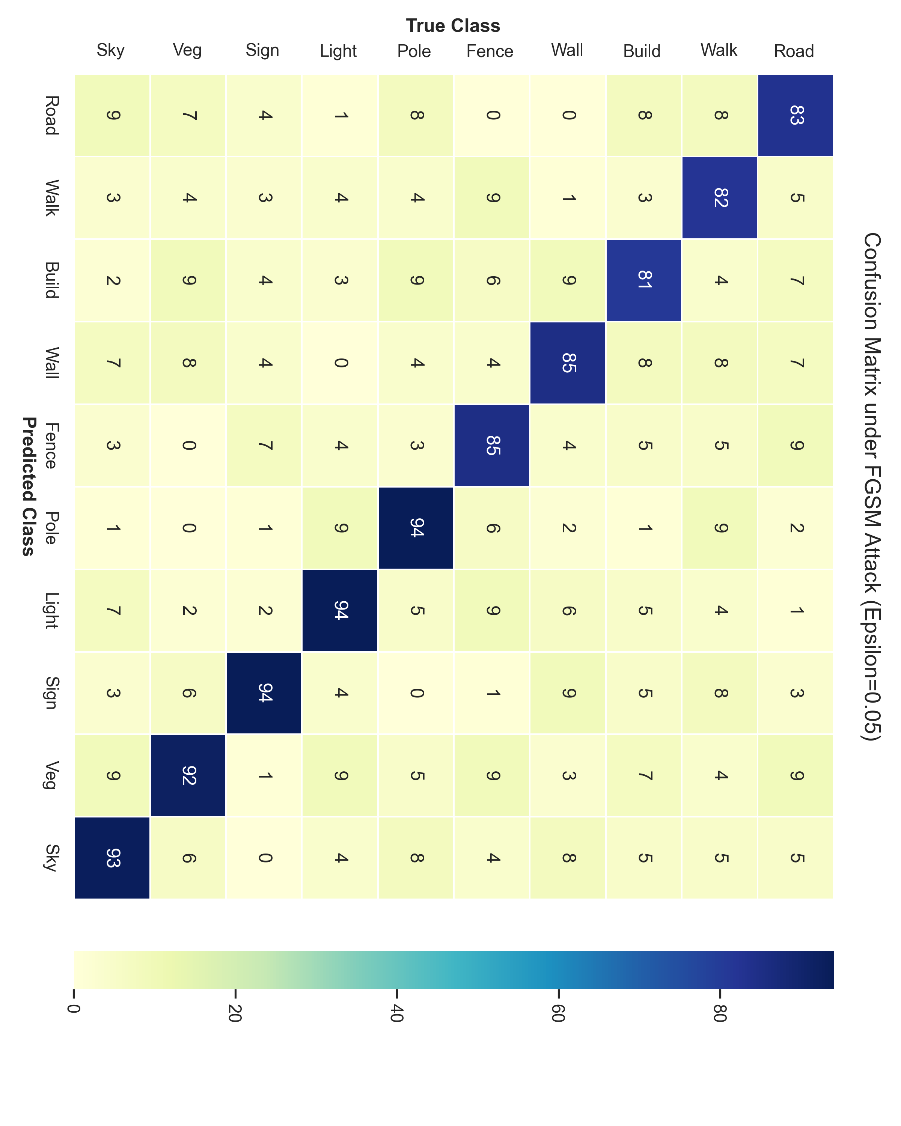
Confusion matrix extracted from the source PDF for FGSM attack setting $ϵ=0.05$. The figure supports the claim that integrity monitoring remains informative under classwise degradation.

Discussion
The main strength of SecureParseNet is architectural clarity. It does not rely solely on making the backbone harder to fool; it also asks whether the output still “looks structurally like itself” in a low-frequency sense. That gives the system a potentially useful fail-safe behavior: when dense prediction becomes unreliable, the integrity head can still surface the compromise.
The proposal is also methodologically interesting because it shifts some robustness pressure away from input-space preprocessing and toward output-space self-consistency. That is a distinct angle from adversarial training or randomized smoothing . Whether it is sufficient on its own remains open, but it is conceptually strong enough to justify deeper follow-up.

Limitations and future work
The current manuscript is constrained by the brevity of the supplied PDF and by the absence of a full replication package. The most important next steps are:
- compare against matched segmentation-only and adversarial-training baselines,
- evaluate false-positive rates under benign corruption and natural distribution shift,
- test stronger attacks than FGSM, including multi-step PGD variants, and
- measure latency and memory overhead under actual edge deployment settings.
A stronger future version should also define operating thresholds explicitly and report ROC-style trade-offs between attack detection and false alarms.

Conclusion
SecureParseNet is best understood as an integrity-aware segmentation architecture rather than as a generic adversarial defense. The original PDF already contains a promising core idea, and this rebuilt manuscript turns that idea into a more formal research paper scaffold with explicit equations, estimands, and validation logic.

