BIO DATA
NAME : Omkar Kshirsagar 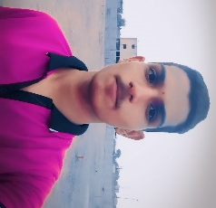
FATHER NAME : Khandu Kshirsagar PHOTO
DATE OF BIRTH : 03/06/2007
ADDRESS : Vidhya nagar,
Matoshree lons,
Ambad Road,
Jalna – 431213
MOBILE NO : 8329404747
EMAIL : omkarkshirsagar150@gmail.com
GENDER : Male
MARITAL STATUS : Unmarried
CATEGORY : “OBC”
RELIGION : Hindu
NATIONALITY : Indian
LANGUAGE KNOWN : English, Marathi, Hindi
EDUCATIONAL QUALIFICATION :
Examination | Board / University | Year Of Passing | Percentage | Stream
10th | S.N.V.J School | 2022-23 | 67.80% | Marathi Medium
11th | B.B.M.J College | 2023-24 | 82.33% | Art’s
Extra Qualification :
- Makron Art Creation Classes from “Online” in 2020-21
Working Experience :
- Working as a Grocery Store from “Shivkrupa General Store” in 2022-23
Declaration : I hereby declare that all the information provided here is true to the best of my knowledge.
Date : 03/06/2024
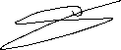
Place : Jalna
Signature

