Name:- Harshal Bharat Patil

Roll No:-34

Class:- IMCA –II Year

Subject:-Lab on C sharp

|  |
| --- |
| 1. Write a program to print given string in number of times |

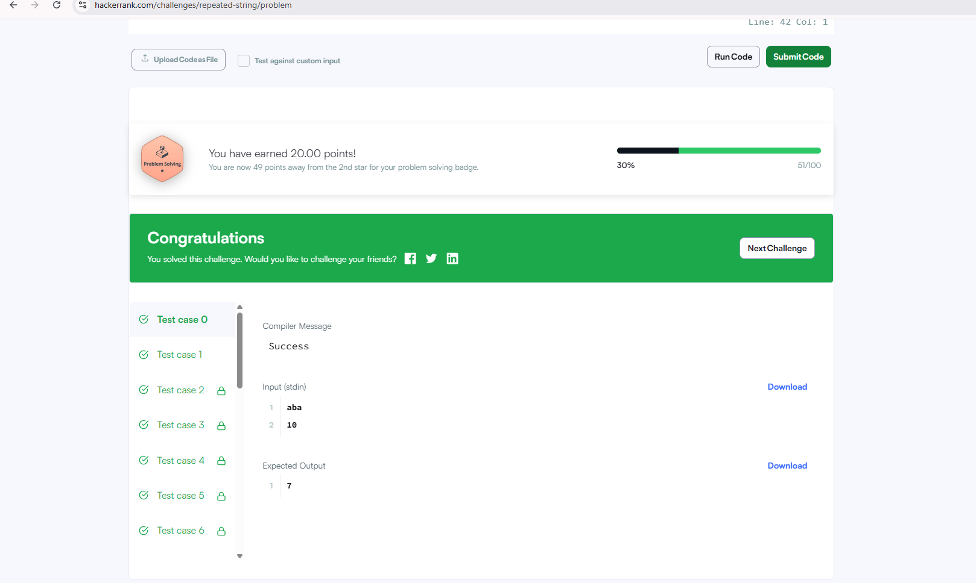

|  |  |
| --- | --- |
| 2.Write a program to show use of different operators   |  | | --- | | i) <https://www.hackerrank.com/challenges/solve-me-first/problem> | |

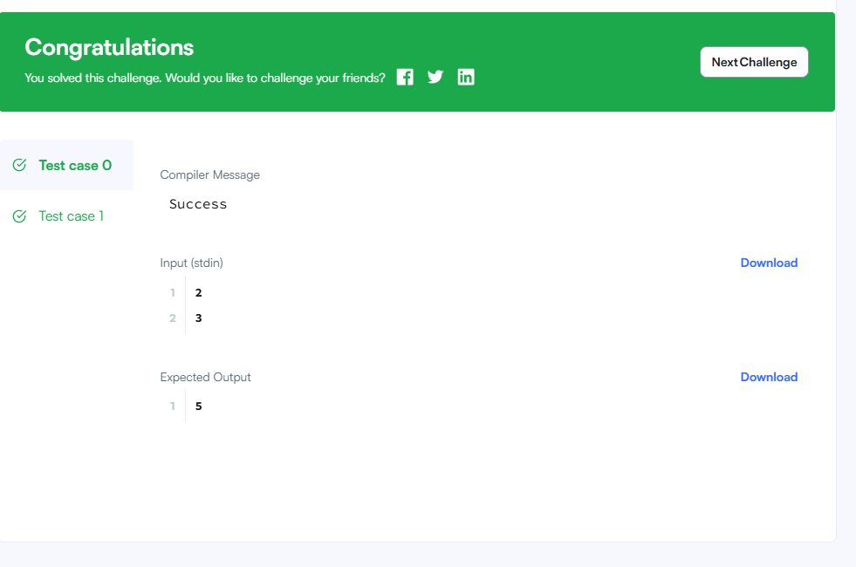

|  |
| --- |
| ii) <https://leetcode.com/problems/subtract-the-product-and-sum-of-digits-of-an-integer/description/> |

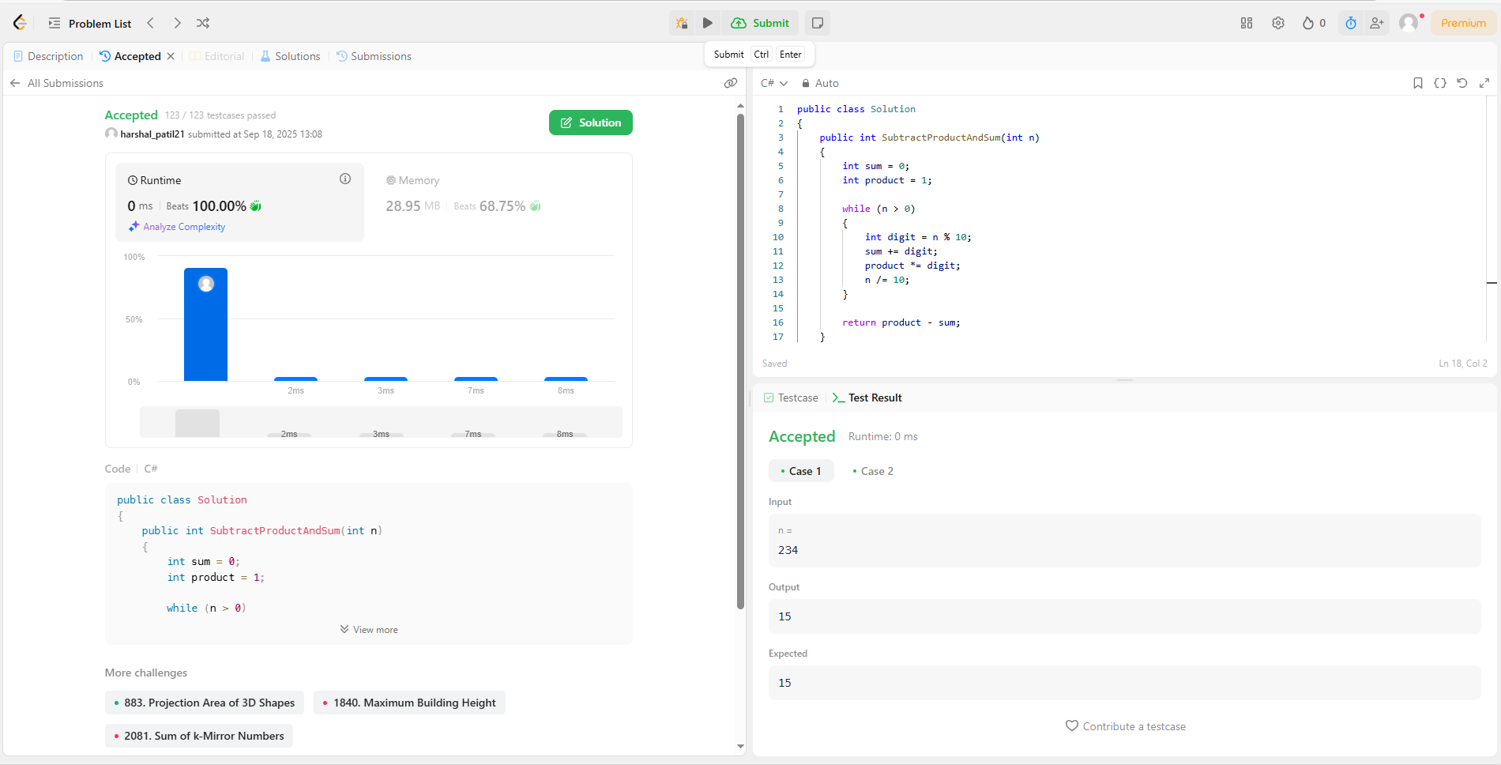

|  |  |
| --- | --- |
| 3.Write a program to show use of Looping Constructs   |  | | --- | | i)<https://www.codechef.com/learn/course/c-sharp/LBCS20/problems/CSB095> | |

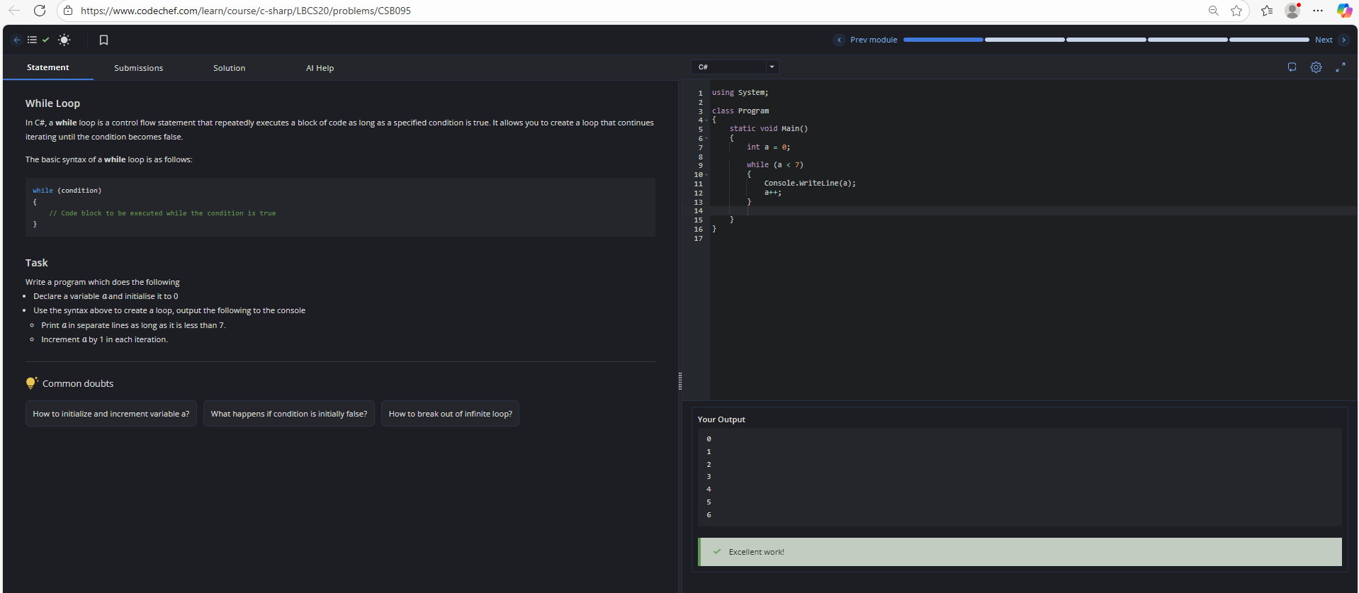

|  |
| --- |
| ii)<https://www.codechef.com/practice/course/c-sharp/PCSL05/problems/GDTURN> |

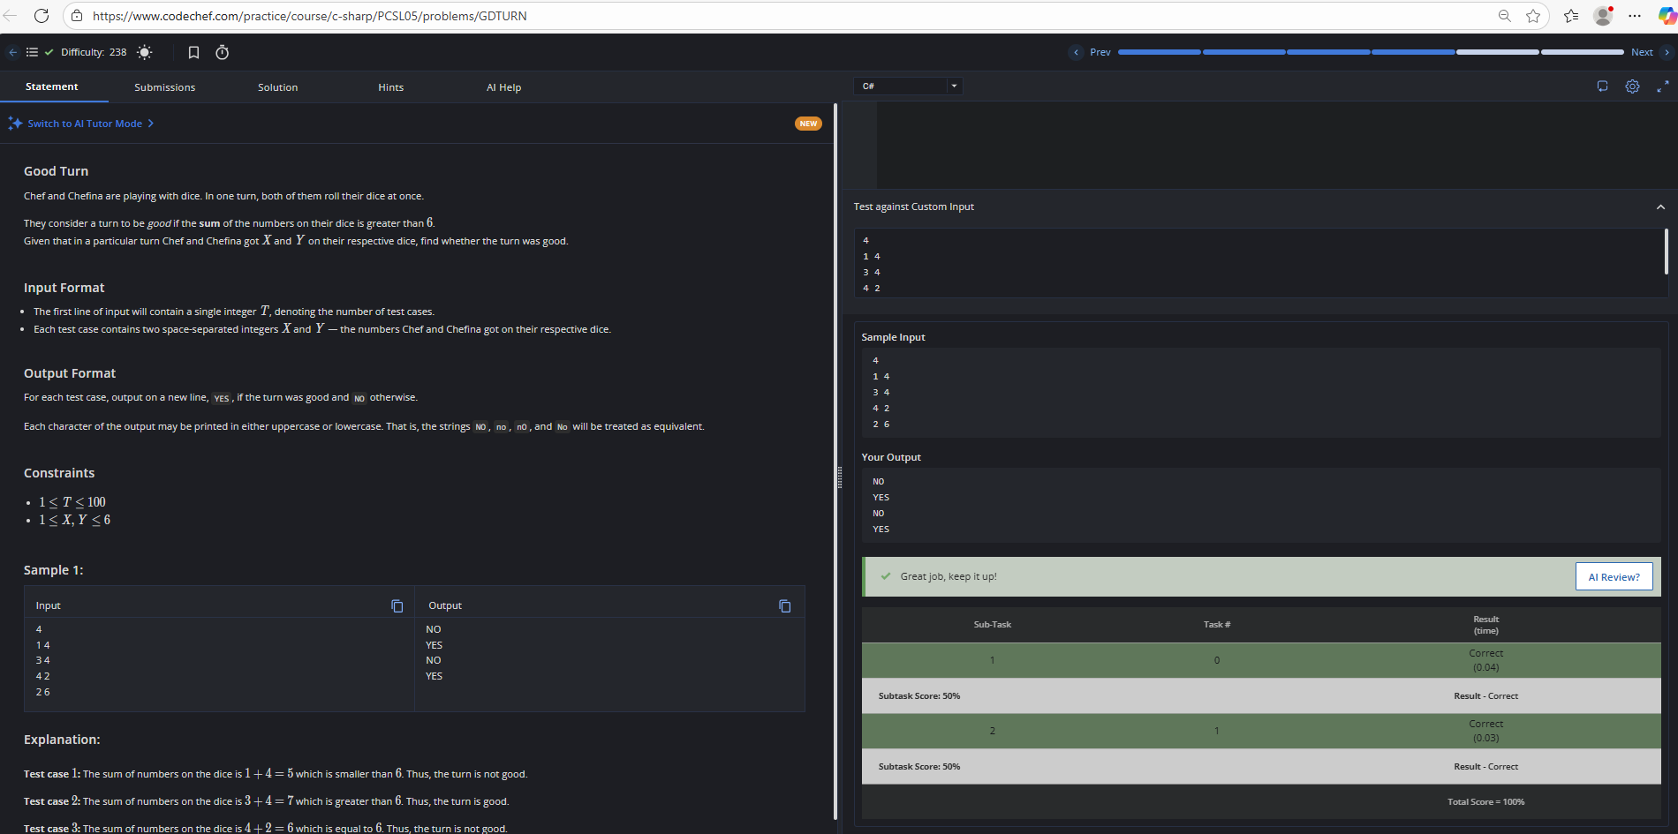

|  |
| --- |
| iii)<https://www.codechef.com/practice/course/c-sharp/PCSL05/problems/WATERCONS> |

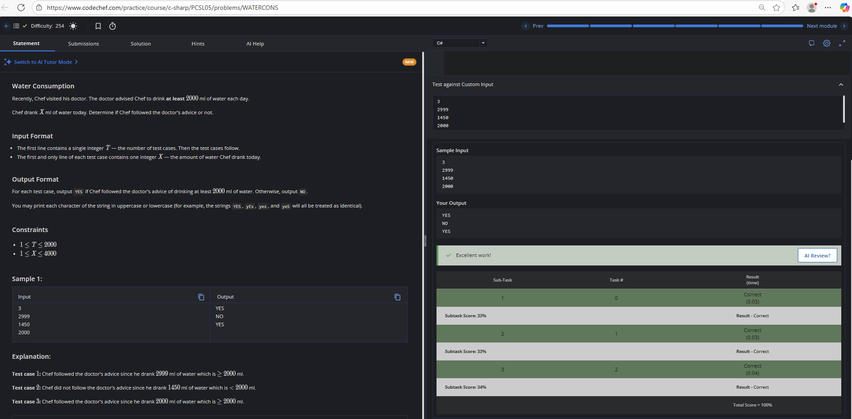

|  |
| --- |
| iv)<https://www.codechef.com/practice/course/c-sharp/PCSL05/problems/FLOW001?tab=statement> |

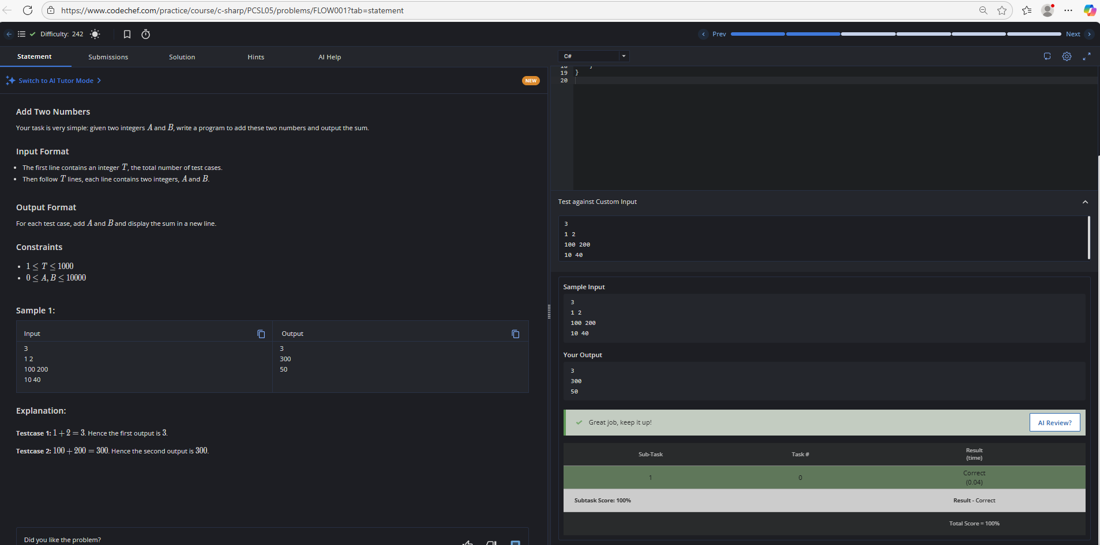

|  |
| --- |
| v)<https://www.codechef.com/practice/course/c-sharp/PCSL05/problems/FLOW001> |

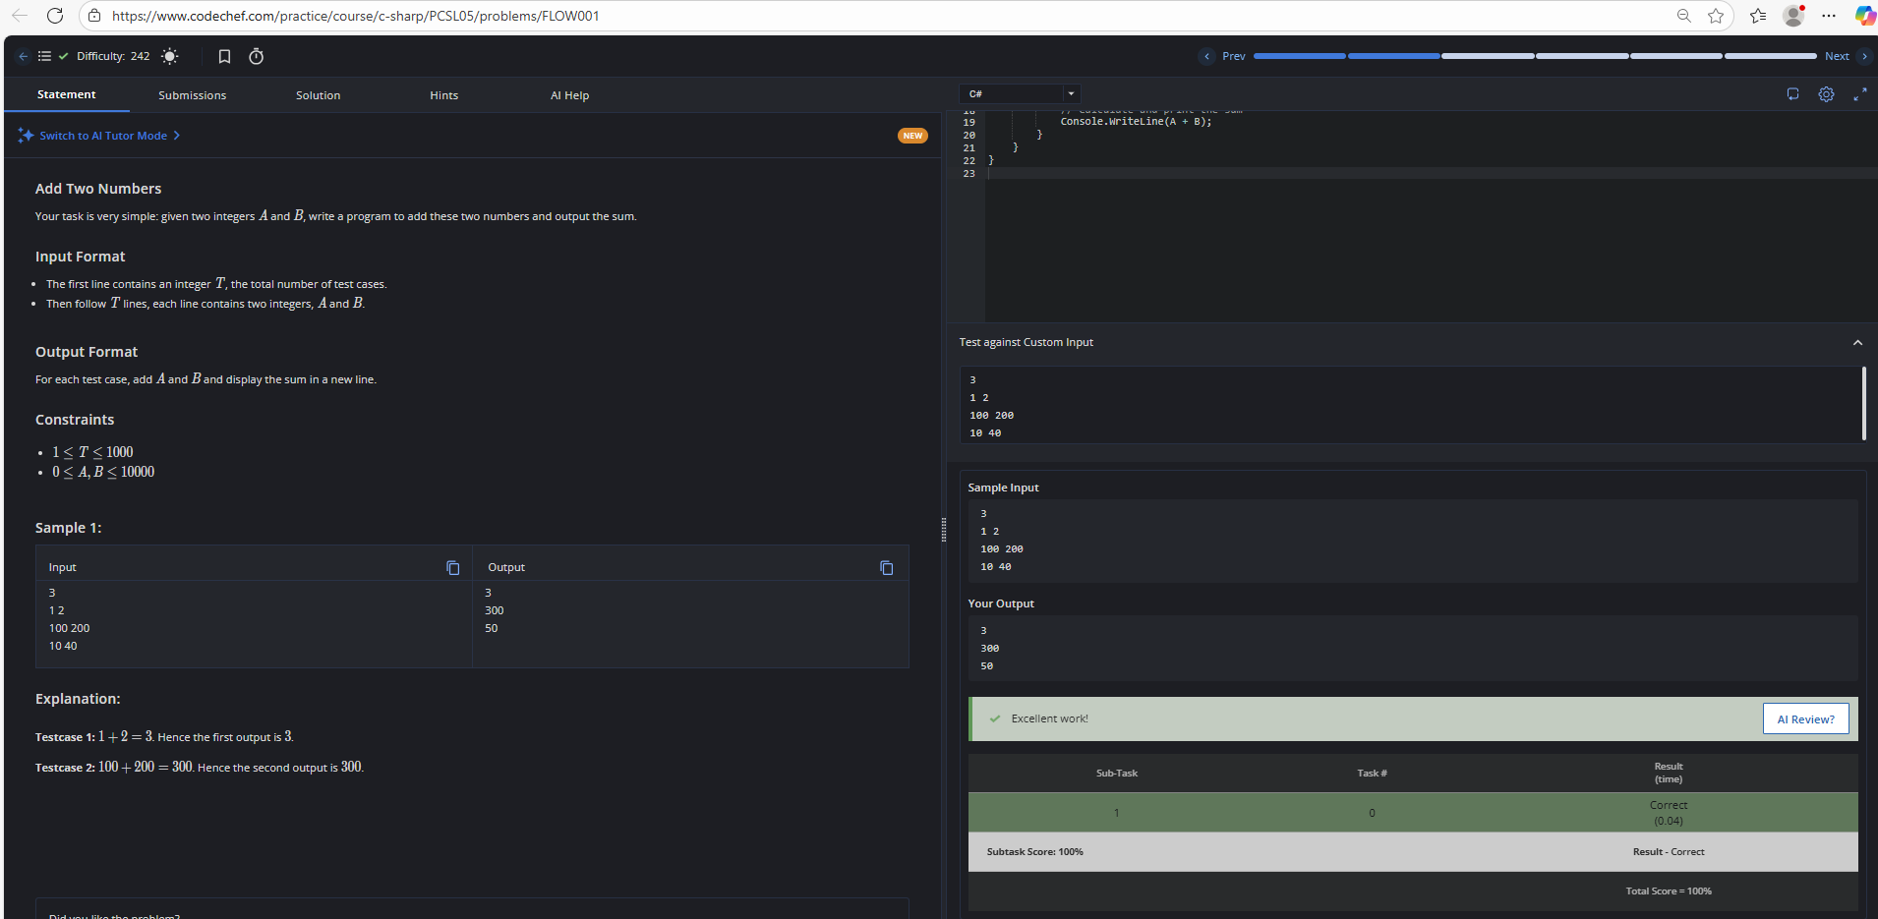

|  |
| --- |
| 4. Write a program to show use of Constructor |

|  |
| --- |
| <https://coderbyte.com/editor/Tree%20Constructor:Csharp> |

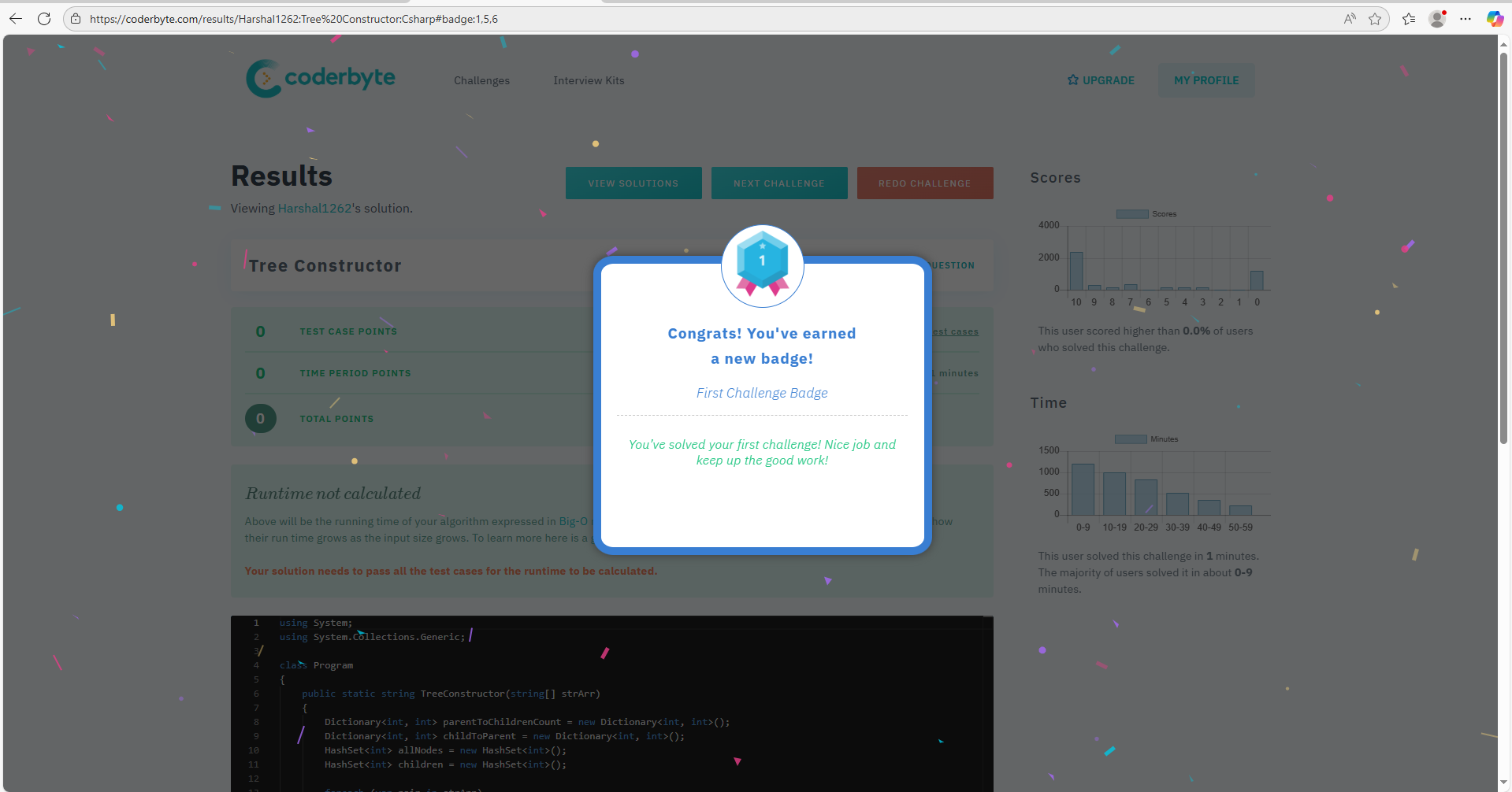

5. Write a program to show use of Constructor

|  |
| --- |
| https://www.hackerrank.com/challenges/inheritance/problem |

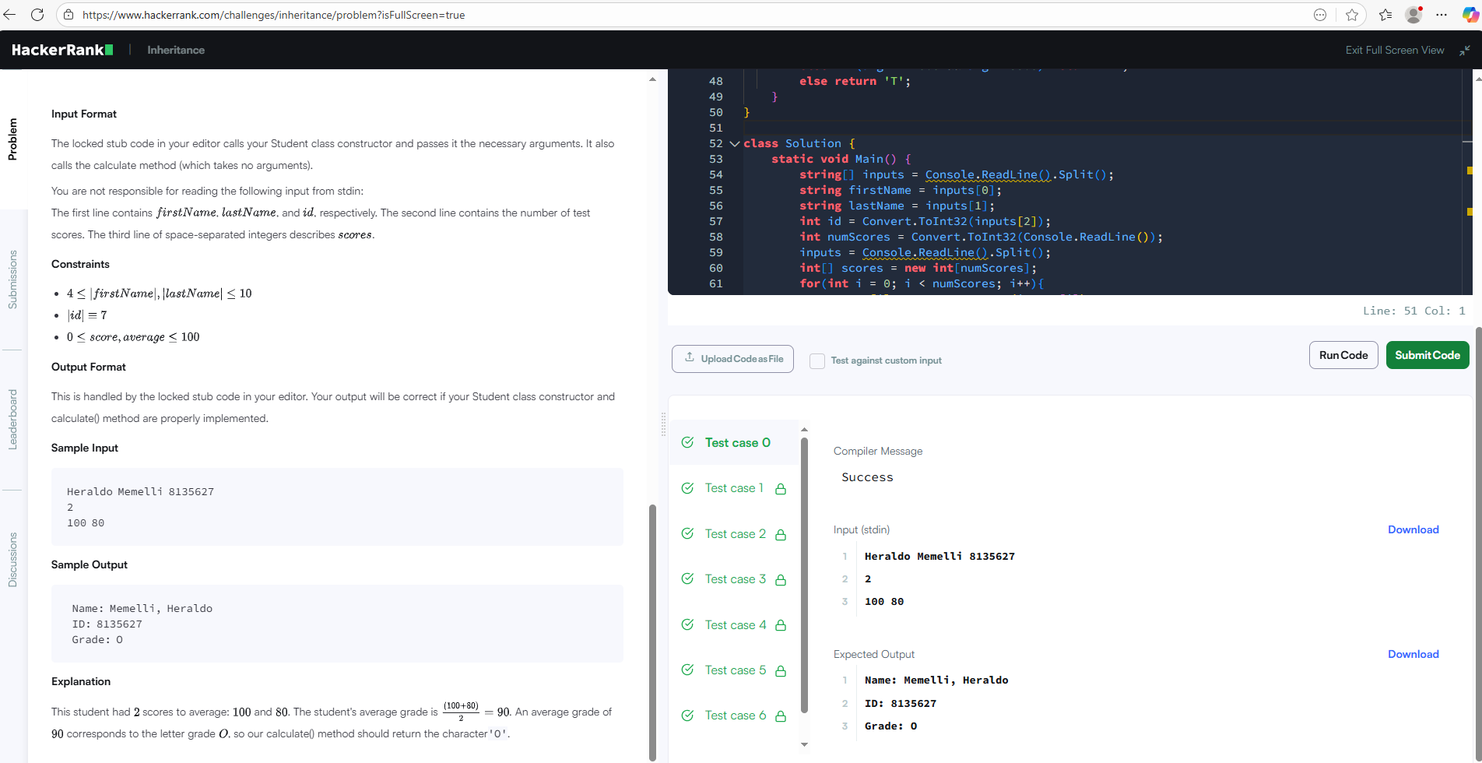

|  |
| --- |
| 6. Write a program to demonstrate the concept of boxing and unboxing |

|  |
| --- |
| i)Write A Program To Demonstrate Boxing And Unboxing In C# - AspDotnetHelp.com |

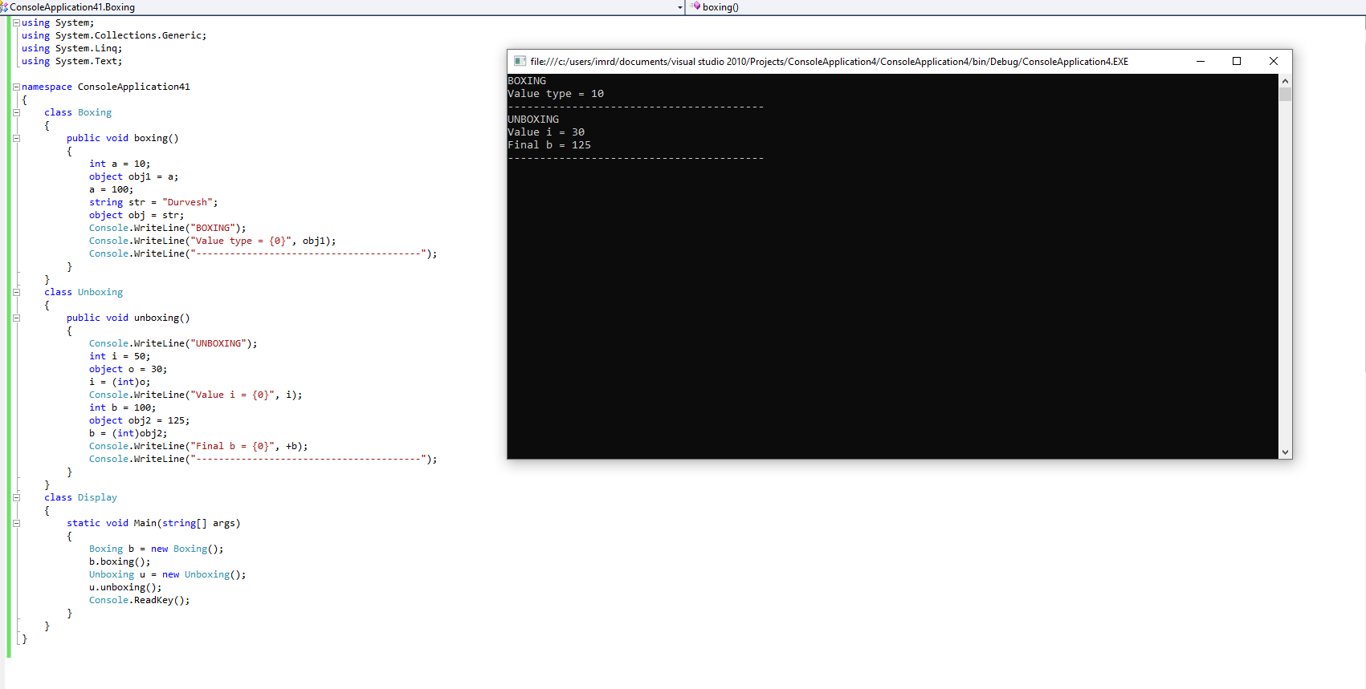

ii)

|  |
| --- |
| Boxing unboxing in C# |



iii)

|  |
| --- |
| Practice | GeeksforGeeks | A computer science portal for geeks |
|  |

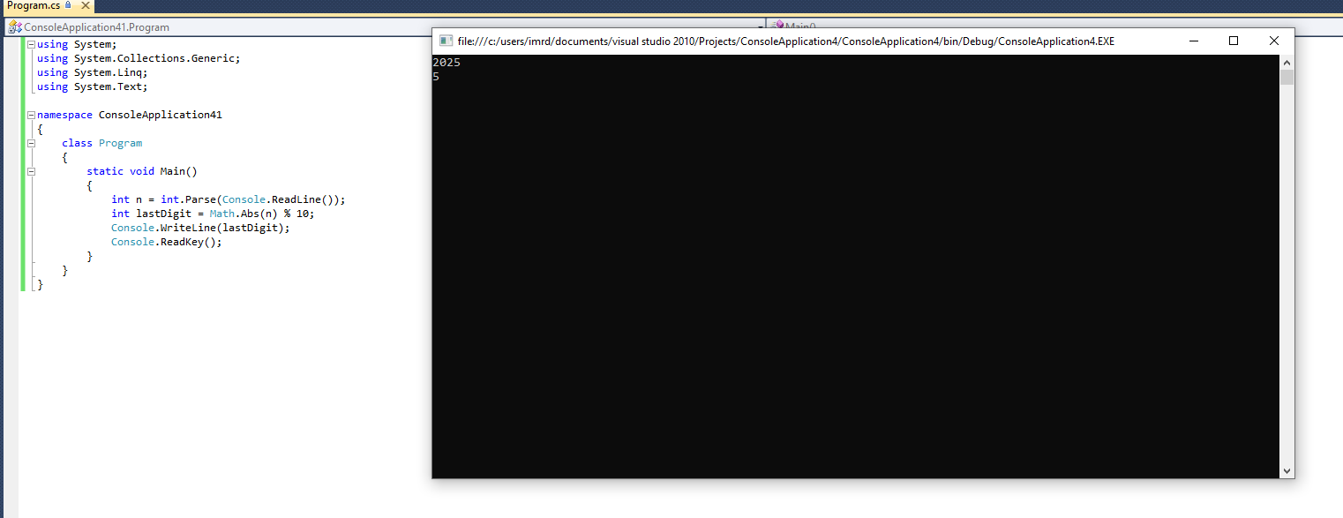

|  |
| --- |
| 7. Write a program to demonstrate the concept of Properties and Indexing |

i)

|  |
| --- |
| Properties in C# - GeeksforGeeks |

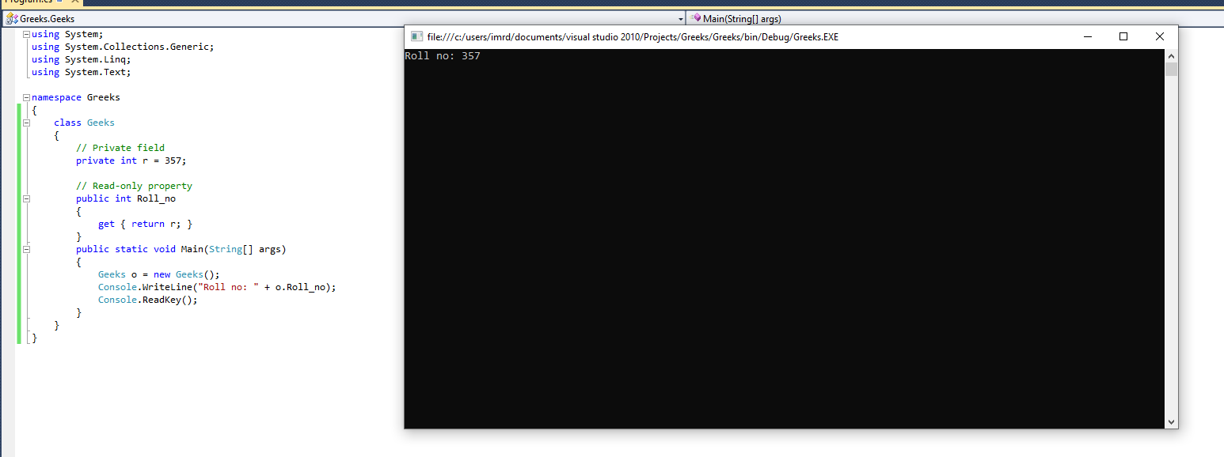

ii)

|  |
| --- |
| C# Indexers - GeeksforGeeks |

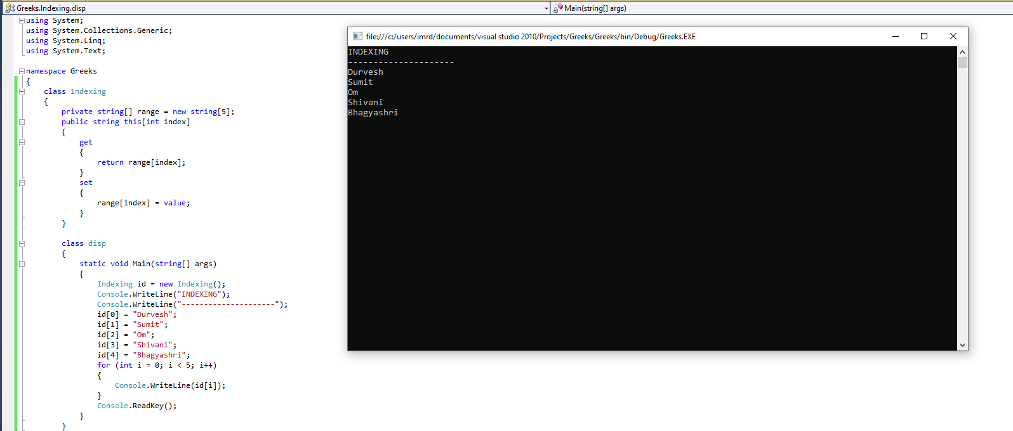

iii)

|  |
| --- |
| Practice | GeeksforGeeks | A computer science portal for geeks |

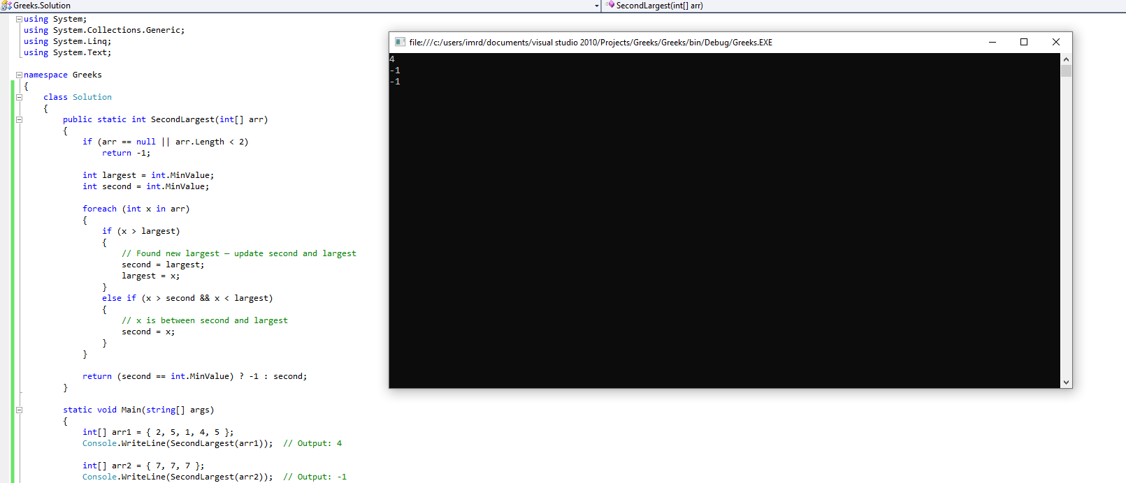

|  |
| --- |
| 8. Write a program to show use of Exception Handling |

i)

|  |
| --- |
| Exception Handling in C# - GeeksforGeeks |

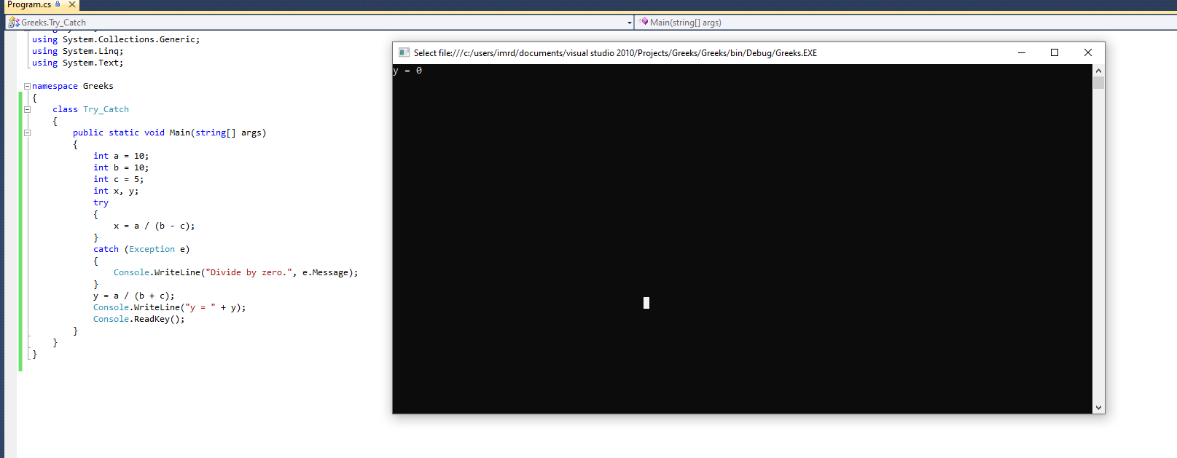

ii)

Implement exception handling in C# console applications - Training | Microsoft Learn

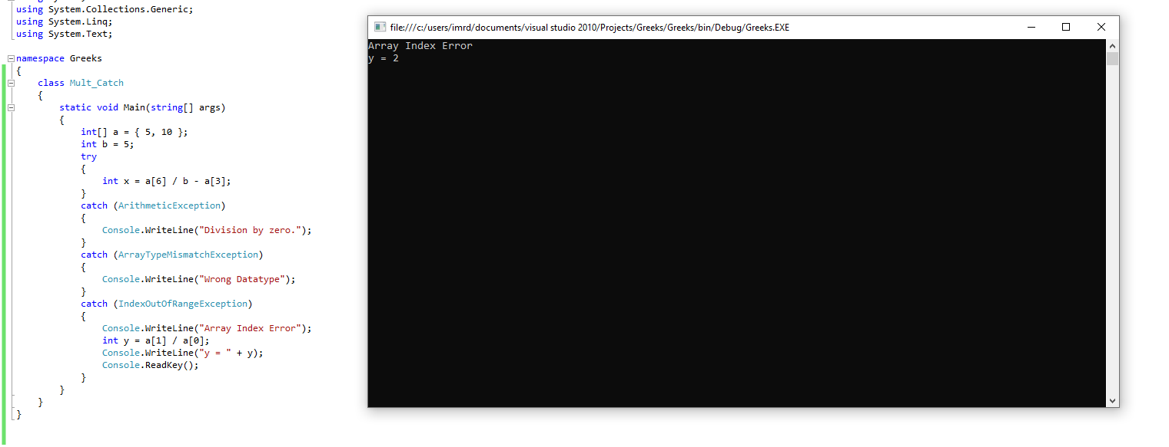

9.Create a simple C# application using Label, TextBox, Button control

Visual C# | Inheritance exercise | Create labels and text boxes based on the same abstract class

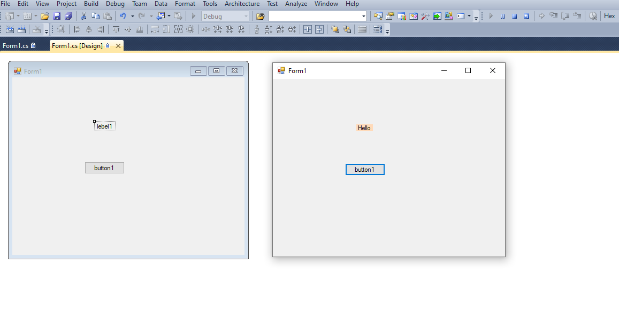

10.Create a C# application using ListBox, ComboBox control

i) 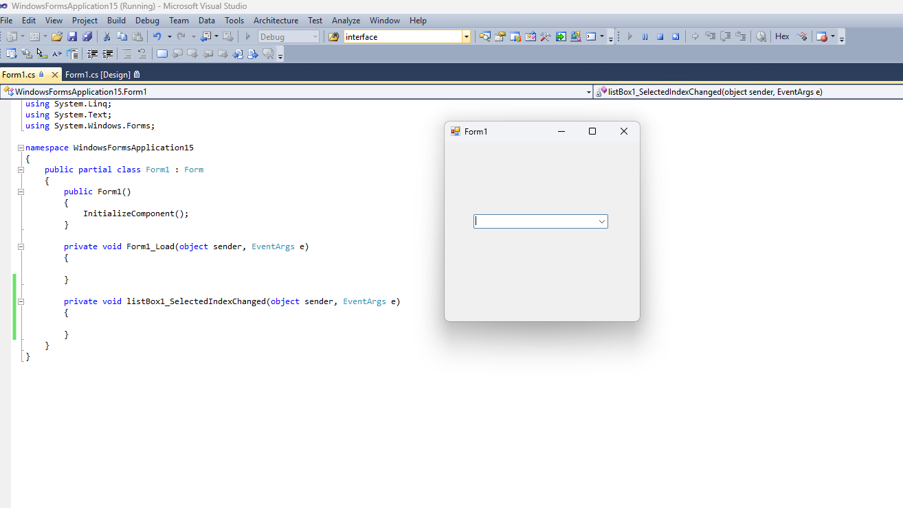

ii)

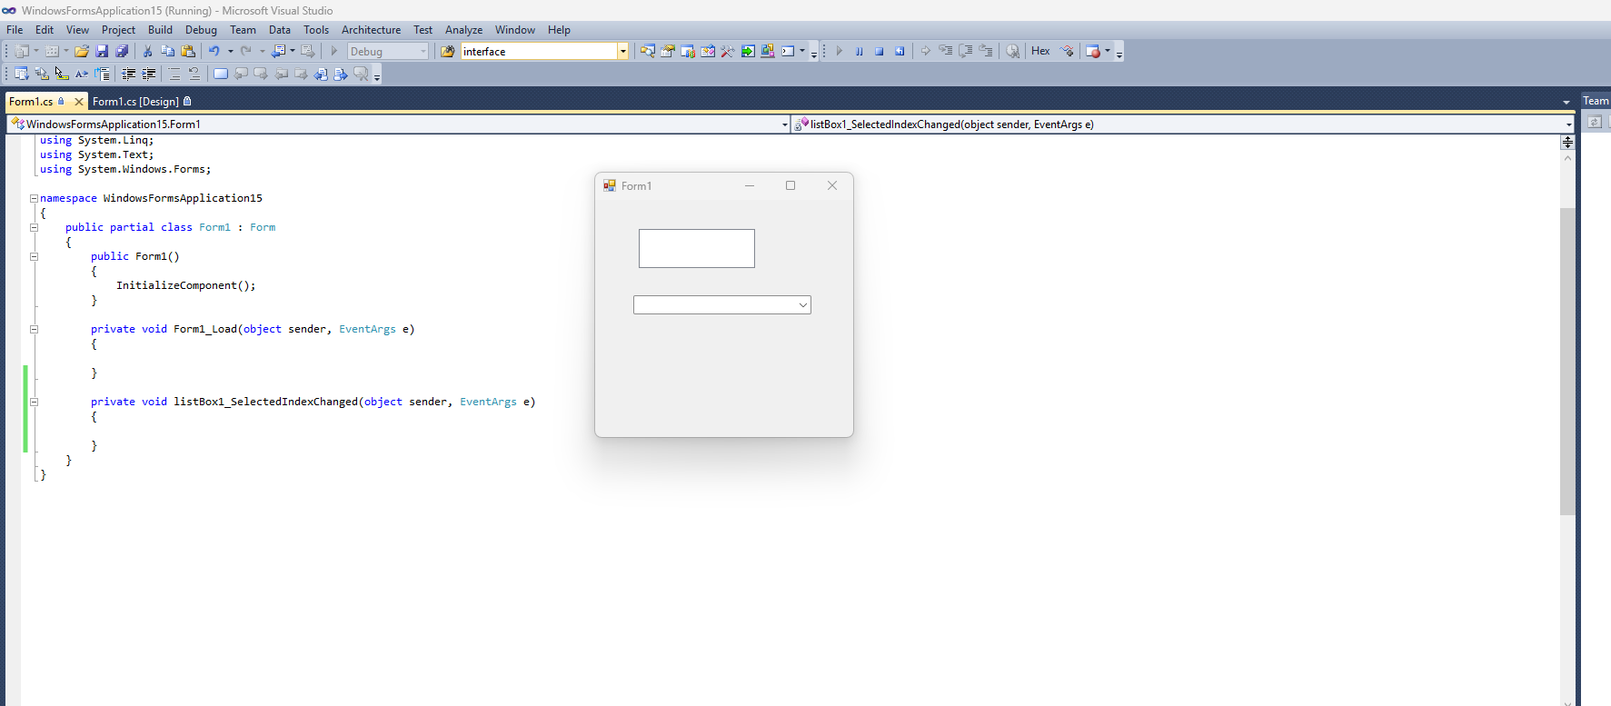

11. Demonstrate the use of Timer control in C#

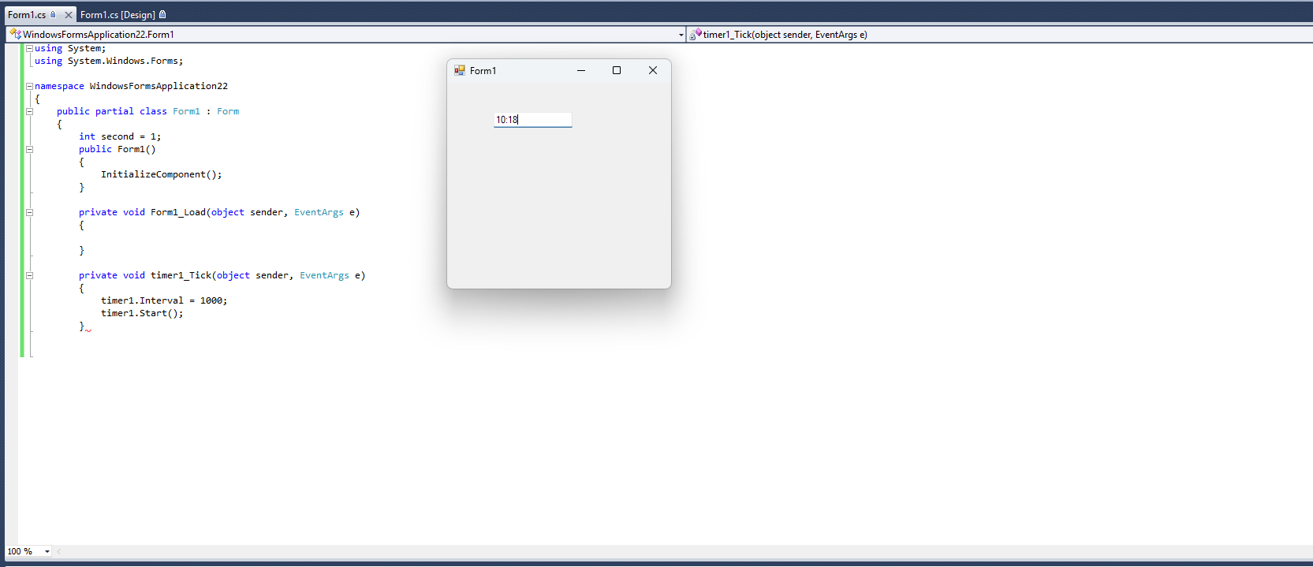

12. Create a C# application using PictureBox, ScrollBar control

i)

