1. Write a program to create barplots for all the categorical columns in mtcars.

2)Create a scatterplot matrix by gear types in mtcars dataset.

head(mtcars)

library(dlpyr)

pairs(~mpg + disp + drat + wt, data = mtcars, main = "Simple Scatterplot Matrix")

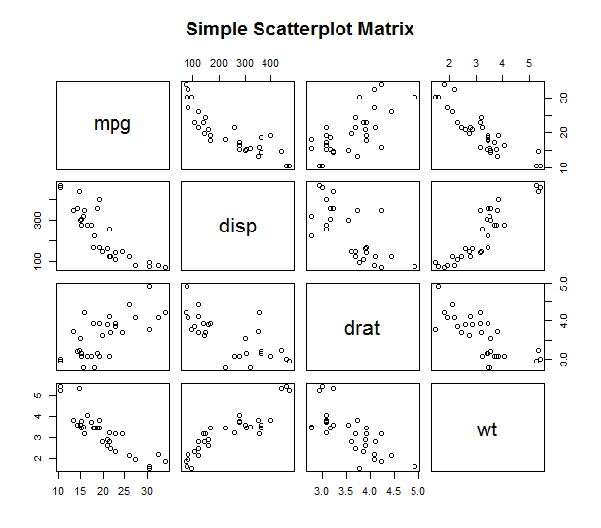

3) program to create a plot density by class variable.

d <- density(mtcars$mpg)

plot(d, main="Kernel Density of Miles Per Gallon")

polygon(d, col="red", border="blue")

